Fall 2022

CORNELL UNIVERSITY

_____________________________________________________________________________

SYSEN 5900 – Cornell University Sustainable Design

Sustainable Education – Nepal

Final Report

______________________________________________________________________________

Prepared by:

| Ashley Turke* | Julian Cardoso | Nicole Tellado* |
| --- | --- | --- |
| Bridget Neely | Karina Rivera-Lanza | Perry West* |
| Diana Bogdanowich* | Kun Wang* | Pia Glaysher |
| Harvey Kou | Liting Bu* | Doris Yuan |
| Hilary Mulford | Lizzie Taber | Ronaldo Li* |
| Indigo Routh | Maite Sadeh | Samuel Karunwi* |
| Jeff Visk* | Mark Bell | Tianzhen(Tim) Jia |
| Jego Fonseca* | Mark Minton | Uyen Hoang |
| Jessie Jia | Nazia Aktas* | William Burchett* |

*MEng Systems Students

Advised by:

Sirietta Simoncini

Cornell University – Systems Engineering

December 15, 2022



The following report (or parts of it) may be sent to the stakeholders. Because this project is run by students and not a professional firm, the team has to officially inform the stakeholders of the following statement:

CUSD (and the **CUSD - Sustainable Education team**) is not a professional engineering firm and therefore all the deliverables that we produce have to be intended as recommendations or guidelines, which can be used by external organizations at their discretion. Furthermore, before any of the materials provided by CUSD can be implemented, they must achieve the needed verifications and authorizations (such as PE stamp) of external licensed professionals, which cannot be provided by CUSD. It is the team's understanding that the stakeholders internally have or are planning to outsource such qualified professional(s).

With all above stated we are iterating that:

Disclaimer of Warranties

Whereas, Cornell University wishes to convey the attached deliverables to the team's stakeholders, and whereas both parties agree to the terms and conditions set forth below and acknowledge that while reasonable efforts have been made to assure that the information in the deliverable is accurate, the information is provided for convenience and reference only and without warranty of any kind. Any reliance that recipient places on such information is therefore strictly at its own risk.

The University is not responsible for the recipient's reliance on the information in this deliverable or errors related to the information contained in the deliverable. All such errors are subject to correction. No warranty, expressed or implied, is made regarding accuracy, adequacy, completeness, legality, reliability or usefulness of any information. This disclaimer applies to both isolated and aggregate uses of the information.

The University provides this information on an "as is" basis. All warranties of any kind, express or implied, including but not limited to the implied warranties of merchantability, fitness for a particular purpose, freedom from contamination by computer viruses and non-infringement of proprietary rights are disclaimed. If you have obtained information, originally created by the University, from a source other than the University, be aware that electronic data can be altered subsequent to original distribution. Data can also quickly become out-of-date. It is recommended that careful attention be paid to the contents of any data associated with a file.

Recipient HEREBY agrees to HOLD, Cornell University, its respective trustees, officers, agents, volunteers, and employees (collectively, “Released Parties”) HARMLESS from any liabilities, damages, expenses, causes of action, claims, or demands of any nature whatsoever, including any claims of negligence related to the recipient’s reliance on the information, research data or findings in this deliverable.

Best Regards,

CUSD – Sustainable Education Team

**Table of Contents**

**1. Project Overview** **6**

1.1 Phase Introduction 6

1.2 Design Philosophy 6

1.3 Stakeholder Deliverables 7

1.4 Project Timeline 7

1.5 CUSD Sustainable Education Team 8

1.6 Stakeholders 9

1.7 UWS Model of Operation 9

**2. UWS Nepal Sunsari School Requirements** **9**

2.1 Stakeholder Requirements 10

2.1.1 Modular Design: Stakeholder Requirements 10

2.1.2 Sustainability and Life Support Systems: Stakeholder Requirements 13

2.1.3 Landscape: Stakeholder Requirements 15

2.1.4 Empathy & Culture: Stakeholder Requirements 16

2.2 LBC Requirements 18

**3. Design Concepts** **19**

3.1 Spring 2022 Initial Design 19

3.2 Fall 2022 Design 21

3.2.1 Modular Design 21

3.2.1.1 School Layout 22

3.2.1.2 Roof 24

3.2.1.3 Windows 24

3.2.1.4 Doors 26

3.2.2 Landscape 26

3.2.2.1 Vegetation 28

3.2.2.2 Waste Management 30

3.2.2.3 Landscape Architecture 31

3.2.2.3.1 Courtyard & Outdoor Seating 32

3.2.2.3.2 Flow of Entry and Exits 33

3.2.2.4 Storage 33

3.2.2.5 Property Safety 34

3.2.2.6 Recreation 35

3.2.2.6.1 Football Pitch 35

3.2.2.6.2 Volleyball Court Elements 36

3.2.2.6.3 Playground Elements 37

3.2.2.7 Ponds, Creeks, and Fountains 37

3.2.2.8 Water Storage and Removal 38

3.2.2.9 Bikes and Scooters 39

3.2.3 Community, Empathy, and Culture 42

3.2.3.1 Decorations 43

3.2.3.1.1 Kindergarten 43

3.2.3.1.2 Elementary 46

3.2.3.2 Main Gate 46

3.2.3.3 Classroom 47

3.2.3.3.1 Kindergarten 47

3.2.3.3.2 Elementary 49

3.2.3.4 Bathroom 50

3.2.3.5 Teacher’s Office 50

3.2.4 Sustainability and Life Support Systems 50

3.2.4.1 Water - Internal 51

3.2.4.2 Water - External 51

3.2.4.3 Solar Power Collection 54

3.2.4.4 Electric Distribution 55

3.2.4.5 Lighting 59

3.2.4.6 Heating and Air Conditioning 61

3.2.4.7 Classroom Accessories 62

3.2.4.8 Kitchen 63

3.2.4.9 Internet 63

3.2.4.10 Building Protection and Safety 63

3.2.4.10.1 Classroom Security 66

3.2.4.10.2 Fire Safety 66

3.2.4.10.3 Rain Safety 66

3.2.4.10.4 Earthquake Safety 66

4 Living Building Challenge (LBC) Overview **67**

4.1 LBC Introduction 67

4.2 Place Petal 68

4.3 Water Petal 69

4.4 Energy Petal 71

4.4.1 Renewable Energy Analysis for Nepal School 71

4.4.2 Network Analysis for Nepal School and Future Computer Lab 78

4.5 Health and Happiness Petal 80

4.5.1 Red List Materials 81

4.5.2 Living Economy Sourcing 82

4.5.3 Responsible Sourcing 83

4.5.4 Net Positive Waste 84

4.6 Equity Petal 84

4.7 Beauty Petal 85

**5. Conclusion** **87**

5.1 Project Management Office 87

5.2 Living Building Challenge 87

5.3 Acknowledgements 87

**6. Appendix** **88**

Appendix A. Annual Climate Conditions Chart in Nepal 88

Appendix B. Living Building Challenge Requirements 88

Place Petal 88

Water Petal 90

Energy Petal 91

Health and Happiness Petal 92

Material Petal 94

Equity Petal 96

Beauty Petal 97

Appendix C. Empathy Field Work Requirements 99

Appendix D. Electric Loads Analysis, Diagrams and Figures 100

Appendix E. Landscape Vegetation Research 107

Appendix F. Water 108

Appendix G. Internal Block Diagrams (IBDs) 110

Appendix H. Block Definition Diagrams (BDDs) 113

Appendix I. LBC Verification Plan Matrix 115

Place Petal 115

Water Petal 127

Material Petal 139

Energy Petal 158

Health & Happiness Petal 169

Beauty Petal 184

Equity Petal 192

Appendix J. Nepal Building Code Requirements 199

Appendix K. Team Data & Communication Structure 209

# 

# 1. Project Overview

The broad mission of the Sustainable Education (SE) team is to incorporate sustainable design, and equitable, fair, and informed user experience solutions into the design of schools in developing countries. In the Fall of 2022, the SE continued its prior collaboration with a Non-Governmental Organization (NGO) in Nepal, the United World Schools (UWS), with which the SE team has had a relationship for several years. The UWS, the stakeholder for the Nepal project, requested the SE team to deliver a design proposal for ten primary schools each consisting of ten classrooms, with the purpose of educating approximately 4,000 students.

In previous semesters, the team has focused on empathy fieldwork studies of the area in which the school is located and the use of schools in Nepalese culture. In this semester, the team’s goals were to focus primarily on sustainable design. Specifically, it aimed to design the school that meets the requirements of the Living Building Challenge (LBC), one of the premier sustainable design certifications created by the International Living Future Institute (ILFI). The team has continued to build upon the previous design work from Fall 2021 which now incorporates the LBC elements as a guide per stakeholder guidance as well as the Nepal Building Code (NBC) requirements. In addition, the team has applied Systems Engineering processes to create an LBC qualified design, which employs a novel approach to reach a new design solution that meets the LBC standards.

## 1.1 Phase Introduction

The team’s primary focus this semester was to improve upon the Spring 2022 design concepts which proved to be more involved than planned - a complete redesign of the school layout. The leadership team was in frequent contact with the stakeholder throughout the semester in order to gain a clear understanding of the stakeholder’s needs and to obtain regular feedback on the team’s work progress. For this semester, the team was broken down into four functional focus areas used in the previous semester: (1) Modular Design, Codes & Resiliency, (2) Landscape & Vegetation, (3) Community, Empathy & Culture, and (4) Sustainability & Life Support Systems. In these teams, design concepts and functional analysis were conducted for all aspects of the project. Next semester, the team will continue to work closely with UWS Nepal and the stakeholders, to refine and finalize the design for the primary schools.

## 1.2 Design Philosophy

The team's design philosophy this semester when brainstorming and refining the design concepts was to satisfy the stakeholder, LBC, and NBC requirements, and also keep the user (students and faculty) at the heart of the design. The team’s goal was to ensure that the substantial empathy fieldwork discovered during previous semesters was utilized to the fullest and integrated within each element of design concepts. Without empathy fieldwork, a designer, engineer, or architect could easily overlook and forget that these students are going to spend eight to nine years of their lives growing up in this school. It is where they will be spending their entire day away from their homes and families and building memories in. The school is a structure of pride for the community. It is a safe space where they trust to send their children to get education, opportunities, and to get ahead in life. It is a place that needs to be both comforting, age appropriate, and stimulating such that the students look forward to coming to school every day.

So, developing a design and experience that is unique for every grade range (kindergarten, elementary, middle school) is going to be extremely important for the users. The team’s goal is to design a school that is a home away from home where the students, facility, and staff feel comfortable, energized, happy, and excited about coming to school each day.

## 1.3 Stakeholder Deliverables

The focus for the Fall 2022 semester was to refine the design developed during the Spring 2022 semester. The final design concepts include structural layouts, drawings and rendering of the school with classroom sizing, entrance designs, and landscape elements. These design concepts would incorporate all the background research from the first semester plus the stakeholder requirements, LBC requirements, NBC requirements, and of course the empathy field work requirements. Throughout the semester, the team met with the stakeholders on a regular basis to receive feedback on the design concepts and clarify the requirements as the design progressed. This allowed for the team to answer critical questions to ensure the designs were heading in the right direction and that the requirements were being satisfied.

## 1.4 Project Timeline

For the Fall 2022 semester it was important to establish a workflow and timeline that synchronized the parallel lines of effort of the project. Throughout the semester, the individual teams kept track of internal timelines and presented weekly updates at the general meeting.

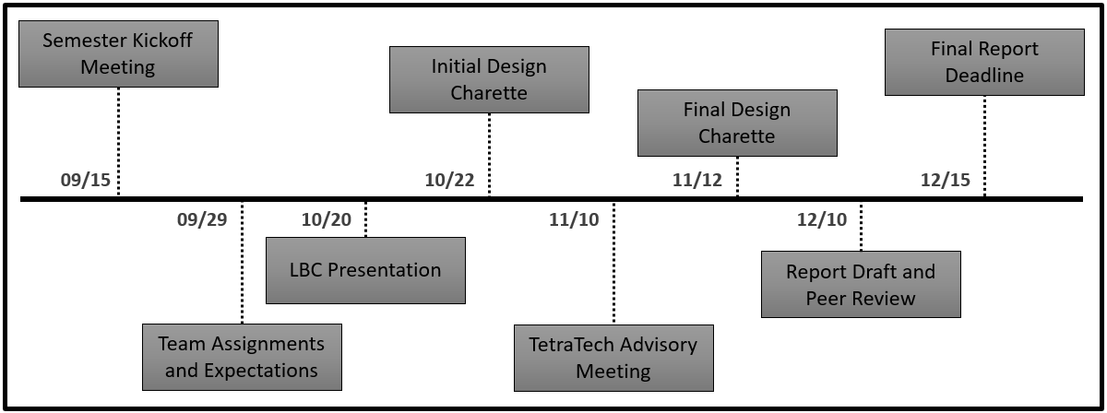

**Figure 1.4-1:** Project Timeline

The team used a task tracking toolkit in the form of Microsoft Teams as well as collaboration tools such as Miros and Google Docs. Refer to Appendix K for more information on the integration and collaboration tools. This workflow transition will continue into the following semester, allowing for a gradual shift to the team’s primary tracking project tool.

## 

## 1.5 CUSD Sustainable Education Team

This semester's Sustainable Education (SE) team structure mirrored the previous semester's structure with the team divided into its four major sub-teams. The SE team as a whole retained roughly a quarter of the original personnel from the previous semester. This high turnover proved to be a challenge in knowledge transfer and project organization.

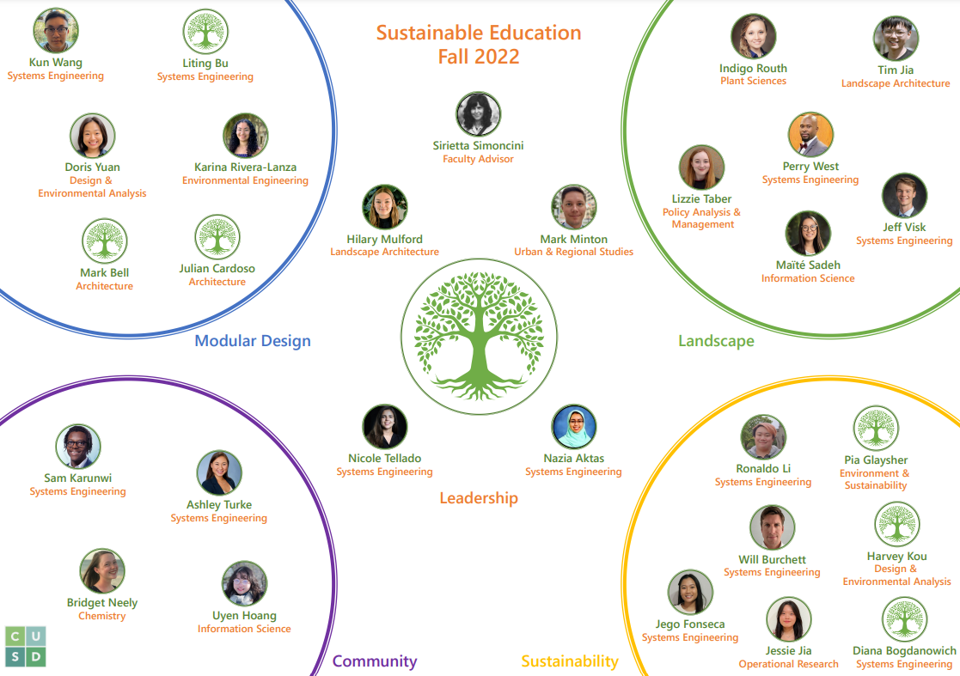**Figure 1.5-1:** SE Organization Chart

The breakdown of the Fall 2022 cohort consisted of twelve systems engineering graduate students, as well as fifteen undergraduate students from the disciplines of Architecture, Landscape Architecture, Chemistry, Environmental Engineering, Information Science, Design and Environmental Analysis, Operational Research, Plant Sciences, Policy Analysis and Management, Urban and Regional Studies, and Environment and Sustainability Sciences. The systems engineering students were embedded in all the sub-teams. The sub-teams were Modular Design, Landscape, Community, and Sustainability. The Modular Design sub-team was responsible for the school layout, the roof, windows, and doors. The Landscape sub-team was responsible for vegetation, waste management, outdoor and entry/exit landscape architecture, storage, property safety, recreation, bodies of water, water storage, and bikes and scooter management. The Community sub-team was responsible for decorations, main gate, classrooms, bathroom, and teacher’s office. Lastly, the Sustainability sub-team was responsible for internal and external water systems, solar power collection, electric distribution, lighting, heating and air conditioning, lighting, classroom accessories, kitchen, internet, and building safety. Figure 1.5-1 shows the SE organization chart for this semester, providing additional details on subteam breakdown.

## 1.6 Stakeholders

As mentioned previously, the stakeholder for this semester’s SE project is the UWS Nepal, a charity that works to improve educational outcomes and opportunities for under-served and disadvantaged children in Nepal. The SE team has worked closely with the UWS previously and has a strong relationship with them. The project for this semester was a broad collaboration between the CUSD Sustainable Education (SE), UWS Nepal, and Cornell University Systems Engineering group. This project’s primary point of contact at the UWS Nepal was Manjeet Raj Pandey. Manjeet is a structural engineer and is on the board of the UWS Nepal. He is also a construction manager for the charity. For this semester, the Sustainable Education team communicated with Manjeet to get the stakeholder’s inputs.

## 1.7 UWS Model of Operation

UWS is a UK registered charity and operates schools in Nepal, Cambodia, Myanmar and Madagascar. The UWS model is to “teach the unreached”, by providing an education for out of school children in remote and marginalized communities. This is accomplished through the construction of safe and positive learning environments incorporating inclusive practices, and ensuring accessibility for all. In partnership with local leaders and government officials, UWS empowers the community through training teachers and staff to run and maintain the schools. This results in a continued benefit to children for many years, reducing inequality and improving opportunities for those most disadvantaged.

In Sunsari District, Region 1, Nepal, UWS will form a district office with a three-person management staff. During the construction phase of the project, local contractors will be hired for the building of the schools. The education portion of the project will run simultaneously and train teachers and staff in the daily operation of the schools and on national curriculum for the classroom. The schools are primarily funded by private donors, which have so far raised over three years of continuous funding for approximately 75 schools across Nepal. The construction phase is expected to take four months, while UWS will remain in the community for five to seven years to provide mentorship and assistance with the management of the schools.

# 2. UWS Nepal Sunsari School Requirements

This section intends to provide an overview of the UWS Nepal Sunsari School Design process and how to consider the requirements in the team’s design concepts; first starting with the walk-through of the high-level stakeholder requirements for each of the functional teams. Following the stakeholder requirements, each of the functional teams dive into the detailed design concepts generated within their groups, respectively. Lastly, the section will touch on the LBC requirements and what the team's initiative was to satisfy them.

## 2.1 Stakeholder Requirements

The purpose of this section is to consolidate the stakeholder requirements. The stakeholder requirements referred to in this document were provided by CUSD's main contact with UWS and separated into four key functional categories, representative of the four CUSD-SE sub-teams. Additionally, applicable requirements from the Nepal Building Code Standard are included in the Appendix J. Please note that these requirements are for reference purposes only and will be converted to originating requirements in the systems engineering format (“shall statements”).

### 2.1.1 Modular Design: Stakeholder Requirements

The modular design team is primarily focusing on various physical layouts of the school design, including the building architecture, the different classrooms, the administrative office, the bathrooms, and other amenities.

Table 2.1.1-1 details the stakeholder needs for the overall school building. The main takeaways from Table 1 are that the school will be a single-story, twelve-room system capped with a pitched roof and foundationally strengthened by low-strength masonry (reinforced concrete).

**Table 2.1.1-1:** Stakeholder Requirements for the Overall School Building

| **Modular Design-Stakeholder Requirements: School Building** | | |
| --- | --- | --- |
| **Plot Dimensions** | 100 m x 100 m |  |
| **Number of Classrooms** | 10 |  |
| **Number of Teacher/Administrative Offices** | 1 |  |
| **Computer Lab** | 1 | Future work. Not included in current design. |
| **Type of Building** | Single Story |  |
| **Wall Composition** | Reinforced Concrete |  |
| **Roof Style** | Pitched Roof Design |  |
| **Roof Composition** | Aluminum |  |
| **Bathrooms** | 2 (separated for boys and girls), separated from the other buildings, must be towards the front of the school | Please see NBC requirements for more information |

Table 2.1.1-2, highlights the stakeholder requirements as defined for each classroom. The key concepts from this section are that there will be 40 students per classroom, which will have ventilation, age-specific flooring, and a small library.

**Table 2.1.1-2:** Modular Design-Stakeholder Requirements for Classrooms

| **Modular Design-Stakeholder Requirements: Classroom** | | |
| --- | --- | --- |
| **Students per Classroom** | 40 |  |
| **Specific Room Size (area per student)** | 1.2 sq m | Maximum allowable (per NBC 1.8 sq m) |
| **Window Requirement (min. per classroom)** | 1 | See NBC for lighting requirements |
| **Classroom Flooring (1-8 grades)** | Polished/smoothed concrete |  |
| **Classroom Flooring (kindergarten)** | Will need to have foam matting/soft flooring |  |
| **Ventilation Requirements (Passive)** | Ventilation Slits is lower one side of the classroom and higher on the other side classrooms and openable windows |  |
| **Ventilation (Active)** | Ceiling Fans | See Life Support Systems for Requirement per room |
| **Library** | Each classroom needs to have a library nook with a small space to store books and a seating area. |  |

The classroom furniture requirements are displayed in Table 2.1.1-3 below. The important facets of this section are that the student seating will be bench-style, arranged in a U-structure facing a blackboard. Also, the teacher will have a desk from which they can see all students.

**Table 2.1.1-3**: Modular Design-Stakeholder Requirements for Classroom Furniture

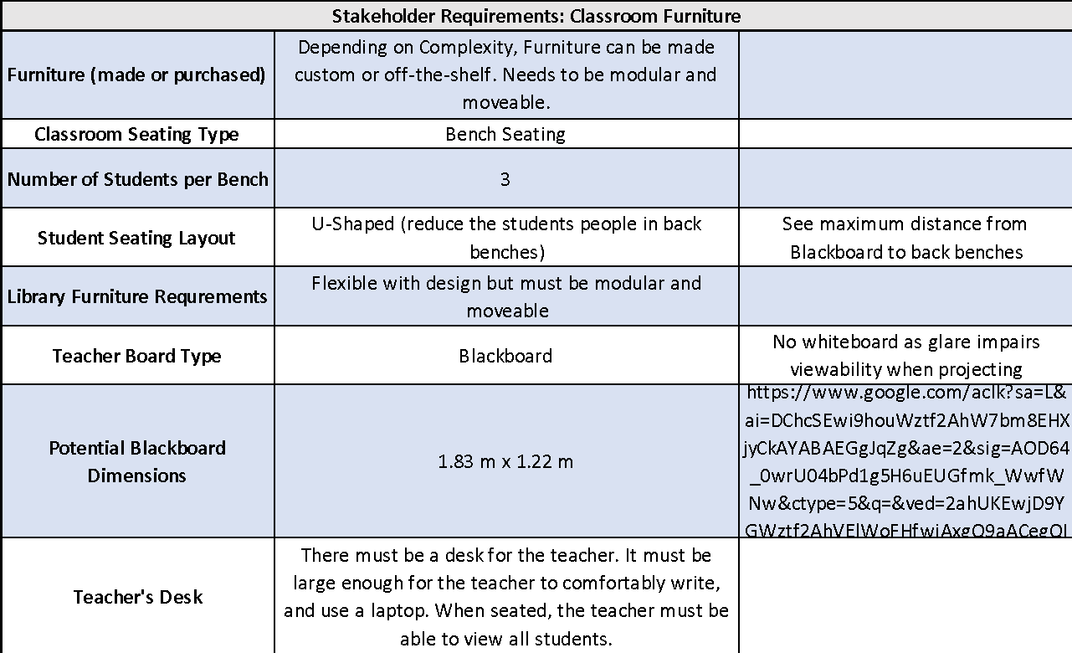

The requirements as defined by Manjeet for the Teacher/Administrative Office are detailed below in Table 2.1.1-4. The Teacher’s office will be big enough to accommodate twelve teachers at the modular, moveable round desk. Additionally, there will be spaces allotted for storage space and a sickbay.

**Table 2.1.1-4:**  Modular Design - Stakeholder Requirements for the Administrative Office

| **Modular Design-Stakeholder Requirements: Teacher/Administrative Office** | | |
| --- | --- | --- |
| **Specific Room Size (area per teacher/staff)** | 1/2 sq. m | Please review NBC guidelines) |
| **Furniture for Room** | Circular table design-moveable and able for 12 teachers to sit comfortably at the same time |  |
| **Seating** | Moveable chairs (wheels on chairs) |  |
| **Storage Closet** | There will be a small storage closet adjacent/within the teacher's office. Will be used to store cleaning materials and other items. |  |
| **Sick Bed Space** | There will need to be a space for a sick bed in the office for students to go to in lieu of a nurse's office | See updated NBC guidelines and recommendations |
| **Electrical Requirements** | Please see Life Support Systems Information |  |

### 2.1.2 Sustainability and Life Support Systems: Stakeholder Requirements

The Sustainability and Life Support Systems team focuses on multiple subsystems including Water, Solar Power, Electric Distribution, and Lighting. Table 2.1.2-1 below outlines the key requirements for each subsystem. For Water Internal, all potable water will be sourced from a well. The treatment system includes high fluoride treatment and a reverse osmosis processor. For Water External, two drinking fountains are required. Additionally, irrigation will be provided via collected rainwater, and wastewater treatment will be done via a closed septic tank. The primary electrical source will be PV-solar, with grid connections provided as a secondary power source. For the Electric Distribution subsystem, accessories needed per classroom include four outlets, two ceiling fans, six lights, one WiFi router, and one projector. In particular, that lighting need will be fulfilled by six fluorescent tubes as well as passive lighting. External lighting will be supplied by security lights. For Heating and Air Conditioning, passive heating and cooling measures will be used. Additionally, two ceiling fans per room will be provided. Along with the projector, each classroom will be equipped with a chalkboard and trash bin. For the Kitchen Subsystem, a stove and utensils will be required. WiFi will also be provided in each classroom. Building Safety will ensure two external doors per classroom to be used for emergency exits and two smoke detectors per room for fire safety. Additional details for each subsystem can be found in Section 3.2.4.

**Table 2.1.2-1:** Sustainability and Life Support Systems- Key Stakeholder Requirements

| **Subsystem** | **Requirement** | **Strategy** |
| --- | --- | --- |
| 3.2.4.1 Water Internal | Potable Water Source | Well dug on site |
| Potable Water Treatment System | High Fluoride Treatment + Reverse osmosis processor |
| 3.2.4.2 Water External | Drinking Fountains | 2 |
| Irrigation | Rainwater Collection |
| Wastewater Treatment (Blackwater) | Closed Septic Tank |
| 3.2.4.3 Solar Power Collection | Primary Electrical Source | PV-Solar |
| Secondary Electrical Source | Grid |
| 3.2.4.4 Electric Distribution | Accessories Powered per Classroom | Outlets (4), Ceiling Fans (2), Lighting (6), Wifi Router (1), Projector (1) |
| 3.2.4.5 Lighting | Classroom Lighting | 6 (3 x 2) Fluorescent Tubes + Passive Lighting |
| External Lighting | Security Lights |
| 3.2.4.6 Heating and Air Conditioning | Classroom Heating | Passive Heating |
| Classroom Cooling | 2 Ceiling Fans + Passive Cooling |
| 3.2.4.7 Classroom Accessories | Projectors per Classroom | 1 Projector, Portable and Shared |
| Chalkboards per Classroom | 1 Chalkboard |
| Trash Collection per Classroom | 1 Trash Bin |
| 3.2.4.8 Kitchen | Kitchen | Stove + Utensils |
| 3.2.4.9 Internet | Connection Method | Wifi |
| 3.2.4.10 Building Safety | Emergency Exits | 2 External Doors per Classroom |
| Fire Safety | 2 Smoke Detectors per Classroom |

### 2.1.3 Landscape: Stakeholder Requirements

The landscape sub-team is that which is focused on creating interactive, functional elements around the school property that improve the students’ experiences. While Manjeet had very specific requirements, he left significant discretion for the team to implement custom ideas. As such, the stakeholder requirements for this section are fewer than the previous two sections. The three main areas that Manjeet emphasized must be present include an outdoor play area, an assembly/gathering area, and a parking space. Table 2.1.3-1 below shows the requirements as defined for the outdoor play area.

**Table 2.1.3-1:** Landscape - Stakeholder Requirements for the Play Area

| **Landscape -Stakeholder Requirements: Play Area** | | |
| --- | --- | --- |
| **Playground** | Needs to be included |  |
| **Separation of Playground from School\** | The playground needs to be separate from the central courtyard |  |
| **Playground Equipment** | Monkey bars, swings, slides |  |
| **Other Play Areas** | Small football pitch and small volleyball pitch | We need to ask Manjit if this is in the same area |

The UWS has designated the design of an outdoor gathering space for the entire student body as a centerpiece of the landscape design. The vision for the courtyard area is for it to be a location that all the students can gather for assembly (special occasions, morning assembly and daily announcements). The courtyard area has to be large enough to support 400 students between kindergarten and eighth grade along with 10 to 12 administrators comfortably standing. The requirements for this outdoor space are noted in Table 2.1.3-2. The view of the flag from this location is another important aspect of the courtyard.

**Table 2.1.3-2:** Landscape - Stakeholder Requirements for the Play Area

| **Landscape -Stakeholder Requirements: Outdoor Courtyard/Assembly Areas** | | |
| --- | --- | --- |
| **Outdoor Seating Area** | Covered Seating required |  |
| **Outdoor Courtyard** | There needs to be a courtyard that can fit all 400 students and teachers for assembly |  |
| **Courtyard Material** | Gravel, grass, concrete |  |
| **Flag Poles** | Five flag poles are required. One for the national Flag of Nepal. Four for each of the houses (yellow, red, green, and blue) | Must be viewable from assembly courtyard |

Most students and faculty that will be attending the school will be arriving either by bicycle (for students) or motorcycle/electric scooter for teachers/administration. A bike rack and scooter lot needs to be incorporated into the design for the school to support the school population that travels to school using either of the previously described methods. The requirements for the structure are outlined below in Table 2.1.3-3. Spatial analysis will need to be conducted to compute the area required for this parking lot.

**Table 2.1.3-3:** Landscape - Stakeholder Requirements for the Bike Rack & Scooter Parking

| **Landscape -Stakeholder Requirements: Bike Rack & Scooter Parking** | | |
| --- | --- | --- |
| **Bicycle & Scooter Lot** | Lot will be required |  |
| **Capacity of Bicycle & Scooter Lot** | Space for 160 student bicycles, 12-20 electric scooters (teachers) | 40% of the student body cycles |
| **Bicycle & Scooter Lot Material Composition** | Smoothed Concrete (asphalt more expensive) |  |
| **Walkway from Bicycle & Scooter Lot** | There needs to be a clear walkway from the parking lot to the school | Needs to comply with NBC category 2 |

### 2.1.4 Empathy & Culture: Stakeholder Requirements

This sub-team plays a crucial role in understanding and effectively representing the potential user base for this design (students, teachers, and the community). Last semester, great strides were made by this team as it conducted survey-based empathy fieldwork (EF). Coupling the feedback received from EF with Manjeet’s requirements, the following two tables were put together.

Table 2.1.4-1 defines certain key requirements/information that was provided with regards to the school overall. The key points captured in this table include that the school will need to support a total of 412 individuals during operational schooldays from Sunday through Friday during the summer, fall and winter months. Table 2.1.4-2 below provides additional feedback and requirements as defined by Manjeet with regards to the classroom.

**Table 2.1.4-1:** Empathy & Culture- Stakeholder Requirements/Details for the School Overall

| **Empathy & Culture-Stakeholder Requirements: School Details** | | |
| --- | --- | --- |
| **Number of Teachers/Staff** | 12 | (Between 10-12) |
| **Number of Students** | 400 | (Assumed equally split by gender) |
| **School Hours (Summer)** | Kindergarten: 0945-1400 1st-8th grade: 0945-1600 | Friday: Half days for all students |
| **School Hours (Fall/Winter)** | Kindergarten: 0945-1400 1st-8th grade: 0945-1530 | Friday: Half days for all students |
| **Operational Days** | Sunday-Friday |  |
| **Student Houses** | Each student (based on roll number) is sorted into one of four houses: green, yellow, blue or red.  Will be used to determine who has different duties (cleaning, leading assembly, games) | Equal number of students per house (100) |
| **Head Boy/Head Girl** | The school shall have a head boy and head girl | Selected from 8th standard students |
| **Separation for Students** | All students (k-12) will attend school together in the same building |  |
| **Security Sign In** | There is no need to log local guests | There will be a logbook for officials or officers of note to sign when they visit (ministers, UWS officials etc.) |
| **Security System** | There will not be a security presence (watchmen) |  |

**Table 2.1.4-2:** Empathy & Culture- Stakeholder Requirements/Details for the Classrooms

| **Empathy & Culture-Stakeholder Requirements: Classroom** | | |
| --- | --- | --- |
| **Decorations** | Each classroom is decorated by the teacher and students |  |
| **Trash Bins** | Each Room will have one trash bin |  |
| **Water Coolers** | Must be present as required by NBC |  |
| **Storage Areas** | There shall be a small area in the back of the classroom that can store students' belongings during the class day | Students usually take all belongings home after school |

## 2.2 LBC Requirements

The LBC consists of seven performance categories called “petals” which are further defined by 20 “imperatives”. These petals and imperatives are shown in a Block Definition Diagram in Figure 2.1.4-1. In order to gain certification, the project must achieve compliance to all petals and core imperatives for a full year prior to audit. The team strives to meet all of these requirements though it is acknowledged that not all are attainable within the budget and time constraints as well as conflicting design needs presented by the primary stakeholders.

An elaboration on background, details, and requirements pertaining to the seven petals is in section 4: Living Building Challenge Overview and Appendix B lists the LBC requirements in relation to the imperatives.

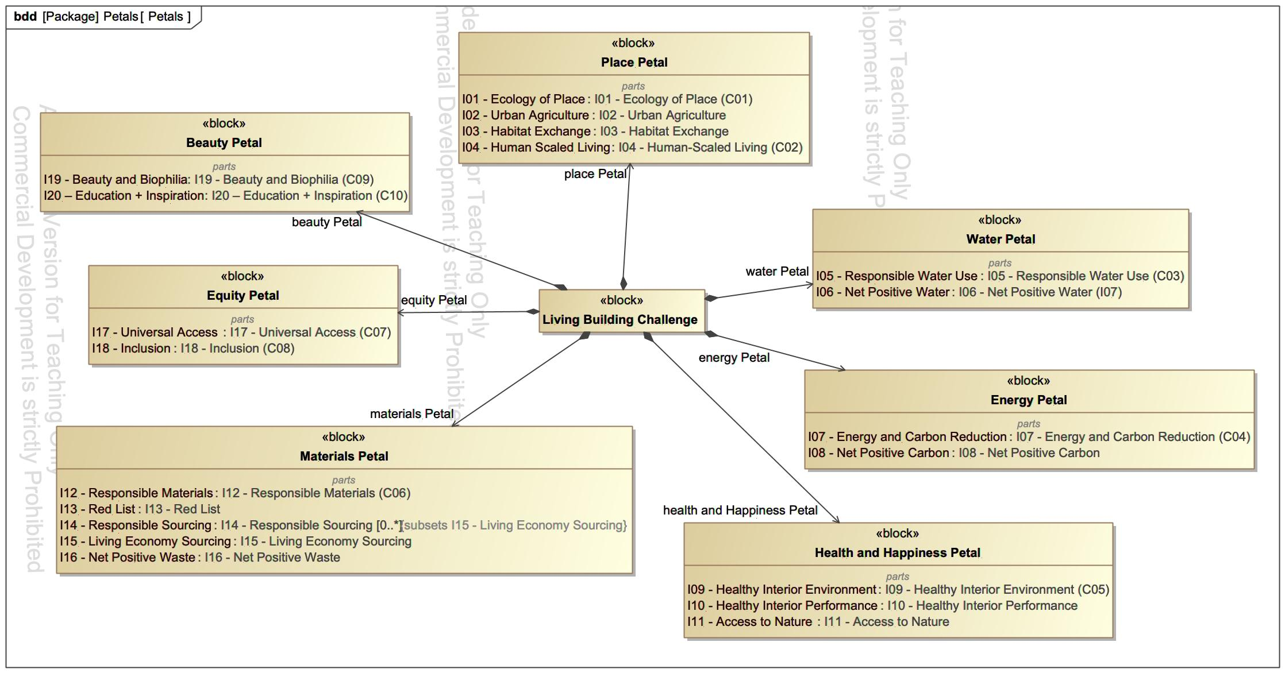

**Figure 2.1.4-1:** Living Building Challenge Block Definition Diagram (BDD)

# 3. Design Concepts

## 3.1 Spring 2022 Initial Design

Spring 2022 semester concluded with a school layout consisting of ten classrooms (two kindergarten and first through eighth grade), one hybrid library-computer lab, one administrative center, two bathrooms, and one disability bathroom. Additionally, a portion of the administrative center would act as storage space. The footprint was rectangular with overall dimensions of 84 m in length and 50 m in width. The bathrooms, one for girls and one for boys, were placed near the front entrance of the school to ensure that they would be adequately maintained. A disability-accessible bathroom shared a wall with the boy's bathroom to allow for shared piping and infrastructure.

Some layout features include strategic angling to optimize the daily available sunlight and a roof overhang around the perimeter school. Additionally, there were six access points for entry and exit for student arrival/departure and access to fields. A main entrance garden sat at the southernmost edge of the site and led from the road directly to the kindergarten classrooms. In addition to the garden, a team-designed gate at the main entrance gave the school a unique look and a sense of belonging. Also, an effort was made to separate grades based on age/maturity using the library-computer lab and teacher rooms as spatial dividers. This approach helped maintain flow and created courtyards for each grade tier. Courtyard 2 was tailored for elementary school students and Courtyard 3 for middle school students.

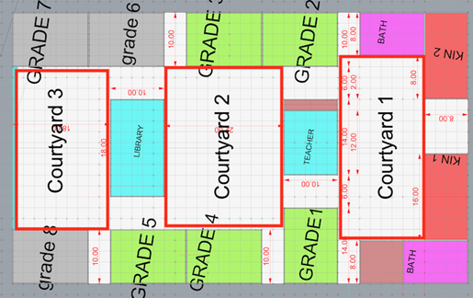

**Figure 3.1.1-1**: Displays the dimensional layout of the school in meters.

Some layout features include strategic angling to optimize the daily available sunlight and a roof overhang around the perimeter school. Additionally, there were six access points for entry and exit for student arrival/departure and access to fields. A main entrance garden sat at the southernmost edge of the site and led from the road directly to the kindergarten classrooms. In addition to the garden, a team-designed gate at the main entrance gave the school a unique look and a sense of belonging.

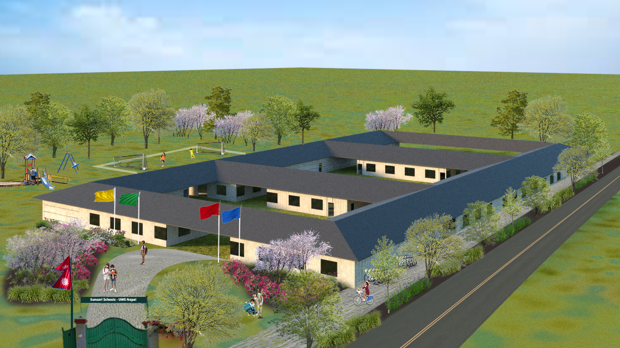

**Figure 3.1.1-2**: Displays the dimensional layout of the school in meters.

Outside the school structure included a recreation area, learning garden and possibly a greenhouse. The school recreation areas featured a volleyball court, a soccer field and covered seating. The learning garden included raised beds with a fence-like structure containing them. The path system throughout the site was circulatory with a sidewalk on the eastern edge of the school that runs parallel to the road. For safety, a vegetated buffer zone of native plants would be planted in between the road and sidewalk. The path system also led to and through the internal courtyards for seamless connection between rooms. A bike parking system existed on the outer edge of each classroom adjacent to the road which was also accessible by sidewalk.

#### 

#### 

#### 

#### 

## 3.2 Fall 2022 Design

The organization contains four primary functional teams: Modular Design; Landscape & Vegetation; Community, Empathy & Culture; and Sustainability & Life Support Systems, chartered with basic research associated with each functional area. The design concepts for this semester focused primarily on the structural solutions that met the stakeholder, NBC and LBC requirements. The following section will illustrate the various design concepts considered and how the team determined the recommendation for the final design layout outlined in the previous section.

### 3.2.1 Modular Design

The modular design was tasked this semester with some core aspects of the current phase of the project. The team was named after the modular aspect that is required by the stakeholders at UWS for the school design; the name “modular” is a reference to the flexible systems’ nature of the school design that will be applied to a number of schools across Nepal in a variety of environments, landscapes and communities.

The team focused on three primary objectives: conducting research into potential construction materials for the school, developing an understanding of the Nepal Building Codes, and designing the layout and preliminary renders for the project.

A fundamental understanding of the potential construction materials for a structural design is vital to its success. The modular design team researched and assessed alternative construction materials that could be incorporated into the final design. The research was primarily focused on identifying material usage with regional precedence in Nepal. Additionally, the material was investigated for sustainability and seismic resilience properties. The materials research information is distributed into four specific structural elements for the school: roof coverings, walls, beams and columns, and ceiling. Regional precedence details and state-issued recommendations were collected in some cases from NBC 203:2015. Information on potential construction materials can be used by the team next semester, Fall 2022, to make informed decisions on material selection; this semester was focused only on research elements for materials, not selection.

The Nepal Building Codes are a set of codified construction bylaws which dictate how buildings must be constructed in Nepal. Without a solid understanding of the various NBC requirements, the team would have potentially created an unviable design. Throughout the semester, the NBCs were referred to extensively during the design phase to make sure that the group was designed as per regulations. Many NBCs were referred to, including NBC 203: 2015 (version)-Earthquake Resilience for Low Strength Masonry and NBC 206:2015 (version)- Architectural Design Requirements. The different NBC requirements were then logged in a verification matrix (see Appendix J).

One of the most crucial functional elements of the modular design team this semester was creating the school's finalized layout and preliminary renders. The finished layout and renders were based on incorporating elements from various sources, including stakeholder requirements, Living Building Challenge mandates, Nepal Building Code standards, and empathy fieldwork from Fall 2021. The design portion of this semester was quite iterative and involved creating many different preliminary drawings, sketches, and models. The team often presented to the stakeholders to gain feedback, and changes were made in accordance. Additionally, the team worked in many cross-functional collaborations with other sub-teams like the Landscape Architecture and the Sustainability-Life Support teams.

#### 3.2.1.1 School Layout

The general layout of the school classroom follows a simple train design configuration. The classrooms are lined up on the site. A notable change in layout from the previous semester’s design is that the newly adopted train layout is purposeful. The simple, linear layout allows for ease of construction in simplicity of building foundation footprint, dimensioning, and continuity in roof structure. The linear layout is also conducive to safety during seismic activity as it is more structurally sound.

Other than structurally, the linear layout is intuitive. On any site, the school will have the ability to break up the site into front and back programming zones. In this case, it allows louder, more recreational activities to take place in the back of the site, separate from the front of the school where quieter, academic activities are meant to be held. Compared with the layout from the previous semester, the linear layout provides more flexibility and ease to be replicated on different sites. The previous semester’s layout relies heavily on the courtyard system and classrooms/grades are arranged based on the courtyards. This semester, the team realized that the courtyard system would bring confusion in the distribution of classrooms and is very rigid. In comparison, the train distribution of classrooms is simple and the most flexible in terms of placing programming zones in the front or back of the train and along the grades gradient.

Finally, the linear design is conducive to an educational environment where students of varying ages can collaborate, yet students with major age gaps such as kindergarteners and eighth graders have their classrooms at opposite ends of the layout. In terms of cost, construction and programming, the linear school layout makes for a simple, yet comprehensive design.

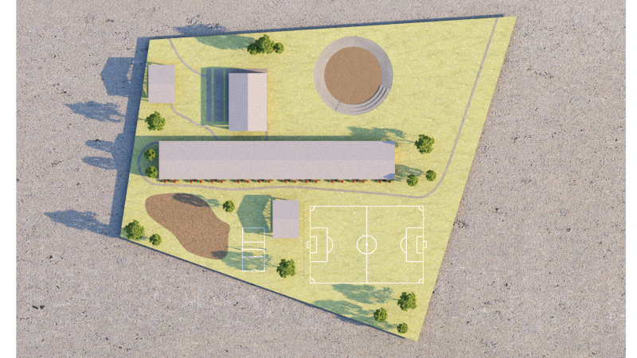

**Figure 3.2.1.1-1:** Overview of the site

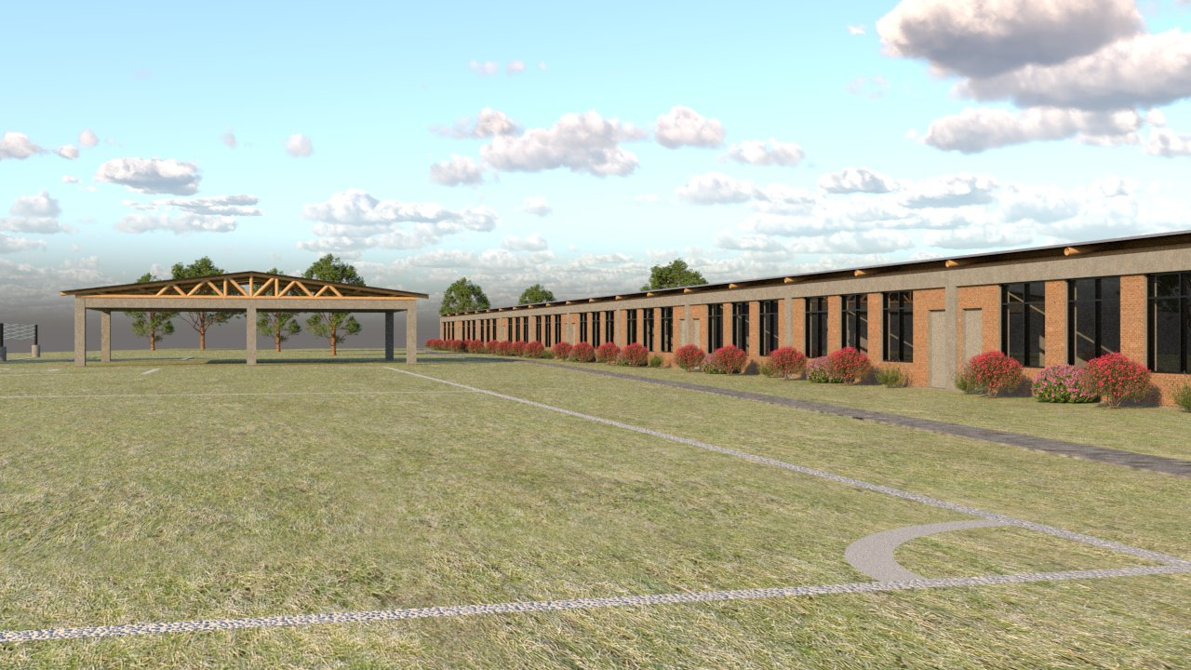

**Figure 3.2.1.1-2**: Outdoor fields

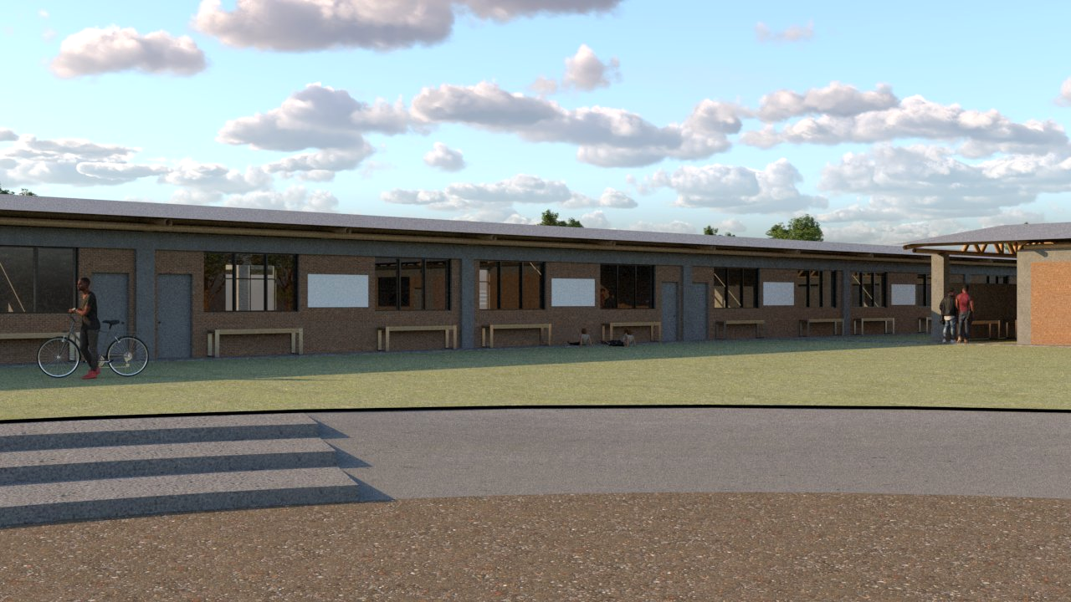

**Figure 3.2.1.1-3**: Outdoor seating

#### 3.2.1.2 Roof

The fundamentals and strength of the Roof structural system is found within its materiality and trust configuration.

Our roof material is made up of bamboo rods for structural systems and aluminum sheets. The utilization of bamboo for the roof structure system design move was facilitated after the success of other CUSD sustainable education projects, specifically the one in Ghana, and the design analysis and cultural significance of local vernacular architectural and building techniques and technologies.

Well-designed and built roofs play a key role in protecting a bamboo structure whilst adding to the beauty and experience of the space. The team began to ask the question of what qualifies as a well-designed bamboo roof. There are a couple of key elements that need to be considered: 1) the roof overhangs that mitigate the weathering of bamboo poles from direct sun and rain, 2) the pitch of the roof for water flow, 3) the spacing of the rafters for rigidity, and finally, 4) the materials used.

For our design, we created a simple trust structure that when densified creates a strong system, placing the vertical loads on the center of the roof to the edge of the exterior walls of the school building.

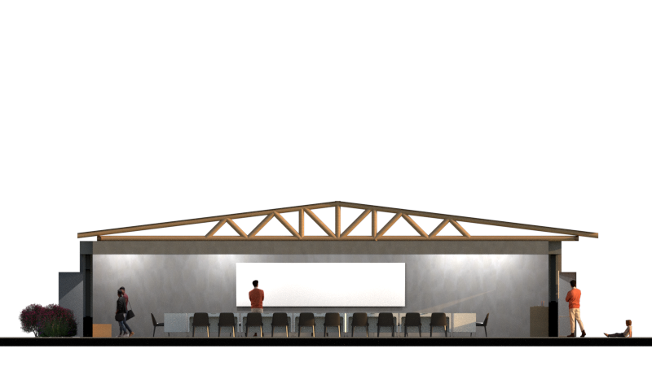

**Figure 3.2.1.2-1**: Indoor Classroom Roof

#### 3.2.1.3 Windows

The window design is primarily driven by facade, ventilation, and lighting considerations.

The row of classrooms has two sides that serve different purposes: the overhang side hosts gatherings such as outdoor teaching sessions and social interactions during breaktime and rain, and the side that faces the sports field connects students with nature. The window design responds to these activities, and therefore, is different on each side of the classrooms. The overhang side has two sets of 3-panel casement windows, separated by space on the wall for potential blackboard and bench seating under each set of windows (see figure 3.2.1.3-1).

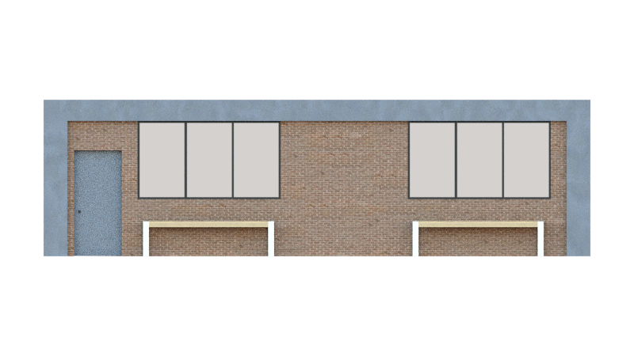

**Figure 3.2.1.3-1**: Two sets of 3-panel casement windows on the overhang side

Casement window is the most common type of window used in the local area and can be opened completely which allows maximum airflow. The distance between window sills and the ground is 1.1 meters, leaving enough room for students to sit on the benches and not bump into the windows. Since the overhang side would potentially have more distractions from the use of the overhang and access to bathroom and teachers’ office, the relatively high window sills also decreases students’ visual access to the outside when they are in the classroom. The classroom side that faces the sports field has planters. This side has three sets of 2-panel casement and awning windows (see figure 3.2.1.3-2).

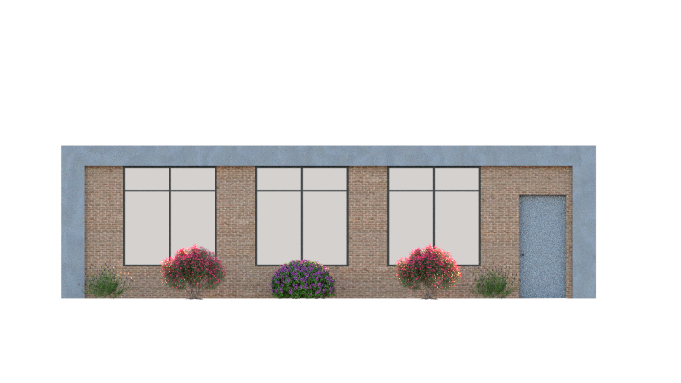

**Figure 3.2.1.3-2**: Three sets of 2-panel casement and awning windows on the planter side.

The awning windows are 2.3 meters above the ground, allowing hot air to exit through these higher openings and creating a stack effect ventilation (see figure 3.2.1.3-3). These high windows also enable the winter sun, which is at a lower angle, inside the classroom.

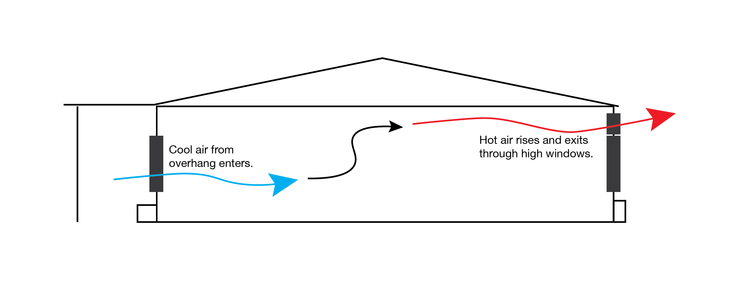

**Figure 3.2.1.3-3**: Stack ventilation effect achieved through high windows on one side.

The specific number and dimensions of windows are decided according to the Nepal Building Codes (NBC 206 3.3: The recommended minimum area of openings for natural light is 1/8th of the room area and for natural ventilation is 1/16th of the room area.). Based on the classroom dimension of 10 by 15 meters, the minimum area of window space to allow sufficient natural light is 18.8m^2 and minimum area of operable window is 9.4m^2. The window dimensions satisfy these requirements: the total window area per classroom is 19.1m^2 and the operable window area is 13.7m^2.

#### 3.2.1.4 Doors

There will be two doors for each classroom, on opposite sides, one leading to the front of the school building, and one leading to the back recreational area of the school building. The two doors will provide an entrance and exit for students and improved circulation. The measurements of the doors will be 2.1m. The material of the doors will be steel, providing durability and strong resistance against weather, and high use from students. The bathroom building will have one door entrance to the boys side and one to the girls side. The teacher’s office at the front of the campus will have two doors.

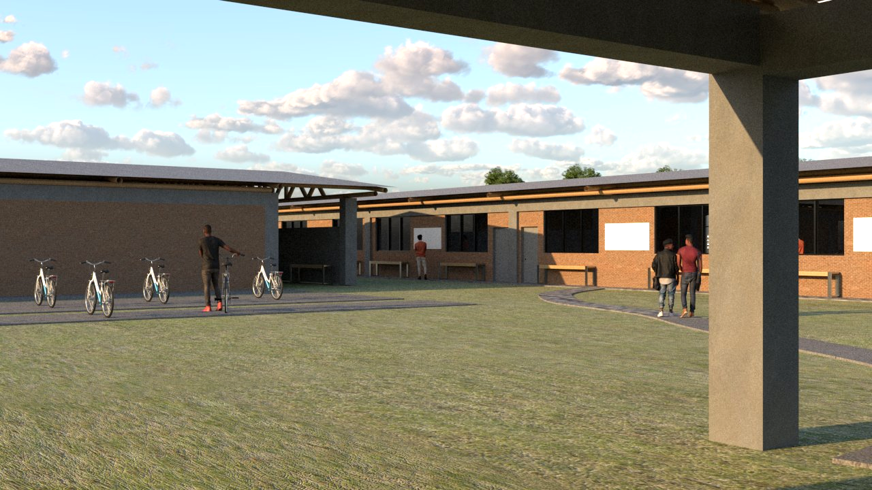

**Figure 3.2.1.4-1**: Doors

### 3.2.2 Landscape

The landscape team is primarily focused on developing an adaptable, functional and interactive design for the schools outdoor layout that minimizes the cost and environmental impact for this Sunsari District School. The outdoor space will serve an important role in a students’ learning experiences when they are not in the classroom. The major elements of the landscape include a courtyard, football pitch, volleyball court, outdoor seating area and the learning garden, shown in Figure 3.2.2-1.

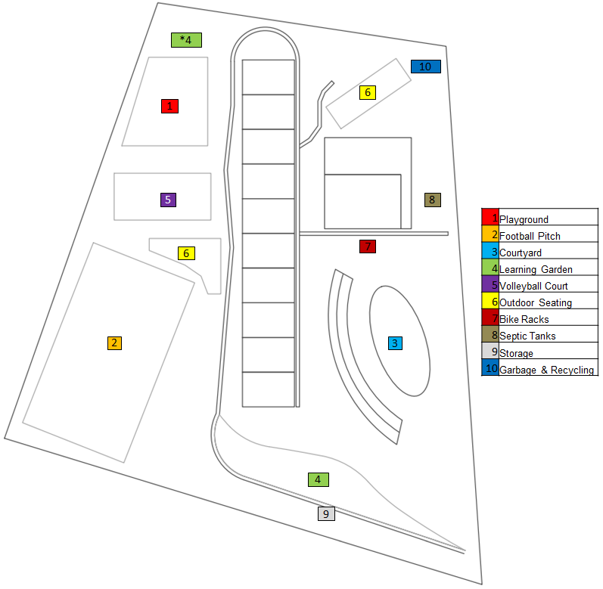

**Figure 3.2.2-1**: Landscape Layout

The stakeholder requirements for the landscape design are very specific for the courtyard, outdoor seating area, flood resistant design, and bike/motorcycle parking. The stakeholder left other elements within the design open to custom ideas and the discretion of the design team such as the learning garden, football pitch and the location of each element within the design.The three main areas emphasized by the stakeholder included the presence of an outdoor play area, an assembly/gathering area, and a parking space. The equipment and location of the playground area will be discussed more in depth in the recreation section of the landscape section.

The landscape design includes landscape architecture, water storage and removal, waste management, recreation, bikes and scooters, vegetation, property safety, storage and ponds, creeks, and fountains. The landscape includes the type and location of vegetation around the school grounds as well as the landscape architecture. Another important feature of the landscape would be the septic tank which is covered within the waste management section. The landscape will require tools to maintain the vegetation as well as the football field and volleyball court. The location and type of storage available on the site is covered in detail. The recreation section will cover the major recreational areas: football field, volleyball court and the playground.

#### 3.2.2.1 Vegetation

The vegetation for the landscape design has been selected based on the hardiness of the plant aligning with the floodplain conditions of the site, culture relevance to the people of Nepal, and ecological benefits. Each plant described below is tolerant of living in floodplain conditions as well as drought conditions. The vision is to obtain native varieties of plants to reduce maintenance and to eliminate a need for herbicides and pesticides. It is ideal to have a diverse planting of many native plants to encourage local pollinators, nectar feedings, birds, and small mammals to assist in eliminating pest insects and animals. Below is a list of preferred plants to use in a future design. Ultimately the plant palette is determined by the plants that are accessible through local nurseries as well as the specific conditions of the soil at the site.

| **Plant Palette** | | |
| --- | --- | --- |
| **Red Rhododendron** | *Rhododendron arboreum* |  |
| **Aztec marigold** | *Tagetes erecta* |  |
| **Henna Tree** | *Lawsonia inermis* |  |
| **Lemongrass** | *Cymbopogon citratus* |  |
| **Ashoka** | *Saraca asoca* |  |
| **Camphor tree** | *Cinnamomum camphora* |  |
| **Himalayan Pine** | *Pinus wallichiana* |  |

**Figure 3.2.2.1-1**: List of plants selected for hardiness, cultural relevance, and ecological benefits.

*Rhododendron arboreum* or Red Rhododendron is an evergreen shrub growing to 12 m (39 ft) by 3 m (9 ft) and prefers a peaty, well-drained sandy loam. This shrub survives in the sun, but prefers shade in a warmer climate with a pH between 4.5 and 5.5. This shrub was chosen because of its cultural importance as the national flower of Nepal. This shrub provides a habitat for local wildlife and has beautiful flowers that emanate a lovely fragrance that will attract native pollinators.

*Tagetes erecta* or Aztec marigold is an herbaceous annual plant known for its large yellow and orange flower heads. It will grow to about 1.2 m (4 ft) tall and 0.6 m (2 ft) wide and will tolerate a variety of soil conditions. This plant will attract native butterflies and hummingbirds as well as repel mosquitos.

*Cinnamomum camphora* or Camphor tree is a fragrant evergreen tree with a massive canopy, providing abundant shade. It will reach up to 21 m (70 ft) tall and 21m (70 ft) wide and prefers a lower pH level. Due to the considerable amount of seeds produced, this tree will attract native bird species. It should be planted away from parking lots, gardens, or sports fields due to the amount of fruit litter.

*Lawsonia inermis* Henna Tree is a large evergreen shrub or tree that can grow up to 6m (20ft) tall with an equal spread. It prefers full sun and will tolerate a wide variety of soil conditions making it suitable for a bioswale environment. The fragrant flower blooms will attract native pollinators. A natural dye can be made out of the leaves that can be safely applied to hair, skin and nails.

*Cymbopogon citratus* or Lemongrass is an rapid-growing perennial grass growing to 1 m (3ft) by 1m and prefers well drained soils of varying quality and access to full sunlight. This grass has a strong fragrance making it a popular herb used for culinary purposes. Lemongrass was chosen because it repels mosquitoes and flies and can be cultivated for culinary, medicinal, and household purposes. It is a beautiful ornamental grass that provides habitat for native wildlife.

*Saraca asoca* or Ashoka is a nitrogen fixing evergreen tree that will grow up to 9 m (29 ft) tall with an equal spread. The blooms can be witnessed year round with peak bloom in January and February attracting native pollinators, nectar feeders, birds, and small mammals. This tree will tolerate a variety of soil and moisture conditions and will grow in full sun or partial shade.

*Pinus wallichiana* or Himalayan Pine is a pine tree that prefers acidic, well drained, sandy loam soils in full sun. It will grow up to 15 m (50 ft)The pine needles lower soil pH over time as well as provide nesting material for native bird species.

In the future it is necessary to obtain specific knowledge about the site including topography, pH levels, soil bulk density, soil drainage rate and finalized site design. It is possible to design a planting key without this information, however the survival rate of the plants are dependent on having as much site information as possible. Another step is to locate plant nurseries that will source the plants used in the design. This will ultimately determine the plant palette because plants that cannot be sourced will not be used in the design.

The final phase is implementation of a learning garden. The vision for the learning garden is to allow students and staff to connect with the land and their food chain by participating in the growth cycle of their own fruits and vegetables. A new garden built on cleared agricultural land must have soil health established. If the soil texture resembles clay or sand, outside loamy soil may need to be brought in. Due to the floodplain location, there is an opportunity to use raised mound planting techniques that have been used in indigenous cultures to prevent soil erosion or drowned plants. The fruits and vegetables grown may be chosen by the class or staff that reflect their culture.

#### 3.2.2.2 Waste Management

The waste management system consists of garbage collection and removal, recycling collection and removal, and a septic system. The decision decisions for these 3 subsystems were made given the population using the system as well as the rural location and budgetary constraints.

Garbage and recycling will have adjacent central collection points near the main road where servicing will occur. The servicing frequency will depend on various factors, such as the amount of students, the type of material needed for class, and the food waste. The primary location for garbage pickup and recycling is on the northeast corner of the site to avoid putrid smells near the school. Each classroom will feature a 30 liter trash and recycle bin, with this size bin garbage will not reach an excessive amount where smells will start to propagate the classroom. These are to be emptied daily into the main garbage and recycle collection point.

The waste management system will make use of a septic system which consists of a two component septic tank located in between the road and bathroom. The blackwater will flow into the septic tank from toilets, bathroom sinks as well as the kitchen sink. The septic system will be buried at least 4 inches underground where waste water can flow by gravity. With the septic tank located near the road, pumping the tank would not be difficult for waste servicing. A concrete septic tank with 12 meters length,4 meters width, and a liquid depth of 1.4 meters can serve the expected student body of 400 students. Using this size of tank, a cleaning interval of 1 year would be sufficient.

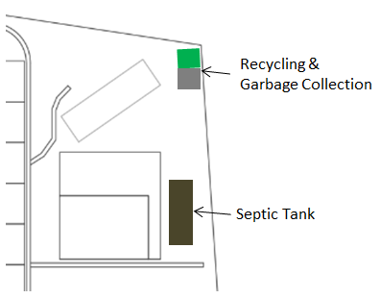

**Figure 3.2.2.2-1**: Septic Tank, Recycling and Garbage Collection Locations

For future work, the exact location of the septic tank is needed and in order to determine a suitable location the grounds must be surveyed. The further the septic tank is placed from the bathrooms, the deeper underground the system will need to be placed to ensure it operates entirely using gravity. The frequency of garbage and recycle collection point pickups will depend on the waste teachers and students produce and should be determined in phase II.

#### 3.2.2.3 Landscape Architecture

The Landscape Architecture was designed keeping in mind the stakeholder requirements regarding the playground area, bicycle/motorcycle parking, outdoor courtyard and assembly areas. Figure 3.2.2.3-1 illustrates each of the elements within the overall landscape design. Drainage, Sanitary Waste Disposal and water storage are elements of the design that are important to meet the living building water petal requirement that the whole site should supply 100% of the project water through a closed-loop water system. The assembly area (courtyard) is designed as an amphitheater which provides natural seating and a place for water runoff from flooding. The amphitheater will also help to aid in the storage of rainwater. The drainage from the recreation elements and other parts of the site will be helpful in potentially diverting water to water storage sources and for water for the learning garden. The learning garden is shown as item 4 in the landscape layout. It is situated at the side of the school, and visitors and students can admire the garden on their way to the back of the school where the sports fields and courts are located.

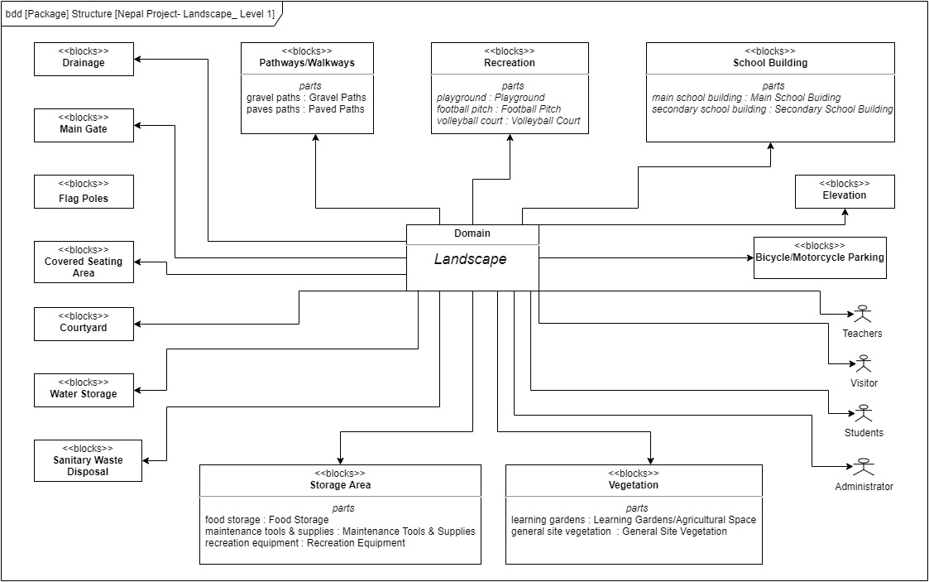

**Figure 3.2.2.3-1 Landscape BDD Level 1 Diagram**

##### 3.2.2.3.1 Courtyard & Outdoor Seating

The courtyard space as shown in the landscape layout as item 3 is a multi use space for students and teaching faculty at the school. The various use cases available to students are shown in the Courtyard Use Case Diagram in Figure 3.2.2.3.1-1. Teachers can use this space to address the whole student body given the size and structure of the landscape element.

The outdoor seating space is indicated as item 6 in the landscape layout. It is positioned in two different locations, one in the front and one in the back facing the football pitch. The outdoor seating in the back of the school provides students a place to sit who don’t necessarily want to be out on the field or volleyball court. Typical seating guidelines recommend 24 inches of space for each person seated at a table, with a range of 2-6 inches of space between each chair. Between each table, a minimum space of 52 inches is required for rows of tables. The total area we have provided for the outdoor seating is 186 sq. meters and 188 sq. meters for the seating areas in the back and front of the school respectively. We propose a potential seating arrangement of 4 tables by 2 tables for one classroom (40 students), and 4 tables by 4 tables for two classrooms (80 students), each table with 6 seats. Teachers may also use this space to hold classes, or it may be a space for students to eat lunch, snack, or play games. We have allotted enough space for two classrooms to use the space at the same time, and with the current seating arrangement, there will be a surplus of 8 seats if one classroom is using the space, and a surplus of 16 seats if two classrooms are using the space. Potted plants or other greenery could potentially be placed in the extra space as decoration.

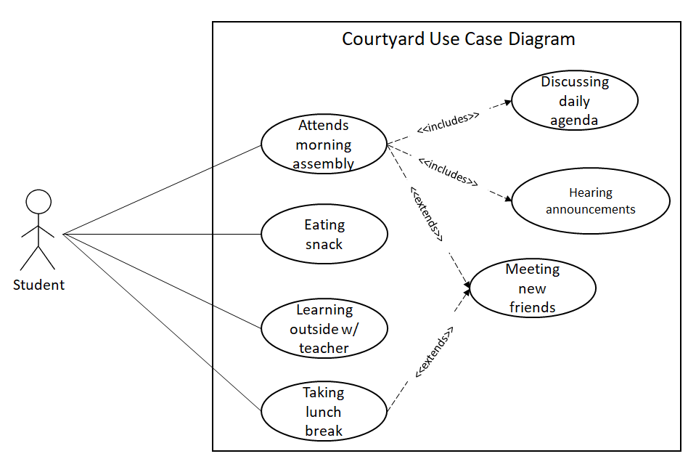

**Figure 3.2.2.3.1-1**: Courtyard Use Case Diagram

##### 3.2.2.3.2 Flow of Entry and Exits

The last significant aspect that affected the proposed design was considering the flow of people throughout the school day. The school's layout needs to balance safety, convenience, and unimpeded pass-through without traffic. During surge events, a primary flow concern is for schools and other buildings with large populations. Surge events are those events in which a sudden, sharp increase in foot traffic is sustained for a short period of time.

There are three main surge sessions associated with an uptick in foot traffic; these are when students arrive at school, depart the school, and venture to the assembly field for the daily assembly. Additional surge periods could occur, like on Fridays when all the students partake in sports behind the school.

Upon the start of the school day, students will arrive predominantly by cycle or on foot. From the current layout, the students have three access points for entry, two facing the road and one perpendicular. The two entryways are relatively large at 4 m, while the perpendicular main entrance is about 10 m wide. Students can depart the school after class using the same ways they entered. The entry pathway leads from the street straight to the main entrance, which allows for easy access. To the right of the pathway is stationed the scooter and bike parking, and to the left of the pathway is the assembly area where students will gather for morning meetings. The students and faculty will move to the amphitheater at the front of the school during the morning assembly.

#### 3.2.2.4 Storage

A small shed for the purpose of storing garden materials is best placed on the Southern property edge next to the student’s learning garden. This placement will allow student’s easy access for class or house activities involving the learning garden. In order to fit standard gardening supplies and avoid the necessity of creating a foundation the shed should be approximately 2.5x2.5 meters large.[1](Ayubov) [2] (Prep). Further research should consider the necessity of a foundation due to the site’s danger of flooding, however, no electric work is required within the building minimizing concerns in regards to flood risk. The shed should include a lockable front entry door to prevent theft and unauthorized student access.

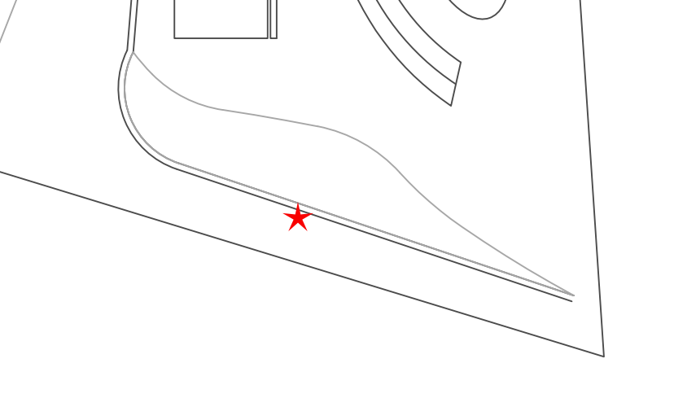

**Figure 3.2.2.4-1**: Shed Storage Location

In the future research the possibility of sourcing prebuilt sheds in Nepal should be investigated as use of smoothed concrete for construction in alignment with the school design may not prove aesthetically preferable.

#### 3.2.2.5 Property Safety

The boundary of the school is an important feature to enforce given the livestock which is present in the area. To prevent cattle from entering school property, a fencing configuration consisting of high-tensile, woven-wire steel mesh is necessary around the perimeter boundary. The fencing can be set back 1 meter from the property line.

Each classroom door, the teachers lounge and the bathrooms can be fitted with a cylindrical lever lock. These locks were chosen because they are easy to install and repair and would provide adequate safety for a rural community of students.

In situations where inclement weather is expected, the students will be safest within the main classroom building. The classrooms are designed such that students will be able to avoid windows and doors if storm weather arises. Additional information on the flow of entry and exits can be found in 3.2.2.3.1.

For future work, the school is expected to withstand flooding and mitigate the effects of permanent damage to the structure and surrounding landscape features. An investigation into the safety of the structure and landscape architecture is needed to ensure the property’s longevity.The buildings ability to resist fire is dependent on building materials and environmental conditions, this is important to consider for the safety of the students.

#### 3.2.2.6 Recreation

The recreation area of the landscape design includes a football pitch, a volleyball court and a playground. In the current design each of these elements will occupy a separate area and these elements will be on the back side of the main school building. The design of each element in the recreational areas will be designed age appropriate to meet the needs of the kids. The playground will be designed for kids from kindergarten to the second grade. The football pitch and the volleyball court will be reconfigurable to meet the needs of all students in the school regardless of age. The football pitch and volleyball court will also be used by the community around the school, after school hours. The recreational areas also consider the scale of the user. This imperative encourages a human-powered lifestyle which also influences the parking layout and plan.

##### 3.2.2.6.1 Football Pitch

The football pitch will be located on the southwest corner of the landscape design behind the school building with a covered sitting area on the northeast side. The dimension of the football pitch will be 50 meters long x 25 meters wide, with 2 standard goals on each end. The crown or slope of the football pitch will be graded at 1/2 -1% slope with drain or 1-1.5% slope without drain, with an elevated center portion to promote water runoff from the center going to the east and west side line. See figure 3.2.2.6.1-1 for an example of the potential sloping of the football pitch.

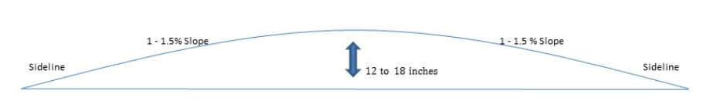

**Figure 3.2.2.6.1-1**: Football pitch slope[3](SFMA)

The height of the crown will depend on several factors that include the type of soil underlying the field, the amount of rainfall the field will receive, and the drainage system for the field. ”The former and less absorbent the soil, the sooner it becomes saturated and susceptible to ponding, so the higher the crown should be. Looser, more absorbent soils can have a lower crown because the soil can soak up more water before ponding begins. McAfee recommends a 12- to 18-inch crown, with the shorter heights used for loamy or sandy soils and the taller crowns for soils with a lot of clay.”[4] (Merritt) The football pitch will have a grass surface to help stabilize the soil, and will help with rain absorption and drainage. The football pitch will have goals that can be moved to shorten the field, so that the field can be reconfigured to accommodate kids of all ages and allow them to play 11v11 or 9v9.

The context diagram in Figure 3.2.2.6.1-2 shows the community. In alignment with the requirements for the recreation design, the football pitch will act as a shared space to play football and meet as a community. The context diagram also highlights the relationship between the kids, teachers, weather, terrain, drainage and the football pitch. Design work will be done to optimize the drainage for the space to ensure that weather, pooling water and poor surfaces does not render the football pitch unusable after heavy rains and seasonal weather conditions. The football pitch also serves as an important exercise, community and learning space for the kids.

**Figure 3.2.2.6.1-2:** Context Diagram for Football Pitch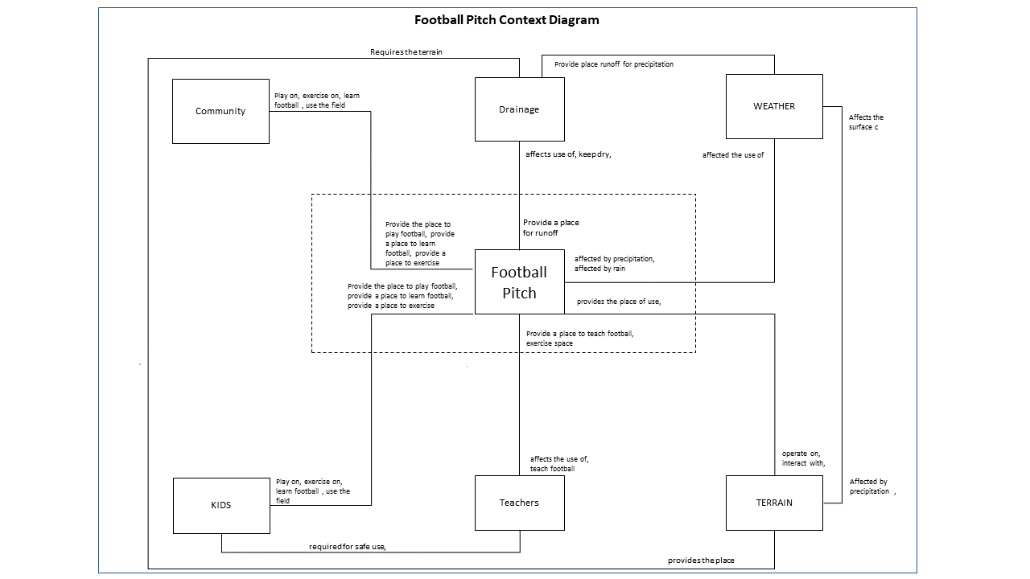

The future planning for the football pitch in the landscape design includes the drainage for the football pitch. An adequate drainage system to move the water away from the sideline to avoid pooling and the water backing up to the field is necessary. The design of the markings on the field will be a part of future planning for the football pitch. These markings will help to determine the starting and stopping of play and the boundaries of the field. The potential storage of soccer balls, mesh jerseys and other potential equipment will be determined in future designs. The security of the goal will also be planned in the next phase.

##### 3.2.2.6.2 Volleyball Court Elements

The volleyball court will be located on the backside of the school building in the center of the design between the football pitch and the playground. The dimension of the volleyball court will be 18 meters long x 9 meters wide. The volleyball court will be a flat surface, with no elevation slope. The volleyball court will be constructed with drainage underneath in the form of pvc pipes with the runoff on the east side of the court. The other approach would be a layered approach with gravel at the bottom and layers of dirt/sand on top with a series of pipes in the gravel layer sloping the water to the eastside of the court. The runoff will go to the learning garden or to the water storage apparatus. The drainage for the volleyball court will tie into the overall drainage from the soccer pitch and the playground. There will be two metal poles to hold the net and adjust the height of the net. The court will have a net that is easy to remove and store, with volleyballs and other equipment needed for volleyball.

The future plans for the volleyball court includes a final decision on the drainage system either the pvc pipes approach or the gravel approach. Finalizing the equipment that will be used for the poles, nets and other necessary equipment will be decided. Also, storage for the volleyball net, balls and potentially the poles is needed.

##### 3.2.2.6.3 Playground Elements

The playground will be located on the northwest corner of the school building on the backside, north of the volleyball court but south of the learning garden. The dimension of the playground will be 557.4 sq meters, with the exact shape of the playground area still to be determined in the next design.The playground will have a flat surface, with a ½ inch slope toward the eastside of the playground. The playground will be constructed with drainage runoff tying into the overall drainage from the soccer pitch and volleyball court. The runoff will go to the learning garden or to the water storage apparatus. The playground will have the required equipment to include a swing set, monkey bars and a slide. The specific layout design of the playground equipment and any additional equipment will be determined in the next design.

The future plans for the playground includes selecting the specific equipment, laying out the playground and determining the additional equipment. Selecting the surface of the playground can be raw ground or a rub soft surface, which will be selected in the next design. Research is required to make adequate decisions for playground construction and will be done in the next phase of the design.

#### 3.2.2.7 Ponds, Creeks, and Fountains

Ponds, streams and fountains can provide aesthetic appeal and meet drainage needs within the landscape design. They can be created on the site with the help of existing topography. Additional pond installation is necessary if they are not present on the site, they require a series of measures for excavation and drainage. The site does not have a natural pond or stream. Adding a fountain would present issues with standing water on the site which is a problem for the region with mosquitoes and diseases that can result from the feature.The landscape team has designed the layout to use the site's natural height difference of one meter, flowing from east to west, the water will flow towards the place of the amphitheater we installed. See feature 3.2.2.7-1 for a topo model of the site.

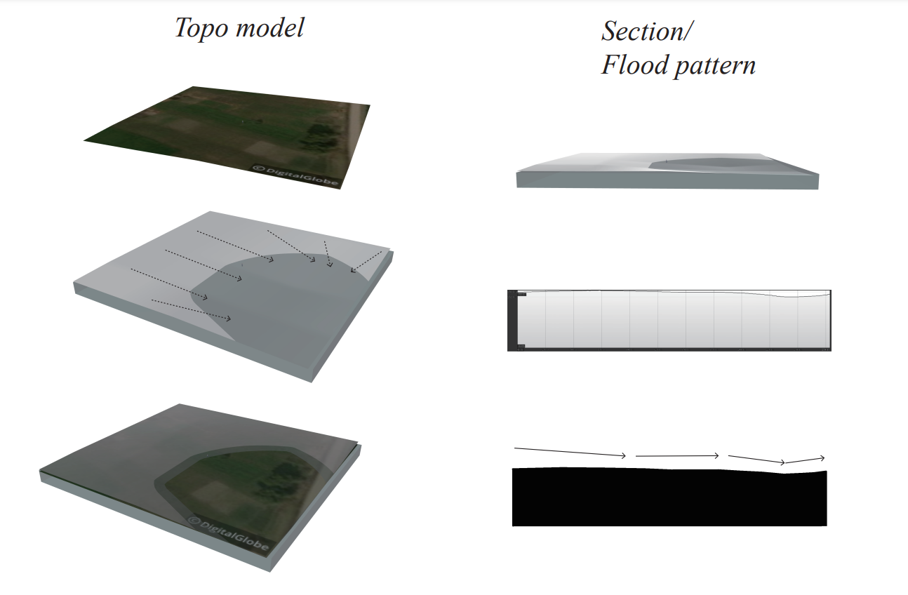

**Figure 3.2.2.7-1**: Topo Model of Site

Since we are already using an amphitheater with an infiltration surface as a water storage device in the waterlogged area of the site, additional ponds are not necessary. The area where the amphitheater is located has sufficient vegetation to absorb and transpire the runoff rainwater. In addition, the stormwater flows through grassy areas such as the soccer field and the learning garden on its way to the amphitheater, which also slows down the runoff and absorbs it.

A vegetated amphitheater is a landscape feature that does not require the installation of drainage pipes. However, if fountains and additional creeks are needed in the future for aesthetic purposes, then a piping installation study will be required. Stand-alone fountains are not restricted by topography and can be installed anywhere on the site, but this requires consideration of water supply and drainage. If new ponds are needed, the creation of new topography can be considered.

#### 3.2.2.8 Water Storage and Removal

Water storage and removal includes a study of the topography and direction of water flow for the site. It includes both pipe drainage and vegetation absorption. Based on the consideration of cost and construction difficulty, we propose a vegetated amphitheater as the solution for water storage and removal.

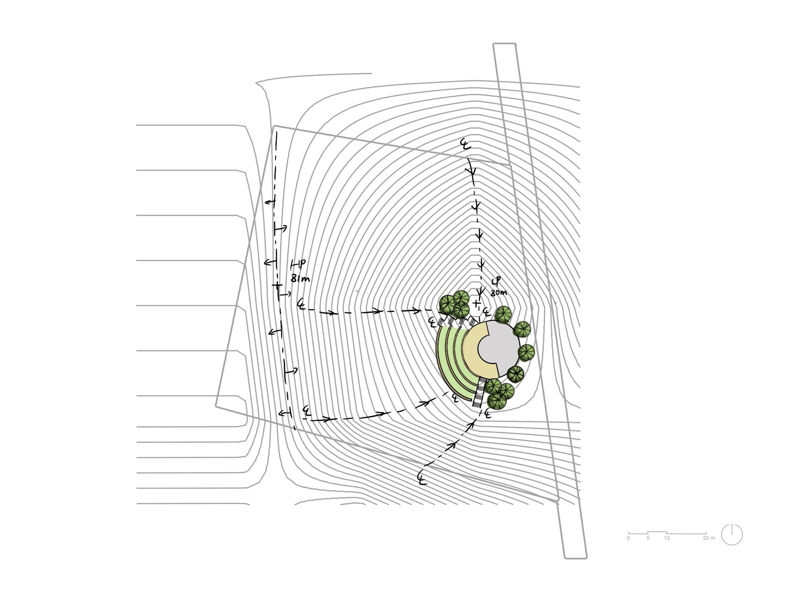

**Figure 3.2.2.8-1**: Amphitheater

Most of the site is a flat area with a slope of about 2%, which only meets the minimum criteria for water to be able to flow. By analyzing the terrain model and generating contour maps, we identified a puddle with a slope greater than 2% in the southeast corner of the site. It has an overall elevation difference of 1m and may become a concentration of water when flooding or heavy rainfall occurs. Therefore, we designed an amphitheater at the concentration of water. The advantage of this is that it fits into the existing topography and provides additional assembly space.

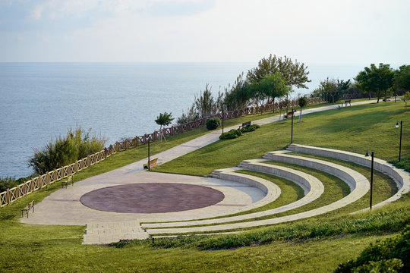

**Figure 3.2.2.8-2**. Courtyard Example Image

In contrast to the all-brick amphitheater, we replaced some of the brick paving with grass and vegetation and designed a landscaped amphitheater. This has three benefits. First of all, it can reduce the cost, time, and difficulty of construction. Using vegetation instead of bricks can reduce the number of bricks used. In addition, vegetation has a lower runoff coefficient than brick pavers, which means that they allow some of the rainwater to infiltrate when it comes and slow down the runoff time, which is ideal for areas with standing water. Finally, the use of vegetation as a water storage device solves the problem of constructing drainage inlets and connecting pipes. Due to the flatness of the site, creating a swale with sufficient slope required many topographic changes. Therefore, a permeable surface is a simple, practical, and economical option.

Although the landscape amphitheater uses mostly vegetation instead of tiles, future research on slope is needed. Some of the required paving tiles such as the building and gathering areas still need further discussion to determine the material. In addition, the choice of vegetation around the amphitheater can be considered. Trees can be planted around it for privacy or shrubs can be used.

#### 3.2.2.9 Bikes and Scooters

Stakeholder requirements mandate a parking lot designed to accommodate 120 bikes, ridden primarily by attending students, and between 12 and 20 scooters, ridden by staff. Our design places parking close to the school’s front gate: motorcycle parking is placed on the East exterior wall of the teachers lounge where an access path will take students to bicycle parking, located on the North side of the bathrooms and teachers lounge.

Scooter parking is designed to minimize the distance between parking and lounge access. Additionally, placement along the East side of the building allows for motorbike coverage, either through extension of the roof overhang or creation of a secondary roof connected to the main building’s wall. Placing scooters along this wall will have the added benefit of pushing them away from the property border, this effort aims to minimize theft and provide space for natural landscaping visual barriers. Scooter parking spaces will measure 0.8 meters in width and 1.6 meters in length with total dimensions of 1.28 square meters. This spacing is above the 1.25 minimum required by the Nepal building code and in line with recommendations for scooter parking from the Institute of Highway engineers. [5] (Government of Nepal Ministry of Urban Development) [6] (Cottrell) This spacing will allow for 20 scooters, in line with stakeholder preference . In locations where space allows the length of scooter parking spaces can be increased to 2 meters to improve parking ease. This access path should be no less than 1 meter in length. Bicycles require a minimum of 0.5 square meters of access path per bicycle, this has been doubled due to the greater width of scooters and the heavier traffic anticipated along the path.

Bicycle parking will consist of 120 spaces divided across four rows of 40 bicycles. Bicycle parking spots will be 55cm wide by 2m long for a square footage of 1.1 square meters, above 1 square meter minimum required by Nepal building code. [7](Government of Nepal Ministry of Urban Development, Architectural Design). The lot will be placed along the northern side of the bathroom-teacher lounge building and offset from the building by a meter to allow space for the roof overhang and french drain.[8] (Government of Nepal Ministry of Urban Development, Load Bearing) Bicycles will be accessed from the main gate through walking paths at the East and West front and rear of the bathroom-teacher lounge building. Within the parking lot bikes may be accessed through two access paths each one meter in width, in line with EU recommendations. Concrete is the optimal material for placing bike racks as pouring allows for bike racks to be stably placed. As such, where price allows a paved lot including would be best. Drainage is a necessary component of a paved lot, in holding with our general design french drains can be used within the parking lot, drains may be placed along exterior access paths in combination of <1% towards the parking lot exterior to minimize standing water.[9](Ryan) Where price disallows the use of concrete gravel may be used as an alternative and holds the benefit of improved drainage. U bike racks (pictured below) are preferred for this design layout as they may come in a freestanding form or in a railed form. Additionally, U racks provide bike support at two points and are, thus, a generally preferred design.[10] (“2.1 Cycle Parking”) Where concrete is used a freestanding U rack would allow for the greatest ease of parking. However, railed U-bike racks prove a sturdy alternative where racks cannot be surface mounted. See below free standing U bike rack and rail-mount U bike rack

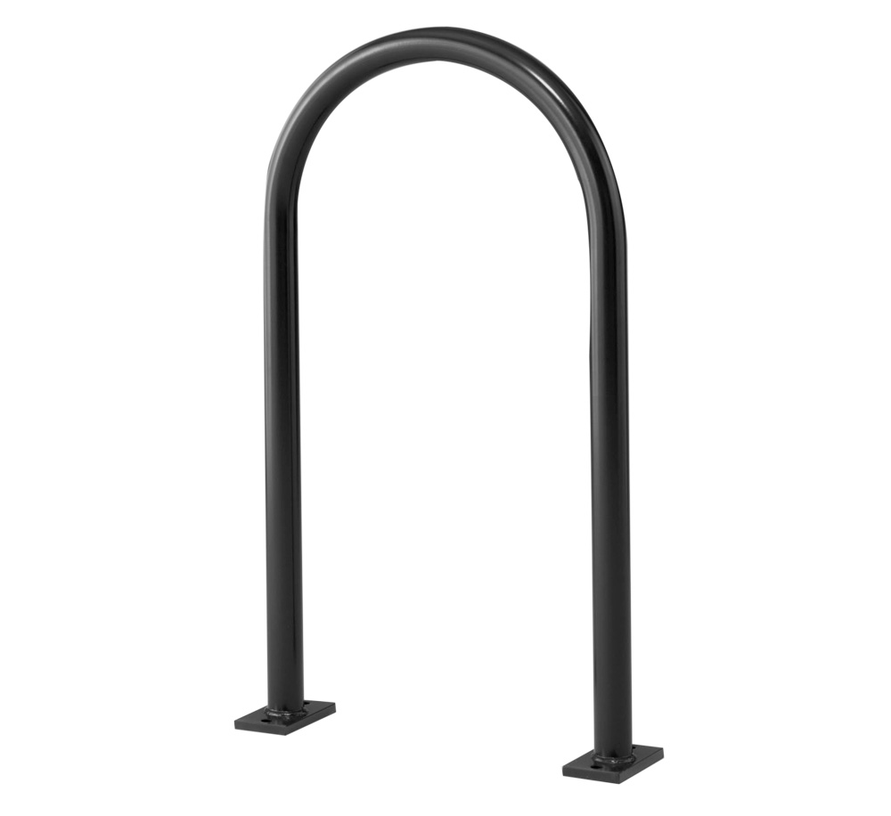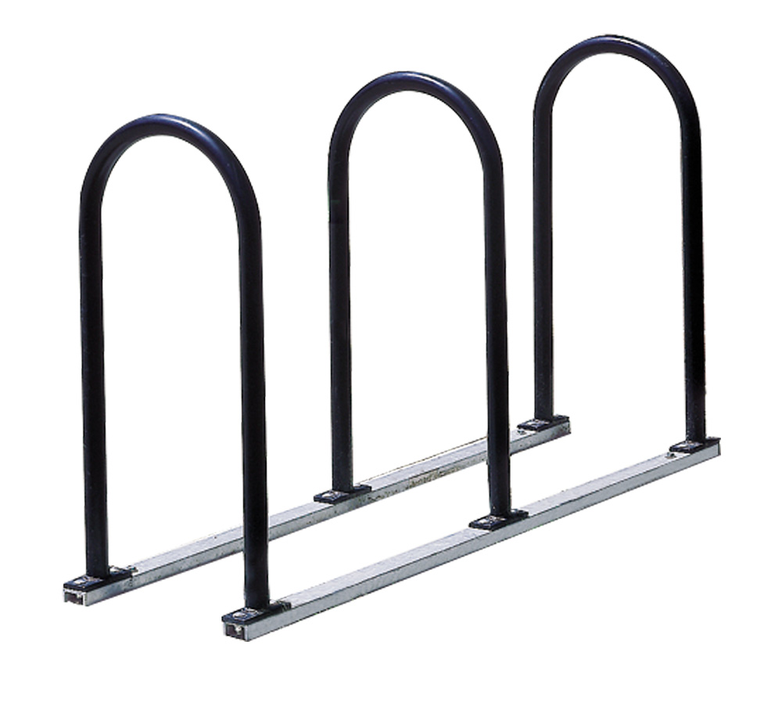

**Figure 3.2.2.9-1**: U Bike Rack Design[11](Graber Manufacturing, Inc., *Inverted U Bike Racks | Madrax Commercial Bike Racks*) [12](Graber Manufacturing, Inc.)

Moving forward with this design will require additional design work on the potential for scooter coverage along the East wall of the teacher’s lounge. If the extension of coverage is not possible scooter parking may have to be offset similarly to the bike parking to allow for draining in accordance with Nepal’s building code. Additional research on the availability and price of U racks in the Sunsari district may also be beneficial. Specifically, the accessibility of railed u-racks consisting of 5 U shapes, as this design would allow for the creation of the four, 40 bike rows pictured in the current design. Additionally, recycled plastic is used in some bike rack construction, determining the accessibility of this sustainable material alternative in Nepal would be of benefit.

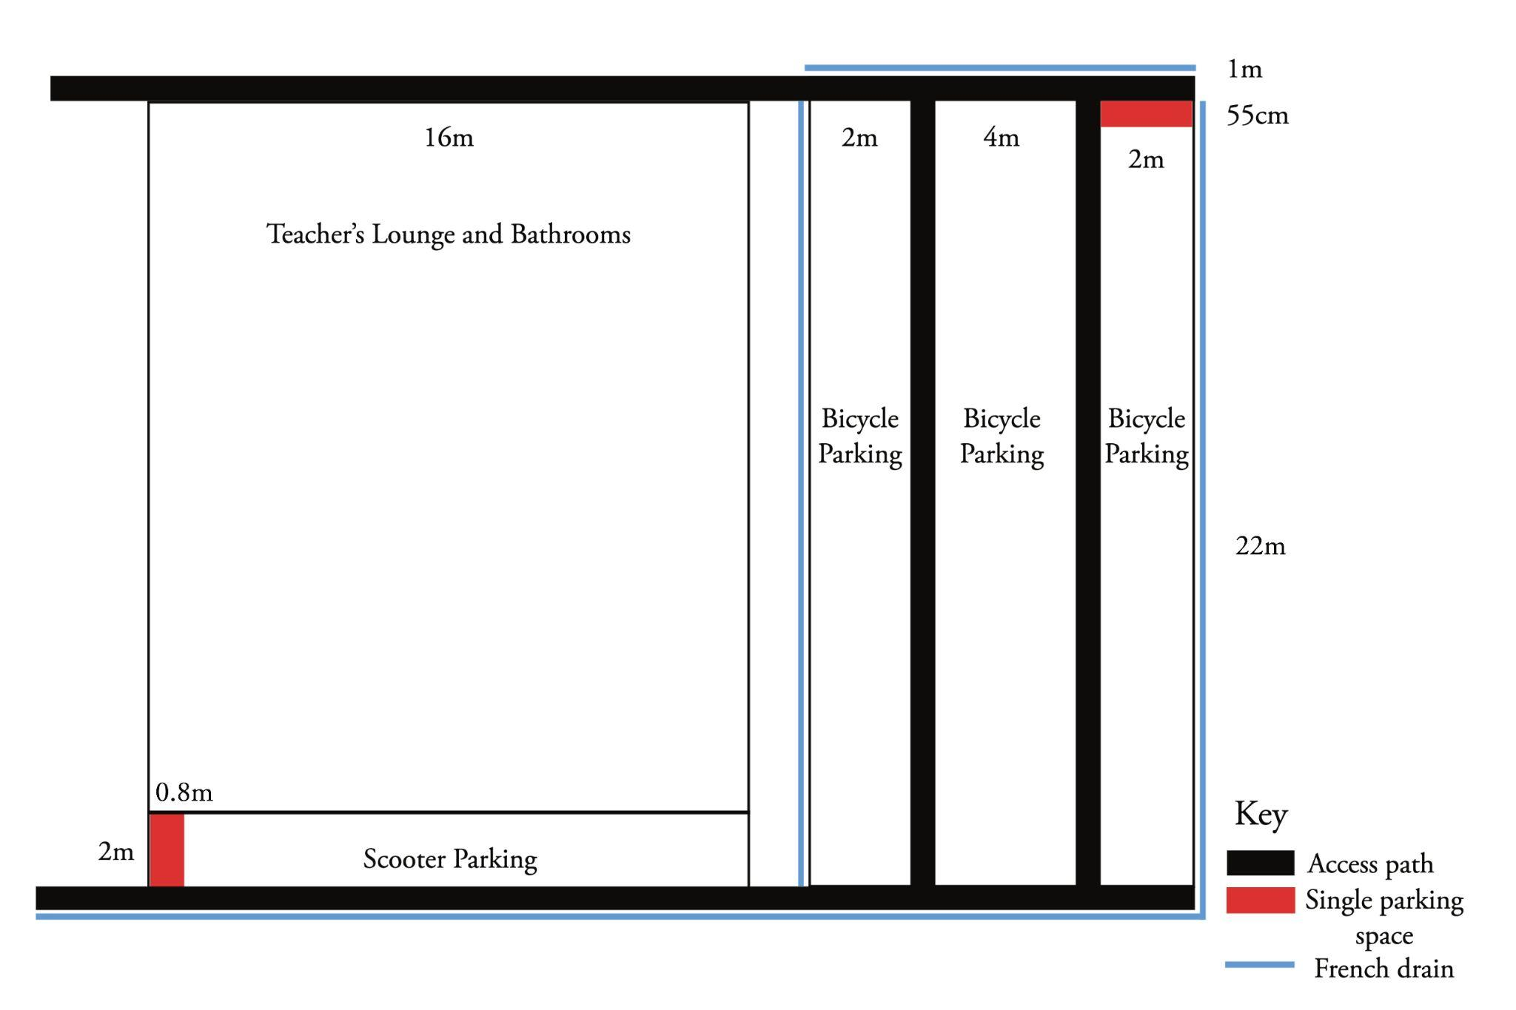

**Figure 3.2.2.9-2**. Bicycle & Scooter Lot Layout

### 3.2.3 Community, Empathy, and Culture

In recent years Nepal has made strides toward increased sustainable standards and increasing community awareness of environmentally friendly agricultural practices. Additionally, The Nepal National Education Planning Commission (NNEPC) is working towards more of a learner-centered education in order to improve the quality of education. Keeping these requirements in mind, the community, empathy and culture subgroup considered design concepts for school decorations, the schools main gate, classrooms, bathrooms and the teacher/administrative office.

Keeping the sense of community and culture was important to keep in mind throughout this design process as this school is a major part of a student's life and childhood. Given this, making sure students could identify the local community/cultural aspects of the design was important.

Firstly, the team took to defining what community meant to a student and teacher in their day to day lives within a school day. This gave the team a better understanding of how each stakeholder interacted with the system and what major design factors come into play when considering each user. An example of a user interaction can be seen in Figure 3.2.3-1. This tool allowed the Community team to get a better understanding of where and how a users' time would be spent. For example, students spend the majority of their time in their respective classrooms, so a primary focus was on classroom design, rather than the nurse's room. While this output does not exactly mirror every single day of the user's experience it provides a general sense that the team could use to further tie the design back to the true needs of the community.

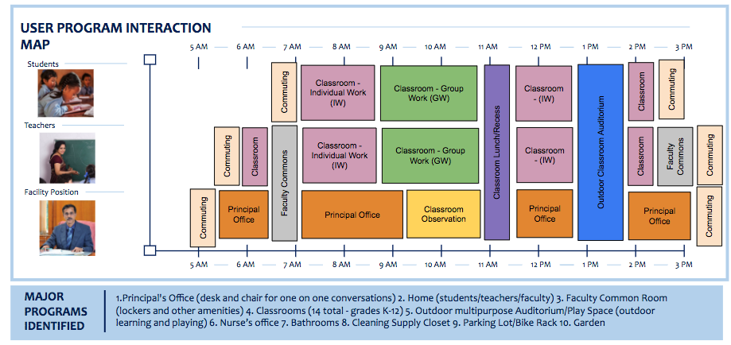

**Figure 3.2.3-1**: User Experience package that outlines the typical school day of each user

#### 3.2.3.1 Decorations

We have two different interior design approaches for two main groups of students: Kindergarten and Elementary students. We provide several iterations for the classroom design based on their different needs and interests.

##### 3.2.3.1.1 Kindergarten

For Kindergarten students, we focus on vivid, colorful, creative, and story-telling design, which encourages students to be creators, artists, and innovators themselves whenever they are in the classroom. Classroom design has to have two main features: Aesthetic and Flexible. The decoration can be changed based on the theme of the time, seasons, events, holidays, etc. This allows students and teachers to decorate their classrooms, collaborate with each other and be responsible for their own space, allowing them to be more creative and engaged in their small community. Therefore, we decided to have two types of decoration: Fixed and flexible.

The fixed decoration, the main decoration in the classroom, can not be changed over a long period. This carries the school and community's spirit, culture, mission, and vision.

The flexible decoration: The theme and design can be changed according to seasons, events, big holidays, etc. The teachers and students in the class will be the ones who decide on everything and implement them. This decoration expresses the students' and teachers’ collaboration, teamwork, engagement, and other abilities.

Below are a few design proposals:

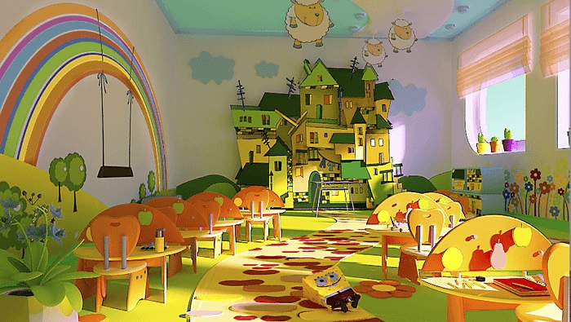

[13]**Figure 3.2.3.1-1:** Example of 3D model decoration

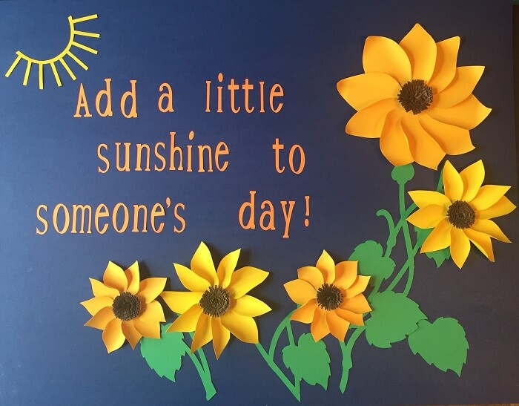

[14] **Figure 3.2.3.1-2**: Color paper decoration on the wall as a flexible decoration

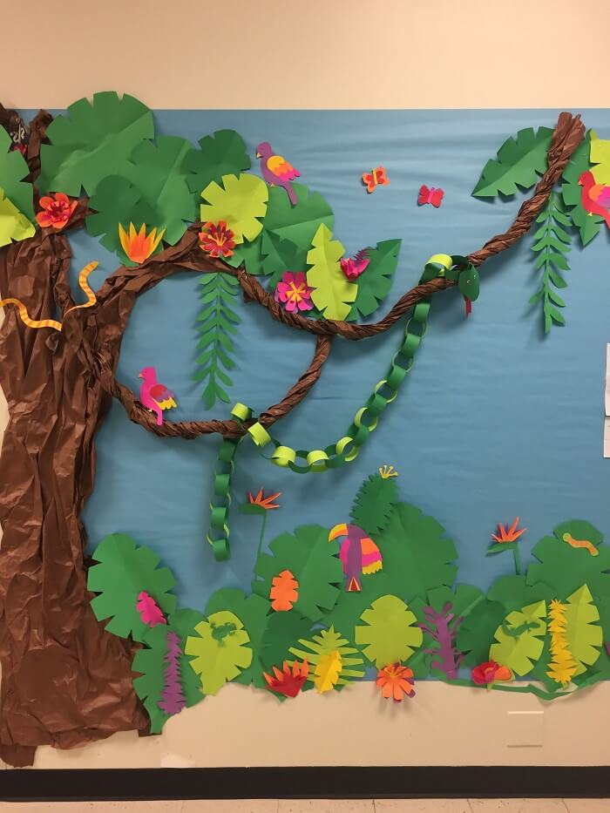

[15]

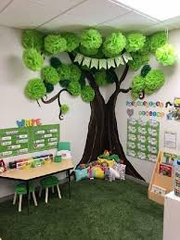[16]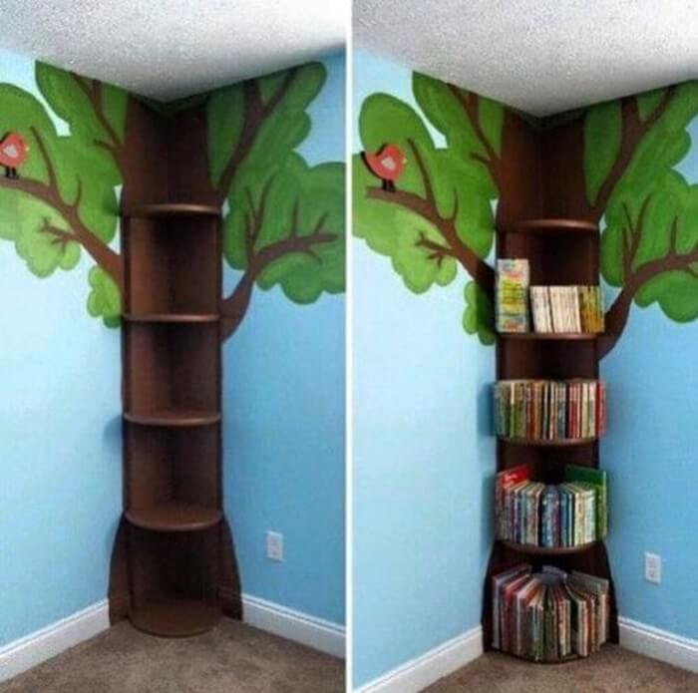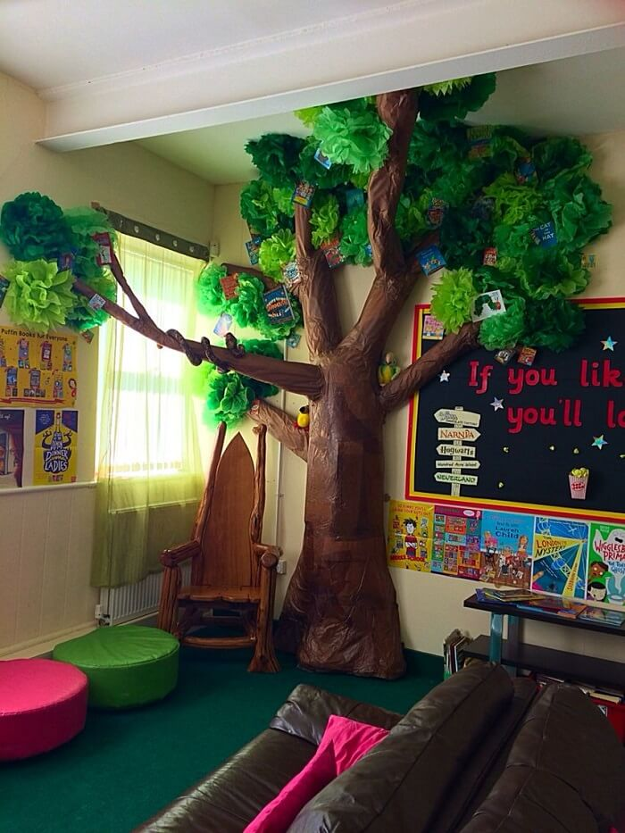

**Figure 3.2.3.1-3:**  Mini corner scene with 3D models as a fixed decoration - functions to facilitate better interactive activities and can be utilized as a reading corner in the classroom decorations

##### 

##### 3.2.3.1.2 Elementary

For elementary students, we focus on more organized and cross-functional spaces. We combine the storage space and the decoration because we have more learning materials, documents, and other stationery for the students, teachers, and courses. 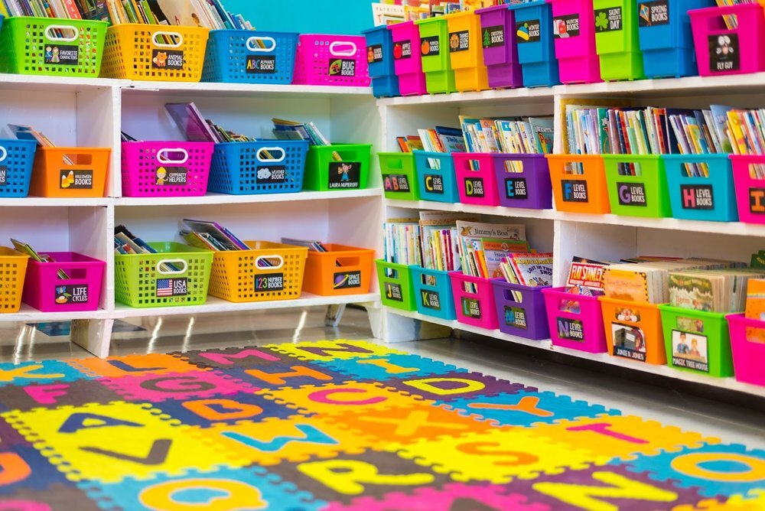

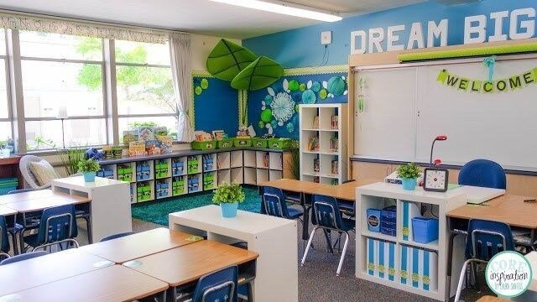

[17],[18]**Figure 3.2.3.1-4:** Storage space

While there are a number of ways a design can be tied back to the community and culture of its surrounding environment, for this project specifically there were major areas that required extensive focus as the design process got kicked off. To summarize, it is crucial to develop an understanding of each user's experience with the system. For the Sunsari school project, various user experience elements were considered including the front gate design and in the additions to the student house system. As the design continues to mature, additional features will be addressed when considering the community/culture.

#### 3.2.3.2 Main Gate

The main gate is a key element of many buildings in Nepal. This entrance to the school is designed to welcome students and guests to the site.The shape of the gateway itself is influenced by the traditional architectural style of the Sunsari district, and several cultural elements are incorporated into the design. The hexagram represents the union between male and female, each depicted as a triangle. The flying flags represent each of the school houses. The gate will connect to the fencing that surrounds the site to keep out livestock and protect students.

The gate is designed to evoke feelings of curiosity and warmth, as students will pass through this gate each time they begin and conclude their school day. It is a landmark structure that students will walk through twice a day during their primary school careers, and will thus closely associate with their childhood experience. The school building will be made of bamboo, concrete, and brick. Like many entrance gates in Nepal, this gate will be made with locally sourced brick for the poles and concrete for the top arch to ensure that it matches the design of the rest of the site. The manual gate will open and close via a hinge and lock system to maintain security.

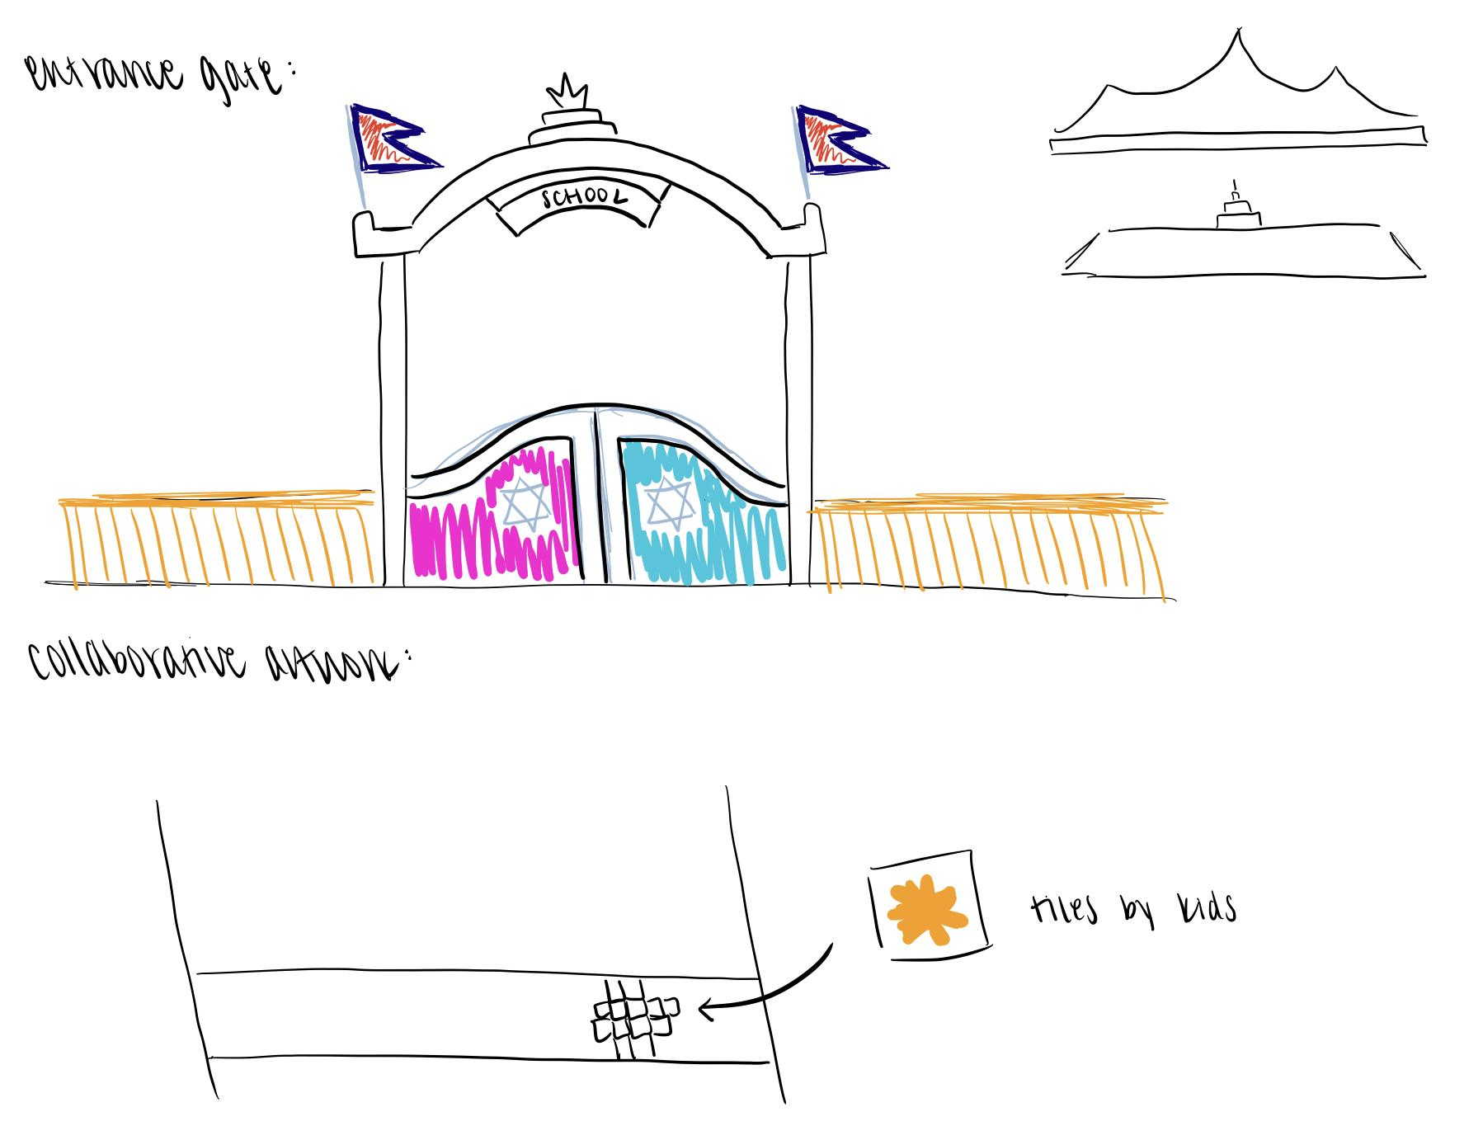

**Figure 3.2.3.2-1**: Finalized Gate design that will be erected in front of the school

#### 3.2.3.3 Classroom

##### 3.2.3.3.1 Kindergarten

Classroom design for Kindergarten students, including 2 classrooms. This document provides ideas and iterations for the classroom setup and design so that communication, education, and fun are the norm from day one.

Considered requirements: A consistent tone of the organization, group work with tables and chairs, reading nook, visual appeal, space for centers and workstations, the organization for centers and workstations, dynamic and flexible seats and tables, dangerous pieces of stuff limitation

Seats and tables design

* Movable, easy to move around the classroom[19]
* No wheels, which is safer for kids when they are playing around the chair
* Comfortable, colorful
* Easy to fold into different shapes, which is good for putting away; make space for other activities

**Figure 3.2.3.3.1-1:** Example seating

* Tables that can be arranged in many different shapes and groups
* Make the classroom organization flexible for many different activities

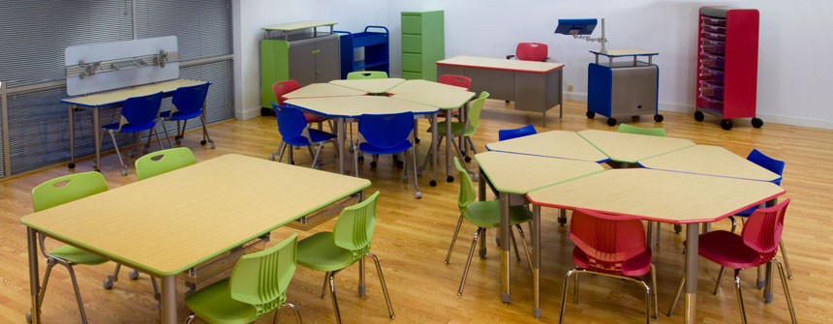[20]

**Figure 3.2.3.3.1-2:** Example seating arrangement

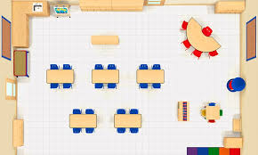[21]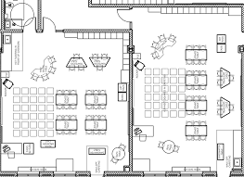[22]

**Figure 3.2.3.3.1-3:** Example Kindergarten Classroom Layout

Supporting tools: Bookshelves, A large area rug, tables or desks, a teacher chair, age-appropriate games, puzzles, hand instruments, and blocks, pencils, crayons, colored pencils, paper, erasers, notebooks

##### 

##### 3.2.3.3.2 Elementary

Design[23]

Movable chairs and tables for different activities

* Exams
* Group activities
* Individual studies
* Easy to put away for other entertaining activities

#### [24]

**Figure 3.2.3.3.2-1:** Elementary layout

Supporting tools

* Classroom Library
* Learning Centers
* Flexible Seating
* Word Wall
* Supplies Storage
* Backpack/Student Storage
* Technology Area.

#### 3.2.3.4 Bathroom

The Department of Education states that in Nepal, “various researches and studies have shown that dearth of girl friendly toilets in school premises is one of the reasons for girl students’ dropping out of schools.” Gita Kharel, a Principal from Ratna Rajya School Baneshwor in Nepal said that “menstruating girl students often remain absent due to lack of separate toilets for them.” The school’s bathroom plan will separate boys and girls bathrooms to provide privacy for girls experiencing menstruation as well as proper place for sanitary pads disposal will be part of the design. The plan to have separate girl toilets and a sanitary pad management system will allow female students to experience & access a more comfortable education experience.

In addition to the sanitary pad management system, there is a need to provide adequate water supply and a regular sanitation plan to reduce disease risk among the students and their families. Having a safe & hygienic environment is imperative for the school. The toilets should be designed in such a way that allows for easy cleaning in addition to a septic tank, and the pad disposal bins to be sent for incineration as is per the customs in Nepal.

Regarding the quantity of toilets, according to the education regulation of Nepal, there will be 1 squat pan toilet to every 50 male students, and 1 squat pan toilet to every 50 female students.

#### 3.2.3.5 Teacher’s Office

The teacher’s office should function as a place of peaceful sanctuary away from the busyness in the classrooms. The design should focus on having plenty of open space and seating to create a refreshing environment and a place for the teachers to gather.

In efforts to align with the customer requirements, the Teacher’s office will be big enough to accommodate twelve teachers at the modular, moveable round desk. Additionally, there will be spaces allotted for storage space and a sickbay. Per the Design Derivations sections, the office will accommodate two doors.

### 3.2.4 Sustainability and Life Support Systems

The design of the school was created with the intent of being able to reproduce it in any location in Nepal. Although this specific layout referenced the Sunsari school district’s location, most of the following recommendations are applicable to wherever a new school is placed. The goal of the sustainability team was to incorporate designs that would allow the school to be off-grid if needed. As a result, there was a focus on Water, Power, Lighting, HVAC, School Material Usage, and Building Safety.

Potable water that will be contained within the buildings and used by students and faculty have completely different requirements as water that will be used for irrigation. As a result, the Water section is broken down into two parts: Internal and External. Although the buildings are designed with the goal of utilizing natural light and ventilation, reliable power is still needed to provide consistent lighting and ventilation. Because Nepal’s weather tends to be favorable, a solar panel system was recommended to serve as the primary source of power for the school. Phase 1 of this system focuses on how electricity will be used for classroom lighting and cooling. The last three sections focus on how the building rooms will be used. Classroom and kitchen accessories, internet installation, and overall safety is covered in further detail in these sections.

#### 3.2.4.1 Water - Internal

The main source of internal water use is the well. There are two main internal water uses: water fountains and bathrooms. Since the stakeholder said that the necessity of a kitchen is limited, the kitchen will only include one sink, located in either the teachers’ lounge or the library.

The well will be dug on site and near the bathrooms. With 1 water fountain placed near each of the bathrooms, water only needs to be introduced to the two bathrooms, and no water will be plumbed into the classroom buildings. The plumping system of the school will be very simplified and cheap to build. While the area where the site is located suffers from floods, a simple plumping system will be easy to maintain.

One filtering system will be placed with the well and the pump. The aim of this filtering system is to clean the water from solid impurities and sanitize the water with chemical methods. The water coming out from this filtering system should be capable for all bathroom needs, including taps and toilets.

Since the school is located in an agricultural area, the waste water pipes should be sealed and kept properly to prevent leakage into the surrounding area, even during floods. Recycling waste water is not considered in this case due to the limited budget and the inconvenience to maintain.

For water used for water fountains, an extra filtering system could be added to further purify the water. Regarding the public hygiene situation in the local area, a boiling system is recommended to further purify and sanitize the water from pathogens like bacteria and parasites. Since boiling water requires extra energy consumption, reverse osmosis water filtering and high fluoride treatment are preferred.

#### 3.2.4.2 Water - External

The strategy for water supply is split between needs within the school buildings and needs outside. To simplify the water system, well water will be used to supply water fountains, sinks, and toilets.

The well will be dug onsite and must be placed close to the bathrooms and teachers’ lounge building. 1 drinking fountain will be located next to both the girls’ bathroom and the boys’ bathroom. No water will be plumbed into the classroom building. Black water from the sinks and toilets will be routed into the septic tank. Since the location of the school is in an agricultural area, the septic tank must not leach into the ground. The septic tank will be placed close to the parking lot for ease of maintenance.

Rainwater will be collected and used for watering plants, as shown in Figure 3.2.4.2-1. A water collection system will be installed to store rainwater captured from the roof. Rainwater tanks for the water collection system placed at the north and south ends of the classroom building will interface with gutters installed on the roof. Students and staff members will fill up buckets and watering cans with water from the rainwater tanks to use in maintaining gardens and plants on campus.

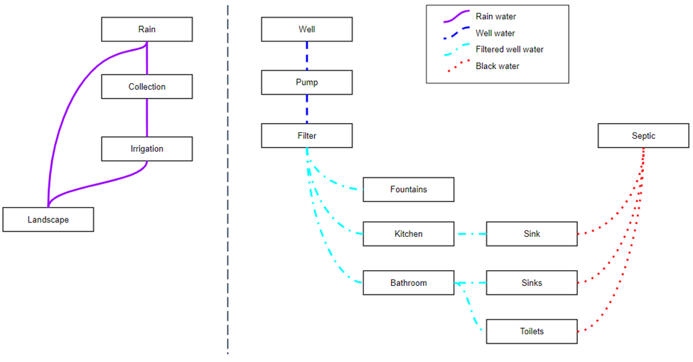

**Figure 3.2.4.2-1:** Water System Schematic

The context diagram in Figure 3.2.4.2-2 shows the staff and students as the main stakeholders interfacing with the system. This highlights the importance of making the water collection system, specifically the rainwater tank, easily accessible for the students that is also safe. An accessible, easy to use rainwater tank will help students properly maintain the gardens on campus, likely leading to a better learning experience. Since the water in the rainwater tank will not be safe to drink, the design must also limit or remove the possibility of a student drinking directly from the rainwater tank. The context diagram also indicates the need to design the water collection system such that it will not be damaged by wildlife.

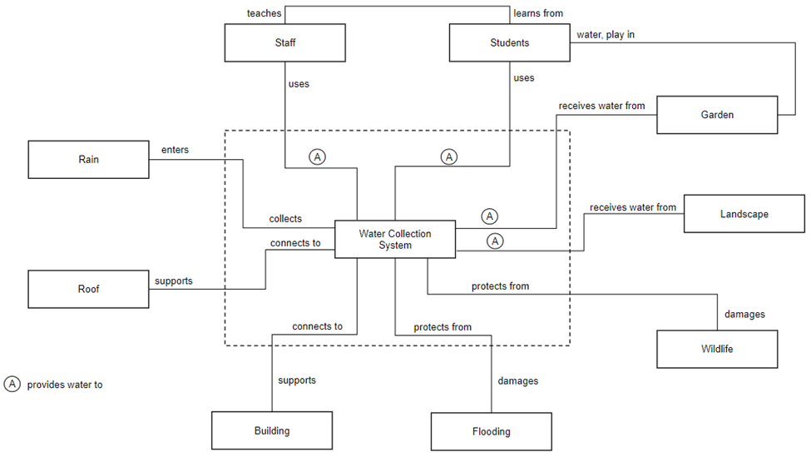

**Figure 3.2.4.2-2:** Context Diagram for Water Collection System

One key feature of the tanks made evident in the IDEF0 shown in Figures 3.2.4.2-3 and 3.2.4.2-4 is the need for the design of the tanks to allow for overflow. The overflow feature will prevent water from stagnating on the roof in the gutters. The IDFE0 also shows there is flexibility in the design of the tank size and the number of tanks. Depending on the cost and needs of the school and future sites, one or multiple tanks may be installed on campus. Though the intention for this site is to place 1 tank (2 total) at the north and south ends of the classroom building, future sites may choose to install tanks in different locations.

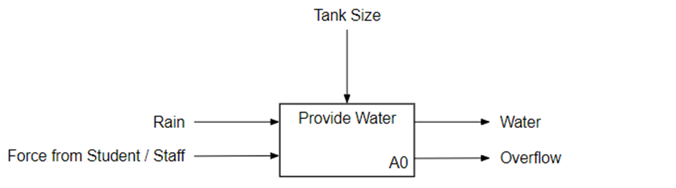

**Figure 3.2.4.2-3:** IDEF0 for Water Collection System (A0)

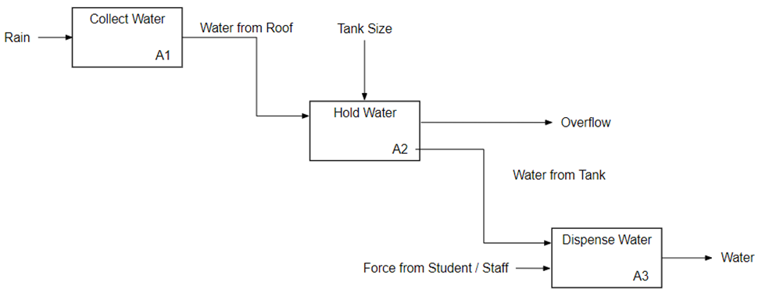

**Figure 3.2.4.2-4:** IDEF0 for Water Collection System (A1, A2, and A3)

The state matrix shown in Table 3.2.4.2-1 was used to identify any transitions from one state to the next that may need additional design considerations. One state is not desirable: *Not Collecting, Not Dispensing, Not Holding, Not Overflowing*. In other words, the design must limit the amount of time the tank is empty. A simple automatic shutoff valve for the spout of the tank will eliminate the possibility of the spout being left open after the students have finished filling up water from the tank.

**Table 3.2.4.2-1:** State Matrix for Water Collection System

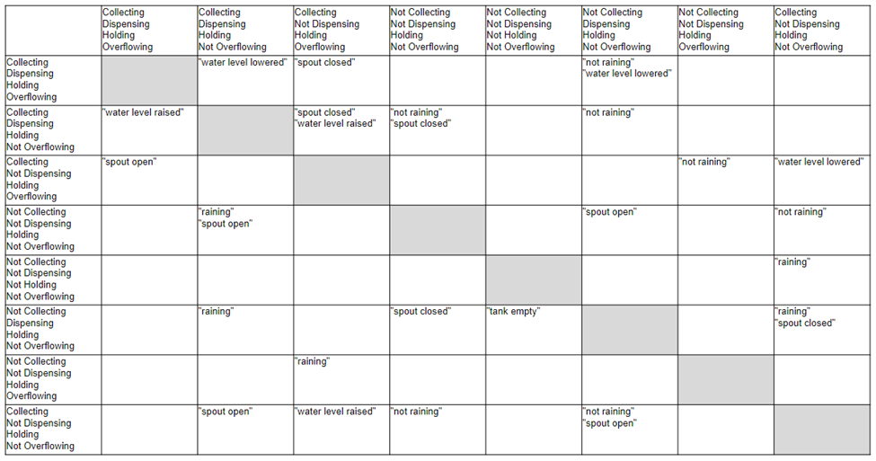

Additional work is required to integrate the rainwater collection tanks with the gutter system and safely attach the tanks to the classroom building. The size of the tanks installed will also need to be determined. Additional details of work from previous semesters regarding water analysis is located in Appendix F.

#### 3.2.4.3 Solar Power Collection

In accordance with stakeholder requirements, the main energy source of the school will be from solar energy harnessed by solar panels. Currently, the roofs of the classrooms are East-West facing, but based on information collected from the Fall 2021 group, the most efficient panel direction is South facing with a tilt between 30° and 45°.

Currently the selected solar power company is SunFarmer, a non-profit based in Nepal who services community driven projects, like schools, hospitals, and health clinics. Through the use of their “on-grid” system, we can provide energy to the school primarily through solar power, but have available grid power if needed. With this system we can meet stakeholder requirements, which request the option for grid energy.

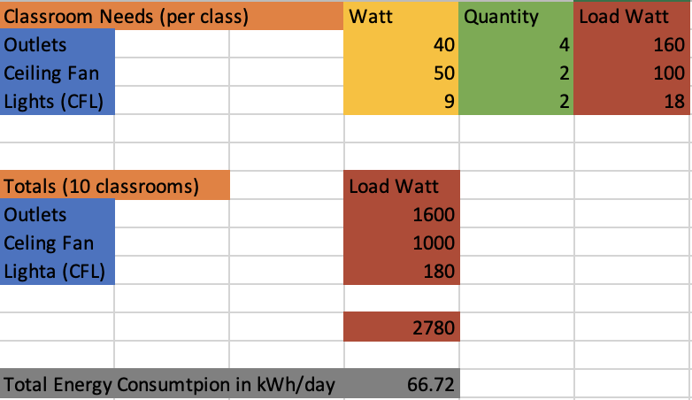

**Figure 3.2.4.3-1:** Load Analysis of the Classrooms

#### 3.2.4.4 Electric Distribution

According to key stakeholder feedback, the local power grid is unreliable in the region for the site of the school. Therefore, solar panels will serve as the primary source of power for the campus. The buildings on campus will be connected to the grid so power can be requested during lower periods of solar energy.

One key feature of the electrical system in Figure 3.2.4.4-1 is the omission of a battery in the system. Batteries are expensive and require additional space for proper maintenance. The system can be reconfigured to include a battery for storing solar power. In the current design, excess power from the solar panels will be sent to the grid.

Figure 3.2.4.4-1 helps illustrate the phased approach to designing and installing the electrical system. The design of the electrical system must allow room for the addition of solar panels as the power demands of the school increase. Phase 1 represents components that will be included in the initial construction of the school. This includes wiring for outlets (4 for each room), lights, ceiling fans, and switches for the power in each room. As more funding becomes available, additional phases can be completed. Phase 2 shows the addition of projectors and computers into the school as well as the computer lab. Phase 3 shows the addition of Wi-Fi to the school.

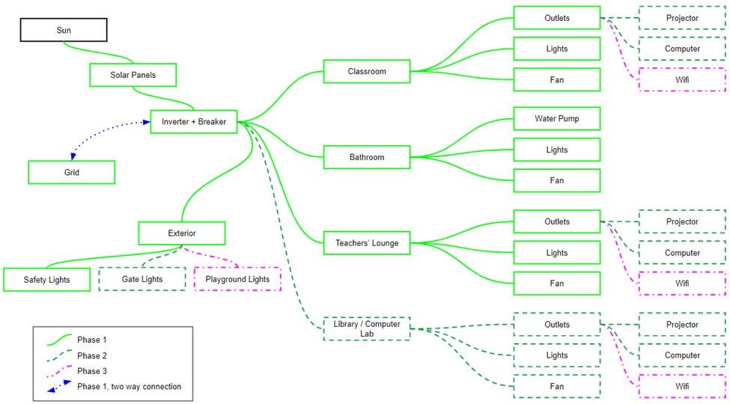

**Figure 3.2.4.4-1:** Electrical System Schematic

Though the school will have 10 classrooms, the context diagram in Figure 3.2.4.4-2 shows the “classroom” only once. In alignment with the overall requirement for modularity in the design, the intent is for each classroom to have the same electrical system. The locations of the fans and lights will be the same in each classroom. The outlets (4 total) will be located on the north (2) and south (2) wall of each classroom. Wiring for the bathrooms, teachers’ lounge, and computer lab will be tailored for each room.

The context diagram also highlights the relationship between the solar panels, roof, and electricity distribution system. Additional work will be required to optimize the integration of each component, especially with regards to leaving space for the additional solar panels as the power demands of the school grow.

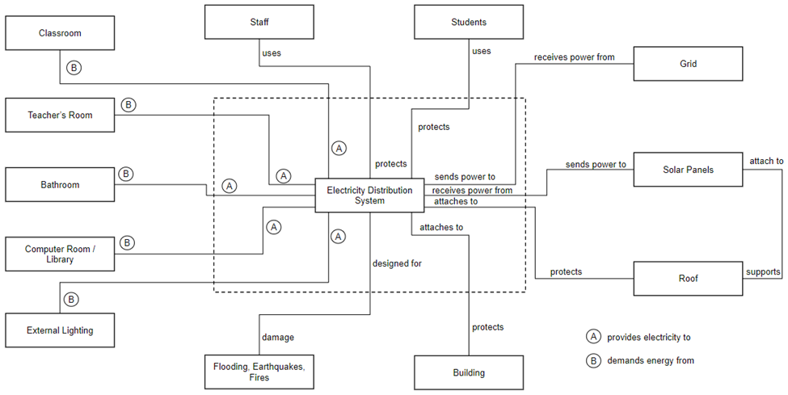

**Figure 3.2.4.4-2:** Context Diagram for Electrical System

The IDEF0 in Figures 3.2.4.4-3 and 3.2.4.4-4 illustrate how energy will move through the system. Energy from the solar panels will be sent through the inverter to the rooms on campus. Energy not being used by the school will be sent through the inverter to the grid, limiting wasted energy.

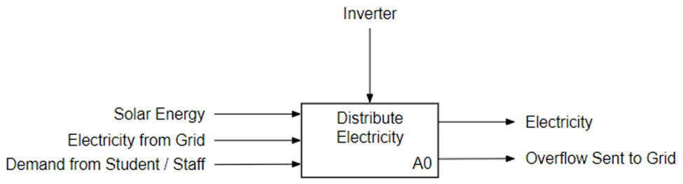

**Figure 3.2.4.4-3:** IDEF0 for Electrical System (A0)

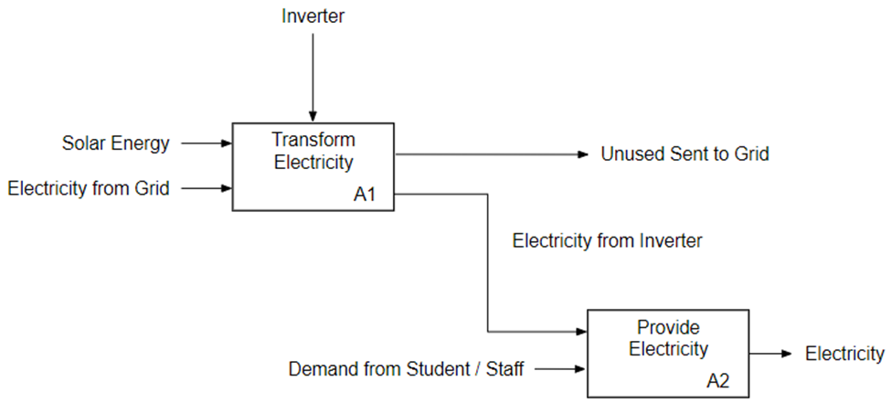

**Figure 3.2.4.4-4:** IDEF0 for Electrical System (A1 and A2)

The state matrix in Table 3.2.4.4-1 shows only 5 different states for the system.

**Table 3.2.4.4-1:** State Matrix for Electrical System

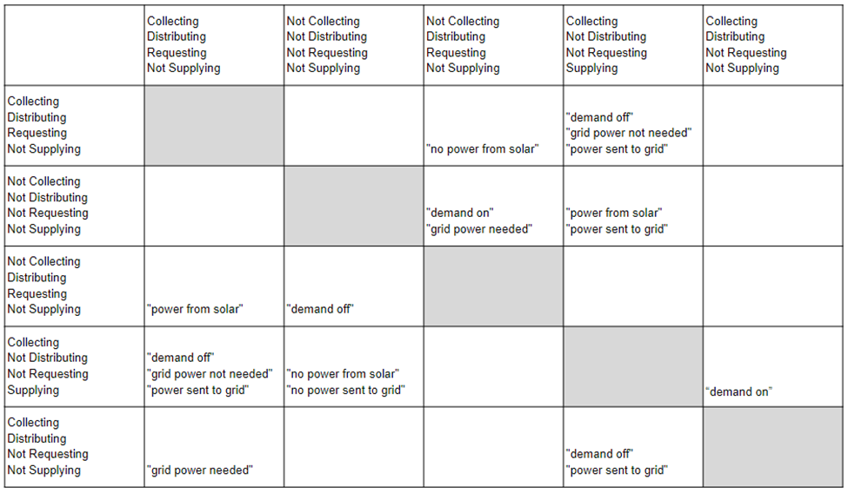

One state of particular importance is the *Collecting, Not Distributing, Not Requesting, Supplying* state when power from the solar panels is being sent through the inverter to the grid. There is opportunity for working with local officials to establish a favorable partnership or agreement to ensure the school is properly compensated for power supplied to the grid. The school would benefit from a more reliable grid. The community would benefit from excess power collected by the school. The solar panel system may help drive improvement of the local grid infrastructure.

With regards to grid reliability, the state matrix also highlights the most undesired state of *Not Collecting, Distributing, Requesting, Not Supplying*. In other words, there is no solar power available and the school is relying solely on the grid for power. One mitigation outside the scope of the project is to improve the reliability of the grid. As aforementioned, a battery can also be added to the system as an alternative strategy if funding becomes available.

#### 3.2.4.5 Lighting

Lighting is a core and necessary component of the whole project, as for every facility that requires human interaction would need certain lighting in order to not only illuminate the surrounding environment, but also allow activities that are needed to be done with enough lighting and brightness that would otherwise be very difficult to perform without.

Lighting within the buildings and campus area are primarily categorized by its location in use, namely, interior lighting and exterior lighting. Given that interior lighting is necessary and is a must regardless of the duration of usage, interior lighting will be the focal point in plotting out lighting configuration and distribution. Interior lighting primarily focuses on implementation of sets of lighting using light strips, tube lights or fluorescent lights; while on the other hand, for exterior and extra lighting cases and purposes, standard light bulbs, lighting with high brightness or light type similar to a searchlight would be applicable to be used to ensure sufficient brightness and luminosity of light pass through, or for extended range of lighting illuminates.

As for interior lighting, the idea is to follow the standard method of lighting within classrooms. Traditionally, light strips or lengthy light bulbs are the choices for classroom, either with the light bulbs enclosed within a cuboid-shaped “container” that protects the light strips, or just have installations of fence-like protection with the light strip naked to the atmosphere and such strip-like protections would hold the gravity and increase endurance of the light strip handler.

For light strip configurations, there are a number of options that can be established and utilized, based on observation and common sense of classroom light configurations. In many cases, classroom light strips are usually configured based on the size of classroom – even for certain larger lecture halls or interior spaces of that size significantly larger comparatively than a standard classroom size of that area. In the case of the project, based on the dimension of the classroom, the configuration of lighting would be 3 × 2, namely, 3 sets of light strips per row and with 2 rows of lighting, with gapped distance in between to make any pair of the light tubes not adjacent to each other. Since the length of the classroom is not that significant and 4 sets of light strips could be too much for approximately 10 meters in length, 3 would fit better in terms of lighting within classrooms. In such a case, all areas of the classroom can be illuminated. Depending on the brand and configuration of the light that will be purchased, for extreme cases like “unprotected” single light strips or a single light tube, the coverage would be maximized due to the appropriate luminosity of close distance light tubes.

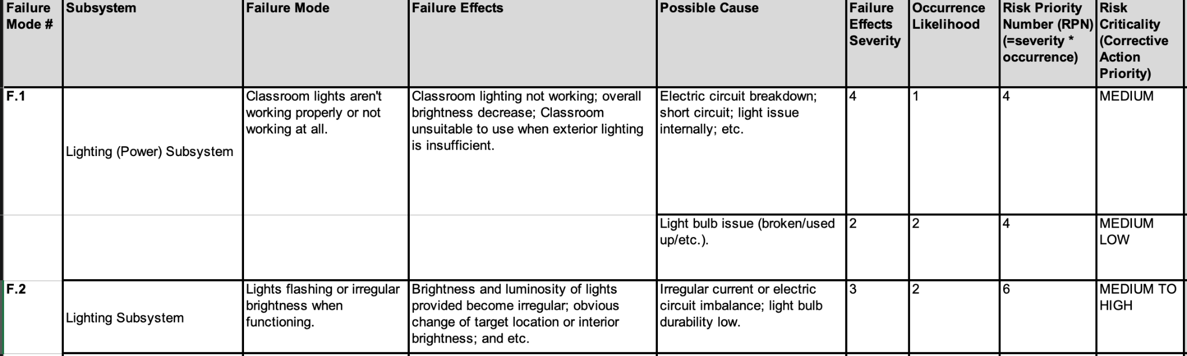

**Table 3.2.4.5-1:** Failure modes (in FMEA form) of potential lighting failures.

Lighting failures could happen in both internal and external lighting subsystems. Failure modes are nearly identical (in most cases, identical) in both cases, hence potential failure modes won’t be described again in the following description of external lighting configurations and conditions.

External lighting is also crucial to the overall safety and security of the school itself and as a system that incorporates many subsystems on hand and on site. However, given the budget and frequency of use, external lighting possesses lesser priority in terms of installation order (phases that it could be implemented) as well as budget intentions. Main usages of external lighting in this project is for security lighting and road/gate lighting, alongside pathways and for security lighting, on safe spots that illuminate dark areas that could cause security breaches and compromises as well as other blind spots that are worthwhile being noticed. For security lights, a searching-light type lighting system would be sufficient and cost-effective. Since the project has a tight budget constraint, adding too much unnecessary external lighting or spending too much on certain lighting brands and modes could be a waste of money, which could be further saved in order to develop potential other future improvements onsite and on towards the school as a whole system. Roadside lighting, including illuminating gate areas, are also needed but given the budget and frequency of people walking by as well as likelihood of human activity on given exterior areas that could be dark in early morning or past dawn, pathway and field lighting could be lessened in terms of quantity of lights that will be installed, of course, for budget reasons.

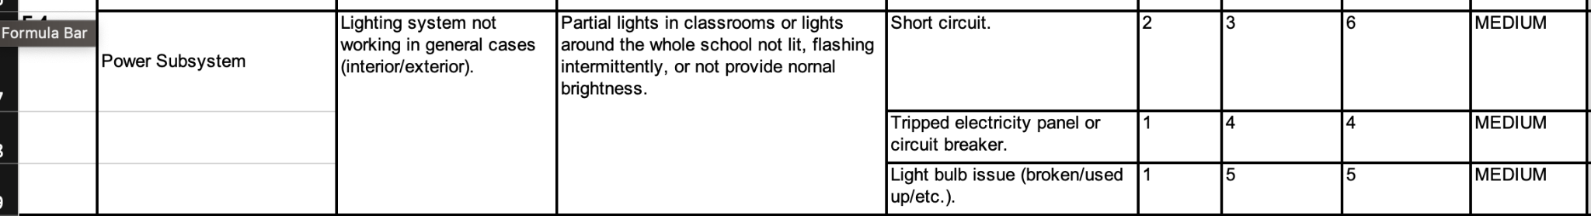

**Table 3.2.4.5-2:** Common failure modes (in FMEA) of brightness and luminosity issues

In general, lighting is a huge portion of the sustainability and life-supporting subsystems itself and comprises multiple factors that could benefit (or else when it fails which could harm) faculties and students’ learning and schooling experiences. A stable and reliable lighting system would be necessary for human activities and also ensures the ability of community gatherings or extracurricular activities before or after normal school hours. With more potential future budget allocations or charity group inputs in terms of funds and resource, additional interior and exterior lighting could be further constructed to add more color and decoration around the school, in which looking from a spectator’s perspective from “above” and overlooking the whole project as well as the school as the system, would be more “colorful” and meaningful while fulfilling the needs of increasing diversity and creativity in education in the modern world with education methods and environments changing at a rapid pace.

#### 3.2.4.6 Heating and Air Conditioning

The main sources of heating and air conditioning will be through passive measures. According to stakeholder feedback, the use of electric devices is not feasible or economically possible.

GCI roofing works well in hot climates; it is considered a “cooling” roof material due to its reflective properties. Additionally, adding highly reflective paint is one option that can increase cooling properties even more. Heating and cooling both begin with strong insulation. If possible to install, a radiant barrier on the underside of the roof would add to the effect of not allowing in excess heat. Roof overhang is another important technique for passive cooling. As depicted in Figure 3.2.4.6-1, an overhang can block out some of the sun’s more direct rays into hitting walls and windows that will retain heat and keep room temperatures high. An overhang should be added to any direction with high sun exposure. In contrast, this overhang will not block exposure in the winter, when the sun stays lower in the sky, and will allow the room some natural heat.

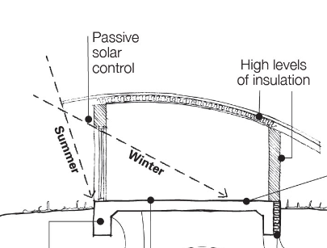

**Figure 3.2.4.6-1:** Diagram showing roof overhang and its effect on summer and winter sun exposure[25]

Glass windows can heat up a room significantly in summer months. One potential measure that can be taken is installing double glazed windows. This will increase the efficiency of keeping the rooms insulated from extreme heat or cold, as they resist energy transfer more than single-paned windows. Preferably, two windows will be installed in each room, opposite each other, to increase airflow and natural ventilation.

Concrete walls have a high thermal mass – they are slow to absorb heat but retain it for a long time. Merely having a high thermal mass material is not always enough to have effective heating and cooling. Insulated concrete, if feasible, is a fairly cost effective material and an efficient way to add to passive cooling in the warmer months.

Plant placement can play a huge role in passive cooling measures. When trees are strategically placed to shield some of the roof’s surface area from the sun in the summer months, room temperatures can decrease significantly. Specifically, deciduous trees common to Nepal would be most efficient at this job, as they can provide shade in summer, while losing their leaves in winter and allowing the sun to penetrate and naturally increase room temperatures in cooler months. Bushes and shrubs can also be placed strategically along walls with direct sun exposure to prevent increasing temperatures to penetrate rooms.

The addition of ventilation slits to the top of each classroom will help keep air circulating and increase airflow. This will reduce heat buildup of rooms.

Stakeholder requirements are for two ceiling fans per room. This measure will also ensure an increased air flow and better circulation. Fans should be placed equidistant from each other and from the walls. Optimal placement of each fan is ¼ the distance of the room away from each wall, and ½ the distance of the room away from each other. In other words, each fan should be ¼ the distance of the room away from the center.

#### 3.2.4.7 Classroom Accessories

There will be a total of ten classrooms, including two kindergartens classrooms and one classroom from each grade from first to eighth. Each classroom is expected to sustain forty students and a teacher, hence each classroom should contain forty pairs of desks and chairs. In the teaching area, each classroom will contain a podium, chalkboards, and color chalk pens for instruction. Ideally, a projector would be implemented for each classroom, especially for the higher grades. Each classroom will have a HDMI convertor and charging port for the projector and the teacher's laptop.

In terms of waste processing, each classroom will have one trash bin, which is expected to be emptied by students regularly. In addition, there is a specified library region with one bookshelf storing some books along with a seating area. In the back of the classroom, there will be a small designated region for students to store belongings during the class day. As students are not expected to leave any belongings after school, the design of this area will merely be a temporary storage area.

There will be no expectation of a water fountain as students are expected to refill water in the general area. Each classroom would be decorated by the teacher and students, hence there will be no guidance on decorating materials.

#### 

#### 3.2.4.8 Kitchen

Based on stakeholder feedback, kitchen necessities are limited. The addition of an oven or refrigerator is unnecessary due to intermittence of electricity. A stove will be added for occasional use. Stove placement options are the teacher’s lounge or the library. The more suitable of these two is the library. Placement should be off to a side or corner, away from everyday activities and not accessible to children at all times for safety reasons.

Utensils will also be required. In a school environment, the basics are knives, cutting boards, trays, large spoons, tongs, and basic flatware. Depending on use, only 1 to 5 of each cooking utensil can be used, while flatware number would depend on use. Anywhere from 20 to 440 (10% surplus for number of students) of each would suffice.

#### 3.2.4.9 Internet

Internet is expected throughout the campus, while mainly to be used in classrooms and teachers' offices. Each classroom will have at minimum one laptop to be connected to wifi during class time. Due to wall construction, wifi mesh repeaters with a wired back-haul are expected to be used to establish stable internet connection.

More research would be done in the following semester in terms of the number of WIFI Routers needed to support such minimum requirements. During later phases of the design, a potential computer lab will be implemented. Then, there will be an addition of wifi router and laptops to be set up.

#### 3.2.4.10 Building Protection and Safety

The key areas of building protection and safety that need to be addressed are: classroom security, fire, rain, and earthquakes. In the following sections, suggestions for the classroom layout, tools, and mitigation measures will be provided. The information listed is meant to be used as a guide and is subject to change based on stakeholder needs. In order to determine the basic requirements, Figure 3.2.4.10-1 is provided to highlight the different use cases and respective priority levels. The six goals related to the safety of the classroom are listed in Figure 3.2.4.10-2. Figure 3.2.4.10-3 is a tool known as a Goal Question and Metric table and is used to help stakeholders understand what is needed to accomplish the goals listed.

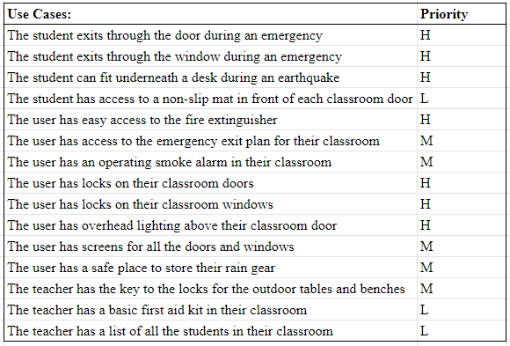

**Figure 3.2.4.10-1:** Use Cases for Building Safety

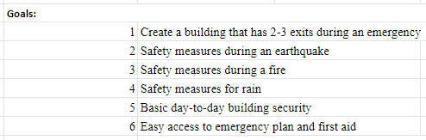

**Figure 3.2.4.10-2**: Goal Question Metric (GQM) Table for Building Safety

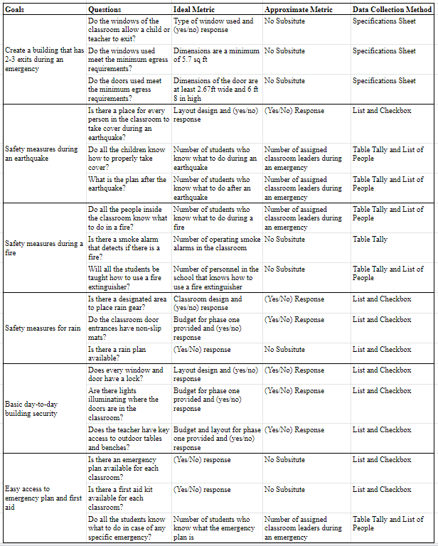

**Figure 3.2.4.10-3:** Goal Question Metric (GQM) Table for Building Safety

##### 3.2.4.10.1 Classroom Security

Based on the current layout of the classroom, each room will be 10m by 15 m. There will be approximately 40 students per classroom, so multiple egress points should be available in the case of an emergency. The international building code advises that a window have a minimum height of 24 in or 610 mm and width of 20 in or 508 mm if it will be used for egress. The types of windows recommended are awning, sliding, or casing. The windows should also have screens to allow for passive ventilation without risk of pest intrusion. As for the doors, the minimum dimensions are 32 in (813 mm) W and 80 in (2032 mm) H. The placement of the doors and windows is discussed in further detail in the Modular section of this report. In addition to emergency exits, basic first aid kits should be available in each classroom. This can be stored with the teacher and easily accessible for even students when needed.

Although theft is not a major concern in Nepal, it is recommended that all doors and windows have interior locks that allow teachers to properly secure the building after each day. There are no specific locks required for the windows, however, the doors should be lockable from inside the classroom and have key access from the outside. Lighting above each door is also recommended so that people in the classroom can easily find the exits in case of an emergency. The type of lights used for this should be energy efficient, as these will need to be operating 24/7.

##### 3.2.4.10.2 Fire Safety

Fires are a major building hazard, especially in tight, crowded spaces. Having a safety plan and mitigations available is important to ensure the overall safety of the people in the classroom. An inexpensive and effective measure is having fire alarms and smoke detectors. According to the US National Fire Protection Agency (NFPA), smoke detectors will cover a radius of 21 ft (6.4 m). Since the classrooms have a maximum length of 15m, two detectors per classroom should be sufficient in detecting a fire. In addition to smoke detectors, fire extinguishers should also be readily available for each classroom. It is common to have fire extinguishers close to a door so that occupants can have access to them while evacuating. It is also easier to locate if they are placed in the same general location for all the rooms.

##### 3.2.4.10.3 Rain Safety

The months between June to August are known as Nepal’s monsoon season. During a rainy day, it is important to have a designated location to store umbrellas and rain gear so that it doesn’t end up being a trip hazard. Whether this is a designated wall outside the classroom, or a cubby area at the inside entrance, having a space for rain gear to go will keep the space organized. In addition, having anti-slip mats at the entrances of the classroom will protect kids from slipping on puddles. Although it is not required to have it by Phase 1 of the school build, having a roofed walkway from the bathrooms to the classroom will protect students from the rain. The school will be built on an area that was previously used for rice paddies, so highlighting the areas on the campus that are prone to flooding will help the adults identify areas to avoid when it rains.

##### 3.2.4.10.4 Earthquake Safety

Earthquakes are one of the most common natural disasters in Nepal. Although it is hard to predict or detect when an earthquake will occur, there are ways to prepare a classroom and its occupants. One easy way to add protection is to have enough space underneath desks for all students and teachers to duck and cover. In California, it is common to have earthquake drills so that students know what to do in the case of an earthquake. Incorporating these types of drills every couple of months or so will allow the students to be prepared. After the tremors of an earthquake have stopped, there should be an evacuation plan the students follow. Each classroom should have their own meetup spot on the school grounds and this location should be located by the entrance of the door.

# 4 Living Building Challenge (LBC) Overview

## 4.1 LBC Introduction

The LBC is a non-profit program that grants a certification to building projects that meet its stringent and comprehensive standards for creating sustainable and innovative projects. The platform challenges people to rethink how they traditionally design and build projects to instead consider how every aspect is an opportunity to enrich the community and surrounding environment.

Although progress has been made to address climate change, in the grand scheme, the effort at the current rate will not be enough to halt the detrimental impacts of the damage that's been and continues to be done. Not only will all the earth's major ecological systems decline further, but they will decline at a growing rate. This ecological degradation will continue to necessitate an increase in the effort required to stop and then reverse the climate issues. The LBC pursues an immense scale of change. This paradigm shift calls for all humans to repair their disconnected relationship with nature and each other, and establish themselves as a part of the natural world. It challenges people to ask: “what if every single act of design and construction made the world a better place? What if every intervention resulted in greater biodiversity and social equity; additional outlets for beauty and personal expression; a deeper understanding of climate, culture, and place; a realignment of the team’s food and transportation systems; increased soil health; and a more profound sense of what it means to be a citizen of a planet where resources and opportunities are provided fairly and equitably?”**2**

The LBC strives to engage designers, contractors, building owners, politicians, government officials, and everyone in between to rethink the “good enough” mentality while developing building projects, and instead ask: “instead of a less bad, what does a good one look like? … The living building challenge is a philosophy, certification, and advocacy tool for the projects to move beyond merely being less bad and to become truly regenerative.”**2** Figure 4.1-1 illustrates how buildings simply being up to code, green, or even high performance, are below the standard that the LBC holds projects to. As shown within the orange dashed box, the LBC requires a sustainable level of performance to qualify.

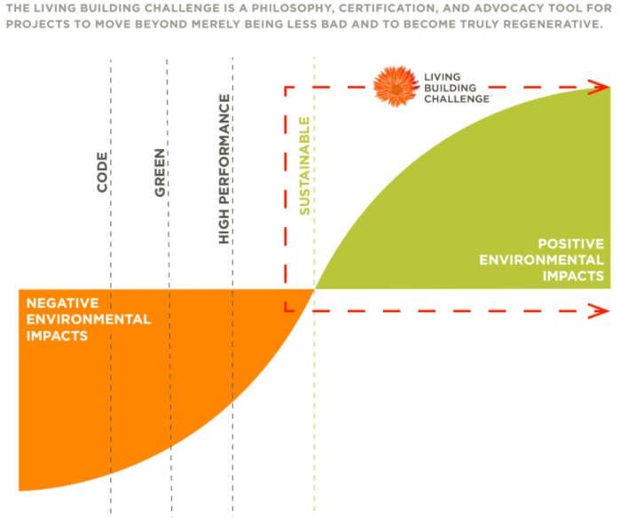

**Figure 4.1-1:** Environmental Performance vs. Environmental Impacts**2**

## 4.2 Place Petal

The Place Petal of the project focuses on how to maintain the unique cultural and environmental characteristics of the local community within the project site. This petal breaks down into four core imperatives: Ecology of Place, Urban Agriculture, Habitat Exchange, and Human Scaled-Living. These imperatives outline the requirements on “where it is acceptable for people to build, how to protect and restore a place once it has been developed, and how to encourage the creation of communities” (LBC 4.0 Handbooks, ILFI).

The intent of the Ecology of Place imperative is to not only protect the current state of the community but to also regenerate and enhance the community for the future. This is done, in part, through avoiding places with pristine wilderness or prime farmland and preserving the local environment. The current landscape design works to preserve the environment and ecology by using only native plants and trees. This will positively influence the ecology of the place by not introducing invasive species and aiding in the long-term maintenance of the landscaping. The design also considers the surveys taken in the empathy fieldwork study. For instance, many surveys indicated students and teachers enjoyed learning outside which led to designs with outdoor learning spaces.

The outdoor learning spaces and recreational areas also consider the scale of the user. The school has students from kindergarten to eighth grade. A kindergartener play area needs to be for smaller humans than a play area for middle school aged children for safety and comfort reasons. This drove the design decision to have two separate play areas for different age groups. This imperative encourages a human-powered lifestyle which also influences the parking layout and plan. There will be ample parking for bikes as well as a bike-friendly pathway to the lot.

The community may also use the space during non-school hours as a gathering place. This also touches on the goals outlined in the Human Scaled-Living imperative. Additionally, the design includes space for growing local produce for the community. This is the main objective of the Urban Agriculture imperative. An element of the Human Scaled-Living imperative calls for the structure to be scaled appropriately for the community. The Human Scaled-Living imperative achieves this by incorporating the school as a community gathering space during non-school hours. This community space leads to the Urban Agricultural imperative, where the school design will incorporate a space to grow produce locally for the community.

The project requirements for the Place Petal are listed in Appendix I LBC Verification Plan Matrix. The matrix sorts the requirements by imperative and much of the preliminary design is on track to meet the current requirements for the school.

## 4.3 Water Petal

The main focus of the Water Petal requirements is the Net Positive Water imperative. Under this imperative, the whole site of the project should supply 100% of the project’s water through a closed-loop water system. For the school, the types of water systems that were considered: well water, rainwater, greywater and blackwater. Well water has been identified as the potable water source for the school. Well water will also be used for toilet flushing. Untreated rainwater will be used for irrigation systems. A septic system will be utilized for wastewater management. Figure 4.3-1 below illustrates an Internal Block Diagram (IBD) of the Proposed Water System and how it can meet the water petal requirement standard that the LBC holds projects to.

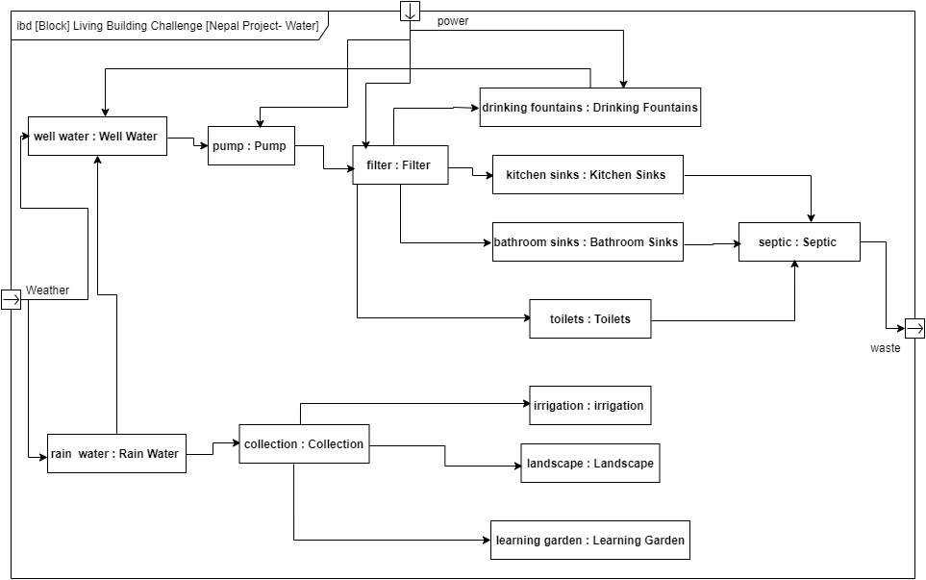

**Figure 4.3-1:** Internal Block Diagram (IBD) of the Proposed Water System (Appendix E)

The drinking water will be available in the kitchen area and water fountains in front of the bathrooms. Water will be supplied to these areas from well water and passed through filters. One of the reasons well water is utilized is due to the higher water table and the imbalance between water demand and water supply.

The water system's final design and installation will be supported by a local company. One option for local support is SmartPaani, a company focused on sustainable water management that is familiar with rainwater harvesting, greywater treatment, and recycling. Utilizing a local company with locally available materials to construct and maintain the system will ensure that the system meets the needs of the school.

Rainwater collection will be utilized as a non-potable water source, to assist with the net positive LBC requirement. The rainwater collection system will be designed to capture rainwater from the roof of the main school building into water collection tanks from the gutters. The water captured will be in above ground tanks on the north and south ends of the main building. The water will then be pumped or dipped out in pots to be used for landscape, leaning gardens and general irrigation for the site. The rainwater collected will reduce the stormwater runoff load that the site will have to handle.

Due to the cost and complexity of treating wastewater, recycling wastewater was not considered as an option. Wastewater from the bathrooms toilets and sinks, as well as the water from the kitchen sink will be handled with a septic tank and then passed into a drain field where the liquids can percolate into the ground. The expected maintenance is that the solid waste from the septic system will be pumped out every year. The septic tank will be located west of the administration building close to the main road, allowing for easy access by the pump truck and minimal impact to the site’s landscape and vegetation.

The work on the water system this semester focused on improving the team’s understanding of practical water systems for well water, stormwater, and wastewater. Future semester’s work will determine the placement of the well and finalize the size calculations as more details about the expected system become available. Recycling water from the sinks to be used as greywater for the toilets will also be revisited to evaluate the cost of the additional plumbing with the benefits.. The design for the rainfall catchment system utilizing the gutters and an above ground tank will be completed in future semesters.

## 4.4 Energy Petal

The Energy Petal design builds on the existing work which was initially developed with the stakeholder feedback and overlaying the LBC requirements. The LBC requirements include renewable energy to reduce the need for carbon emissions (CO2) and use of sustainable materials, covered in detail in the materials section. The Energy Petal focuses on the renewable power needs and strategies to satisfy those needs based on the refined information gathered in this iteration of the energy and electrical power design.

SunFarmer6 has been chosen to supply solar panel solutions for the Nepal School project. SunFarmer6 is a solar company in Nepal that serves 38 districts locally. Utilizing locally sourced and maintained suppliers meets the LBC Energy Petal standard for sourcing sustainably and locally. An analysis of the power needs is covered in the Energy Analysis section. The *primary* power system for the school is the *PhotoVoltaic (PV)* solar system, and the *secondary* is an *on-grid* utilities system. The goal is to achieve 105% of the critical power needed from the PV System (solar) to where the 5% is to feed back to the grid. However, connection to on-grid utilities will enable the school to maintain power if the PV solar system supply runs low.

### 4.4.1 Renewable Energy Analysis for Nepal School

The initial assessment (made in Spring 2022) for the school power needs was based on one classroom for each grade (K-8) and a teacher’s lounge. Kindergarten initially was one building but is now divided into two buildings, with attached bathrooms for convenience, for a total of 2 bathrooms. There is an addition of a library that will also serve as a computer lab in the future. This is a total of 14 buildings that have power requirements and individual power needs that have been accounted for in the Electrical Load Analysis (ELA) spreadsheet (Appendix D). Generally, all buildings are expected to have two tube (CFL or LED) lights, two ceiling fans (non-critical), and miscellaneous power for charging phones and other mobile devices. In addition, the Wifi router and security lights will also be a part of the critical systems. Some non-critical loads located in the teachers lounge are a laptop, an attached projector, and printers/ scanners for administrative purposes. Other non critical power needs are located in the Library/Computer lab which is expected to have power needs for 10 raspberry PI devices as the computer and 10 attached monitors. The Library/Computer lab will be the home for the networking devices such as cellular modem, and a wifi router. It is suggested to put in place network switches that will connect every building through a wired connection for future growth. There is a solar water pump not included in the ELA because it was determined it is self-sustained by its own power source, and that it does not need to connect into the grid or the main solar array for power.

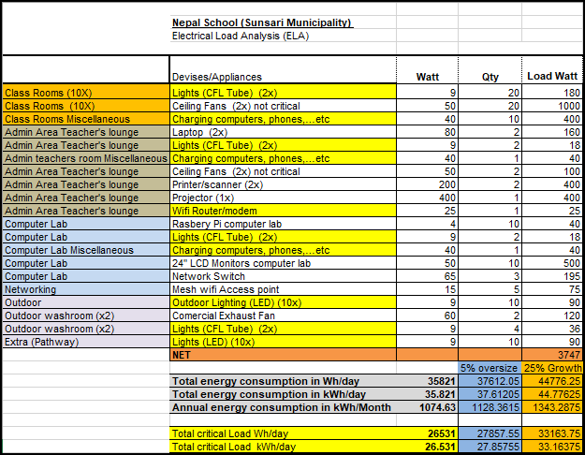

**Figure 4.4.1-1:** ELA - List of loads

A solar analysis for Nepal revealed the average number of days of sun per year and estimated an average of 7 hours per day of sunshine. The ELA was set up for 24 hrs, and divided into 1 hour increments with the expected load per device. Critical loads must happen in the average 7 hrs of sunlight in order to achieve the necessary power for the system.

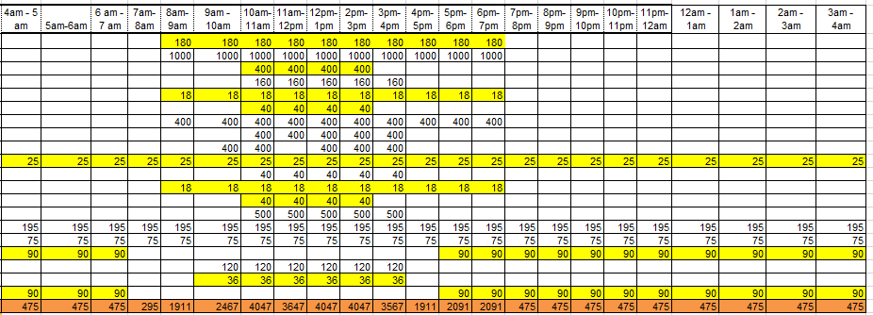

**Figure 4.4.1-2:** ELA - Power usage by the hour

The ELA is taking into account expected school activity starting from 8am till 6-7pm. Peak occupancy school hours are around 6 hrs where the loads are accounted for. The expected building occupancy is from Sunday to Friday (6 days a week), where Friday is a half day and lunch is a common time. The class schedule is as follows:

Summer: 9:45 AM - 2 PM for kindergarten

9:45 AM - 4 PM for grades 1 - 8

Winter: 9:45 AM - 2 PM for kindergarten

9:45 AM - 3:30 PM for grades 1 - 8

The units in the ELA are in watt hours per day (Wh/day) , kilowatt hours per day (kWh/day), and kilowatt hours per month (kWh/month). These three units are used in the online calculators requesting the info in these units. The main units discussed further will be in watt hours per day. The anticipated overall electrical needs for the school is calculated to be 35,821Watt hour per day. The critical load calculation for the school came out to 26,531 Watt hour per day, which will be reliant on the solar system. The outdoor security lights are also reliant on solar power, and will draw power from the battery at night. That load was estimated to be around 2,520 Watt hour per day, which is enough to run off the battery backup all night.

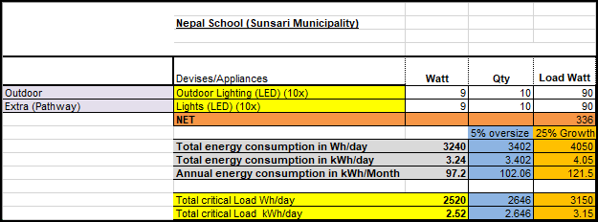

**Figure 4.4.1-3:** ELA - Outdoor lighting at night

In order to achieve the 105% power challenge, only critical power systems were taken into consideration for the PV system, which includes lights, charging outlets for mobile devices, laptops, and the Wifi modem/router.

The identified budget for the PV system is approximately $2,500 and as such, Sunfarmer6  has specified a 1kW system that consists of four (4) 325W panels that will provide adequate power during the day for critical devices for the whole school. The full kit of the solar system is shown in the table below.

**Table 4.4.1-1:** PV System Kit from SunFarmer6

| **SNo.** | **Items** | **Qty** |
| --- | --- | --- |
| 1 | 325Wp 72 cells Solar PV Modules | 4 |
| 2 | 200Ah 12V Tubular Battery | 4 |
| 3 | 3.5KVA Solar Hybrid Inverter | 1 |
| 4 | Solar Support Structures | 1 |
| 5 | Cable and installation accessories | 1 |
| 6 | LA, earthing and protection | 1 |
| 7 | Installation and transportation | 1 |

From the list shown in Table 4.4.1-1, the five key components for the School’s grid-tied solar power systems are:

* Photovoltaic Solar Panels: These will generate Direct Current (DC) electricity
* Inverters (Hybrid): This conducts the power from the solar panels to the inverter, and then onwards to the net meter. The grid-tie inverter converts DC electricity from the panels into alternating current (AC) electricity. It also assesses energy flows in real time to determine if solar output should be used in the building or exported. The Hybrid inverter is the most cost-effective way to add batteries, but generally has a trade off as it has limited backup power capability and usually has a delay (5 sec to 30 sec) when switching to backup mode during blackouts because these combine a solar and battery inverter together in one simple unit.
* Storage/Backup: The 200Ah battery will be used in addition to the inverter tied to the grid that will act as a buffer when blackouts occur to help overcome the delay when switching.
* Net Meter: This is a meter that allows and monitors the two-way exchange of power between the school and utility company. This will allow earning credits for every watt of excess solar energy that is sent back to the grid
* Solar Racking and Mounting: These serve to hold the solar panels in place, as well as allow for ventilation to cool the panels. These ideally face south and are angled between 30-45 degrees.

Photovoltaic systems use solar panels to convert sunlight into DC electric current which is sent to the hybrid inverter charging the battery for later use. The inverter changes the DC current to AC current that feeds the electrical panel with circuit breakers that are connected to the electrical outlets in the buildings. When battery and solar panel generation are low, the grid-assisted power will kick in to power the buildings as shown in the Block Definition Diagram in Figure 4.4.1-4.

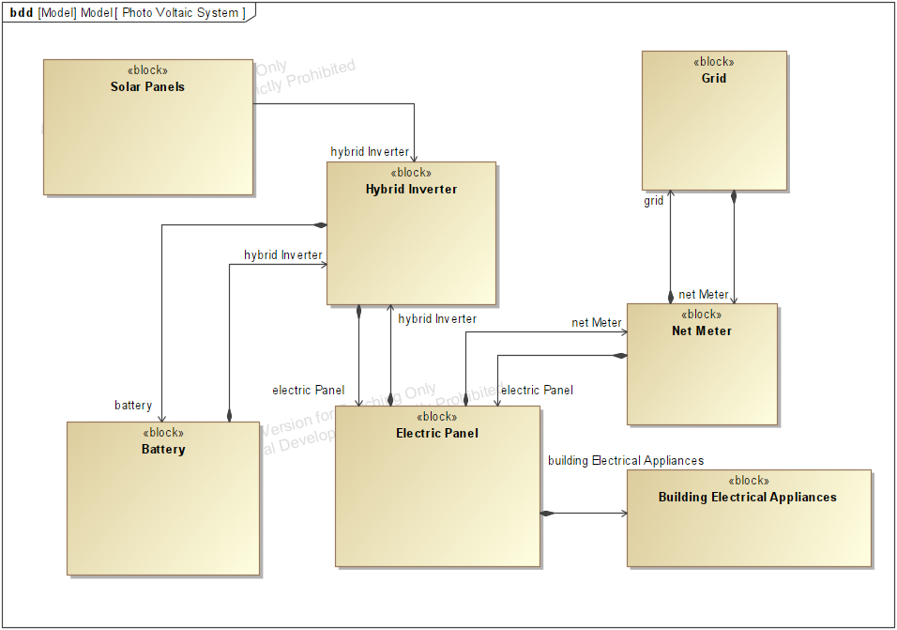

**Figure 4.4.1-4:** PhotoVoltaic Electrical On-Grid System (BDD)

With 1kW generated from the panels, the assumption will be that the electrical light source will be secondary and will run less than 50% capacity or as needed, since the primary light source will be natural light from the windows. The Modular team performed a solar analysis to optimize the position of the building and to maximize the amount of natural light projected into the buildings. Additionally, for the natural light source, it is recommended to utilize solar tubes installed on the roof in order to further achieve the LBC energy objective. This further achieves the goals for the energy efficiency, carbon neutrality and net zero of this building. The bulbs will last longer as a result, which has its own intrinsic value that lends to further carbon neutrality compared to other buildings in the area.

Using an online PV battery calculator7, for a 1kW PV system, the estimated capacity for a lithium ion battery is 110Ah (Amp-hours) at 12 volts. The battery included in the kit is more than adequate with a capacity of 200Ah, to run critical power needs in the event of a full power outage.

In order to increase energy efficiency and lower energy consumption, occupancy sensors and timers are strongly recommended to be installed to aid energy reduction. The benefit of occupancy sensors would be added to each room to control the lights and/or the fans when the rooms are not occupied during recess and after-school hours. Dusk to dawn timers would be extremely helpful with outdoor lighting such that lights are operational only for their intended need. This reduces energy consumption and lends to satisfying LBC challenge reduction of energy use overall.

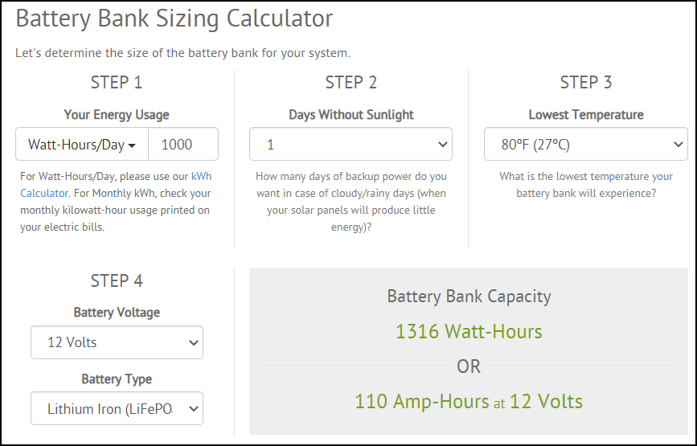

**Figure 4.4.1-5:** PV Lithium Ion Battery Sizing Calculator7

The geographical coordinates of the Sunsari District in Nepal is around 26.6276°N 87.1822°E. For optimal energy production, the position of the solar panels must be between 30 to 45 degrees facing south, where 30 degrees is preferred for these geographical coordinates. Depending on installation restrictions, it is recommended to space out the 4 panels. The suggested location of the panels is seen in Figure 4.4.1-6, illustrated in blue.

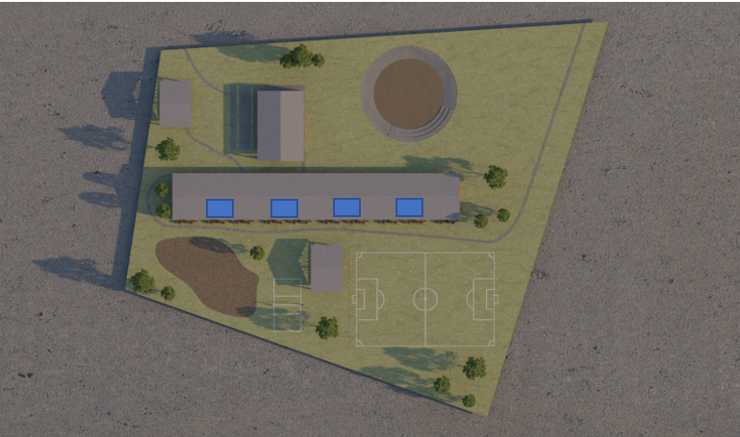

**Figure 4.4.1-6:** Suggested solar panel location (Option 1)

Depending on the installation requirements of the panel, if the panels are required to be in-line with one another, a suitable location is centrally located on the building, shown in Figure 4.4.1-7.

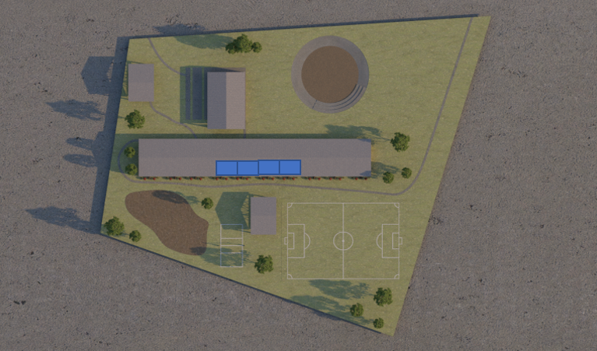

**Figure 4.4.1-7:** Suggested solar panel location (Option 2)

Since the optimal angle for the panels is 30 degrees, installation hardware will have to accommodate any differences that exist with the roof. For example, an 18 degree roof angle will require an additional 12 degree lift of the PV panels during installation.

### 4.4.2 Network Analysis for Nepal School and Future Computer Lab

The Internet and networking is important to keep the school connected to information. Cellular internet services providers (ISP) are very common in the Nepal area. NCELL for example is one of the most popular and economical choices. Notianal location of the cellular modem will be in a centralized location of the school, the teacher’s room, which also serves as an administration area or in the library/computer lab. A wired backbone connection from the modem/router is preferred due to the density of the walls causing interference with the wifi reflections and penetration of the signal. A network diagram of connections is shown in Figure 4.4.2-1. Some modems include features like firewall, wifi, and routing capability. This is preferred from an economical perspective, and a power perspective since one device will draw less power over multiple devices.

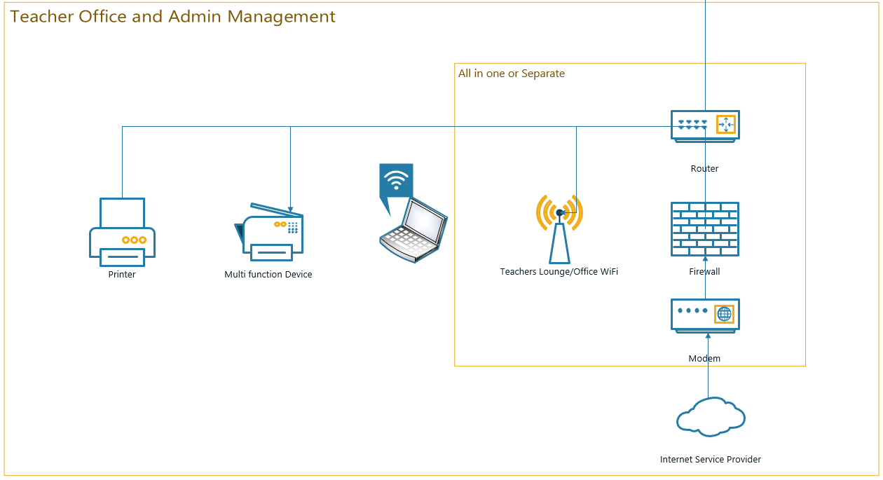

**Figure 4.4.2-1:** School Internet Network Diagram 1

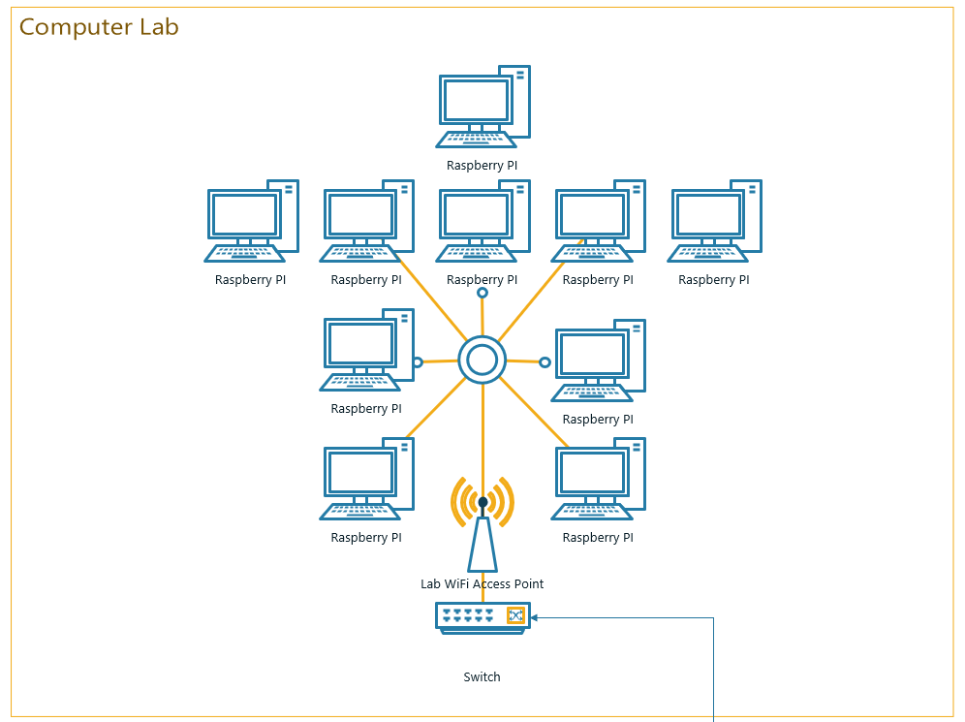

**Figure 4.4.2-2:** School Internet Network Diagram 2

As mentioned, due to the wall construction, wifi mesh repeaters with a wired back-haul are recommended to be used in any area the internet is to be extended to. Wireless mesh technology is simple to set up and doesn't require extensive knowledge of setting up wifi repeaters. They also seamlessly cover and transfer devices without interruptions when the devices are moving around. For spots with low wifi signal, a general diagram of a back-haul connection with connected wireless mesh access points is shown in the diagram in Figure 4.4.2-3.

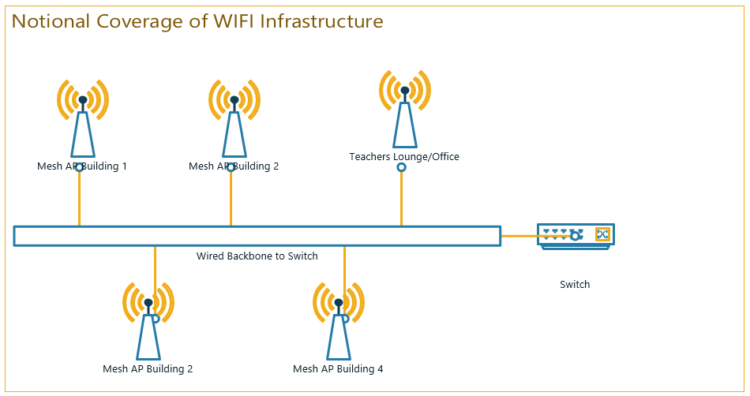

**Figure 4.4.2-4:** Notional Coverage of Wifi Infrastructure

## 4.5 Health and Happiness Petal

The purpose of the Health and Happiness petal is to incorporate nature within the building design in order to encourage healthy air and light and an environment for optimal productivity and health. This is very important for a school environment to maximize productivity and health since it is a place where children spend a large portion of their day.

The first focus of the Health and Happiness petal is compliance with the current version of American Society of Heating, Refrigerating, and Air-Conditioning Engineers (ASHRAE) 62 standard or international equivalent. This standard prohibits smoking inside any buildings or within 25 feet of any building opening, effective exhaust and ventilation, and the development of a Healthy Indoor Environment Plan (HIEP). This plan at minimum covers cleaning protocols, particulate prevention, indoor air quality strategies, and occupant health improvement. To address this focus, the team will implement smoke prohibition, walk-off rugs near entrances that have to be cleaned according to a schedule, shoe racks, and develop a Healthy Indoor Environmental Plan in the future. This project ensures proper ventilation via. fans, windows, and roof slits.

The second focus of the Health and Happiness petal is that the building shall provide outdoor views and allow for natural sunlight to penetrate 75% of regularly occupied spaces. The team has conducted solar analysis and simulation to ensure that all areas of the building have the required amount of sunlight.

The third focus of the Health and Happiness petal is access to nature. The building occupants need to be able to have opportunities to interact with nature inside and outside of the building. The center of the UWS school has a large courtyard. Selected plants are planned to be strategically planted in the courtyard to create a natural environment. Informational signage about native plants will be designed and placed in front of the corresponding plants in an effort to add an educational component to the courtyard. Additionally, benches and pathways will also be included in the courtyard for a user-friendly experience. There will also be a playground, learning garden, and agriculture section in the outdoor landscape to provide synergy between indoor and outdoor learning environments.

Indoor spaces will also have solar tubes and large windows that connect to the roof to ensure that occupants have access to views of the outside and natural light throughout the day to satisfy the related requirements. The team has also already conducted solar analysis of different layouts in order to select the best design to satisfy the requirements regarding natural light. The halls will incorporate multiple green walls to freshen the air and improve the natural feel inside the building. There will be indoor lounges that will be flexible spaces where students may spend time doing work, spending time with friends, eating, or relaxing. Similarly there will be outdoor seating where students can eat or study outside in direct sunlight. The furniture has been selected such that the benches and desks can be arranged in a U-shaped pattern to encourage collaboration and awareness.

**3.3.1.5 Materials Petal**

The main goal of the Materials Petal is to provide principles to guide in material selection such that the project’s materials have no negative impact on humans and the environmental ecosystem. Building materials are known to have many adverse environmental effects such as personal illness, pollution, and resource depletion. The project team must be vigilant about the materials chosen for the Nepal school building to avoid these negative consequences of material on the community. This petal is broken up into the following five imperatives: Responsible Materials, Red List Materials, Living Economy Sourcing, Responsible Sourcing, and Net Positive Waste. The Responsible Materials Imperative is an overarching framework that encompasses principles found in the other four imperatives, hence this imperative will not be documented. The four main imperatives are broken down in the sections below.

### 4.5.1 Red List Materials

The Red List Materials Imperative is used to reduce toxins and harmful chemicals from the material selection of a project. It is recommended by the LBC that 90% of new material by cost does not include any Red List Material items. A list of Red List Materials is shown below.

• Antimicrobials (marketed with a health claim)

• Alkylphenols and related compounds

• Asbestos compounds

• Bisphenol A (BPA) and structural analogues

• California-banned solvents

• Chlorinated Polymers, including:

• Chlorinated polyethylene (CPE)

• Chlorinated polyvinyl chloride (CPVC)

• Chloroprene (neoprene monomer)

• Chlorosulfonated polyethylene (CSPE)

• Polyvinylidene chloride (PVDC)

• Polyvinyl chloride (PVC)

• Chlorobenzenes

• Chlorofluorocarbons (CFC) and hydrochlorofluorocarbons (HCFC)

• Formaldehyde (added)

• Monomeric, polymeric and organophosphate halogenated flame retardants (HFRs)

• Organotin Compounds

• Perfluorinated compounds (PFCs)

• Phthalates (orthophthalates)

• Polychlorinated biphenyls (PCBs)

• Polycyclic aromatic hydrocarbons (PAHs)

• Short-chain and medium-chain chlorinated paraffins

• Toxic heavy metals

• Arsenic

• Cadmium

• Chromium

• Lead (added)

• Mercury

• Volatile organic compounds (VOC) (wet-applied products)

• Wood Treatments containing creosote or pentachlorophenol

One naturally available material in Nepal is bamboo. It is important that if selected, the bamboo is not treated with any of the red list materials. Treatment processes for bamboo often include Boric acid or Borax which were not identified on the LBC Red List.

### 4.5.2 Living Economy Sourcing

The goal of the living economy sourcing imperative is to support local communities and businesses and minimize transportation impacts. The project must contribute to the expansion of the local economy; 20% or more of the materials construction budget must come from within 500 kilometers of the construction site, 30% must come from within 1000 kilometers of the construction site, and 25% of materials must come from within 5000 kilometers of the construction site.

With 75% of material having a restriction on geographic origin, this further emphasized the idea to use locally sourced bamboo as a main construction material. Another idea for locally sourced construction material is to use sun-dried brick shear walls as this material is strong and provides a good thermal barrier for buildings. Through some research, it was found that bamboo was a very versatile material that was used in many different aspects for projects of similar nature, see Figure 4.5.2-1 for an example of bamboo architecture at a schoolhouse in the Philippines, which was found to hold up through tough storm winds.

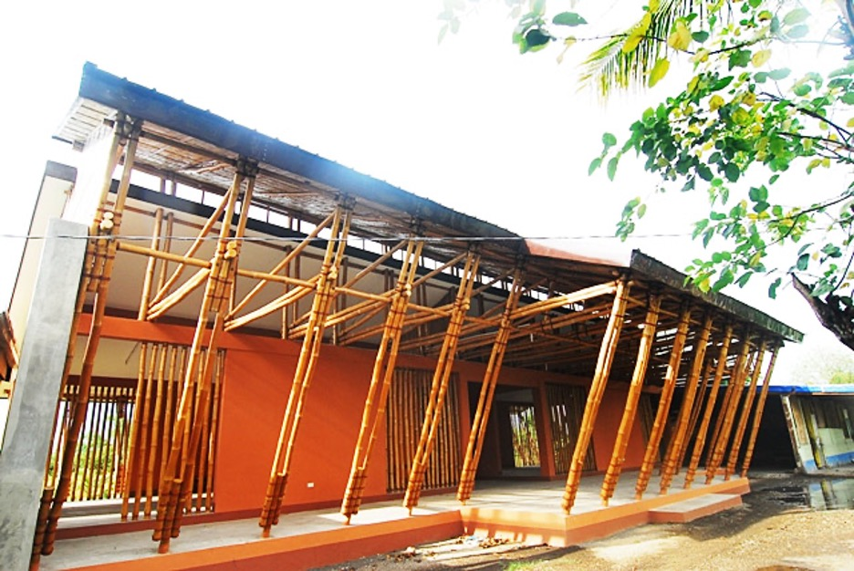

**Figure 4.5.2-1:** Bamboo schoolhouse in the Philippines

### 4.5.3 Responsible Sourcing

The goal of this imperative is to support sustainable extraction of materials and transparent labeling of products. The project must advocate for fair labor practices for extraction of rock, metal, minerals, and timber. The project must either source 80% of all wood as Forest Stewardship Council (FSC) certified or as salvaged. The remaining 20% of wood must be from low-risk sources. Alternatively, the project may achieve FSC project certification.

Upon research of FSC certified timber in Nepal, it was found that there is no current certification for timber in Nepal due to lack of demand. However, Nepal community forests have an approved forest operations plan where an annual allowable harvesting quantity of forest products is conducted. These community forest programs perform harvesting of wood in a sustainable manner and the project will consider sourcing timber from these community forests.

### 4.5.4 Net Positive Waste

The goal of this imperative is to integrate waste reduction into all phases of the project and to encourage imaginative reuse of salvaged waste materials. The project must try to eliminate the production of waste during all phases of the project and find ways to integrate waste back into the design. The project must feature at least one salvaged material per 500 square meters of gross building area. The project must divert waste from the landfill according to the levels in Figure 4.5.4-1.

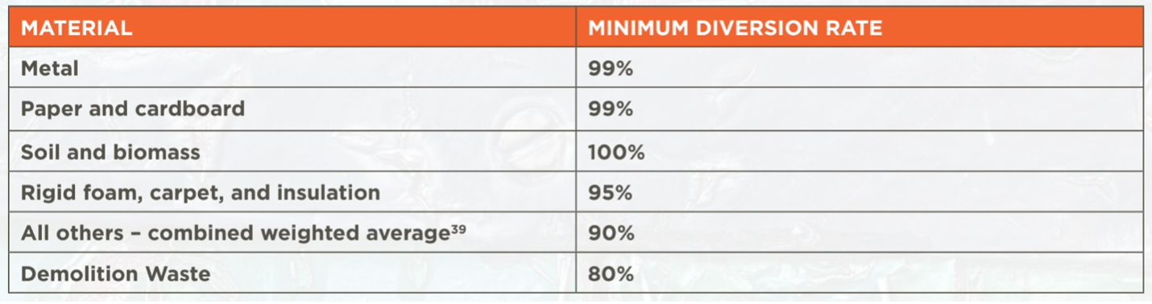

**Figure 4.5.4-1:** Minimum diversion rate of materials (LBC)

One thought is to salvage scrap material to make into either furniture or art pieces around the building. Containers, transportation materials, and scrap wood are all good waste products that can be manipulated into new pieces. The project team will have to be cognizant of the amount of material bought and the amount of waste produced and be creative with scrap material in order to meet this imperative.

## 4.6 Equity Petal

The definition of equity is the quality of being fair and impartial. The Equity petal has two imperatives: Universal Access and Inclusion. The Universal Access imperative is required to ensure equitable access to all members of the community. In order to provide equitable access to the school, the design incorporates entrances that allow for different forms of transportation, whether that be walking, biking, or automobiles. For any travel scenario, the school can accommodate, shown in Figure 4.6-1. Further, this design does not include stairways or elevators to ensure that it is wheelchair friendly. While this situation may be in the minority, the school was designed considering anyone with a possible disability. These requirements meet the standards of the Principles of Universal design (United States Access Board), the Americans with Disabilities Act (ADA), and the Architectural Barriers Act (ABA) Accessibility Guidelines, or international equivalents. In addition, the school is designed in a way to not block access to fresh air and sunlight. The design takes advantage of numerous outdoor courtyards as well as outdoor walkways to allow an abundance of opportunities for fresh air to flow. Furthermore, each classroom and indoor facility incorporates strategically placed windows to take full advantage of natural sunlight to not only reduce electricity needs, but also leverage natural heating in cooler months. While these are just a few examples of Universal Access incorporated into the design, this ideology was consistent throughout the rest of the mock up.

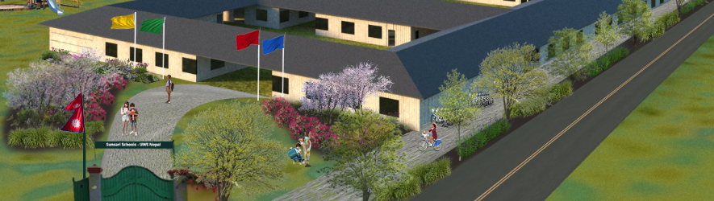**Figure 4.6-1**: Entrance to the school that allows for commuters that are walking, biking or driving equal access to the school

Inclusion is another important imperative that needs to be satisfied for the Equity petal per LBC guidelines. The goal of Inclusion is to help provide fair and competitive job opportunities for people in local communities as well as promoting diverse businesses. One way the design promotes diverse business is through the use of diverse stakeholders. Throughout the design process numerous different stakeholders/users were interviewed, so that a fair representation of the community was taken into consideration before entering the design phase. These stakeholders ranged from young to old, male to female, and from various areas within the community. The use of diverse stakeholders not only allows for a variety of different requirements to come to light, but also will promote a diverse business down the line. The uniqueness of stakeholders prevents the design from being targeted and only beneficial for specific members. . While this is one example of Inclusion being incorporated, a number of other requirements have proven to be challenging to satisfy from a cultural and societal perspective during the design and construction phases. Examples include obtaining a JUST label, gender neutral restrooms, and 0.1% total project cost donation to a local non-profit that focuses on equity and inclusion. While restrooms were put under immense scrutiny during the design phase for the different sizes of the students and the different toilet sizes, gender neutral bathrooms were unable to be accomplished. The rest of the requirements fall into a similar boat.

The Equity Petal played a huge role in the design process of the school. Ensuring access to all types of people and community members was extremely important because this is a place where everyone should be welcome. A place where everyone can be treated equally. While few requirements proved to be challenging to meet, a majority of this petal can be checked off as being satisfied as there have been a number of design elements that have gone into the school that make it fair and impartial to the people of the community.

## 4.7 Beauty Petal

As one of seven petals of the LBC, the Beauty Petal contains two imperatives, Beauty + Biophilia and Education + Inspiration. Branching from these two imperatives are five design branches: design, meeting, open day, education, and design expert. With no design limitations, the beauty petal favors a biophilic design that: embraces natural shapes and patterns, environmental features, public art, light, and space and incorporates a number of ways people interact with nature.

Since the intent of the Beauty Petal is to recognize the beauty in connecting to nature, The team performed research and identified different ways the natives of the Sunsari District and nearby districts spend time with nature. Approximately 66% of the population of Nepal engages in agriculture (FAO, 2022). Known for staple food crops such as rice, wheat, and corn, the team has designated a portion of the school grounds for agricultural activities. The Place Petal calls for urban agriculture with a portion of the land dedicated to growing food. To satisfy these requirements, learning gardens containing agricultural vegetation along with other native plants and trees will be placed throughout the landscape, surrounding the main entrance housing the flag poles, all three courtyards, playground, learning gardens, classrooms, bike parking, and walking paths. The plan is to plant seasonal cultural vegetation and store them on- site once harvested.

To alleviate the effects of flooding on the area, the team performed research on vegetation that satisfies the requirements of the beauty + biophilia imperative. Vegetation research focused on plants and trees that help mitigate flooding of the area. Vegetation will be placed throughout the school grounds to encourage human interaction with nature. Aware of the soil constraints within the District, alternatives will be put in place to mitigate these issues.

In addition to planting vegetation for site beautification, the Community and Empathy Design team plans on incorporating murals and creative spaces with art designed by students by utilizing classrooms and hallways. The murals and creative spaces will satisfy the public art requirement of the beauty petal. These murals and creative spaces which will be accessible to the public, will highlight and celebrate the culture of the people of the Sunsari District.

Signage will be placed throughout the landscape to align with the Education + Inspiration imperative . Each plant planted throughout the school grounds will have signage to educate its occupants and visitors. The signage will serve as an educational tool, defining each plant or tree planted throughout the landscape.

The overall structure of the landscape allows for the school to serve as a place for community gatherings when school is not in session. With 3 courtyards on the interior of the landscape, the Open Day Event branch of the Education + Inspiration will be satisfied, allowing an ample amount of room for gathering. With the current landscape design, Open Day community events such as the Dashain and Tihar festivals will be able to take place.

All information detailed in this section will be documented in a Framework and Plan along with additional information as the project progresses for future reference for occupants and visitors who are on-site during operation to utilize as reference.

# 

# 5. Conclusion

## 5.1 Project Management Office

Many systems engineering team members will be returning to continue the work with the CUSD team and, specifically, the UWS Nepal Sunsari School project. New leaders will rise from the current team, and current leaders will be available in some capacity as an advisor. Given this, the team is focused on ensuring project sustainability and will be recruiting new team members through handouts, advertisements, club fairs, and other means. Additionally, the team would like to expand the working relationship with TetraTech and reach out to other consulting firms.

The CUSD team would like to explore the possibility to travel to Nepal and have an immersive experience. This would be beneficial for understanding the requirements and resources available. Also, the team would be able to do more than just a survey for empathy fieldwork and actually observe the student, facility, and staff in their day-to-day life. Another opportunity to explore is presenting in-person to UWS. This would be beneficial for the team's involvement in CUSD, Cornell’s publicity, and for the students' experience presenting to stakeholders. Both of these initiatives would also support the team’s sustainability and continue to attract more members.

From a general management perspective, the team will continue to primarily meet via Zoom as Distance Learning (DLs) students make up the majority of the system engineering team. However, the on-campus students will meet at in-person meetings and optimize the face-to-face time. Typically for the milestone design charrettes, these are done in-person with a Zoom interface for the DLs. Microsoft Teams and Slack will continue to be used as a single location for communication, collaboration, documentation, and history tracking. As with previous semesters, the leadership team will meet ahead of the next semester to determine who the new leadership team will be, what the deliverables are for the semester, who the stakeholders are, and the general operation timeline.

## 5.2 Living Building Challenge

There are many challenges in attempting to achieve an LBC certified design. In the next semester the team will work to assess the expected compliance for each of the LBC petal requirements and determine if LBC certification is achievable. To date, none of the CUSD projects have been LBC certified due to the very high standards. A potential opportunity for the next team would be to request the LBC organization to create different tiers - gold, silver, or bronze to allow for smaller projects with less budget to also achieve LBC certification. Lastly, if UWS should decide to pursue an LBC certification for the Sunsari School project in the future, the verification artifacts listed in the verification matrices will act as a statement of work for the stakeholder.

## 5.3 Acknowledgements

The team would like to thank:

* Sirietta Simoncini, our advisor, for her weekly support and guidance on architecture.
* Manjeet Raj Pandey for his bi-weekly stakeholder meetings and support.
* Sean O’Brien of Tetra Tech for his architectural and design guidance.

# 6. Appendix

## Appendix A. Annual Climate Conditions Chart in Nepal

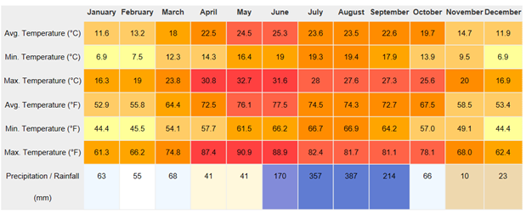

## 

## Appendix B. Living Building Challenge Requirements

### Place Petal

The Place Petal focuses on realigning the current way humanity engages with and understands the natural world. It encourages communities to recognize the unique features of their homes, and to seamlessly integrate them with the environment without causing any negative impacts. This petal has four core imperatives; Ecology of Place, Habitat Exchange, Human-Scaled Living, and Urban Agriculture.

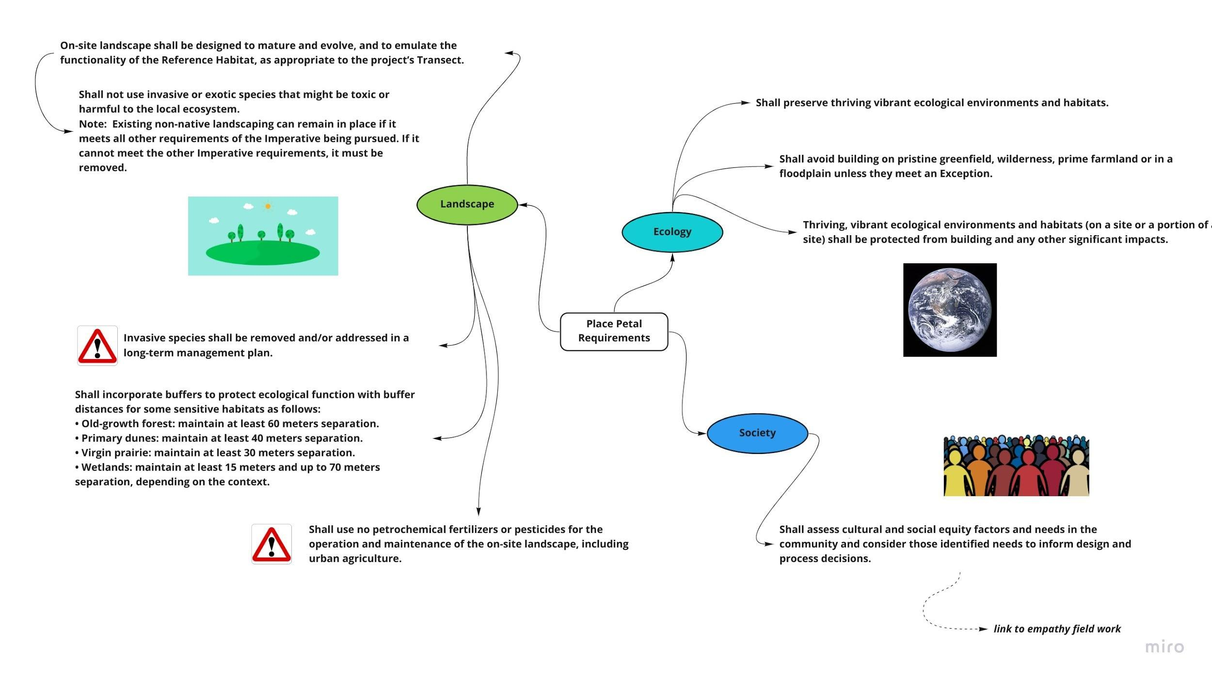

**Figure B-1:** Place Petal- Ecology of Place Requirements

Ecology of Place centers on protecting nature, encouraging ecological restoration, and making communities where projects are built more functional. The Ecology of Place is broken down further into three subcategories; Landscape, Ecology, and Society. The requirements related to these three sub categories that are derived from the LBC are shown in Figure B-1.

The second pillar, Habitat Exchange, aims to make sure the land is protected for animals and other species, as humans continue to expand their cities and towns. The LBC derived requirements are shown below in Figure B-2, branching from the Habitat node.

The third pillar, Human-Scale Living, focuses on guiding communities to be more walkable and (if needed) vehicles will not utilize fossil fuels but instead be all electric. The LBC derived requirements can also be shown below in Figure B-2, off of the Site node.

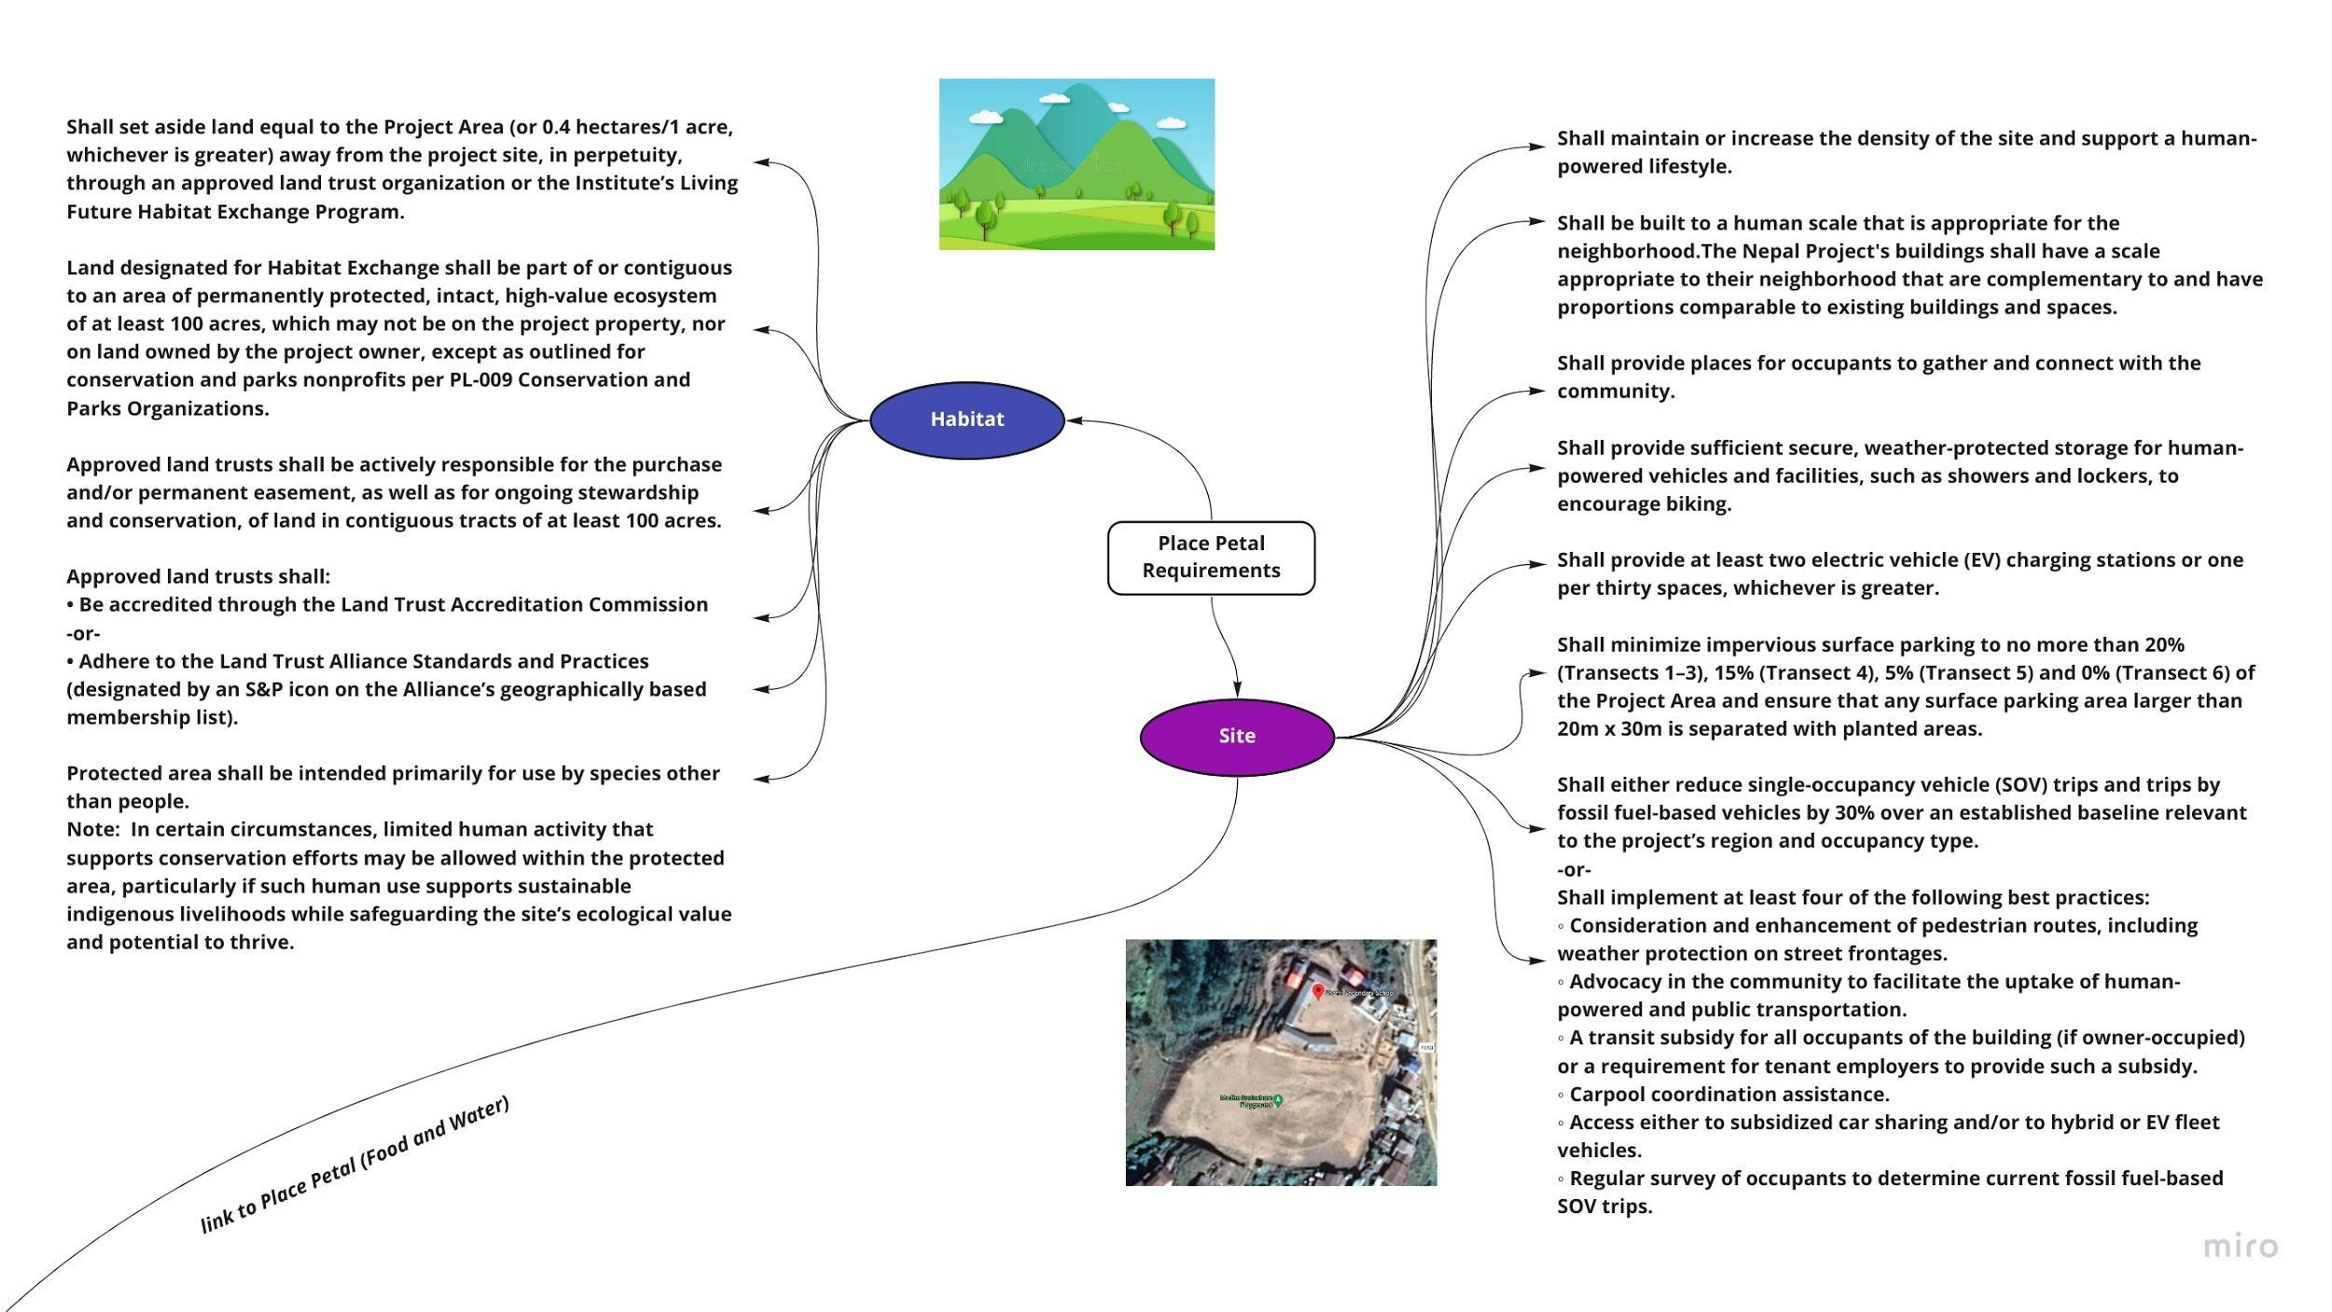

**Figure B-2:** Place Petal- Habitat Exchange + Human-Scaled Living Requirements

Finally, the fourth pillar, Urban Agriculture, emphasizes the need to connect the community with locally sourced fresh food. The LBC derived requirements can be viewed extending from the Food node below in Figure B-3. Water is very closely related to the parameters within the Place Petal but impacts so many areas of life that it makes up its own petal. Further information on water can be found in the next section.

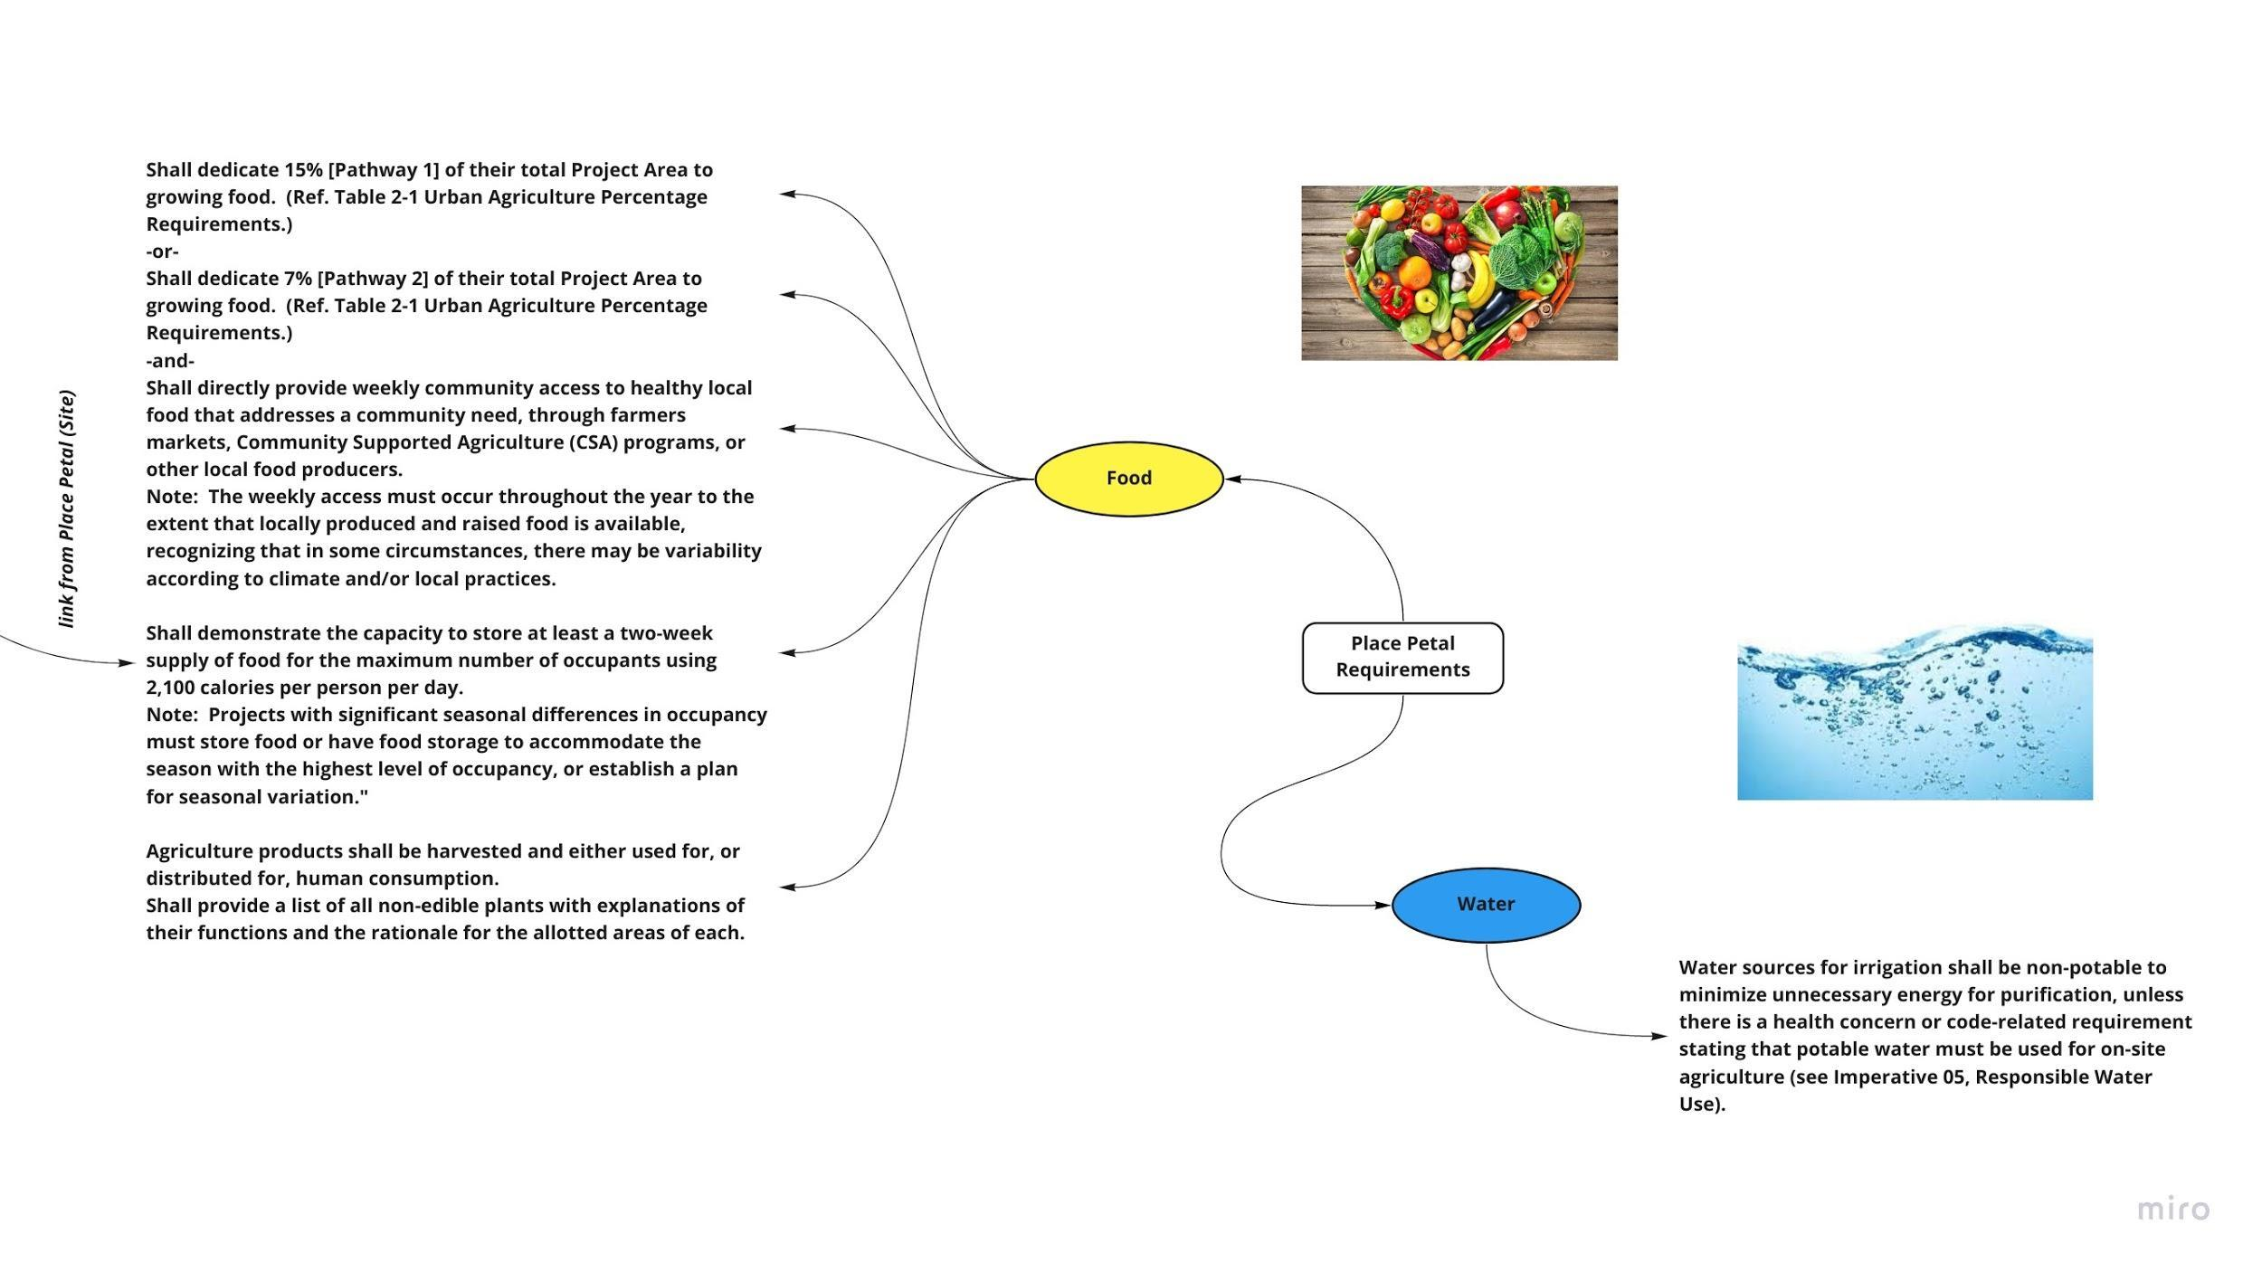

**Figure B-3:** Place Petal- Urban Agriculture Requirements

### Water Petal

The water petal consists of two imperatives: responsible water use and net positive water. Responsible water use, ensuring the system uses water properly, and net positive water is a holistic way to look at the water system from its water source, utilization, impact and return to another water source. These two imperatives focus on sustainability and completing the Living Building Challenge.

The requirements for the water petal are grouped into four categories: baseline preparation, non-potable water, water treatment, and code/standard. Figure B-4 illustrates how the requirements are divided into those four categories.

The four water categories are code/standard, non-potable water, water treatment, and baseline preparation. The code/standard ensures that water requirements follow proper local water usage protocols and protection of the environment. The baseline preparation is the starting point to establish potable water use. The water treatment focuses on filtering and reusing water sustainably. Lastly, the non-potable water section is focused on water usage that does not require filtration for toilet flushing and landscape irrigation.

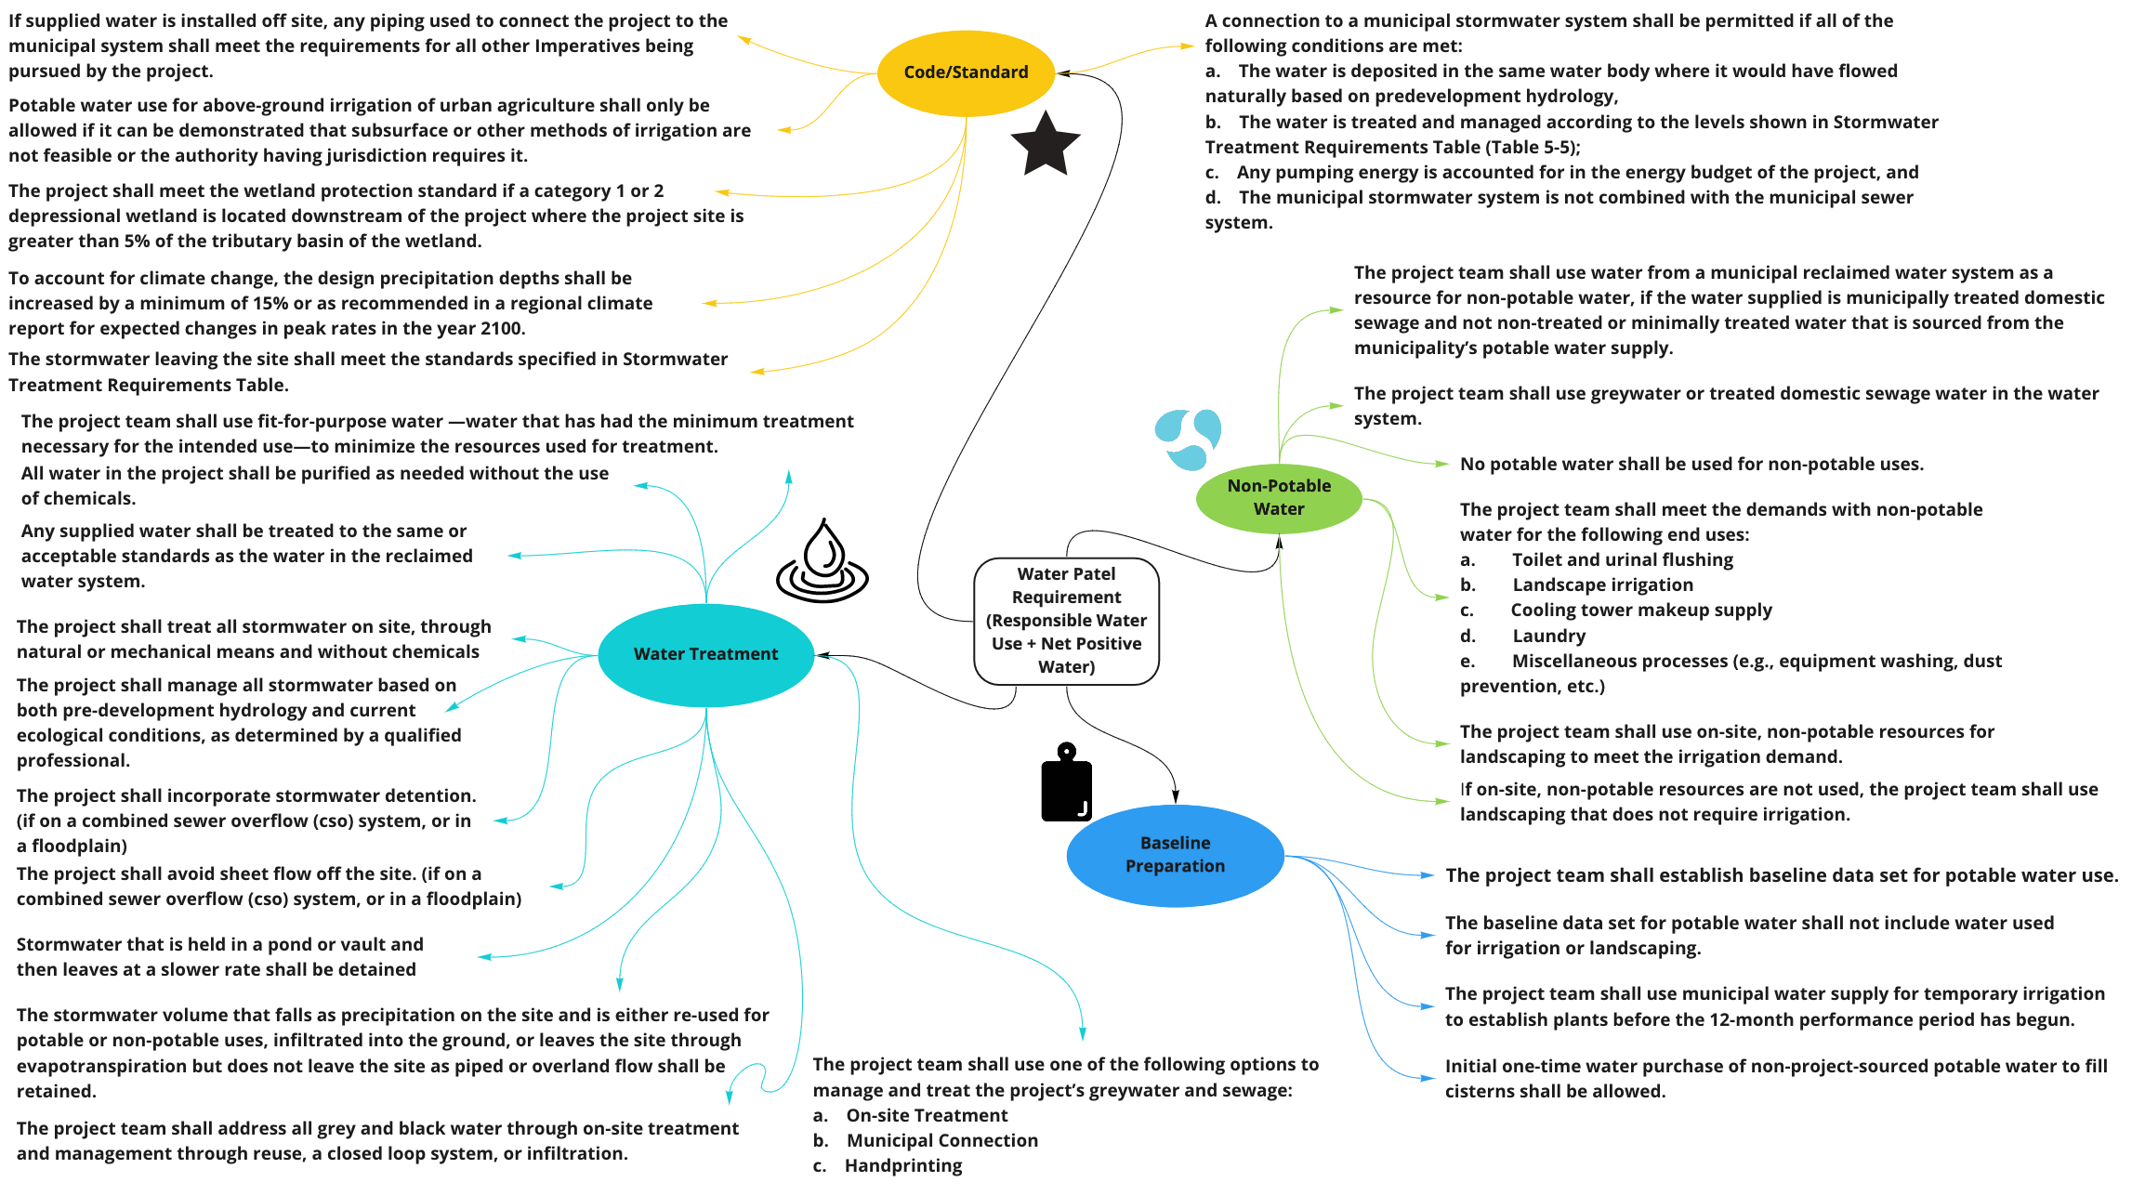

**Figure B-4:** Water Petal - Water Requirements

### Energy Petal

Carbon Reduction and Net Positive Carbon are the two Energy petal imperatives the team is focusing on. The Carbon Reduction imperative is broken into five categories: Carbon Materials, Energy Performance, Carbon Sequencing, Combustion Limits, and Renewable Energy Infrastructure. Figure B-5 shows the detailed requirements for each of those five categories.

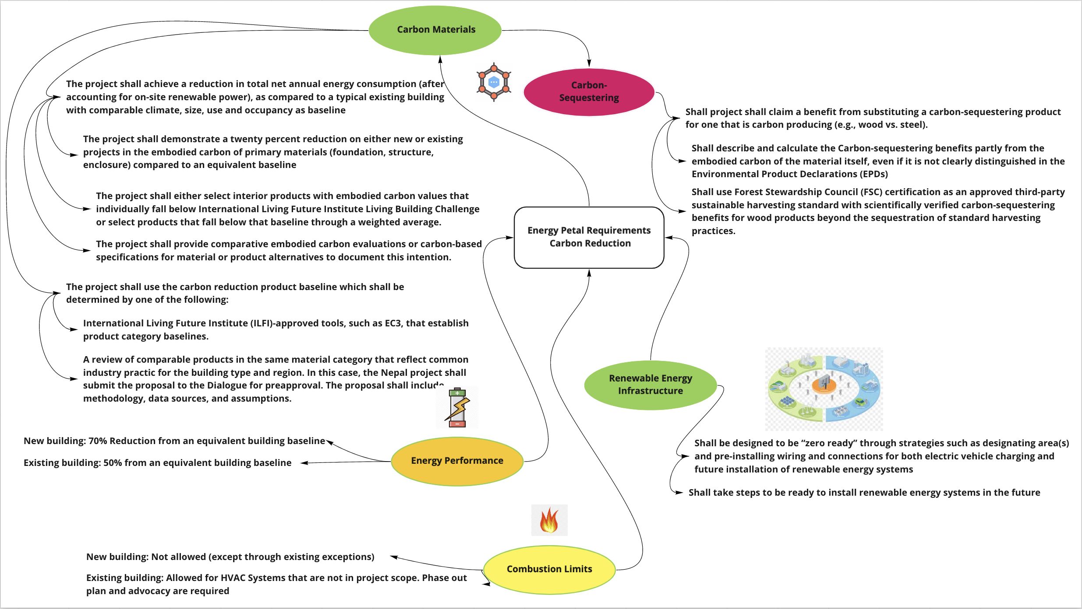

**Figure B-5:** Energy Petal Carbon Reduction Requirements

These energy petal imperatives explore strategies to implement renewable energy that will allow the project to operate year-round in a self-sustaining and pollution-free system. Figure 53 shows the requirements that aim to reduce and eliminate any CO2 emissions from unsustainable energy. In addition, the aim is to achieve material sources, resilient and sustainable power that can be developed, repaired, replaced and/or refurbished by users using locally sourced and reused resources.

Ultimately, the usage of sustainable low-energy sequestering materials, locally grown and harvested, aims to decrease the embodied energy of the buildings.

The Net Positive Carbon imperatives are grouped into three categories: Renewable Energy, Solar, and Resilience Strategy. Figure B-6 illustrates the requirements for each of these three categories for Net Positive Carbon imperatives.

The imperative of achieving carbon neutrality explores renewable energy resources and avoids the use of carbon emissive fuels and energy sources. As a result, high CO2 emissions from generators and fire burning power generating systems are not desirable. Instead, renewable energy alternatives like: passive solar, photovoltaic, solar thermal, wind, hydroelectric and other off-the-shelf systems that are locally available and maintained are the target.

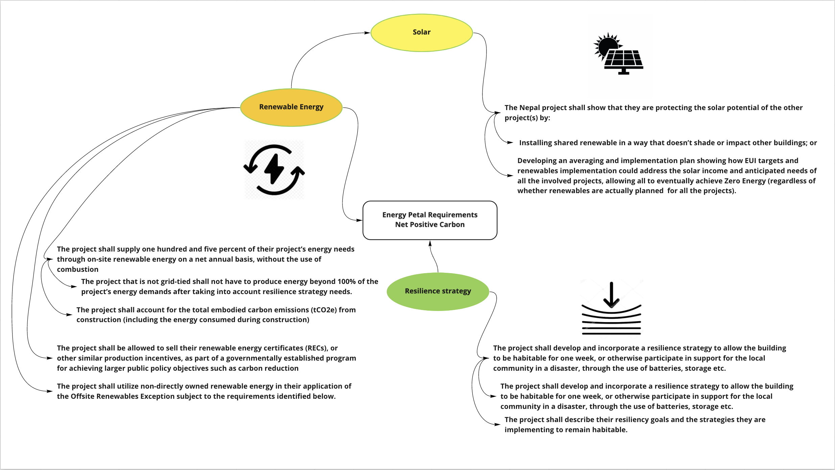

**Figure B-6:**  Energy Petal Requirements for Net Positive Carbon

### Health and Happiness Petal

The focus of the Health and Happiness petal is to create a healthy internal and external environment in which the users are connected with nature, supplied with clean and dependable air, and provided with lush access to natural light sources. The Health and Happiness petal consists of three core pillars; Healthy Interior Environment, Healthy Interior Performance, and Access to Nature.

To start, the Healthy Interior Environment pillar aims to maintain a healthy interior environment for all occupants. As shown in Figure B-7, the Healthy Interior Environment pillar consists of seven sub-categories which can be classified as Codes and Standards, User Experience, Equipment and Appliances, Airflow, Entrances, Windows, and Lighting. Each sub-category was formed to capture the overarching requirements as derived by the Living Building Challenge.

In order to meet the requirements defined by the first pillar, the system design must abide by the present ASHRAE 62 guidelines (or international equivalent), smoking shall be prohibited inside the building and within 7.62 meters of any building opening, and a Healthy Indoor Environment Plan (HIEP) will be developed to outline cleaning protocols and strategies to improve air quality.

Additionally, 75% of regularly occupied space will have views of nature and visible daylight, dirt walk-off systems will be placed at all entry points to the building, and the kitchens, bathrooms, and janitorial areas will have direct exhaust to the outside to ensure no mixing occurs with returning ventilation.

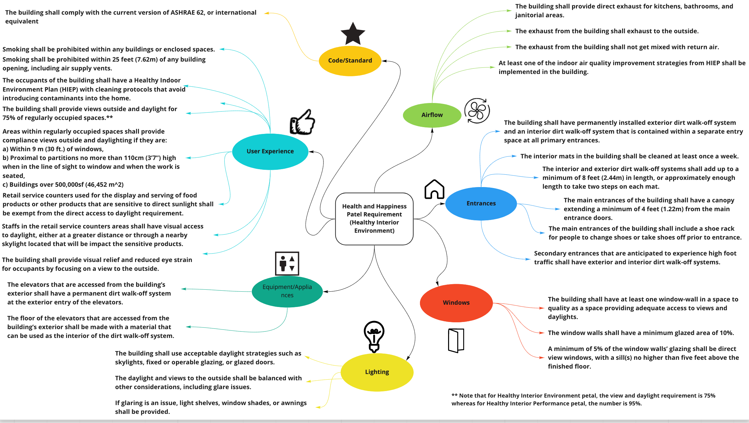

**Figure B-7:** Health and Happiness Petal Requirements - Healthy Interior Environment

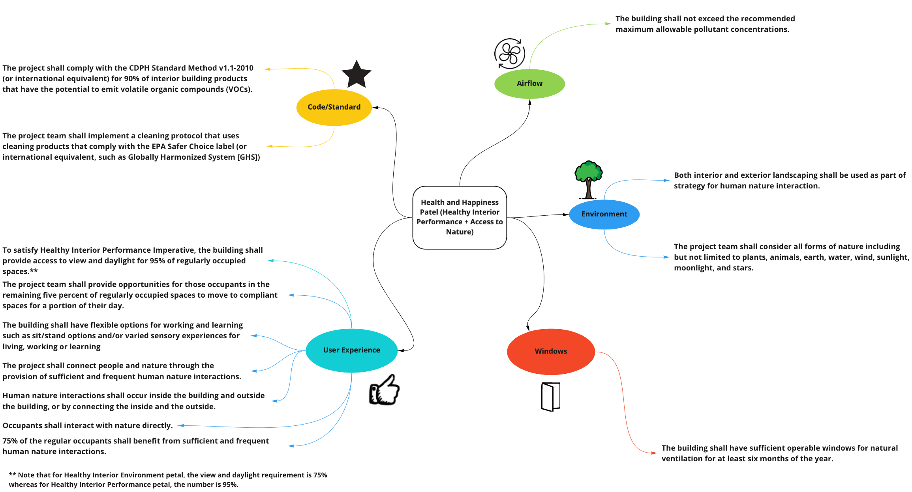

**Figure B-8:** Health & Happiness Petal - Healthy Interior Performance & Access to Nature

The remaining two pillars of the Health & Happiness petal are Healthy Interior Performance and Access to Nature. Figure B-8 above shows the five sub-groups created based on the requirements for both of these pillars; Codes and Standards, User Experience, Airflow, Environment, and Windows. The objective of the Healthy Interior Performance pillar is to exhibit continuous high-quality interior air and maintain a healthy indoor environment.

To satisfy this pillar’s requirements, an Indoor Air Quality test must be conducted and results reported after 1-6 months of initial occupancy, conform with CDPH Standard Method v1.1-2010 (or international equivalent) for 90% of interior building products that may release Volatile Organic Compounds, and select cleaning products that comply with the EPA Safer Choice label (or international equivalent).

In addition, 95% of regularly occupied spaces must permit access to the outside environment and provide sufficient daylight as well as accommodations for occupants that relocate to compliant spaces over the course of the day. The aim of the Access to Nature pillar is to support human and nature interactions. To fulfill the requirements of this pillar, the building must incorporate opportunities within the design to allow for frequent and ongoing interactions with nature from both the interior and exterior environments.

### Material Petal

The material petal aims to create a structure that is non-toxic, ecologically restorative, and transparent. The intent of this petal is to reduce many adverse effects that materials could have, such as invoking personal illness, loss of habitat or species, pollution and resource depletion. There are five key imperatives under the material petal: responsible materials, red list, responsible sourcing, living economy sourcing, and net positive waste.

The responsible material imperative sets the baseline for transparency, sustainable extraction, support of local industry and waste diversion. This imperative is superseded by information in the other four imperatives. The red list imperative provides a list of material that must be avoided in 90% of the project’s new material by cost. These items could be toxic or harmful to the environment. Figure B-9 shows the red list of materials to avoid.

The responsible sourcing imperative supports sustainable extraction of materials and transparent labeling of products. This imperative states that you must source 80% or more of all wood as Forest Stewardship Council certified, or as salvaged or harvested from the construction site for the purpose of clearing the area or restoring ecological function.

The living economy sourcing imperative supports local communities and businesses while minimizing transportation impacts. This imperative states that manufacturer location for materials must adhere to the following standards: 20% or more of materials must come from within 500 km of the construction site, 30% of material must come from within 1000 km of the construction site, 25% of material must come from within 5000 km of the construction site, and the remaining 25% of material can be sourced from any location.

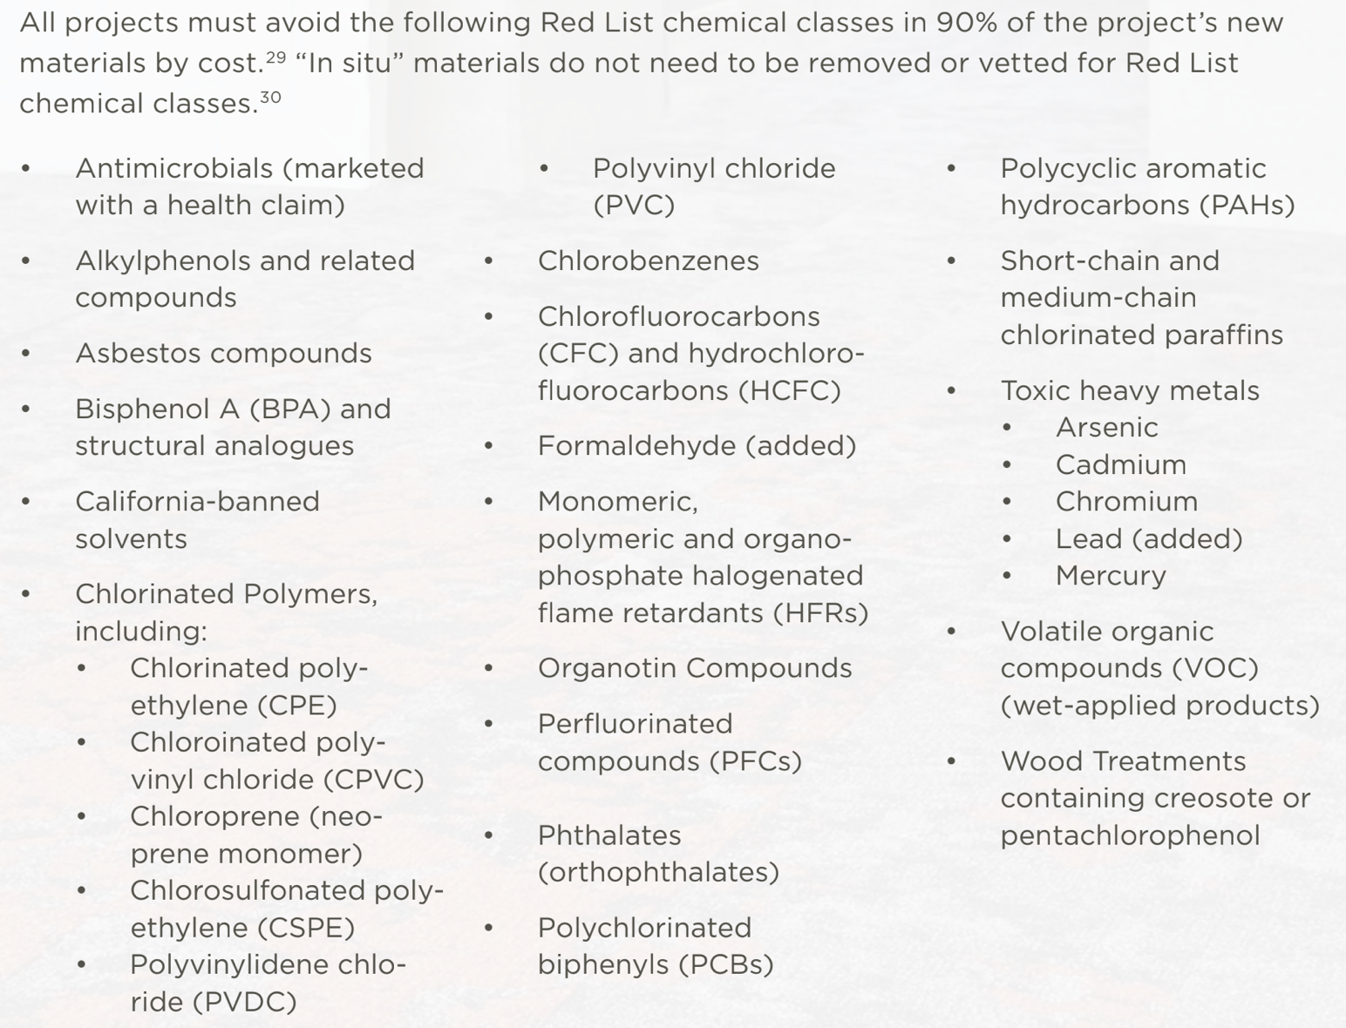

**Figure B-9:** Red List Materials

Lastly, the net positive waste imperative aims to integrate waste reduction into all phases of the project and to encourage imaginative reuse of salvaged waste materials. It states that all projects must create a Materials Conservation Management Plan that explains how the project optimizes material in each of the project stages - the design phase, the construction phase, the operation phase, and end of life. See Figure B-10 for guidelines on waste diversion.

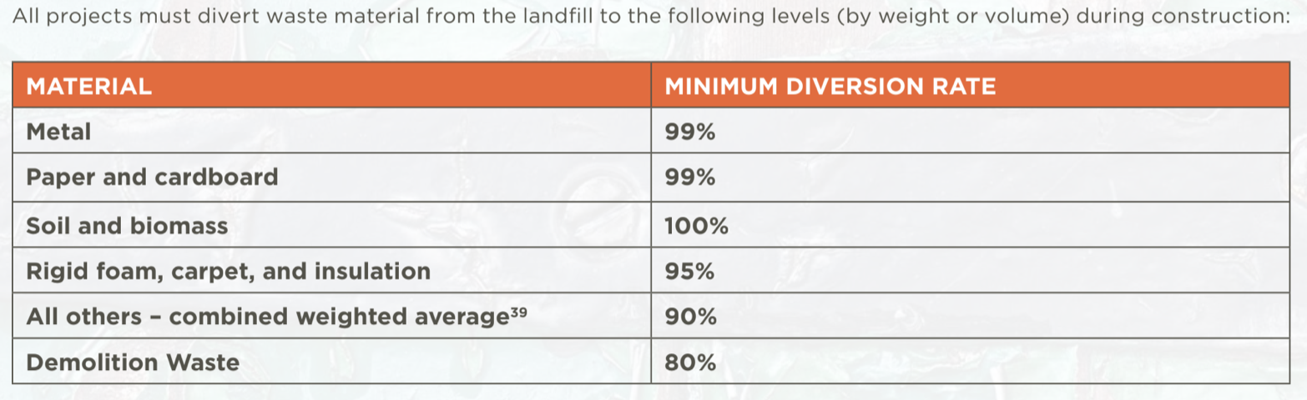

**Figure B-10:** Waste diversion percentages

### Equity Petal

The definition of equity is the quality of being fair and impartial. For this project the goal of the equity petal is to transform developments to foster a just and inclusive community that enables all people to participate, prosper, and reach their full potential. As defined by the LBC requirements, this petal is broken down into two main categories: Universal Access and Inclusion. The team broke these two categories down further to define the specifics that makeup the equity petal.

Looking at the Universal Access side of the equity petal, these requirements can be broken down into further sub categories. These are location, accessibility, and equitable access. Location revolves around making sure the project is accessible to all people regardless of age, background, and socioeconomic states. Accessibility pertains to making the project accessible to all people regardless of physical disabilities. The final category, equitable access, is focused on making sure the project uses all natural resources equally and fairly. See Figure B-11, below, for specifics on this side of the petal.

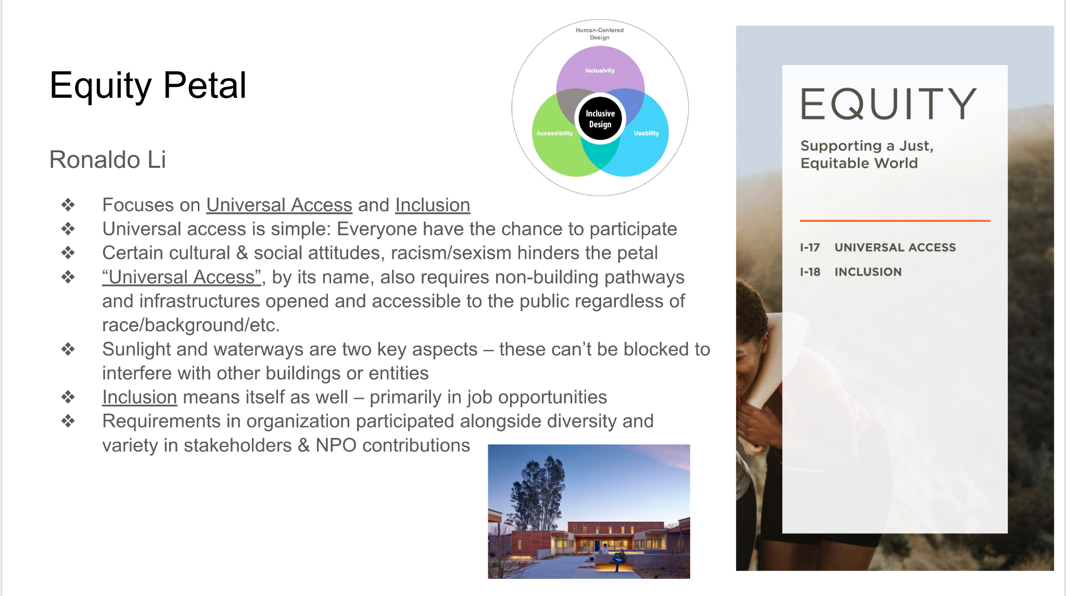

**Figure B-11:** The Universal Access Equity Petal requirements the team outlined

The Inclusion side of the equity petal was broken down into two sub-categories. These were the JUST labels and diversity. Diversity pertains to ensuring that the project considers a diverse group of stakeholders when designing and getting feedback on the implementation. The JUST label is a specific voluntary transparency program that allows teams to evaluate their social equity status. There are specific indicators outlined by the International Living Future Institute that measure accountabilities in order for organizations to be recognized at four levels of performance. These levels are summarized in a label type format, where additional information can be found at the Living Future website3. Picture it as a nutritional label, but for equity. Additional details on these requirements can be found in Figure B-12.

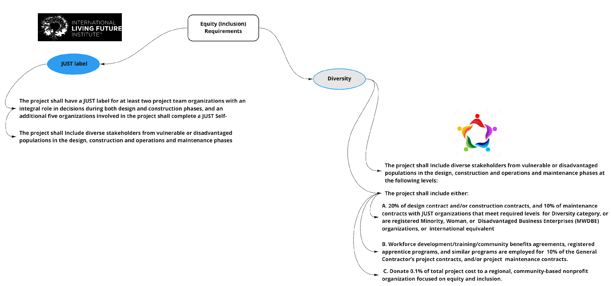

**Figure B-12:** The Inclusion Equity Petal requirements the team outlined

### Beauty Petal

The intent of the Beauty Petal is to develop a design that will educate and inspire the desire to preserve and conserve the beauty of one’s environment. Creating a design that focuses on the connectivity that people have with nature, inspires and grants joy to stakeholders who want to care for and maintain their environment. Beauty is defined as a person, place, or thing being pleasing and attractive to those observing. In an effort to preserve the beauty of one's environment, the LBC recommends utilizing a design that embraces a biophilic design, see Figure B-13.

There are no design limitations to the beauty petal. The beauty petal encourages incorporating different ways stakeholders interact with nature. By identifying ways interactions occur with nature, the beauty petal suggests incorporating said research into the biophilic aspect of the design. The incorporation of the biophilic and beauty requirement involves environmental features, natural shapes & patterns, light & space, and how humans interact with nature. Including public art that celebrates and highlights the culture and spirit of any environment is necessary to meet the beauty and biophilic requirements of the petal.

To ensure overall designs meet the requirements of the Beauty Petal, these five branches of the petal need to be met: design, education, meeting, open-day event, and design expert. In regards to the meeting branch of the beauty petal, keeping a record of the goals and design is required. According to the LBC, it is required that one full day of exploring a potential biophilic design be complete before proceeding to the next step. As a result of exploring a potential biophilic design, documenting the framework and plan that details the approach that will be used to achieve the goals within the plan, and how those goals will be implemented is necessary. The biophilic framework and plan shall document how the six elements relating to keeping record of the biophilic plan throughout the duration of the project found in the LBC 4.0 handbook shall be addressed.

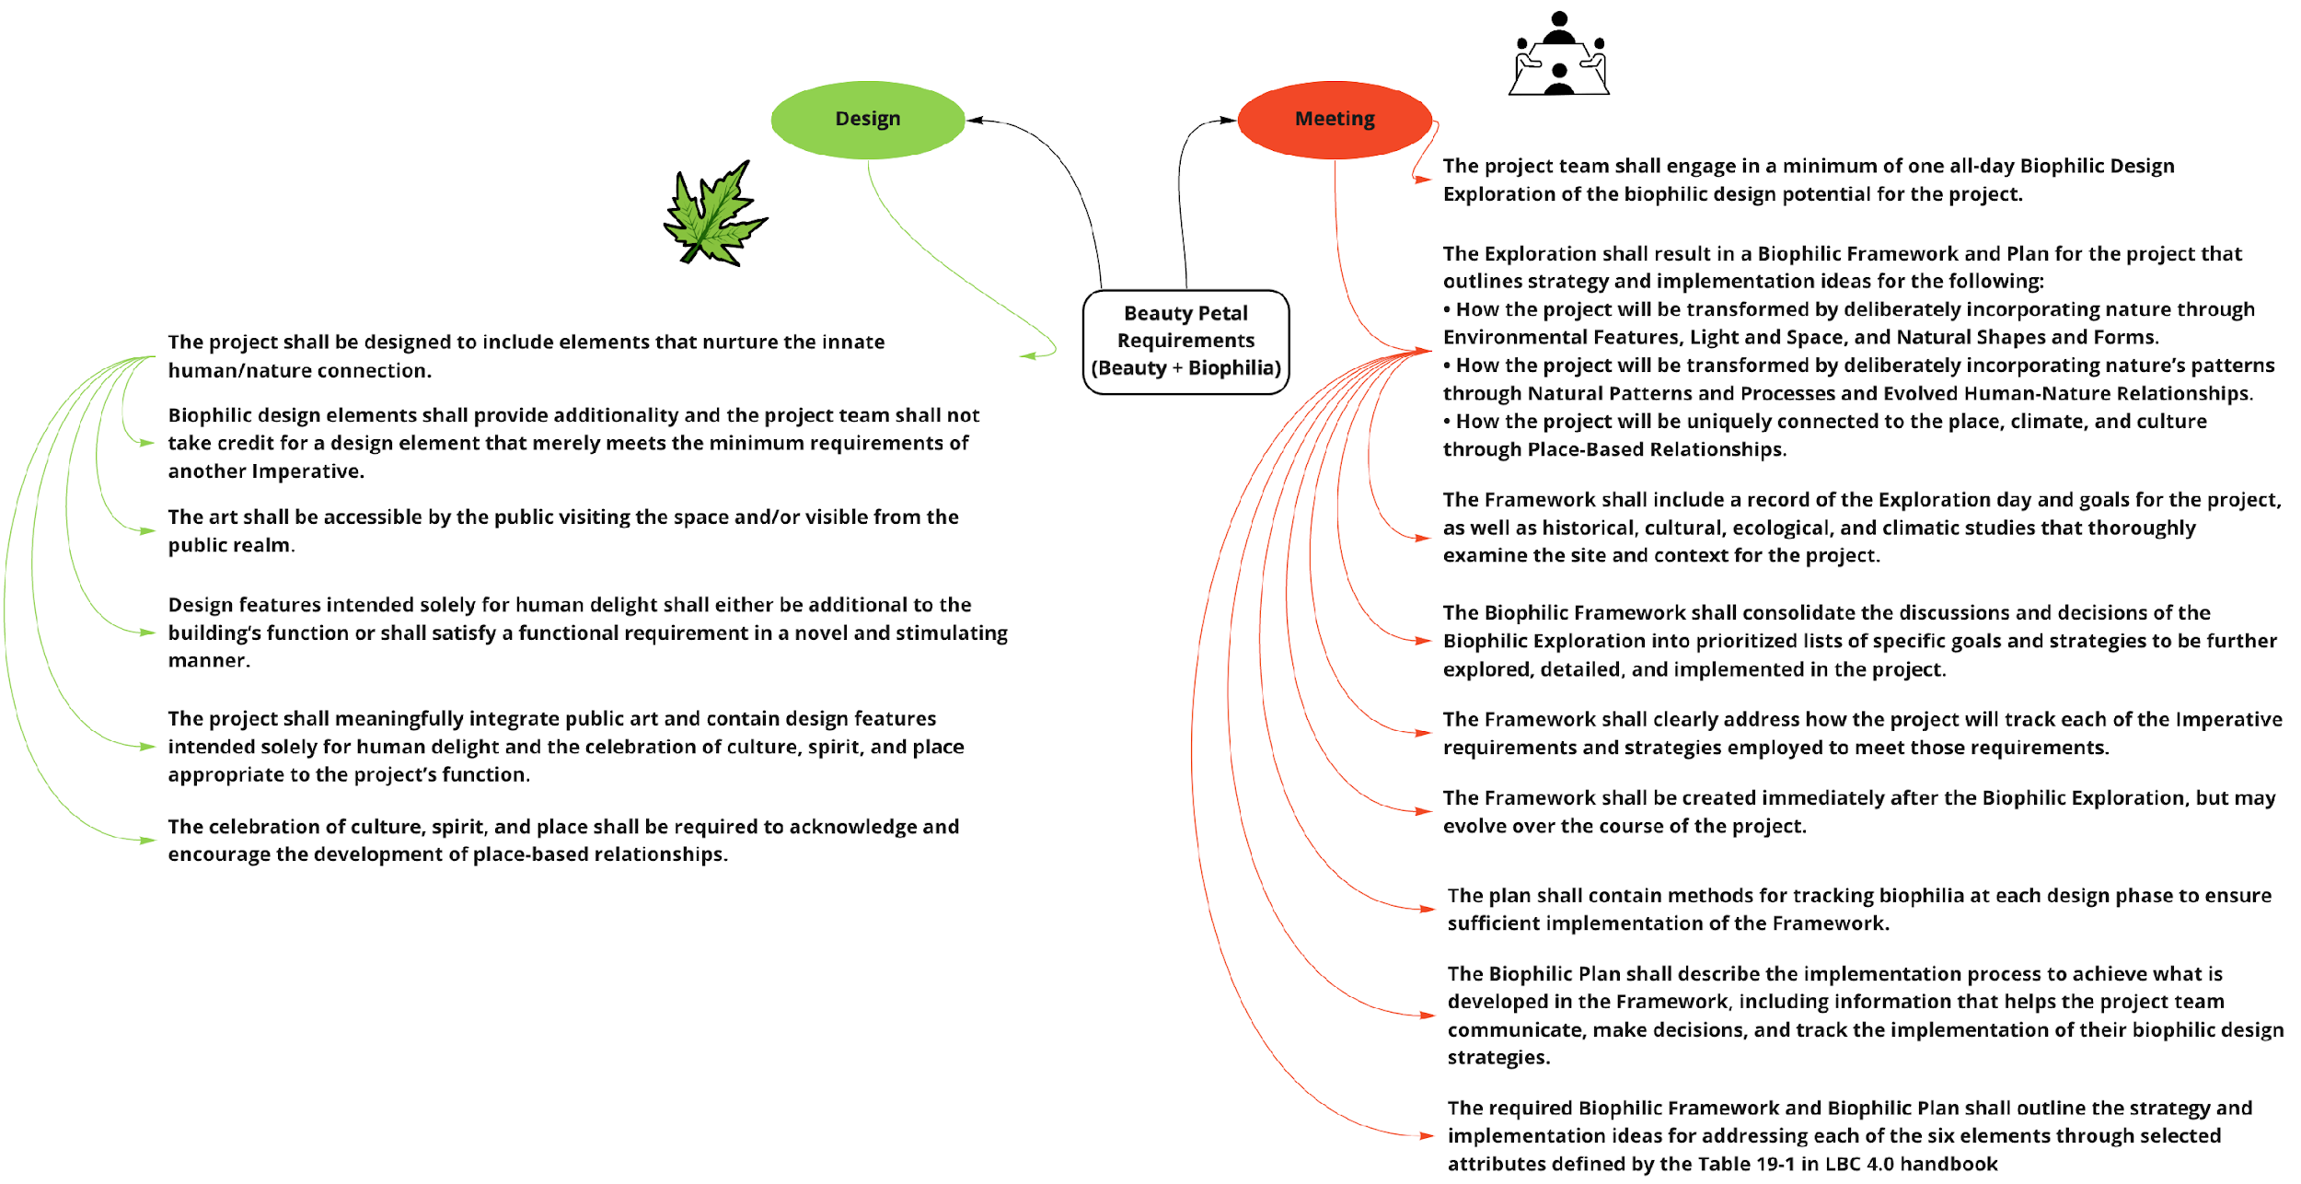

**Figure B-13:** The design and meeting branches of the Beauty Petal

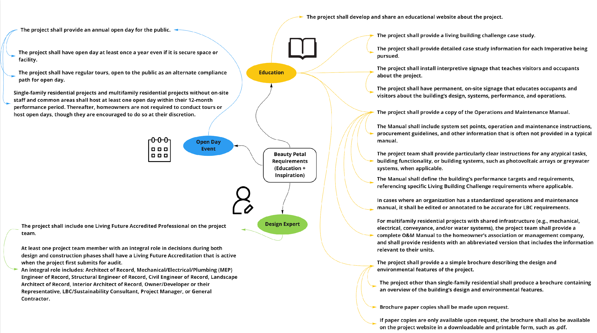

**Figure B-14:** The open day event, education, and design expert branches of the Beauty Petal

The biophilic framework and plan shall incorporate an open day event that will allow the public to engage with the facility. The design presented should allow for an open day event to take place at least once per year, see Figure B-14. The biophilic framework and plan that includes details about an open day event shall serve as an educational tool to all stakeholders. All records and details found within the framework and plan leading up to the completion of the project will serve as reference for all users. To ensure the project remains on track and adheres to the recommendations found in the LBC, at least one accredited Living Future Professional with an integral role should be on the project team. At the initial submission for audit, an individual who plays an integral role in the design and construction phases of the project such as a project manager, general contractor, structural engineer or record, or architect of record should have accreditation.

## Appendix C. Empathy Field Work Requirements

In addition to the LBC, stakeholder, and NBC requirements, the SE team has also defined user requirements based on Empathy Field work. The Empathy Field work team brainstormed targeted questions and generated surveys to ask the students and teachers in Nepal in hopes to better understand what the user requirements are. Fortunately, the team has a few members well versed in the Nepali language and could translate the surveys for the students and teachers and also translate their responses back into English. This provided a communication channel for the team to truly grasp the responses of the users.

The full unpacking and modeling of the team’s empathy field work will be discussed in a later section, this section will cover the consolidated list of user requirements that were derived from the research. For easy representation and clarity, the user requirements were also translated into a mind mapping diagram which can be referred to in Figure C-1. The user requirements were categorized into seven key groups: Collaboration, Nature/Outdoors, Quiet/Private Space, Layout Flexibility, Cleaning, Storage, and Floors.

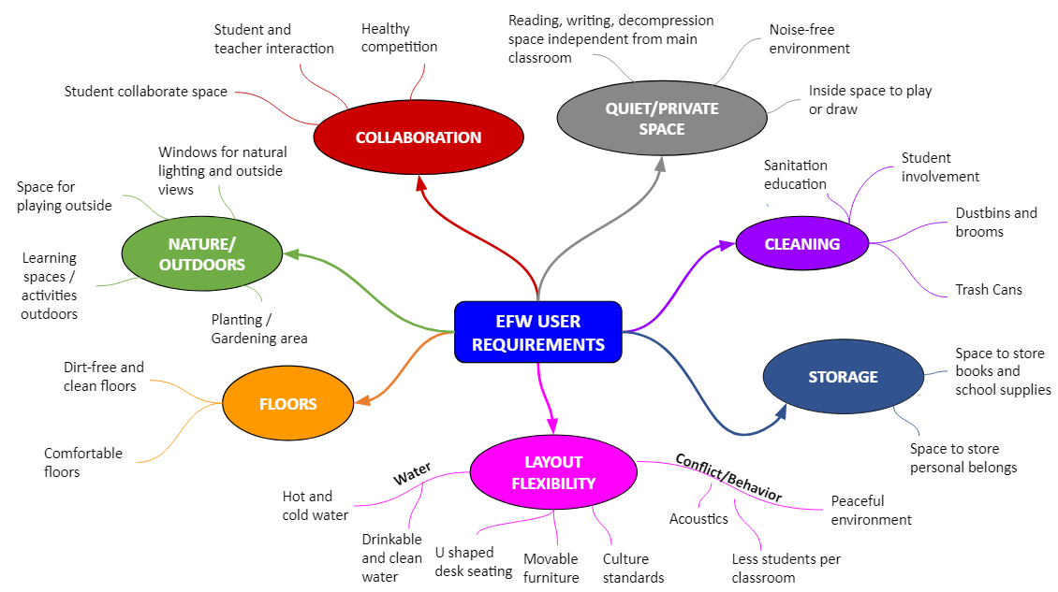

**Figure C-1:** Empathy Field Work Requirements

Collaboration is arguably the most important of the seven categories. The number of comments surrounding collaboration between classmates and teachers was substantial. For example, students mentioned that they learn best when they work with their fellow classmates and that they enjoy interacting with their teacher. As part of the Nature/Outdoors group, there were several important user requirements such as having space to play outside with friends, incorporating learning into outside activities and field trips, having lots of windows for natural lighting and outside views of nature, and a section for plants and a garden. Most students responded that interacting with nature is when they are happiest and most productive.

The third category is Quiet/Private Space. This is an important category considering the class size is on average 35-40 students per classroom. A large quantity of user responses fell within this section. Most are targeted towards a peaceful and noise-free environment and having a designated time and space to decompress, read, or write independently from the rest of the class.

In addition to this category, the Empathy Field Work team identified two sub-categories, Water and Behavior/Conflict. Water and Behavior/Conflict are located under the Quiet/Private Space group because of the lack of individual space available to the students which causes conflict and the need for water to cool down. Layout Flexibility is the fourth area of the user requirements. Teachers and students would like an adaptable classroom to accommodate different learning styles (i.e., textbook learning, whiteboard/chalkboard, hands-on), rearrangeable furniture, and U-shaped desk layout are just a few of the high-level requirements from this grouping.

The fifth area is Cleaning. Within this group the main requirements are ensuring a dustbin and broom are in each room and that students are educated on sanitation standards and participate in keeping the classrooms clean. Storage is the sixth group and is focused around ensuring students have space to keep their belongings and avoid having to carry heavy school materials back and forth from school. Most students have to walk more than 20 minutes with these heavy bags - if the design can incorporate storage spaces then it can potentially save many students from injury as well. The last and most surprising category is Floors which captures the desire from the students to be more comfortable. The research team is planning to dig more into why the students don’t like the current floor design since the responses were vague. In the end, all of these user requirements from within each of these overarching groups will be considered in the design.

## Appendix D. Electric Loads Analysis, Diagrams and Figures

The following details are from the Spring 2022 report:

Calculating the electricity needs using the Electrical Load Analysis (ELA) tool was the first step in the process of investigating renewable energy systems. A key part of electrical management is the ELA. ELA is a list of all electricity-consuming equipment in a building that shows the individual and cumulative power loads in the operational condition. This includes all electrical devices that will be plugged into power sources such as projectors, computers, lights, and ceiling fans. Some loads, like Wifi routers, use electricity all the time, while others, like lighting, use electricity intermittently. The ELA serves as the basis for the electrical loads that drive energy consumption and costs while giving insights into energy usage that can be used to save on electricity costs. Additionally, this part of the process helped evaluate where the energy efficiencies can be applied and how to size and design the renewable energy system.

The ELA consists of a table showing power ratings, or loads (in Watts) for all electrical devices in the facility along with an estimate of the number of hours each device will operate on a daily basis. Critical electrical loads supported by the battery backup were calculated separately. The ELA analysis results in an estimate for consumption, showing the number of watt-hours used per day, and the total electrical load. The total electric load is a sum of all the loads.



**Figure D-1:** ELA List of Loads



**Figure D-2:** ELA Outdoor Lighting at Night



**Figure D-3:** PV Lithium Ion Battery Sizing Calculator.

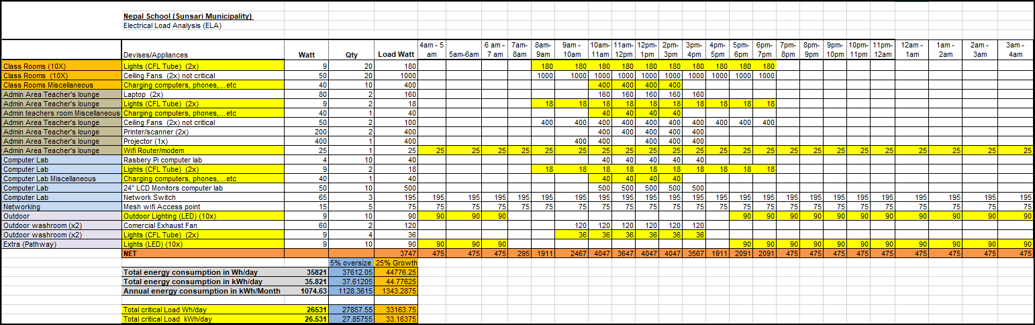**Figure D-4:** Electric Load Analysis

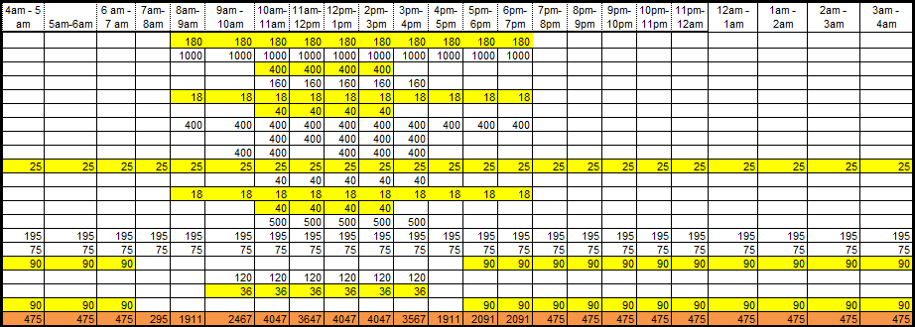

**Figure D-5:** ELA Power usage by the hour



**Figure D-6:** PhotoVoltaic Electrical On-Grid System (BDD)



**Figure D-7:** School Internet Network Diagram 1



**Figure D-8:** School Internet Network Diagram 2



**Figure D-9:** Notional Coverage of Wifi Infrastructure

## Appendix E. Landscape Vegetation Research

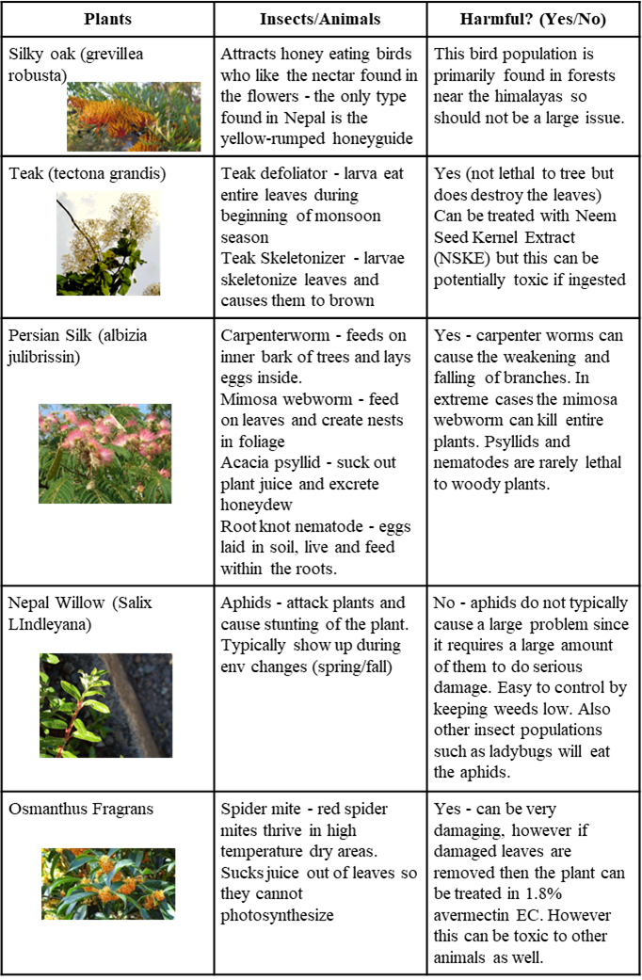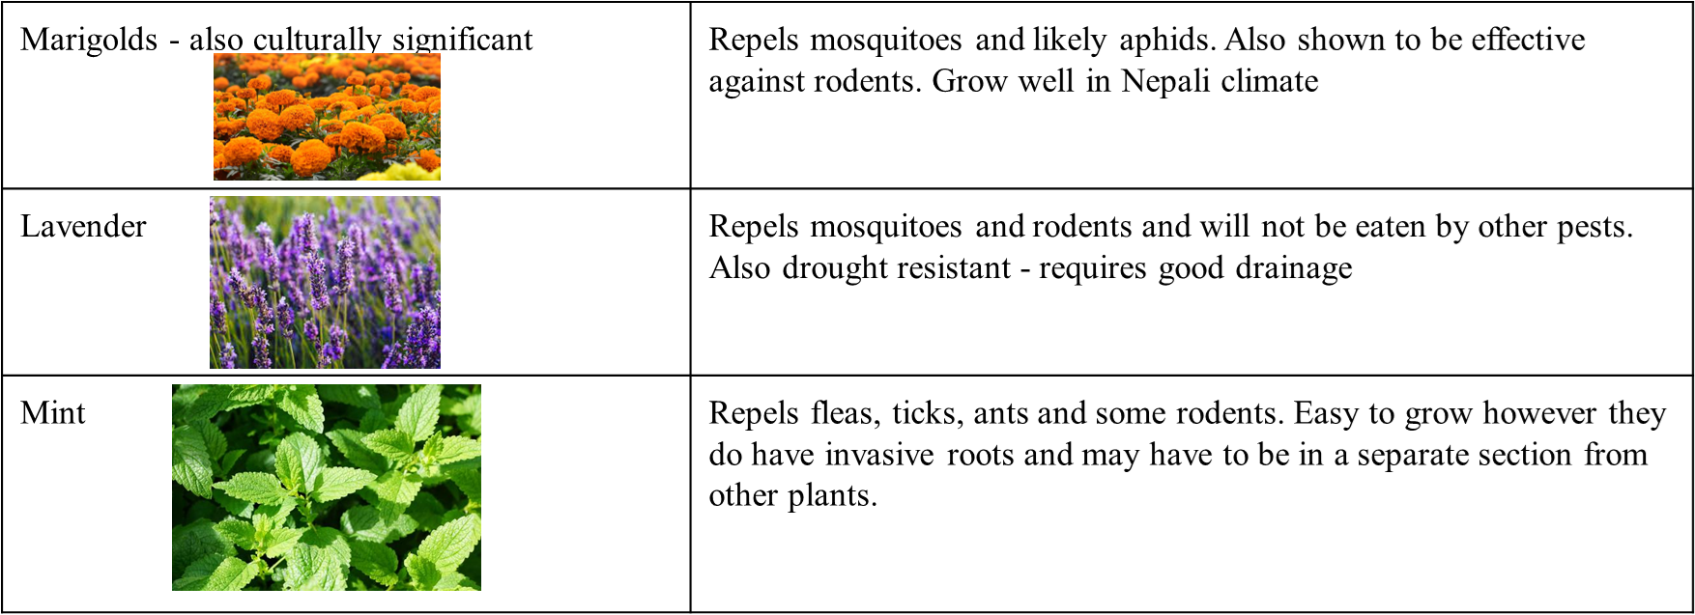

**Figure 76:** Landscape Vegetation for the Nepal School

## 

## Appendix F. Water

The following details on the water system are from the Spring 2022 report:

The water supply and demands for the school have been updated and adjusted as additional information and expectations were understood from the stakeholder. Key updates include the water source and expected waste treatment.

The team utilized the water model developed from the prior semester which had the water system divided up to show the supply, demands, and requirements for each. This aids in creating a self-sufficient and closed loop water system to achieve the LBC requirements.

The water supply system selected by the stakeholder is a well that is drilled on site. The location and required water treatment needs of the well are unknown at this time. The water that will be used for drinking will be pumped to the teachers’ room where there will be a reverse osmosis filtration system.

To supplement the well water, precipitation was further evaluated for non-potable needs. The focus on non-potable needs was due to the cyclic nature of precipitation in the Sunsari district. According to the *Observed Climate Trend Analysis in the Districts and Physiographic Regions of Nepal (1971-2014)*, Sunsari has a mean annual precipitation of 1794.3 millimeters (DHM, 2017). The monsoon season starts from June and usually ends in early September. During these months, the district’s precipitation skyrockets to 1433.6 millimeters from the previous season’s 226.9 millimeters. Precipitation during winter is only at a level between 20 to 40 millimeters.

**Table F-1.** Average precipitation per day per season in the Sunsari District

| Average Daily Precipitation (mm) | | | |
| --- | --- | --- | --- |
| Winter | Pre-Monsoon | Monsoon | Post-Monson |
| 0.37 | 2.52 | 15.9 | 1.12 |

Capturing this precipitation with a roof-based rainwater catchment system would be done with the support of the local organization SmartPanni. The recommendation would be to capture the runoff from the roofs and store it in underground cisterns. The preliminary design for the structure includes a 3490 sq. meter roof. Using the average total annual rainfall of 1794 mm. The following equation was used:

Roof Area (m2) X Precipitation Amount (mm) X Runoff Coefficient = Amount Collected (liters)

**EQ F-1. -** Amount of rainwater collection calculation31

This produces a total of 5,634,954 liters of rainwater per year. It is important to keep in mind that this rainfall is not uniformly distributed during the year but rather is most concentrated in the months of June to August. This will likely be more water than we can feasibly store especially due to the high concentration during the monsoon season. The team in coming semesters will have to continue the evaluation of space and cost for water storage.

Next, the bathrooms were subdivided into water needs; the sinks require potable water and the toilets will use non-potable water. The team recommends implementing low flow and metering self-closing push faucets in an effort to conserve potable water at the sinks. Standard sink flow is 1.3 L/min. If each person spends 30 seconds washing their hands and does so 4 times a day, then the sink water usage is approximately 1,071 liters. The non-potable water will only be used in the toilets in the bathrooms. All other water must be potable. During the school day, the average person uses the bathroom 3 times a day so there will be a total of 1,236 flushes per day (Bladder & Bowel Community 2021). One flush represents roughly 3 liters of water; hence 3,708 liters must be dedicated to toilets per day (Elemental Green 2021).

The landscape design will be finalized in the upcoming semester. This will drive the team's calculations for non-potable irrigation requirements as well as how to handle stormwater runoff.

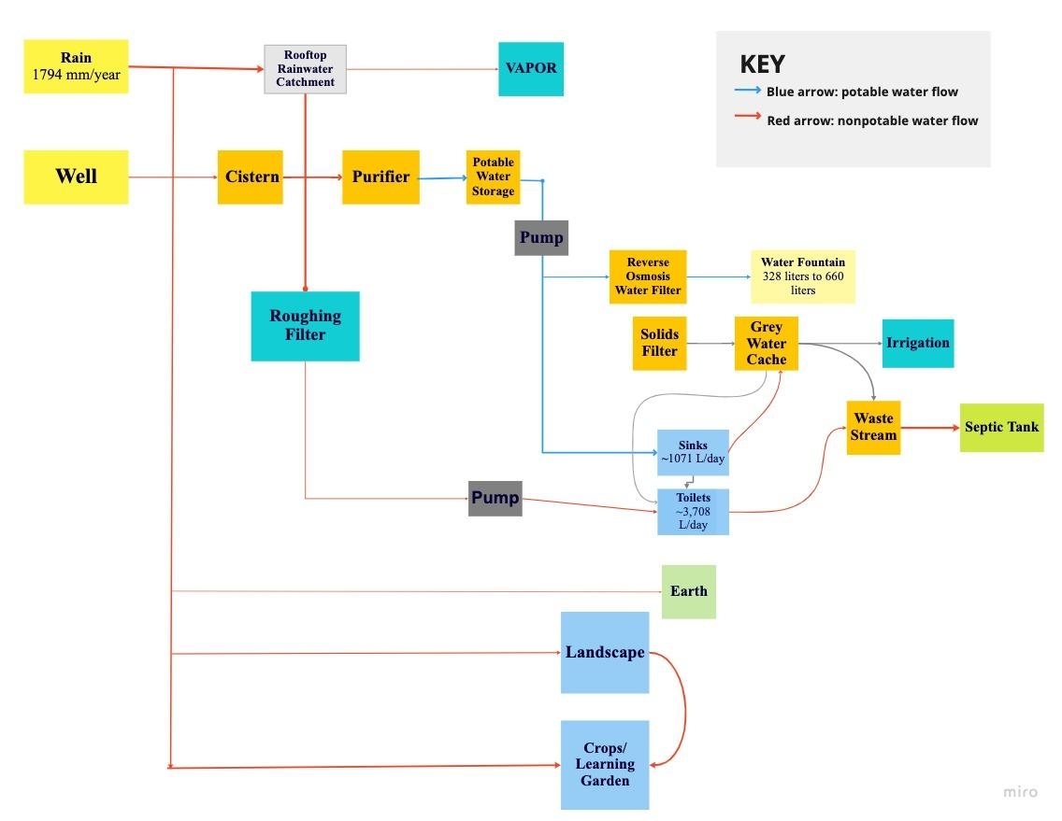

**Figure F-1:** Water Flow Chart (Appendix E)

Figure 3 portrays the flow and approximate volumes of water both potable and non-potable in the system. To aid in understanding the weight of the lines was adjusted to depict the volume of water required.

## Appendix G. Internal Block Diagrams (IBDs)

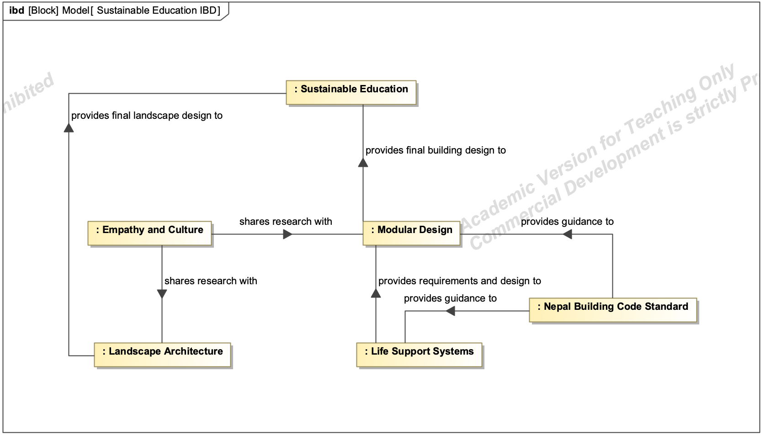

**Figure G-1:** Systems IBD

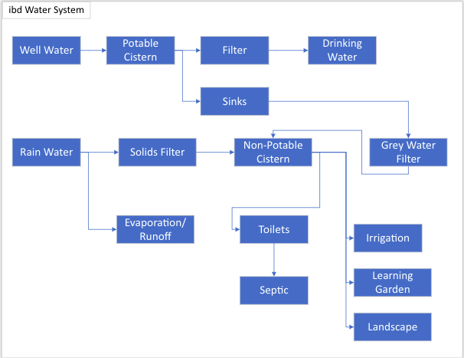

**Figure G-2:** Ideal Closed Loop Water System compliant to LBC requirements

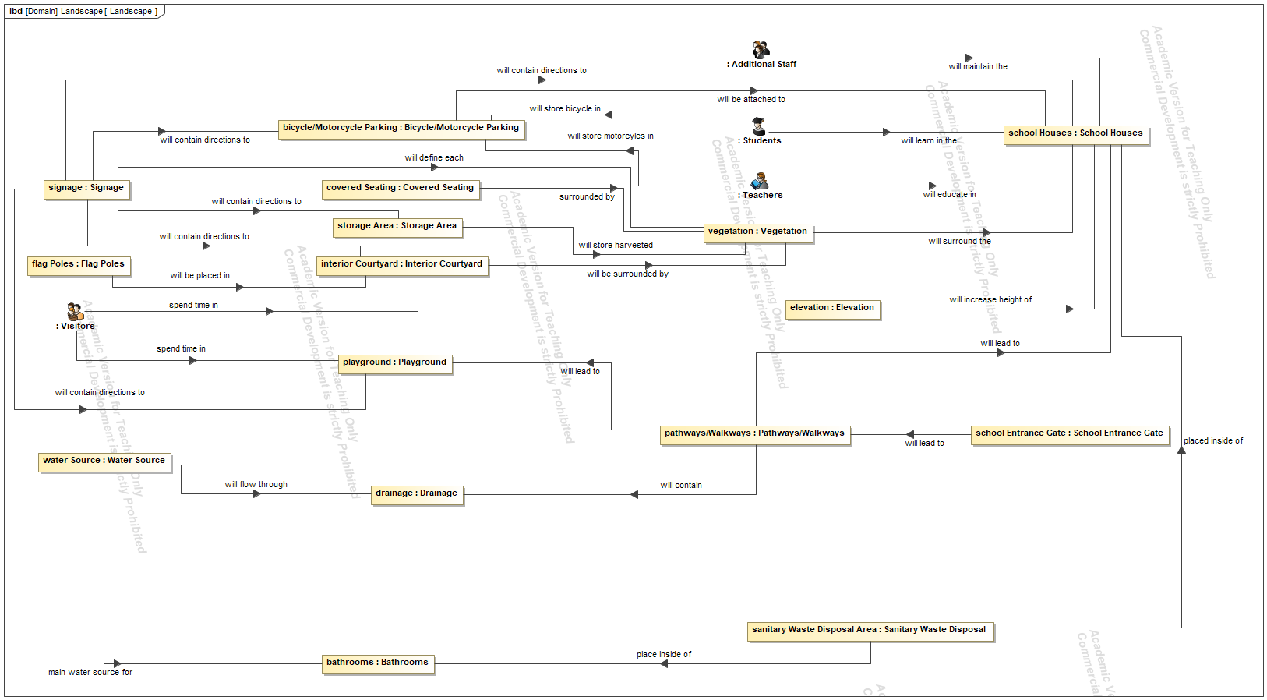

**Figure G-3:** Interaction between components of the landscape

## Appendix H. Block Definition Diagrams (BDDs)

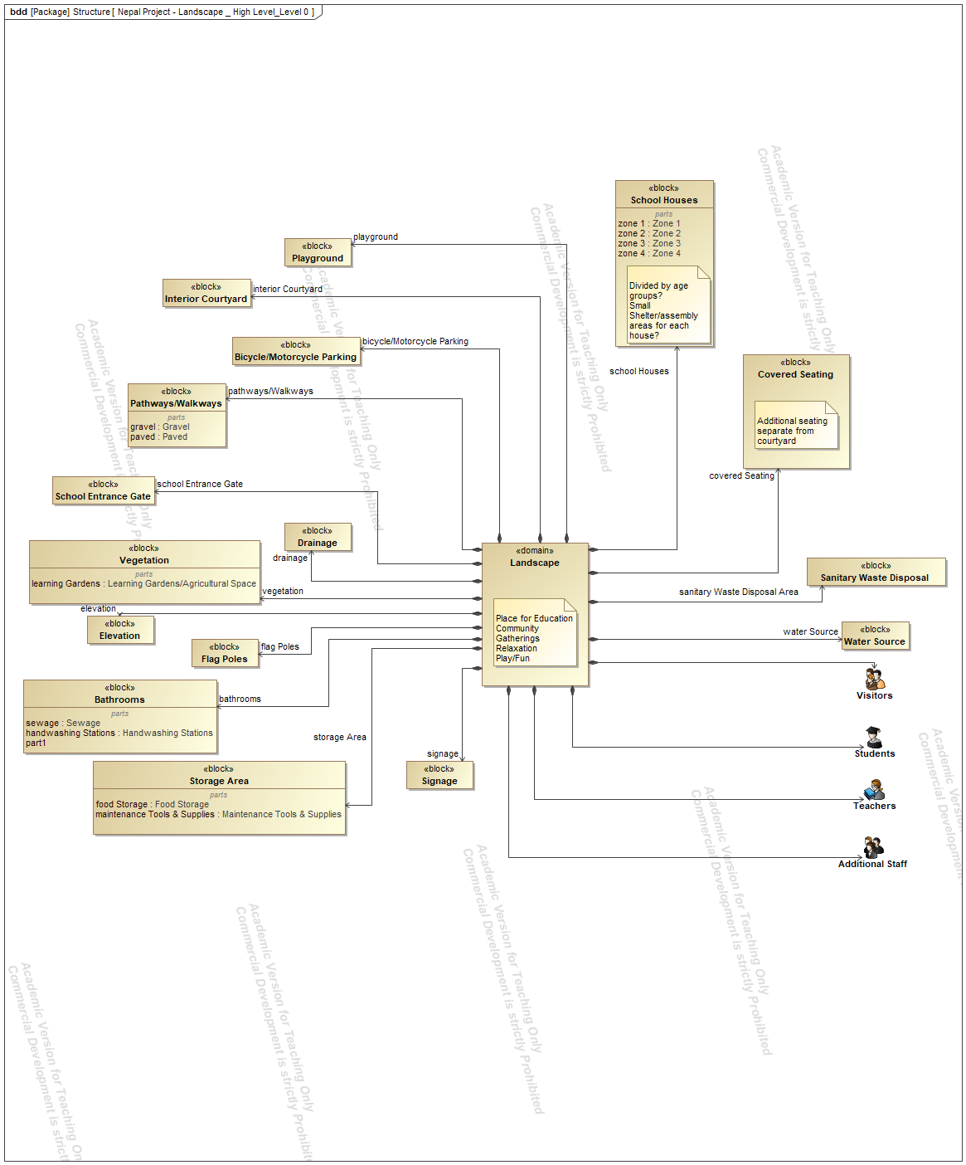

**Figure H-1:** Landscape Domain, defining all aspects of the school grounds



**Figure H-2:** PhotoVoltaic Electrical On-Grid System (BDD)

## Appendix I. LBC Verification Plan Matrix

Available at: <https://drive.google.com/file/d/12WOLamqRCOC80S_S5NXOQMSyDgnLpAB9/view?usp=sharing>

### Place Petal

| **Object ID** | **Requirement Description** | **Category** | **Verification Method** | **Success Criteria** | **Verification Plan** | **Artifact** |
| --- | --- | --- | --- | --- | --- | --- |
| I01- Ecology of Place (C01) | | | | | | |
| I01.1 | The Nepal project shall avoid building on pristine greenfields, wilderness, prime farmland or in a floodplain unless they meet an Exception. | Ecology | Inspection | Inspection of before and after images will show repurposed fields (associated with schools) used for school location. | Document site conditions with images prior to beginning the project. Document completed project with images after construction is complete. Compile images into Place Petal compliance reports. | Place Petal Compliance Report |
| I01.2 | The Nepal project shall preserve thriving vibrant ecological environments and habitats. | Ecology | Inspection | Inspection of design drawings will show effective use of site resources for buildings integrated with dedicated areas for ecological environments and habitats. | Inspect design drawings for use of effective ecological environments and habitats that are compliant with imperatives documented in Living Building Challenge Handbook. Document findings in Place Petal Compliance Report. | Place Petal Compliance Report |
| I01.3 | The Nepal project shall document site and community conditions prior to the start of work, including but not limited to identification of the project’s Reference Habitat.  Note: The Reference Habitat must be as specific as possible to the project site, addressing not just the larger ecoregion but the specific traits and characteristics of that micro-climate and area. | Documentation | Inspection | The Reference Habitat will be documented for The Nepal project site prior to the start of work. | The Reference Habitat Report will contain site and community conditions prior to the start of work, and will be as specific as possible for the specific traits and characteristics of the micro-climate and area. | Reference Habitat Report |
| I01.4 | The Nepal project shall demonstrate that it contributes positively to the ecology of the place and restore or enhance the ecological performance of the site toward a healthy ecological baseline.  Note: Conditions resulting from changes immediately prior to the project in order to prepare it  for development, such as land clearing, should not be considered part of the site’s baseline condition. | Documentation | Inspection | Inspection of design drawings will show a site that has been converted from a brown field to a restored, healthy ecology. | Inspect design drawings, especially landscape architecture, to verify effective use of agriculture, its surroundings or environment. | Place Petal Compliance Report |
| I01.4.1 | The Nepal project's thriving, vibrant ecological environments and habitats (on a site or a portion of a site) shall be protected from building and any other significant impacts. | Ecology | Inspection | Inspection of design drawings will show a portion of the site that is protected from building by use of dedicated open space. | Inspect design drawings for use of dedicated open space that is protected from buildings. | Place Petal Compliance Report |
| I01.5 | The Nepal project’s on-site landscape shall be designed to mature and evolve, and to emulate the functionality of the Reference Habitat, as appropriate to the project’s Transect. | Landscape | Inspection | Inspection of the design drawings, specifically the landscape architecture, as compared to the Reference Habitat report, will show an emulation of the functionality of the Reference Habitat. | Inspect the landscape architecture drawings to verify that the design emulates the functionality of the Reference Habitat. | Place Petal Compliance Report |
| I01.6 | The Nepal Project shall not use invasive or exotic species that might be toxic or harmful to the local ecosystem.  Note: Existing non-native landscaping can remain in place if it meets all other requirements of the Imperative being pursued. If it cannot meet the other Imperative requirements, it must be removed. | Landscape | Inspection | Inspection of design drawings will show no invasive species in the plan. | Inspect design drawings, especially landscape architecture, to verify no invasive species are in the plan. | Place Petal Compliance Report |
| I01.6.1 | The Nepal Project's invasive species shall be removed and/or addressed in a long-term management plan. | Landscape | Inspection | The Nepal site will have no invasive species 1 month after the start of work. | The Nepal site will be inspected for invasive species 1 month after the start of work. Any invasive species found will be documented in the Place Petal Compliance report and removed. | Place Petal Compliance Report |
| I01.7 | The Nepal project shall incorporate buffers to protect ecological function with buffer distances for some sensitive habitats as follows:  • Old-growth forest: maintain at least 60 meters separation.  • Primary dunes: maintain at least 40 meters separation.  • Virgin prairie: maintain at least 30 meters separation.  • Wetlands: maintain at least 15 meters and up to 70 meters separation, depending on the context. | Landscape | N/A | Exception | An exception will be filed with ILFI that shows the site is not adjacent to any of the following: old-growth forest, primary dunes, virgin prairie, or wetlands. | Exception Report |
| I01.8 | The Nepal project shall assess cultural and social equity factors and needs in the community and consider those identified needs to inform design and process decisions. | Society | Analysis | Analysis will show that cultural and social equity factors and needs in the community were considered to inform design and process decisions. | Analysis of the design documents, specifically the architectural drawings and landscape drawings, will show incorporation of Stakeholder Requirements that are based on empathy field work. | Place Petal Compliance Report |
| I01.9 | The Nepal project shall use no petrochemical fertilizers or pesticides for the operation and maintenance of the on-site landscape, including urban agriculture. | Landscape | Inspection | Inspection of design drawings will show only native species in the plan that require no petrochemical fertilizers or pesticides. | Inspect design drawings, especially landscape architecture, to verify only native plant species are in the plan. | Place Petal Compliance Report |
| I01.10 | The Nepal Project shall document in I01-4 Fertilizers and Pesticides a list of chemicals used and planned for use in the maintenance and operation of the on-site landscape and agriculture showing that they do not contain petrochemicals or that they meet the requirements of an applicable organic program. | Documentation | Inspection | Inspection of design drawings will show only native species in the plan that require no petrochemical fertilizers or pesticides. | Inspect design drawings, especially landscape architecture, to verify only native plant species are in the plan. | I01-4 Fertilizers and Pesticides |
| I01.11 | The Nepal Project shall assess in the I01-1 Site Conditions Documentation the site’s baseline (i.e., pre-project development) ecological condition using the Society for Ecological Restoration International Standards for the Practice of Ecological Restoration (SER Standards) Five-Star Method (see table 1-1). | Documentation | Inspection | Inspection of site images from pre-project development will show ecological conditions. | Inspect images from pre-project development to show ecological conditions in accordance with the Society for Ecological Restoration International Standards for the Practice of Ecological Restoration (SER Standards) Five-Star Method. | I01-1 Site Conditions Documentation |
| I01.11.1 | The Nepal Project shall identify the project’s Reference Habitat. | Documentation | Analysis | The Reference Habitat will be documented for The Nepal project site prior to the start of work. | The Reference Habitat Report will clearly show the site's reference habitat. | Reference Habitat Report |
| I01.11.2 | The Nepal Project shall document a zoning diagram or letter from the Authority Having Jurisdiction (AHJ) addressing the site’s relationship to the 100-year floodplain may be submitted. | Documentation | Analysis | Documentation of a zoning diagram which shows the 100-year floodplain. |  |  |
| I01.11.3 | The Nepal Project shall document an overview narrative with photographs describing site conditions at the start of the project and a general history of the site. | Documentation | Inspection | Inspection of images will show site conditions at the start of the project and a general history of the site | Document site conditions with images prior to beginning project, during, and at the end of the project. Compile images into Place Petal compliance report. | Place Petal Compliance Report |
| I01.12 | The Nepal Project shall generate an Adaptive Plan based on the project site’s baseline ecological condition and appropriate to the project’s Transect.  Note: The minimum target levels of improvement by Transect and Attribute are shown in Figure 1-2 Minimum Attributes by Transect. The Adaptive Plan should establish the vision, goals, restoration measures, and quantitative evaluation metrics, as well as the monitoring and maintenance strategies, to be applied to the project. | Documentation | N/A | Exception | An exception will be filed with ILFI that shows the Adaptive plan would require extensive planning that is beyond the scope of the detail displayed in this requirement as there are several pages of adaptive plan creation guidance in the LBC handbook. | Exception Report |
| I01.12.1 | The Nepal Project's Adaptive Plan shall establish the vision, goals, restoration measures, and quantitative evaluation metrics, as well as the monitoring and maintenance strategies, to be applied to the project. | Documentation | N/A | Exception | An exception will be filed with ILFI that shows the Adaptive plan would require extensive planning that is beyond the scope of the detail displayed in this requirement as there are several pages of adaptive plan creation guidance in the LBC handbook. | Exception Report |
| I01.13 | The Nepal Project's site ecology report shall evaluate and report on improvements to the project site ecology at the end of the 12-month performance period. | Documentation | N/A | Exception | An exception will be filed with ILFI that shows the Adaptive plan would require extensive planning that is beyond the scope of the detail displayed in this requirement as there are several pages of adaptive plan creation guidance in the LBC handbook. | Exception Report |
| I01.13.1 | The Nepal Project's site ecology report shall describe, based on what was learned from monitoring, the progress towards meeting metrics and goals, and identify any corrective measures.  Note: Incorporate the Recovery Wheel to show graphically, both baseline pre-project conditions, and ecological improvement (see figure 1-1 Recovery Wheel Template, and figure 1-3 Recovery Wheel Example). | Documentation | N/A | Exception | An exception will be filed with ILFI that shows the Adaptive plan would require extensive planning that is beyond the scope of the detail displayed in this requirement as there are several pages of adaptive plan creation guidance in the LBC handbook. | Exception Report |
| I01.14 | The Nepal Project's documentation shall include photographs showing change over the performance period. | Documentation | Inspection | Inspection of photos will show change over the performance period beginning prior to project start to 12 months after site occupancy. | Document site conditions with images prior to beginning project. Document completed project with images from 12 months after first occupancy. Compile images into Place Petal compliance report. | Place Petal Compliance Report |
| I02- Urban Agriculture | | | | | | |
| I02.1 | The Nepal Project shall dedicate 15% [Pathway 1] of their total Project Area to growing food. (Ref. Table 2-1 Urban Agriculture Percentage Requirements.)  -or-  The Nepal Project shall dedicate 7% [Pathway 2] of their total Project Area to growing food. (Ref. Table 2-1 Urban Agriculture Percentage Requirements.)  -and-  The Nepal Project shall directly provide weekly community access to healthy local food that addresses a community need, through farmers markets, Community Supported Agriculture (CSA) programs, or other local food producers.  Note: The weekly access must occur throughout the year to the extent that locally produced and raised food is available, recognizing that in some circumstances, there may be variability according to climate and/or local practices. | Food | Demonstration | The Nepal site will demonstrate that educational gardens will be used to produce food for the students; however, this will be <7% of the total Project Area. Local food producers will be utilized to the extent practicable. | The Place Petal Compliance Report will document successes from the students growingtheir own food for educational purposes after one year of site occupancy. | Place Petal Compliance Report |
| I02.2 | The Nepal Project shall document in the I02-2 Weekly Food Access Narrative (if relevant) a narrative that describes the strategies used to provide community access to healthy local food. | Documentation | Inspection | I02-2 Weekly Food Access Narrative will show that educational gardens will be used to produce food for the students. | Document plan for student gardens and associated lesson plans for teaching how to grow healthy food. | I02-2 Weekly Food Access Narrative |
| I02.3 | The Nepal Project shall demonstrate the capacity to store at least a two-week supply of food for the maximum number of occupants using 2,100 calories per person per day.  Note: Projects with significant seasonal differences in occupancy must store food or have food storage to accommodate the season with the highest level of occupancy, or establish a plan for seasonal variation. | Food | Inspection | Food storage for food grown on property | Inspect design drawings for sufficient food storage of produce grown on property | Place Petal Compliance Report |
| I02.4 | The Nepal Project shall provide a narrative describing:  • The project’s food-storage capacity.  • Rationale and calculations used to determine the number of occupants.  • Other calculations showing compliance with Imperative requirements. | Documentation | Analysis | Analysis will show the required food storage capacity is sufficient for containing produce grown on property | Analyze and document in the Petal Place Compliance Report the results for required food storage capacity. | Place Petal Compliance Report |
| I02.5 | The Nepal Project's agriculture products shall be harvested and either used for, or distributed for, human consumption. | Food | Demonstration | Demonstration will show agricultural products grown in the student gardens can be harvested for human consumption. | The Place Petal Compliance Report will document successes from the students growing their own food for educational purposes after one year of site occupancy. | Place Petal Compliance Report |
| I02.6 | The Nepal Project's agriculture products shall provide a list of all non-edible plants with explanations of their functions and the rationale for the allotted areas of each. | Documentation | Inspection | Inspection of design drawings, specifically landscape architecture, will show a list of all non-edible plants. | Documentation in the Place Petal Compliance Report will show a list of all non-edible plants and explanations of their functions and rational for use. | Place Petal Compliance Report |
| I02.7 | The Nepal Project's water sources for irrigation shall be non-potable to minimize unnecessary energy for purification, unless there is a health concern or code-related requirement stating that potable water must be used for on-site agriculture (see Imperative 05, Responsible Water Use). | Water | Inspection | Inspection of design drawings, specifically the Water System Internal Block Diagram, will show non-potable water use for irrigation. | Inspect the Water System Internal Block Diagram for non-potable water use for irrigation. | Place Petal Compliance Report |
| I02.8 | The Nepal Project shall document in the I02-1 Agriculture Narrative a one-to-three-page narrative written by the landscape architect or other appropriate project team member describing the methods of agriculture used to meet the Imperative (crops planted, livestock raised, etc.), their intended use, and a long-term support and harvest plan.  Note: The narrative should address:  • Why the selected strategies were chosen and how non-edible plants, if any, meet related requirements.  • How the surrounding climate is supportive of the proposed species as a harvestable resource.  • Occupants’ access to the infrastructure necessary for harvest and use of agriculture.  • A clear plan of use for the harvest and how urban agriculture will be maintained over time. | Documentation | Inspection | Inspection of design drawings, specifically landscape architecture, will show  • Why the selected strategies were chosen and how non-edible plants, if any, meet related requirements.  • How the surrounding climate is supportive of the proposed species as a harvestable resource.  • Occupants’ access to the infrastructure necessary for harvest and use of agriculture.  • A clear plan of use for the harvest and how urban agriculture will be maintained over time. | Document key points of success criteria in I02-1 Agriculture Narrative. | I02-1 Agriculture Narrative |
| I02.9 | The Nepal Project shall grow at least one season of agriculture that is planted and harvested before the site visit which takes place after the 12-month performance period during the LBC certification audit. | Food | Demonstration | Demonstration will show agricultural products grown in the student gardens can be harvested for human consumption. | The Place Petal Compliance Report will document successes from the students going their own food for educational purposes after one year of site occupancy. | Place Petal Compliance Report |
| I03- Habitat Exchange | | | | | | |
| I03.1 | The Nepal Project shall set aside land equal to the Project Area (or 0.4 hectares/1 acre, whichever is greater) away from the project site, in perpetuity, through an approved land trust organization or the Institute’s Living Future Habitat Exchange Program. | Habitat | N/A | N/A | Certification for I03-Habitat Exchange will not be pursued due to cost limitations from the stakeholder. | N/A |
| I03.1.1 | The Nepal Project's land designated for Habitat Exchange shall be part of or contiguous to an area of permanently protected, intact, high-value ecosystem of at least 100 acres, which may not be on the project property, nor on land owned by the project owner, except as outlined for conservation and parks nonprofits per PL-009 Conservation and Parks Organizations. | Habitat | N/A | N/A | Certification for I03-Habitat Exchange will not be pursued due to cost limitations from the stakeholder. | N/A |
| I03.1.2 | The Nepal Project's approved land trusts shall be actively responsible for the purchase and/or permanent easement, as well as for ongoing stewardship and conservation, of land in contiguous tracts of at least 100 acres. | Habitat | N/A | N/A | Certification for I03-Habitat Exchange will not be pursued due to cost limitations from the stakeholder. | N/A |
| I03.1.3 | The Nepal Project's approved land trusts shall:  • Be accredited through the Land Trust Accreditation Commission  -or-  • Adhere to the Land Trust Alliance Standards and Practices (designated by an S&P icon on the Alliance’s geographically based membership list). | Habitat | N/A | N/A | Certification for I03-Habitat Exchange will not be pursued due to cost limitations from the stakeholder. | N/A |
| I03.1.4 | The Nepal Project's protected area shall be intended primarily for use by species other than people.  Note: In certain circumstances, limited human activity that supports conservation efforts may be allowed within the protected area, particularly if such human use supports sustainable indigenous livelihoods while safeguarding the site’s ecological value and potential to thrive. | Habitat | N/A | N/A | Certification for I03-Habitat Exchange will not be pursued due to cost limitations from the stakeholder. | N/A |
| I03.2 | The Nepal Project shall document receipt for the Habitat Exchange contribution from either the approved land trust or the Living Future Habitat Exchange Program reflecting the required habitat offset area. | Documentation | N/A | N/A | Certification for I03-Habitat Exchange will not be pursued due to cost limitations from the stakeholder. | N/A |
| I03.3 | The Nepal Project shall obtain an official letter or document from the approved land trust stating the terms of the habitat offset and confirming that the selected land trust meets pathway requirements. | Documentation | N/A | N/A | Certification for I03-Habitat Exchange will not be pursued due to cost limitations from the stakeholder. | N/A |
| I04- Human-Scaled Living (C02) | | | | | | |
| I04.1 | The Nepal Project shall maintain or increase the density of the site and support a human-powered lifestyle. | Site | Inspection | The finished site will clearly demonstrate the density is increased. | Inspection of the images from prior to project start vs. the finished site will show that the project has increased the density from the original condition. | Place Petal Compliance Report |
| I04.2 | The Nepal Project shall be built to a human scale that is appropriate for the neighborhood. | Site | Inspection | The finished site will clearly demonstrate the human scale that is appropriate for the neighborhood. | Inspection of the finished site will show the human scale is appropriate as compared to the local neighborhood. | Place Petal Compliance Report |
| I04.2.1 | The Nepal Project's buildings shall have a scale appropriate to their neighborhood that are complementary to and have proportions comparable to existing buildings and spaces. | Site | Inspection | The finished site will clearly demonstrate proportions comparable to existing buildings and spaces. | Inspection of the finished site will clearly demonstrate proportions comparable to existing buildings and spaces. | Place Petal Compliance Report |
| I04.3 | The Nepal Project shall provide places for occupants to gather and connect with the community. | Site | Inspection | Inspection of design drawings will show places for occupants to gather and connect with the community. | Inspect design drawings for places for occupants to gather and connect with the community. | Place Petal Compliance Report |
| I04.4 | The Nepal Project shall provide sufficient secure, weather-protected storage for human-powered vehicles and facilities, such as showers and lockers, to encourage biking. | Site | N/A | Exception | An exception will be filed with ILFI as cars are not a focal point for transportation. Covered parking will be provided for bicycles. | Exception Report |
| I04.5 | The Nepal Project shall provide at least two electric vehicle (EV) charging stations or one per thirty spaces, whichever is greater. | Site | N/A | Exception | An exception will be filed with ILFI that shows the impracticality of EV usage in the local area due to lack of in-country charging station infrastructure. | Exception Report |
| I04.6 | The Nepal Project shall minimize impervious surface parking to no more than 20% (Transects 1–3), 15% (Transect 4), 5% (Transect 5) and 0% (Transect 6) of the Project Area and ensure that any surface parking area larger than 20m x 30m is separated with planted areas. | Site | N/A | Exception | An exception will be filed with ILFI that shows vehicle parking is not applicable to the school as human-powered vehicles and walk will be the primary mode of transportation. | Exception Report |
| I04.7 | The Nepal Project shall either reduce single-occupancy vehicle (SOV) trips and trips by fossil fuel-based vehicles by 30% over an established baseline relevant to the project’s region and occupancy type.  -or-  The Nepal Project shall implement at least four of the following best practices:  ◦ Consideration and enhancement of pedestrian routes, including weather protection on street frontages.  ◦ Advocacy in the community to facilitate the uptake of human-powered and public transportation.  ◦ A transit subsidy for all occupants of the building (if owner-occupied) or a requirement for tenant employers to provide such a subsidy.  ◦ Carpool coordination assistance.  ◦ Access either to subsidized car sharing and/or to hybrid or EV fleet vehicles.  ◦ Regular survey of occupants to determine current fossil fuel-based SOV trips. | Site | N/A | Exception | An exception will be filed with ILFI that shows vehicle parking is not applicable to the school as human-powered vehicles and walking will be the primary mode of transportation. | Exception Report |
| I04.8 | The Nepal Project shall demonstrate that the project’s density is being maintained or increased. | Site | Inspection | The finished site will clearly demonstrate the density is increased. | Inspection of the finished site will show that the project's density as compared to the local neighborhood has increased. | Place Petal Compliance Report |
| I04.9 | The Nepal Project shall document Project Area FAR before and after the project, or images that clearly show that the project has increased the density from the original condition. | Documentation | Inspection | The finished site will clearly demonstrate the density is increased. | Inspection of the images from prior to project start vs. the finished site will show that the project has increased the density from the original condition. | Place Petal Compliance Report |
| I04.10 | The Nepal Project shall document I04-2 Human Scale and Human Powered Documentation via the following:  • Minimum one-page narrative describing how the project has addressed Imperative requirements and  promotes pedestrian-oriented communities that reduce the use of fossil fuel vehicles.  • Plan indicating location and dimension of spaces available for community gathering  • Calculations showing the amount of compliant storage for human-powered vehicles. | Documentation | Inspection | Inspection of design drawings will show places for occupants to gather and connect with the community. | Inspect design drawings for places for occupants to gather and connect with the community. | I04-2 Human Scale and Human Powered Documentation |

### 

### 

### Water Petal

| **Object ID** | **Requirement Description** | **Category** | **Verification Method** | **Success Criteria** | **Verification Plan** | **Artifact** |
| --- | --- | --- | --- | --- | --- | --- |
| IO5.1 | The project shall use 50% less water for the project’s other needs than a baseline regional building of the same type. | Performance Testing | Inspection | The water consumption of the Nepal School is 50% less than that of similar schools in the area. | Document water consumption of the Nepal school. Document water consumption of similar schools in the area. Compare the water consumption of the two. Document the result in the Potable Water Use Reduction Documentation. | Potable Water Use Reduction Documentation |
| IO5.2 | The project team shall establish a baseline data set for potable water use. | Baseline Preparation | Inspection | The potable water consumption of similar schools in the region is used as a baseline dataset. | Document potable water consumption data in the Potable Water Use Reduction Documentation. | Potable Water Use Reduction Documentation |
| IO5.2.1 | The baseline data set for potable water use shall align with the potable water end uses that are within the project scope. | Baseline Preparation | Inspection | The potable water end uses of the similar school whose data we are using as a baseline align with the requirements from the water imperatives. | Check the potable water end uses of the similar school we are using as a baseline. Inspect the potable water end uses of the baseline dataset do not include water used for irrigation or landscaping. | Potable Water Use Reduction Documentation |
| IO5.2.2 | The baseline data set for potable water shall not include water used for irrigation or landscaping. | Baseline Preparation | Inspection | The potable water end uses of the similar school whose data we are using as a baseline do not include water for irrigation or landscaping | Check the potable water end uses of the similar school we are using as a baseline. Inspect the potable water end uses of the baseline dataset do not include water used for irrigation or landscaping. | Potable Water Use Reduction Documentation |
| IO5.3 | The project team shall use water from a municipal reclaimed water system as a resource for non-potable water, if the water supplied is municipally treated domestic sewage and not non-treated or minimally treated water that is sourced from the municipality’s potable water supply. | Non-potable water | Inspection | The municipal water system is used for non-potable water | Confirm with the local authority/LBC committee that spring water is considered as the municipal reclaimed water. Inspect the usage of spring water. Verify that spring water is used as non-potable water. | Water Petal Compliance Report |
| IO5.4 | The project team shall use greywater or treated domestic sewage water in the water system. | Non-potable water | Demonstration | The school has a greywater treatment system as well as septic system for sewage, and water treated from those systems is used in the school. | Verify if there is a greywater treatment system installed.  Verify if there is a septic system installed.  Verify if there are piping installed to use the treated greywater as non-potable water. | Water Petal Compliance Report |
| IO5.5 | Any supplied water shall be treated to the same or acceptable standards as the water in the reclaimed water system. | Water treatment | Inspection | The supplied water is treated as greywater. | Inspect if there is any water supplied to the school.  If there is, verify that the supplied water is treated the same as greywater or water in the reclaimed water system. | Treatment Documentation |
| IO5.6 | If supplied water is installed off site, any piping used to connect the project to the municipal system shall meet the requirements for all other Imperatives being pursued by the project. | Code | Inspection | The piping used for supplied water is compliant with the requirements from other imperatives. | Inspect if the supplied water used in the school is installed off-site.  If so, verify that the pipings used for the supplied water meet the requirements stated in the compliance reports of other petals. | Water Petal Compliance Report |
| IO5.7 | No potable water shall be used for non-potable uses. | Non-potable water | Inspection | Potable water is not used for non-potable purposes. | Check the usage of potable water in the school.  Check the end uses of potable and non-potable water established as baseline data.  Verify that potable water is not used for non-potable purposes. | Water Petal Compliance Report |
| IO5.7.1 | The project team shall meet the demands with non-potable water for the following end uses:  a. Toilet and urinal flushing  b. Landscape irrigation  c. Cooling tower makeup supply  d. Laundry  e. Miscellaneous processes (e.g., equipment washing, dust prevention, etc.) | Non-potable water | Demonstration | The end uses listed in the requirement use non-potable water | Check the piping of the toilet and urinal, sinks, landscaping and irrigation. Verify that the piping is connected to the cistern which stores non-potable water. | Water Petal Compliance Report |
| IO5.7.2 | The project team shall use on-site, non-potable resources for landscaping to meet the irrigation demand. | Non-potable water | Demonstration | Landscape irrigation of the school uses on-site non potable water. | Verify that there is a water storage system (cistern) for the non-potable water. Ensure that the irrigation system is connected to the non-potable water system. | Irrigation Documentation |
| IO5.7.3 | If on-site, non-potable resources are not used, the project team shall use landscaping that does not require irrigation. | Non-potable water | Demonstration | The Nepal school does not use off-site non-potable water for irrigation. | Verify that the irrigation system of the school uses on-site non-potable water | Irrigation Documentation |
| IO5.8 | Potable water use for above-ground irrigation of urban agriculture shall only be allowed if it can be demonstrated that subsurface or other methods of irrigation are not feasible or the authority having jurisdiction requires it. | Code | Demonstration | The Nepal school does not use potable water for its irrigation system. | Verify that the irrigation system of the school is only connected to non-potable water sources. | Irrigation Documentation |
| IO5.9 | The project team shall use municipal water supply for temporary irrigation to establish plants before the 12-month performance period has begun. | Baseline Preparation | Demonstration | Well water is used as one of the water sources for irrigation systems. | Check the sources of the irrigation system. Verify that well water is used as one of the water sources for the irrigation system. | Irrigation Documentation |
| IO5.9.1 | The municipal water shall not be used after the 12-month performance period has started. | Baseline Preparation | N/A | N/A | Municipal water will be used even after a 12-month performance period due to cost limitation. | Exception Report |
| IO5.10 | The project shall treat all stormwater on site, through natural or mechanical means and without chemicals | Water treatment | Demonstration | There is a treatment system for stormwater installed at the Nepal school | Check the water treatment plan to ensure there is a treatment system installed for stormwater for water end uses that require potable water. Demonstrate that the treatment system uses natural or mechanical means and without chemicals. | Treatment Documentation |
| IO5.11 | The project shall manage all stormwater based on both pre-development hydrology and current ecological conditions, as determined by a qualified professional. | Water treatment | Inspection | Stormwater is managed based on pre-development hydrology and current ecological conditions. | Ensure that qualified professionals are consulted to understand the hydrology and ecological conditions of the site. Inspect that the usage of stormwater does not interrupt the hydrology of the site. | Water Petal Compliance Report |
| IO5.11.1 | The project shall incorporate stormwater detention. (if on a combined sewer overflow (cso) system, or in a floodplain) | Water treatment | Demonstration | The Nepal School has a plan to use stormwater as one of the water supply sources. | Identify the water end uses where stormwater is going to be used. Demonstrate that those water end uses are supplied by stormwater. | Water Petal Compliance Report |
| IO5.11.2 | The project shall avoid sheet flow off the site. (if on a combined sewer overflow (cso) system, or in a floodplain) | Water treatment | Demonstration | There is no sheet flow off the site. | Inspect all the water flows that are directed out to the nature. Demonstrate that those flows do not cause sheet flow off the site. | Water Petal Compliance Report |
| IO5.12 | The project team shall develop an appropriate stormwater model, to show compliance with the hydrologic stormwater standards. | Documentation | Inspection | A stormwater model that complies with the hydrologic stormwater standards is developed. | Inspect that the stormwater model does not interrupt the hydrology and ecological conditions of the site. | Water Petal Compliance Report |
| IO5.12.1 | The project team shall use the Santa Barbara Urban Hydrograph method (SBUH) single-event hydrologic analysis technique for estimating runoff based on the curve number method. | Documentation | Inspection | The Santa Barbara Urban Hydrograph method (SBUH) single-event hydrologic analysis technique is used for estimating runoff based on the curve number method. | Check the method that is used to calculate the runoff. Inspect that the correct method is used for the calculation. If the correct method is not used, check other acceptable methods in the LBC handbook and apply for exceptions if needed. | Water Petal Compliance Report |
| IO5.12.2 | For contexts with a stormwater volume management requirement, the project team shall use a continuous simulation model. | Documentation | Inspection | The Nepal School team uses continuous simulation model for stormwater management | Check the method that is used to calculate the stormwater. Inspect that a continuous simulation model is used for the calculation. If the correct method is not used, check other acceptable methods in the LBC handbook and apply for exceptions if needed. | Water Petal Compliance Report |
| IO5.13 | The project shall meet the wetland protection standard if a category 1 or 2 depressional wetland is located downstream of the project where the project site is greater than 5% of the tributary basin of the wetland. | Code | N/A | The Nepal School site is not considered a wetland. | N/A | N/A |
| IO5.14 | To account for climate change, the design precipitation depths shall be increased by a minimum of 15% or as recommended in a regional climate report for expected changes in peak rates in the year 2100. | Code | Inspection | The design precipitation depth increases by the amount recommended in a regional climate report to account for climate change. | Check the regional climate report to obtain the desired precipitation depths. Inspect that precipitation depth projected by the year 2100 is not less than the year the school is built. | Water Petal Compliance Report |
| IO5.15 | The project team shall obtain the 24-hour precipitation depths for the following recurrence interval events: 2-year, 10-year, 25-year, and 100-year. | Documentation | Inspection | The precipitation depth data are collected at the intervals desired. | Obtain the precipitation depth data for the year the school is built. Calculate the projection of the data for the intervals stated in the requirement. Record the results in the Water Petal Compliance Report. | Water Petal Compliance Report |
| IO5.16 | The project team shall obtain a minimum of 40 years of daily precipitation data and create a mass balance model to demonstrate compliance with the rainwater volume management requirements | Documentation | Inspection | A minimum of 40 years of daily precipitation data is collected and a mass balance model is created to demonstrate the compliance. | Check Nepal's annual precipitation data report and obtain data for a minimum of 40 years. Inspect the mass balance model derived according to the data shows compliance with the rainwater volume management requirements. | Water Petal Compliance Report |
| IO5.17 | The stormwater volume that falls as precipitation on the site and is either re-used for potable or non-potable uses, infiltrated into the ground, or leaves the site through evapotranspiration but does not leave the site as piped or overland flow shall be retained. | Water treatment | Demonstration | The Nepal School has a plan to use stormwater as one of the water supply sources. | Identify the water end uses where stormwater is going to be used. Demonstrate that those water end uses are supplied by stormwater. Inspect there is storage for stormwater. | Water Petal Compliance Report |
| IO5.18 | Stormwater that is held in a pond or vault and then leaves at a slower rate shall be detained | Water treatment | N/A | N/A | Due to cost constraint and mosquito concerns, a complete stormwater retention system would not be installed. In other words, stormwater that is held in a pond or vault would not be reused. | N/A |
| IO5.19 | A connection to a municipal stormwater system shall be permitted if all of the following conditions are met:  a. The water is deposited in the same water body where it would have flowed naturally based on pre development hydrology,  b. The water is treated and managed according to the levels shown in Stormwater Treatment Requirements Table (Table 5-5);  c. Any pumping energy is accounted for in the energy budget of the project, and  d. The municipal stormwater system is not combined with the municipal sewer system. | Code | N/A | N/A | The project team does not have a plan to connect to a municipal stormwater system | N/A |
| IO5.20 | The project team shall review the downstream receiving waters that the project drains to and determine any known water quality impairments or pollutants of concern and the context (i.e., combined sewer, marine waters, wetland, other). | Performance Testing | Inspection | Review the quality of the water drained from the school | Check if there is any water drained from the school. Inspect the quality of the drained water. Document the result in the water petal compliance report. | Water Petal Compliance Report |
| IO5.21 | The project team shall implement a drainage plan addressing the pollutants of concern from the downstream receiving waters. | Documentation | Demonstration | A drainage plan to address the pollutants is implemented. | Ensure there is a drainage plan for the Nepal School water system. Verify that the water drainage does not introduce pollutants to the site. | Water Petal Compliance Report |
| IO5.22 | The project team shall demonstrate that stormwater leaving the site is treated to support downstream habitat using green infrastructure. | Performance Testing | Demonstration | The stormwater leaving the site supports the downstream habitat. | Inspect any stormwater leaving the site. Ensure that the stormwater leaving the site is free from polluant or is treated enough to support the habitat downstream. | Water Petal Compliance Report |
| IO5.22.1 | The stormwater leaving the site shall meet the standards specified in the Stormwater Treatment Requirements Table (Table 5-5). | Code | Inspection | The stormwater leaving the site meets the standards specified in the Stormwater Treatment Requirements Table (Table 5-5). | Check the standards specified in the Stormwater Treatment Requirements Table (Table 5-5). Verify that the stormwater leaving the school complies with those standards. | Water Petal Compliance Report |
| IO5.23 | The project team shall provide the following documentation to meet the responsible water use imperative:  a. Potable Water Use Reduction Documentation  b. Irrigation Documentation  c. Stormwater Documentation  d. Treatment Documentation  e. Combined Sewer System Documentation | Documentation | Inspection | The documentation listed is prepared. | Verify that the project team has created documentation that is listed in the requirement. | None |
| IO6.1 | The project shall supply one hundred percent of the project’s water needs through captured precipitation or other natural closed-loop water systems, and/or through recycling used project water. | Performance Testing | N/A | N/A | The Nepal school will have a rainwater storage system, greywater treatment system, and septic system. However, not one hundred percent of the project's water needs will be supplied through captured precipitation or other natural closed loop water systems. Spring water will be used all year round on top of the water systems listed above, due to cost limitation. | Exception Report |
| IO6.1.1 | The project shall demonstrate at the time of certification that it has minimized, or met 100 percent of, its water demand through site-sourced water for a continuous 12-month performance period | Performance Testing | N/A | N/A | The Nepal school will have a rainwater storage system, greywater treatment system, and septic system. However, not one hundred percent of the project's water needs will be supplied through captured precipitation or other natural closed loop water systems. Spring water will be used all year round on top of the water systems listed above, due to cost limitation. | Exception Report |
| IO6.2 | All water in the project shall be purified as needed without the use of chemicals. | Water treatment | Inspection/Test | All the water used in the school is treated without chemicals | Review all the water treatment systems installed in the school. Inspect that water in the treatment system is purified without the use of chemicals. Alternatively, test the water from the treatment systems for any chemical. | Water Petal Compliance Report |
| IO6.3 | The project team shall address all grey and black water through on-site treatment and management through reuse, a closed loop system, or infiltration. | Water treatment | Demonstration | The school has an onsite grey and black water treatment system. | Demonstrate that there are treatment and storage systems installed for grey and black water, as well as piping connected between those systems and end uses. | Water Petal Compliance Report |
| IO6.3.1 | The project team shall use one of the following options to manage and treat the project’s greywater and sewage:  a. On-site Treatment  b. Municipal Connection  c. Handprinting | Water treatment | Demonstration | The school has onsite grey and black water treatment system. | Demonstrate that there are treatment and storage systems installed for grey and black water, as well as piping connected between those systems and end uses. | Water Petal Compliance Report |
| IO6.4 | The project shall incorporate a resilience strategy to provide drinking water for up to a week for all regular building occupants through water storage on site. | Performance Testing | Inspection | The school has enough drinking water stored for up to a week for all building occupants. | Inspect the storage capacity of the drinking water. Verify that all regular building occupants have recommended quantity of drinking water for up to a week | Water Petal Compliance Report |
| IO6.5 | The project shall provide one gallon of drinking water per full time equivalent occupant per day. | Performance Testing | Demonstration | The school provides 1 gallon of drinking water for each occupant per day. | Inspect the storage capacity of the drinking water. Demonstrate that the storage tank provides 1 gallon of water for each occupant per day. | Water Petal Compliance Report |
| IO6.6 | The project water needs shall be met, to the maximum extent possible, by a closed-loop system within the carrying capacity of the site’s natural water systems. | Performance Testing | N/A | N/A | The Nepal school will have a rainwater storage system, greywater treatment system, and septic system. However, not one hundred percent of the project's water needs will be supplied through captured precipitation or other natural closed loop water systems. Spring water will be used all year round on top of the water systems listed above, due to cost limitation. | Exception Report |
| IO6.7 | The project as developed shall emulate the natural hydrologic state of the site prior to human development to the maximum extent possible. | Performance Testing | Inspection | Stormwater is managed based on pre-development hydrology and current ecological conditions. | Ensure that qualified professionals are consulted to understand the hydrology and ecological conditions of the site. Inspect that the usage of stormwater does not interrupt the hydrology of the site. | Water Petal Compliance Report |
| IO6.8 | If the project team is treating sewage on site, they shall develop a plan for the biosolids (solids) and leachate (liquids) that are produced as a result of the treatment process. | Documentation | Demonstration/Inspection | The sewage treatment system addresses the handling process of the biosolids and lechage. | Demonstrate that the blackwater treatment system of the school addresses how the biosolids and leachates from the treatment system are handled. | Treatment Documentation  Water Petal Compliance Report |
| IO6.9 | The project team shall use fit-for-purpose water —water that has had the minimum treatment necessary for the intended use—to minimize the resources used for treatment. | Water treatment | Inspection | The school uses fit-for-purpose water. | Inspect the documentation that states the water end uses. Check which end uses require potable and non-potable water. Verify that the end uses require non-potable water and do not use potable water. | Water Petal Compliant Report |
| IO6.10 | Initial one-time water purchase of non-project-sourced potable water to fill cisterns shall be allowed. | Baseline Preparation | Inspection | The team purchases potable water to fill the cisterns at the beginning of the project. | Inspect how the potable water storage tank is filled initially. Check the source of the potable water. Verify that the purchase only happens once. | Water Petal Compliant Report |
| IO6.11 | The building shall be at least 85 percent occupied at the start of the performance period. | Performance Testing | Demonstration/Inspection | The school has at least 85% of occupancy at the start of the performance period. | Check the number of students attending school at the beginning of the performance period. Demonstrate/inspect that the number is at least 85% of the planned full occupancy. | Water Petal Compliant Report |
| IO6.12 | The metered data shall be adjusted appropriately to show that if/when 100 percent occupied, the project could still meet the water demand. | Performance Testing | Inspection | The school demonstrates that the water treatment system is adequate to handle the volume for 100% occupancy. | Inspect the number of occupants attending school. Determine the occupancy percentage the current attendants provide. Determine the amount of water produced from the treatment system. If not 100% occupied, verify that the treatment system produces adequate water for 100% occupancy. | Treatment Documentation  Water Petal Compliance Report |
| IO6.13 | The project shall use adequate water metering and tracking systems to show compliance. | Performance Testing | Inspection | The school has adequate water metering and tracking systems installed. | Verify there are water meters installed on site. Verify the documentation for tracking the compliance is regularly updated. | Water Petal Compliant Report |
| IO6.14 | Monthly readings shall be recorded documenting the project’s actual water use (gal/month) as well as quantity from each supply source, including:  a. Harvested rainwater  b. Groundwater and/or surface water  c. Condensate  d. On-site reclaimed greywater and sewage  e. Municipally provided reclaimed water  f. Municipally provided potable water (when allowed) | Documentation | Inspection | Readings from the water meters are recorded monthly | Inspect the Water Petal Compliant Report for records of readings from water meters. Verify that the records are updated monthly. | Water Petal Compliant Report |
| IO6.15 | Where a project team has met the criteria for fully occupied with less than 100% occupancy, the team shall provide an extrapolation calculation to demonstrate that the treatment system has the capacity to treat the volume that would be expected at 100% capacity. | Documentation | Inspection | The school demonstrates that the water treatment system is adequate to handle the volume for 100% occupancy. | Inspect the number of occupants attending the school. Determine the occupancy percentage the current attendants provide. Determine the amount of water produced from the treatment system. If not 100% occupied, verify that the treatment systems produce adequate water for 100% occupancy. | Treatment Documentation  Water Petal Compliance Report |
| IO6.16 | The project team shall provide the following documentation to meet the net positive water imperative:  a. Water Narrative  b. Annual Water Balance Diagram  c. Metered Data Table  d. Biosolids + Leachate Disposal Documentation  e. Resilience  f. Photographs | Documentation | Inspection | The project team keeps records of all the documentation specified in the requirement | Inspect that the documentation specified in the requirements exists. | Water Petal Compliant Report |

### Material Petal

| **Object ID** | **Requirement Description** | **Category** | **Verification Method** | **Success Criteria** | **Verification Plan** | **Artifact** |
| --- | --- | --- | --- | --- | --- | --- |
|
| I13. Red List | | | | | | |
| I13.1 | The project shall avoid the Red List chemical classes in 90% of the project’s new materials by cost. | Red List | Inspection | No Red List materials for 90% materials by cost | Document information in Material Tracking Table indicating 90% of materials by cost are not from red list | Materials petal Compliance Report |
|
|
| I13.1.1 | 90%, by cost, of products within the Materials Petal Scope shall be tracked for Red List compliance. | Red List | Inspection | Track >90% material by cost in the Material Tracking Table | Document information in Material Tracking Table and inspect if 90% materials by cost have been tracked | Materials petal Compliance Report |
| I13.1.2 | All products included within the 90% compliance threshold shall be vetted and include the required ingredient disclosure documentation to demonstrate Red List compliance. | Red List | Inspection | Ingredient disclosure documentation for > 90% components by cost | Obtain and document ingredient disclosure from the material supplier and update red list compliance status in Material Tracking Table | Materials petal Compliance Report |
| I13.1.3 | Products shall either be entirely free of Red List chemicals, or fulfill the requirements of one or more of the published Exceptions. | Red List | Inspection | >90% of materials by cost shall have a documentation for its ingredients, demonstrating red list compliance | Obtain and document the LPC Certification, Declare label and HPD or verify ingredient disclosure to check for red list chemicals for 100% ingredients at or above 100ppm level. | Materials petal Compliance Report |
| I13.1.4 | Wet-applied products (including coatings, adhesives, and sealants) applied on site shall have VOC levels below the South Coast Air Quality Management District (SCAQMD) Rule 1168 for Adhesives and Sealants or the CARB 2007 Suggested Control Measure (SCM) for Architectural Coatings, as applicable. | Red List | Inspection | Compliance to VOC levels as per SCAQMD or CARB 2007 | Obtain and document the certifications/declaration for wet products having VOC levels as per SCAQMD or CARB 2007. Update the status of SCAQMD or CARB 2007 compliance in Material Tracking Table | Materials petal Compliance Report |
| I13.1.5 | Miscellaneous hardware that is known to be primarily composed of Red List ingredients, such as PVC brackets, shall be avoided. | Red List | Inspection | Ingredient disclosure documentation for > 90% components by cost | Obtain ingredient disclosure from the material supplier and update red list compliance status in Material Tracking Table | Materials petal Compliance Report |
| I13.1.6 | Red List materials shall be allowed when they are left in situ in any Typology. | Red List | Inspection | Consult the remediation expert if in situ materials contain hazardous substances. | Obtain and document the ingredients for in situ materials and confirm hazardous content | Materials petal Compliance Report |
| I13.1.7 | Products and materials with recycled content are encouraged, but shall not have Red List materials as a  primary ingredient or create a secondary market for Red List materials. | Red List | Inspection | Demonstrate Recycled content in products/materials do not have red list materials as primary ingredient nor do create secondary market for red list materials | Document recycled products and materials used in the project and update primary ingredient in Material Tracking Table. Primary material shall not be red list material. Document thorough reporting of all known ingredients including pre-consumer recycled content, generated by the manufacturer. | Materials petal Compliance Report |
|
| I13.1.8 | Like recycled materials, salvaged materials are encouraged, but shall not have Red List materials as a primary ingredient or create a secondary market for Red List materials. | Red List | Inspection | Demonstrate that Salvaged products/materials used in the project do not have red list materials as primary ingredient nor will create secondary market for red list materials | Document salvaged products and materials used in the project and update primary ingredient in Material Tracking Table. Primary shall not be red list material. Document thorough reporting of all known ingredients including pre-consumer recycled content, generated by the manufacturer. | Materials petal Compliance Report |
| I13.1.9 | The project team shall report the source of salvaged products and list all known ingredients and all suspected primary ingredients at the highest threshold possible. | Red List | Inspection | Inspection of source of all salvaged products. | Document the source of all salvaged products. Document all known ingredients and all suspected primary ingredients at highest possible threshold. | Materials petal Compliance Report |
| I13.1.10 | Surplus materials shall not have Red List materials as a primary ingredient or create a secondary market for Red List materials. | Red List | Inspection | Demonstrate surplus products/materials used in the project do not have red list materials as primary ingredient nor do not create secondary market for red list materials | Document surplus products and materials used in the project and update primary ingredient in Material Tracking Table. Primary shall not be red list material. Document thorough reporting of all known ingredients including pre-consumer recycled content, generated by the manufacturer. | Materials petal Compliance Report |
| I13.1.11 | Project teams shall be required to collect full ingredient disclosure documentation for all surplus (new) materials sourced from projects by the same owner or general contractor, as the manufacturer of these materials is known and the project team has greater control of the initial materials purchase. | Red List | Inspection | Demonstrate full ingredients disclosure for all surplus parts sourced from the projects by the same owner/contractor. | Document full ingredients disclosure for all surplus parts sourced from the projects by the same owner/contractor. | Materials petal Compliance Report |
| I13.1.12 | Surplus materials sourced from other project teams and materials with known manufacturers and SKUs sourced from architectural salvage warehouses shall contact the product manufacturer and document the highest threshold of ingredient disclosure possible per RL-018 Inventory Threshold Exception. | Red List | Inspection | Demonstrate efforts to contact the product/material manufacturer and obtain highest threshold of ingredient disclosure as per RL-018 Inventory Threshold Exception | Document the highest threshold of | Materials petal Compliance Report |
| ingredient disclosure possible per RL-018 Inventory Threshold Exception. Project teams may self-report the |
| known and primary ingredients for products with no known manufacturer, SKU, or original supplier. |
| I13.1.13 | Recycled and salvaged materials that create a secondary market for Red List materials shall not be allowed. | Red List | Inspection | Demonstrate that the recycled product does not contain red list items which are important for the functional attributes of the product. | Document the red list items present in the product and demonstrate why the red list items are not critical for the functional attribute of the product. | Materials petal Compliance Report |
| I13.1.14 | Products shall have no “intentionally added” Red List ingredients. | Red List | Inspection | Demonstrate that no intentionally added ingredient from the red list is present in the product. | Document a full list of intentionally added ingredients. | Materials petal Compliance Report |
| I13.2 | The project shall provide the following documents to fulfill Red List imperative:  1. Materials Tracking Table (MTT)  2. Materials Vetting Process Narrative  3. Ingredients List (Product Content Inventory) Documentation  4. VOC Content Documentation | Documentation | Inspection | Inspection of availability of following documents:  1. Materials Tracking Table (MTT)  2. Materials Vetting Process Narrative  3. Ingredients List (Product Content Inventory) Documentation  4. VOC Content Documentation | Confirm presence of following documents:  1. Materials Tracking Table (MTT)  2. Materials Vetting Process Narrative  3. Ingredients List (Product Content Inventory) Documentation  4. VOC Content Documentation  in the materials petal compliance report | Materials petal Compliance Report |
|
|
|
|
|
| I13.2.1 | The project team shall request, and prioritize wherever possible, products that reflect the highest level of public ingredient disclosure and proof of Red List compliance. Use of Industry Standard Public Disclosure Programs including the Living Product Challenge, Declare, and Health Product Declarations are encouraged by ILFI. | Documentation | Inspection | Demonstrate ingredients list that is 100% disclosed at 100 ppm level. | Documentation that product/material meets the vision described under Intent Clarifications including an ingredients list that is 100% disclosed at 100 ppm from the manufacturer. | Materials petal Compliance Report |
| I13.2.2 | As part of receiving any level of Living Product Challenge (LPC) certification, a product shall have a Declare  label with a Declaration Status of Red List Free or Red List Approved. | Documentation | N/A | Demonstrate ingredients list that is 100% disclosed at 100 ppm level. | Documentation that product/material meets the vision described under Intent Clarifications including an ingredients list that is 100% disclosed at 100 ppm from the manufacturer. | Exception Report |
|
| 13.2.4 | Health Product Deeclaration (HPD) shall be publicly disclosed, and shall report intentionally added ingredients to 100 ppm. | Documentation | N/A | Demonstrate ingredients list that is 100% disclosed at 100 ppm level. | Documentation that product/material meets the vision described under Intent Clarifications including an ingredients list that is 100% disclosed at 100 ppm from the manufacturer. | Exception Report |
| 13.2.5 | A compliant ingredients list shall:  • Include the CASRN, alloy number (metals only), or meet the Special CASRN Reporting Requirements  outlined below for all intentionally added ingredients and residuals present at or above 100 ppm in the  final product.  • Include written confirmation from the manufacturer that all required ingredients and residuals have  been reported when the ingredient list includes percentage ranges for quantities (i.e., 40-55%). | Documentation | Inspection | Demonstrate compliant ingredients list contains CASRN, alloy no, meets special CASRN reporting requirements and confirmation that all ingredients and residuals are reported for materials having percentages ranges for quantities. | Documentation for compliant ingredients list shall have CASRN, alloy no, meets Special CASRN reporting requirements and confirmation that all ingredients and residuals are reported for materials having percentages ranges for quantities. | Materials petal Compliance Report |
|
|
|
|
|
| I13.3 | All Exceptions require additional documentation. | Documentation | Inspection | Demonstrate that the exceptions contain additional documentation as per I13 Exception Documentation Summary Table. | Record Documentation for all exceptions as per I13 Exception Documentation Summary Table. | Exception Report |
| I13.3.1 | The exception documents shall include:  1. Due Diligence Documentation  2. Technical Documentation  3. Ingredients Documentation  4. Advocacy Letters  5. Manufacturer Letters | Documentation | Inspection | Demonstrate that the exceptions contain  1. Due Diligence Documentation  2. Technical Documentation  3. Ingredients Documentation  4. Advocacy Letters  5. Manufacturer Letters | Document below documents for all exceptions  1. Due Diligence Documentation  2. Technical Documentation  3. Ingredients Documentation  4. Advocacy Letters  5. Manufacturer Letters | Materials petal Compliance Report |
|
|
|
|
|
| I13.3.2 | Advocacy to remove Red List ingredients shall be required for both General and Specific Exceptions, unless noted otherwise. | Exception | Inspection | Demonstrate Copies of all advocacy letters sent to product manufacturers not currently in Declare must be provided. | Document only one type of letter for any exception:  • Letters to whichever Authority Having Jurisdiction (AHJ) requires Red List ingredients be used, requesting that the policy be changed.  • Letters to the manufacturer of the code-required but non-compliant material, requesting a Red List–compliant alternative.  • Letters to the manufacturer advocating that the manufacturer provide 100% ingredient transparency at 100 ppm using an Industry Standard Public Disclosure Program. | Materials petal Compliance Report |
|
|
|
| I13.3.3 | Possible Red List Exceptions shall be evaluated using the following evaluation process described in LBC 4.0 handbook | Exception | Inspection | Demonstrate that exception evaluation process as per LBC 4.0 handbook has been used for Red list exceptions | Document step by step usage of exception evaluation process as per LBC 4.0 handbook. | Materials petal Compliance Report |
| I13.3.4 | For products with a Red List ingredient that are not granted an Exception through this evaluation process, the project team shall use the RL-001 General Red List Exception to use the product. | Exception | Inspection | Demonstrate usage of RL-001 General Red List Exception to use the product.. | Document both:  1. A good faith effort by researching and vetting a minimum of three competing products from three different  manufacturers (unless there are only two or fewer manufacturers of the product).  2. Advocacy to the selected manufacturer for elimination of the Red List ingredients from their product. | Materials petal Compliance Report |
|
|
|
| I14. Responsible Sourcing | | | | | | |
| I14.1 | The project shall advocate the creation and adoption of third-party certified standards for sustainable resource extraction and fair labor practices for extraction of rock, metal, minerals, and timber. | Industry Advocacy | Inspection | Demonstrate Copies of one advocacy letter per industry encouraging the development of independent third party standards not funded by the industry. | Document one advocacy letter per industry sector, encouraging the development and enforcement of independent, third-party standards that are not funded by the industry which the standard is intended to regulate. | Materials petal Compliance Report |
| I14.1.1 | For those industries that do not yet have third-party certified standards in place for raw material extraction  (rock, metal, and minerals), the project team shall send one advocacy letter per industry sector to the corresponding National Trade Association or ASTM International, encouraging the development and enforcement of independent, third-party standards that are not funded by the industry which the standard is intended to regulate | Industry Advocacy | Inspection | Demonstrate Copies of one advocacy letter per industry encouraging the development of independent third party standards not funded by the industry. | Document one advocacy letter per industry sector (For those industries that do not yet have third-party certified standards in place for raw material extraction), encouraging the development and enforcement of independent, third-party standards that are not funded by the industry which the standard is intended to regulate. | Materials petal Compliance Report |
|
| I14.2 | The project shall advocate certification under the Natural Stone Council (NSC) 373 Standard by quarries and/or manufacturers of all dimension stone products used within the project. | Industry Advocacy | Inspection | Advocate to stone suppliers to certify to ANSI/NSC 373 Sustainable Production of Natural Dimension Stone standards | Document Advocacy letters sent to stone suppliers to certify to ANSI/NSC 373 Sustainable Production of Natural Dimension Stone standards. | Materials petal Compliance Report |
| I14.3 | The project shall either source 80% or more of all wood, by cost or volume, as Forest Stewardship Council (FSC) certified, or as salvaged, or from the intentional harvest of on-site timber for the purpose of clearing the area for construction or restoring/maintaining the continued ecological function of the on-site bionetwork, and the remaining 20% of wood must be from low-risk sources. Alternatively, the project may achieve FSC Project Certification. | Wood | Inspection | Demonstrate 80% wood sourcing as FSC certified or salvaged or from intentional wood harvest of on site timber | Document 80% wood sourcing as FSC certified or salvaged or from intentional wood harvest of on site timber by: | Materials petal Compliance Report |
| 1. Receipts referencing FSC-certified wood acquisition and final FSC chain-of-custody (COC) certificates and numbers updated in Material Tracking Table. |
| 2. Receipts from the seller/broker of all salvaged wood procurements. |
| 3. If intentional on-site harvest occurred: An illustrated narrative documenting both why tree removal either was required for construction or was part of a reforestation/ restoration program, and information documenting that the extraction was minimally invasive. |
| I14.3.1 | To be compliant with FSC, the project’s owner, architect, contractor, or other person managing all wood purchases for the project shall be FSC-certified – providing the final link in the FSC Chain of Custody (COC). | Wood | Inspection | Demonstrate that the project’s owner, architect, contractor, or other person managing all wood purchases for the project is FSC-certified. | Document that the project’s owner, architect, contractor, or other person managing all wood purchases for the project is FSC-certified. | Materials petal Compliance Report |
| I14.3.2 | All FSC-certified material shall be purchased from FSC-certified companies with the requisite claims included on the invoice. | Wood | Inspection | Demonstrate that FSC certified material is procured from FSC certified companies. | Document Receipts referencing FSC-certified wood acquisition and final FSC chain-of-custody (COC) certificates and numbers updated in Material Tracking Table. | Materials petal Compliance Report |
| I14.3.3 | The FSC Project Certification structure shall require that a project manager (either from in-house or a consultant) choose an outside Certification Body (Auditor) to put in place a system of organizing and verifying documents relating to purchases of FSC-certified timber by all contractors and subcontractors working on the project(s). | Wood | Inspection | Demonstrate deputation of an outside Certification Body (Auditor) by project manager, to put in place a system of organizing and verifying documents relating to purchases of FSC-certified timber | Document deputation of an outside Certification Body (Auditor) by project manager, and demonstrate system of organizing and verifying documents relating to purchases of FSC-certified timber through receipts referencing FSC-certified wood acquisition and final FSC chain-of-custody (COC) certificates and numbers updated in Material Tracking Table. | Materials petal Compliance Report |
| I14.3.4 | Either Full FSC Certification or Percentage Claims shall be compliant. | Wood | Inspection | Demonstrate full certification or percentage claims of usage of compliant wood. | Document full certification or Demonstrate 80% wood sourcing as FSC certified or salvaged or from intentional wood harvest of on site timber. | Materials petal Compliance Report |
| I14.4 | The project shall contain two Declare products per 200sm of gross building area, or project area, whichever is smaller, up to forty products, and advocate to all manufacturers that are not in Declare that they register their products in the Declare database. | Declare Products | Inspection | Demonstrate usage of 2 Declare products (up to 40) per 200sm of gross building area and advocate manufacturers not in Declare to register their products. | Document usage of 2 Declare products (up to 40) per 200sm of gross building area and advocacy to manufacturer to Declare their products in Declare database through developed template letter or email to complete the advocacy requirement. | Materials petal Compliance Report |
| I14.4.1 | The project team shall advocate to all manufacturers that do not have products represented in the Declare program to register their products in Declare, disclose their product ingredients, and identify any Red List ingredients. | Declare Products | Inspection | Demonstrate advocacy to manufacturers not in Declare to register their products in Declare database | Document advocacy to manufacturer to Declare their products in Declare database through developed template letter or email to complete the advocacy requirement. | Materials petal Compliance Report |
| I14.4.2 | The Declare labels shall provide transparent information about building materials' ingredients and toxicity as well as raw material sourcing location information, to better inform a discussion of materials health and sustainable resource extraction and management. | Declare Products | Inspection | Demonstrate Declare containing the transparent information about building materials' ingredients and toxicity, raw material sourcing location information. | Document the Declare label photographs containing the transparent information about building materials' ingredients and toxicity, raw material sourcing location information for each Declare product | Materials petal Compliance Report |
| I14.4.3 | For projects required to include at least 20 but not more than 39 Declare labels based on the project size, the Declare labels shall be from at least 5 different manufacturers. | Declare Products | Inspection | Inspection that no. of manufacturers of declare products > 5 for projects requiring more than 20 but less than 39 declare labels. | Document declare products and the manufacturer of declare produces in "Material Tracking Table". Confirm no. of manufacturers of declare products > 5 for projects requiring more than 20 but less than 39 declare labels. | Materials petal Compliance Report |
| I14.4.4 | Projects that are 8,000sm or more may cap the total number of Declare labels at forty, and  those forty Declare labels shall be from at least 10 different manufacturers. | Declare Products | Inspection | For projects >=8000sqm Inspect that no. of manufacturers of declare products > 10 and total number of declare products to be 40. | Document declare products and the manufacturer of declare products in "Material Tracking Table". Confirm no. of manufacturers of declare products > 10 for projects requiring 40 declare labels. | Materials petal Compliance Report |
|
| I14.4.5 | New building and existing building projects shall calculate the number of required Declare labels using the enclosed gross building area. | Declare Products | Inspection | Inspection that number of Declare products is calculated based on enclosed gross building area. | Document the calculations of declare label product requirement based on enclosed gross building area. | Materials petal Compliance Report |
| I14.4.6 | Interiors projects shall use the tenant’s leased area or interior scope area. | Declare Products | N/A | N/A | N/A | N/A |
| I14.4.7 | Landscape and infrastructure projects shall use the project area. | Declare Products | N/A | N/A | N/A | N/A |
| I14.5 | The project shall incorporate one product certified under the Living Product Challenge per 1,000sm of gross building area or project area, whichever is smaller, up to three products. Residential projects shall incorporate one product certified under the Living Product Challenge | Living Product Challenge | Inspection | Inspection of one Living product challenge certified product per 1000sqm of gross building area and maximum up to 3 products. | Document the calculations and confirm presence of one Living product challenge certified product per 1000sqm of gross building area and maximum up to 3 products in the "Material Tracking Table" | Materials petal Compliance Report |
| I14.6 | The project shall provide the following documents to fulfill Responsible Sourcing imperative:  1. Advocacy Letters  2. FSC-Certified, Salvaged, and Intentionally Harvested Wood Documentation  3. Low Risk Wood Documentation  4. FSC Project Certification  5. Wood Calculations  6. Declare Documentation  7. Living Product Challenge (LPC) Documentation  8. Exception Narrative (for exception)  9. Technical Documentation (for exception)  10. Photographs (for exception) | Documentation | Inspection | Inspection of availability of following documents to fulfill responsible sourcing imperative:  1. Advocacy Letters  2. FSC-Certified, Salvaged, and Intentionally Harvested Wood Documentation  3. Low Risk Wood Documentation  4. FSC Project Certification  5. Wood Calculations  6. Declare Documentation  7. Living Product Challenge (LPC) Documentation  8. Exception Narrative (for exception)  9. Technical Documentation (for exception)  10. Photographs (for exception) | Confirm the documentation of:  1. Advocacy Letters  2. FSC-Certified, Salvaged, and Intentionally Harvested Wood Documentation  3. Low Risk Wood Documentation  4. FSC Project Certification  5. Wood Calculations  6. Declare Documentation  7. Living Product Challenge (LPC) Documentation  8. Exception Narrative (for exception)  9. Technical Documentation (for exception)  10. Photographs (for exception)  in the materials petal compliance report. | Materials petal Compliance Report |
|
|
|
|
|
|
|
|
|
|
|
| I15. Living Economy Sourcing | | | | | | |
| I15.1 | Manufacturer location for materials shall adhere to the following restrictions:  • 20% or more of the materials construction budget must come from within 500 kilometers (km) of the  construction site.  • 30% of the total materials construction budget must come from within 1000 km of the construction site  or closer.  • An additional 25% of the materials construction budget must come from within 5000 km of the  construction site.  • The remaining 25% of materials may be sourced from any location | Living Economy Sourcing | Inspection | Inspection of no shortfall in "amount over/under minimum requirement" in the "Materials Tracking Table". | Fill the material cost and manufacturer information in all the relevant columns of the "Material Tracking Table" and check for positive amount in "amount over/under minimum requirement" for all three Economic Zones. | Materials petal Compliance Report |
|
|
|
|
|
|
|
| I15.1.1 | The manufacturer location shall be the place where the final product is fabricated or assembled. | Living Economy Sourcing | Inspection | Inspection of the final product fabrication/assembly manufacturer location from the information available on internet or the manufacturer. | Document the final fabrication/assembly location for each product in the "Material Tracking Table". | Materials petal Compliance Report |
| I15.1.2 | The Materials Construction Budget shall include all project material costs and excludes labor, soft costs, and land. | Living Economy Sourcing | Inspection | Inspection that only material cost is included in the material construction budget and not other costs like labour, soft costs, and land. | Document the only the "actual material cost" for each material used in the project in the "Material Tracking Table" , excluding other costs like labour, soft costs, and land. Fill labour costs in the dedicated column for labour in the "Material Tracking Table". | Materials petal Compliance Report |
| I15.1.3 | The cost of each individual product added to the LBC vetting scope shall also be added to the overall project materials cost. | Living Economy Sourcing | Inspection | Inspection that the cost of products added in LBC vetting scope is added to project materials cost. | Check and document that the cost of each product added in LBC vetting scope is added in the "Material Tracking Table" | Materials petal Compliance Report |
| I15.2 | The project shall provide the following documents to fulfill living economy sourcing imperative: | Documentation | Inspection | Inspection of following documents to fulfil living economy sourcing imperative: | Confirm the documentation of the following documents: | Materials petal Compliance Report |
| 1. Materials Tracking Table (MTT) | 1. Materials Tracking Table (MTT) | 1. Materials Tracking Table (MTT) |
| 2. Distance Map | 2. Distance Map | 2. Distance Map |
| 3. Supporting Documentation that state manufacturer location information for each tracked product | 3. Supporting Documentation that state manufacturer location information for each tracked product | 3. Supporting Documentation that state manufacturer location information for each tracked product |
| 4. Exception Narrative (for exception) | 4. Exception Narrative (for exception) | 4. Exception Narrative (for exception) |
| 5. Photographs (for exception) | 5. Photographs (for exception) | 5. Photographs (for exception) |
|  |  | in the Materials Petal Compliance report. |
| I16. Net Positive Waste | | | | | | |
| I16.1 | The project shall feature at least one salvaged material per 500 square meters (sm) of gross building area, or be an adaptive reuse of an existing structure. | Salvaged Materials | Inspection | Inspection of one salvaged material (or an adaptive reuse of an existing structure) per 500sqm of gross enclosed area. | Verify Documentation of Salvaged materials in the "Material Tracking Table". Check and confirm that "Installed" salvaged products are greater than "Minimum required" salvaged products in the "Material Tracking Table". | Materials petal Compliance Report |
| I16.1.1 | The project over 15,000 square meters may cap the number of unique salvaged products at 30. Multiple salvaged products may be used in the same product category, but projects using this cap shall use salvaged products in at least 10 separate product categories | Salvaged Materials | Inspection | Inspection of a maximum of 30 "Minimum Required" salvaged material in "Materials Tracking Table" for projects greater than 15,000 square meters in at least 10 separate product categories. | Verify documentation of "Minimum Required" Salvaged products in "Material Tracking Table" is = 30 for projects greater than 15,000 square meter area. Document that the salvaged products are spread over at least 10 separate product categories in the Materials Petal Compliance Report. | Materials petal Compliance Report |
| I16.1.2 | Salvaged materials shall not be primarily comprised of Red List ingredients | Salvaged Materials | Inspection | Inspection of no primary red list material in the Salvaged Products. | Verify documentation of the "primary material" and "red list" status in the "Material tracking Table" for all salvaged products. Confirm that the primary materials for salvaged products are red list free in the Materials Petal Compliance Report. | Materials petal Compliance Report |
| I16.2 | The project shall create a Materials Conservation Management Plan (MCMP) that explains how the project optimizes materials in each of the following phases: | MCMP | Inspection | Inspection of MCMP document explaining how the project team optimized | Verify documentation: | Materials petal Compliance Report |
| • Design Phase, including the consideration of deconstruction and appropriate durability in product specifications. | materials and reduced waste in the design, construction, and operations phases, and how they | 1. for implemented strategies wherever possible (e.g., quantity |
| • Construction Phase, including product optimization and collection of waste materials for reuse or recycling. | planned for reduced waste at the project’s end of life. | of material/waste reduction by area, transportation avoided, or carbon saved). At minimum one strategy in each of the four phases must provide some quantitative documentation of the results. |
| • Operation Phase, including a collection plan for extra consumables and durables. |  | 2. for detailed summary of all changes and updates to the plan over the course of the project. |
| • End of Life Phase, including a plan for adaptable reuse and deconstruction. |  | in the material petal compliance report. |
| I16.2.1 | The MCMP shall be created at the start of the project and include information from the pre-building audit in order to set the tone and foster creative solutions for each phase. | MCMP | Inspection | Inspection of MCMP from beginning of the project and linkage of the pre-building audit to the MCMP. | Document presence of the MCMP in the materials petal compliance report and establish its linkage to pre-building audit to the MCMP. | Materials petal Compliance Report |
| I16.2.2 | The MCMP shall be reviewed and updated regularly as the project advances to ensure that the project team is taking best advantage of the opportunities for waste reduction. | MCMP | Inspection | Inspection of a live MCMP document which is reviewed at different stages of the project to track progress on the MCMP strategies and document any changes | Document review of the MCMP at different stages (Design, construction, operation and end of life) of the project and record any new introductions or changes done to any existing strategy in the material petal compliance report | Materials petal Compliance Report |
| I16.2.3 | If strategies change over the course of the project, the project team shall show how the plan evolved in their documentation. | MCMP | Inspection | Inspection of a live MCMP document which is reviewed at different stages of the project to track progress on the MCMP strategies and document any changes | Document review of the MCMP at different stages (Design, construction, operation and end of life) of the project and record any new introductions or changes done to any existing strategy in the material petal compliance report | Materials petal Compliance Report |
| I16.2.4 | The project team shall provide quantitative documentation for implemented strategies wherever possible. | MCMP | Inspection | Inspection of a live MCMP document which is reviewed at different stages of the project to track progress on the MCMP strategies and document any changes | Document review of the MCMP at different stages (Design, construction, operation and end of life) of the project and record any new introductions or changes done to any existing strategy in the material petal compliance report | Materials petal Compliance Report |
| I16.3.5 | At minimum one strategy in each of the four phases shall provide some quantitative documentation of the results. | MCMP | Inspection | MCMP containing at least one strategy in each of the four phases (Design, construction, operation and end of life). | Verify MCMP Documentation containing at least one strategy in each of the four phases (Design, construction, operation and end of life). | Materials petal Compliance Report |
| I16.4 | The project shall divert waste material from the landfill to the following levels (by weight or volume) during construction: | Waste Diversion Rate | Inspection | Divert waste material from landfill during construction to below levels by weight or volume: | Document the waste material sent to landfill during construction and demonstrate compliance to below levels for each material category: | Materials petal Compliance Report |
| Metal = 99% | Metal = 99% | Metal = 99% |
| Paper + Cardboard = 99% | Paper + Cardboard = 99% | Paper + Cardboard = 99% |
| Soil + Biomass = 100% | Soil + Biomass = 100% | Soil + Biomass = 100% |
| Rigid Foam, Carpet, and Insulation = 95% | Rigid Foam, Carpet, and Insulation = 95% | Rigid Foam, Carpet, and Insulation = 95% |
| All Others (Combined Weighted Average) = 90% | All Others (Combined Weighted Average) = 90% | All Others (Combined Weighted Average) = 90% |
| Demolition Waste = 80% | Demolition Waste = 80% | Demolition Waste = 80% |
| I16.4.1 | The project shall divert “all other” materials from the landfill at a rate of 90 percent. This can be calculated on a combined weighted average by weight or volume. The definition of all other materials includes: asphalt; concrete and concrete masonry units (CMUs); brick, tile, and masonry materials; untreated lumber; plywood, oriented strand board (OSB), and particle board; gypsum wallboard scrap; glass; plumbing fixtures; windows; doors; cabinets; architectural fixtures; millwork, paneling and similar; electric fixtures, motors, switch gears, and similar HVAC equipment; duct work; control systems; and switches. | Waste Diversion Rate | Inspection | Divert "all other" waste material from the landfill at a rate of 90% by weight or volume. | Document the "all other" waste material sent to landfill during construction and demonstrate compliance to landfill diversion to >90% | Materials petal Compliance Report |
| I16.5 | The project shall provide dedicated infrastructure for the collection of recyclables and compostable food scraps. | Infrastructure | Inspection | Inspection of design and drawings for confirming infrastructure for collection of recyclables and compostable food scraps. | Document inspection of actual site for confirming infrastructure for collection of recyclables and compostable food scraps. | Materials petal Compliance Report |
| I16.6 | The project located on sites with existing infrastructure shall complete a pre-building audit that inventories available materials and assemblies for reuse or donation. | Pre-Building Audit | N/A | The project site does not contain any existing buildings, landscape elements or infrastructure that can be reused. | N/A | N/A |
| I16.6.1 | The project team using sites with existing buildings, landscape elements, and/or infrastructure shall complete a | Pre-Building Audit | N/A | The project site does not contain any existing buildings, landscape elements or infrastructure that can be reused. | N/A | N/A |
| “pre-building audit” that inventories available materials and assemblies for reuse or recycling. A pre-building |
| audit is an inventory of all existing materials found on site for the purpose of identifying opportunities to |
| reuse and divert materials otherwise slated for demolition and landfill. |
| I16.6.2 | At least, 80% of demolition waste shall be diverted from the landfill to recycling, salvage, or other beneficial use. | Pre-Building Audit | N/A | The project site does not contain any existing buildings, landscape elements or infrastructure that can be reused. | N/A | N/A |
| I16.6.3 | Salvageable materials, such as carpet, cabinets, windows and appliances, shall be identified in the pre-building audit and diverted for reuse, recycling or donation. | Pre-Building Audit | N/A | The project site does not contain any existing buildings, landscape elements or infrastructure that can be reused. | N/A | N/A |
| I16.6.4 | The project team shall include the demolition waste in diversion calculations for any building, landscape elements, infrastructure, and/or tenant fit-out materials on the site when the project team takes possession of the property | Pre-Building Audit | N/A | The project site does not contain any existing buildings, landscape elements or infrastructure that can be reused. | N/A | N/A |
| I16.6.5 | An audit report shall be produced, identifying each material, as well as potential markets for salvage, recycling, or on-site reuse | Pre-Building Audit | N/A | The project site does not contain any existing buildings, landscape elements or infrastructure that can be reused. | N/A | N/A |
| I16.6.6 | The pre-building audit report shall be included in the project’s Materials Conservation Management Plan (MCMP). | Pre-Building Audit | N/A | The project site does not contain any existing buildings, landscape elements or infrastructure that can be reused. | N/A | N/A |
| I16.7 | The project shall provide the following documents to fulfill Net Positive Waste imperative | Documentation | Inspection | Inspection of below documents: | Document evidence of below documents: | Materials petal Compliance Report |
| 1. Pre-Building Audit Report, if applicable | 1. Pre-Building Audit Report, if applicable | 1. Pre-Building Audit Report, if applicable |
| 2. Materials Conservation Management Plan | 2. Materials Conservation Management Plan | 2. Materials Conservation Management Plan |
| 3. Waste Diversion Documentation | 3. Waste Diversion Documentation | 3. Waste Diversion Documentation |
| 4. Salvaged Materials Documentation | 4. Salvaged Materials Documentation | 4. Salvaged Materials Documentation |
| 5. Operations Documentation | 5. Operations Documentation | 5. Operations Documentation |
| 6. Exception Narrative (for exception) | 6. Exception Narrative (for exception) | 6. Exception Narrative (for exception) |
| 7. Technical Documentation (for exception) | 7. Technical Documentation (for exception) | 7. Technical Documentation (for exception) |
| 8. Advocacy Documentation (for exception) | 8. Advocacy Documentation (for exception) | 8. Advocacy Documentation (for exception) |
| 9. Photographs (for exception) | 9. Photographs (for exception) | 9. Photographs (for exception) |
|  |  | in the materials petal compliance report. |

### Energy Petal

| **Object ID** | **Requirement Description** | **Category** | **Verification Method** | **Success Criteria** | **Verification Plan** | **Artifact** |
| --- | --- | --- | --- | --- | --- | --- |
| I07- Energy and Carbon Reduction (C04) | | | | | | |
| 107.1 | The Nepal project shall achieve a reduction in total net annual energy consumption (after accounting for on-site renewable power), as compared to a typical existing building with comparable climate, size, use and occupancy as baseline | Carbon Reduction | Inspection | Inspection of energy consumption before and after to show the total net annual energy reduction | Document energy consumption reduction before project starts. Document energy consumption reduction after project is completed. Compile Energy reduction into the Energy Petal compliance report. | Energy Petal Compliance Report |
| 107.1.1 | The Nepal project shall adhere to the following new building energy use reduction requirements:  A. Energy Performance Requirement:70% Reduction from an equivalent building baseline  B. Combustion Limits: Not allowed (except through existing exceptions)  C. Renewables: Shall be on-site to count toward the efficiencies | Carbon Reduction | Inspection | Inspection of new building energy performance to meet 70% in comparison to an equivalent building baseline. Inspection of available renewable energy onsite | Document energy consumption efficiencies before and after project starts to ensure meeting 70% reduction. Document the availability of renewable energy onsite into the Energy Petal compliance report | Energy Petal Compliance Report |
| 107.1.2 | The Nepal project shall adhere to the following existing building energy use reduction requirements:  A. Energy Performance Requirement: 50% from an equivalent building baseline  B. Combustion Limits: Allowed for HVAC Systems that are not in project scope. Phase out plan and advocacy are required  C. Renewables: Shall be on-site to count toward the efficiencies above | Carbon Reduction | Inspection | Inspection of existing building energy performance to meet 50% in comparison to an equivalent building baseline. Inspection of an available renewable energy onsite | Document of energy consumption efficiencies before and after project starts to ensure meeting 50% reduction. Document the availability of renewable energy onsite into the Energy Petal compliance report | Energy Petal Compliance Report |
| 107.2 | The Nepal project shall be designed to be “zero ready” through strategies such as designating area(s) and pre-installing wiring and connections for both electric vehicle charging and future installation of renewable energy systems | Renewable | Inspection | The reference of "zero ready" will be documented for The Nepal project site. The document will contain site conditions prior to the start of work, and as much as possible to have designating and pre-installing wiring for electric vehicle charging and future renewable energy systems | Document of any "zero ready" installation before and after project starts into the Energy Petal compliance report | Energy Petal Compliance Report |
| 107.2.1 | The Nepal project shall take steps to be ready to install renewable energy systems in the future. | Renewable | Inspection | Inspection of site before and after to ensure infrastructure readiness to install renewable energy systems | Document site conditions with images prior to beginning project. Document completed renewable energy installation with images after construction is complete. Compile images and document them into the Energy Petal compliance report | Energy Petal Compliance Report |
| 107.3 | The Nepal project shall use sub-meter major energy end uses which includes heating, cooling, lighting, fans/pumps, plug loads, vertical transportation and domestic hot water, unless some of the listed items are not applicable to the project. | Energy Tracking | Inspection | Inspection of sub-metering of energy to measure energy loads and sufficiently provide a feedback loop on predicted vs. actual energy | Document sub-metering solutions before and after the project starts into the Energy Petal compliance report | Energy Petal Compliance Report |
| 107.4 | The Nepal project shall demonstrate a twenty percent reduction on either new or existing projects in the embodied carbon of primary materials (foundation, structure, enclosure) compared to an equivalent baseline | Materials | Inspection | Inspection of existing building current carbon bodied materials. Inspection of building after achieving 20% reduction of embodied carbon materials | Document embodied carbon materials reduction before and after project starts to ensure meeting 20% reduction and add them into the Energy Petal compliance report | Energy Petal Compliance Report |
| 107.4.1 | The Nepal project shall provide comparative embodied carbon evaluations or carbon-based specifications for material or product alternatives to document this intention. | Documentation | Demonstration & Analysis | Demonstration & analysis of embodied carbon evaluation and reductions is documented during the design and construction phases of the project | Document the demonstration & analysis of embodied carbon before and after project start. Incorporate the documentation into the Energy Petal compliance report | Energy Petal Compliance Report |
| 107.4.2 | The Nepal project shall source embodied carbon data from Environmental Product Declarations (EPDs) provided by qualified program operators on behalf of product manufacturers or industry organizations. | Reference | Demonstration | Demonstration of evaluating embodied carbon data in accordance to EDPs | Document the demonstration of the embodied carbon data before the start of the project and after sourcing the data from EDPs. Incorporate the documentation into the Energy Petal compliance report | Energy Petal Compliance Report |
| 107.4.2.1 | The Nepal project uses the following EPD database to search for materials for ISO approved EPDs:  • mindful Materials (http://www.mindfulMaterials.com)  • International EPD System (https://www.environdec.com/EPD-Search/)  • Sustainable Minds (http://www.sustainableminds.com/)  • UL SPOT (https://spot.ul.com/) | Verification | Demonstration | Demonstration of evaluating embodied carbon data in accordance to approved EDPs such as: • mindful Materials (http://www.mindfulMaterials.com)  • International EPD System (https://www.environdec.com/EPD-Search/)  • Sustainable Minds (http://www.sustainableminds.com/)  • UL SPOT (https://spot.ul.com/) | Document the demonstration of sourcing the embodied carbon data before and after the project and incorporate the documentation into the Energy Petal compliance report | Energy Petal Compliance Report |
| 107.4.3 | The Nepal project shall use approved tools, including Zero Tool (https://zerotool.org/zerotool/) or the EDGE tool (https://www.edgebuildings.com/), to calculate energy baselines. | Verification | Demonstration | Demonstration of a reduction in total net annual energy consumption as compared to a project specific  baseline which can be established using a current typical building with a comparable climate via Zero Tool or EDGE Tool | Document the total annual energy consumption before the project begins. Document the total annual energy consumption after project completion using the baseline tool. Incorporate the documentation into the Energy Petal compliance report | Energy Petal Compliance Report |
| 107.4.4 | The Nepal project shall verify that all information used in an embodied carbon assessment is as accurate as possible for the project in question, prioritizing product-specific and geographically relevant data. | Verification | Inspection | Inspection of the accuracy of information used to assess the building embodied carbon before the project begins and after completion | Document accurate information of the building's embodied carbon before the project begins. Accurately document the information of the building's embodied carbon after the project completion. Incorporate the documentation into the Energy Petal compliance report | Energy Petal Compliance Report |
| 107.5 | The Nepal project shall use any of the following approved tools to conduct Life Cycle Assessment (LCA) calculations for buildings, materials, and products: a. Athens Impact Estimator (https://calculatelca.com/software/impact-estimator) b. Environment Agency's Carbon Calculator (https://assets.publishing.service.gov.uk/government/uploads/system/uploads/attachment_data/file/571707/LIT_7067.pdf) c. eTool (https://etoolglobal.com/) d. GaBi (http://www.gabi-software.com/america/software/gabi-software) e. Tally (https://choosetally.com/) Note: A preapproval through the Dialogue is required In the case of using different tool that is comparable to at least one of the listed calculators | Assessment | Demonstration | Demonstrate the use of approved tools used to assess the materials performance over its entire life-cycle before project begins and after completion. | Document the tools used to assess the materials performance before the project begins. Document the tools used to assess the materials performance after the project completion. Incorporate the documentation into the Energy Petal compliance report | Energy Petal Compliance Report |
| 107.6 | The Nepal project shall use the following Material quantity reduction baseline:  • A building design that is identical to the proposed design with the exception of the claimed reduction measures.  • The same project scope and function; a building of equivalent area, use type(s), and energy  performance.  • Materials and design parameters based on common industry practice for the building type, scale, and  region, and which comply with all of the same applicable land use and building codes as the proposed  design. | Materials | Inspection | Inspection of before and after images will show material quantity reduction baseline as defined in the requirements | Document the material quantity before the project begins. Document the material quantity reduction after the project completion. Incorporate the documentation into the Energy Petal compliance report | Energy Petal Compliance Report |
| 107.7 | The Nepal project shall use the carbon reduction product baseline which shall be determined by one of the following:  • International Living Future Institute (ILFI)-approved tools, such as EC3, that establish product category baselines.  • A review of comparable products in the same material category that reflect common industry practice for the building type and region. In this case, the Nepal project shall submit the proposal to the Dialogue for pre-approval. The proposal shall include methodology, data sources, and assumptions. | Standards | Demonstration | Demonstrate the use of approved carbon reduction baseline. The demonstration will show a complete proposal that includes the methodology, data sources, and assumptions. | Document the current carbon reduction baseline before the project begins. Document the Material quantity reduction baseline after the project completion. Incorporate the documentation into the Energy Petal compliance report | Energy Petal Compliance Report |
| 107.8 | The Nepal project shall claim a benefit from substituting a carbon-sequestering product for one that is carbon producing (e.g., wood vs. steel). | Assessment | Demonstration | Document and claim benefits from removing or substituting a carbon-sequestering based product for one that is carbon producing. The demonstration of Carbon-sequestering benefits will need to be described and calculated separately from the embodied carbon of the material itself. | Document the current method of using carbon materials. Document the substitution or removal of carbon-sequestering based products. Incorporate the documentation into the Energy Petal compliance report | Energy Petal Compliance Report |
| 10.7.8.1 | The Nepal project shall describe and calculate the Carbon-sequestering benefits partly from the embodied carbon of the material itself, even if it is not clearly distinguished in the EPD. | Assessment | Demonstration | Document the demonstration of Carbon-sequestering benefits by describing and calculating separately from the embodied carbon of the material itself. | Document the current method of using carbon materials. Document the substitution or removal of carbon-sequestering based products via certification from an approved third-party. Incorporate the documentation into the Energy Petal compliance report | Energy Petal Compliance Report |
| 10.7.8.2 | The Nepal project shall use Forest Stewardship Council (FSC) certification as an approved third-party, sustainable harvesting standard, with scientifically verified carbon-sequestering benefits for wood products beyond the sequestration of standard harvesting practices. | Verification | Demonstration | Demonstrate the Carbon-sequestering benefits by describing and calculating separately from the embodied carbon of the material itself. | Document the current method of using carbon materials. Document the substitution or removal of carbon-sequestering based products via certification from an approved third-party Forest Stewardship Council (FSC). Incorporate the documentation into the Energy Petal compliance report | Energy Petal Compliance Report |
| 10.7.9 | The Nepal project shall demonstrate the use of interior materials that have lower embodied carbon emissions than the industry average, where sufficient embodied carbon data is available for the product category to establish a baseline. | Verification | Demonstration | Demonstrate the use of interior materials that have lower embodied carbon emissions. All embodied carbon reductions will need to be associated with intentional actions taken by the project team during the design and construction phases of the project. | Document the current interior materials used. Document the new interior materials used that shows lower embodied carbon emissions. Incorporate the documentation into the Energy Petal compliance report | Energy Petal Compliance Report |
| 10.7.10 | The Nepal project shall either select interior products with embodied carbon values that individually fall below the industry baseline or select products that fall below that baseline through a weighted average. | Verification | Demonstration | Document the selection and use of interior products with embodied carbon values that fall below the industry baseline for the product category | Document the current interior materials values used. Document comparative embodied carbon evaluations of the newly selected materials. Incorporate the documentation into the Energy Petal compliance report | Energy Petal Compliance Report |
| I08- Net Positive Carbon |  |  |  |  |  |  |
| 108.1 | The Nepal project shall supply one hundred and five percent (105%) of their project’s energy needs through on-site renewable energy on a net annual basis, without the use of combustion. | Renewable | Inspection | Inspect supplying 105% of building energy needs through renewable energy | Document the current use and percentage of renewable energy. Document satisfying 105% of building energy needs through renewable energy. Incorporate the documentation into the Energy Petal compliance report | Energy Petal Compliance Report |
| 108.1.1 | The Nepal project that is not grid-tied shall not have to produce energy beyond 100% of the project’s energy demands after taking into account resilience strategy needs. | Renewable | Inspection | Inspect, if the building is not grid-tied then no need to produce more than 100% of the energy needs | Document if the building is not tied to the local grid. Document producing no more than 100% of the building energy needs. Incorporate the documentation into the Energy Petal compliance report | Energy Petal Compliance Report |
| 108.2 | The Nepal project shall account for the total embodied carbon emissions (tCO2e) from construction (including the energy consumed during construction) | Embodied carbon emissions (tCO2e) | Inspection | Inspect the inclusion of total embodied carbon emissions from construction | Document accounting for the total embodied carbon emissions from the construction through the utilization of carbon-sequestering materials and/or through a one-time carbon offset purchase through an ILFI-approved carbon offset provider. Incorporate the documentation into the Energy Petal compliance report | Energy Petal Compliance Report |
| 18.2.1 | The Nepal project shall include all permanently installed materials that represent the majority of material quantities and costs associated with the project. | Materials | Analysis | Provide analysis of all permanently installed material quantities and their associated costs | Document the current quantities of materials. Document the question of installed materials and their associated costs. Incorporate the documentation into the Energy Petal compliance report | Energy Petal Compliance Report |
| 108.2.2 | The Nepal projects that are reusing or repurposing existing structures shall not be required to claim the original emissions associated with any in-situ materials in the project’s embodied carbon calculations or to purchase carbon offsets for these materials. | Materials | Demonstration | Demonstrate the reuse/repurpose of the existing structure to be exempted from providing claim of the original materials emissions | Document the reuse or repurpose of the existing structure. Document the exemption from providing a claim of the original materials emissions. Incorporate the documentation into the Energy Petal compliance report | Energy Petal Compliance Report |
| 108.2.3 | The Nepal project shall seek approval for Carbon offsets and certification by Green-e Climate (www.green-e.org) or an equivalent program that ensures additional leakage prevention, permanence, and audited verification. | Verification | Analysis | Obtain evidence the buildings will receive Carbon offsets approval and certification by Green-e Climate or an equivalent program | Document receiving Carbon offsets approval certificate and approval from a recognized program. Incorporate the documentation into the Energy Petal compliance report | Energy Petal Compliance Report |
| 108.3 | The Nepal project shall develop and incorporate a resilience strategy to allow the building to be habitable for one week, or otherwise participate in support for the local community in a disaster, through the use of batteries, storage, etc. | Resilience Strategy | Inspection | Inspect the building readiness and compliance with resilience strategy. In addition to being habitable for one week or being part of a local community in disasterous circumstances | Document current building readiness and resilience situation. Document the building disaster and resilience readiness after the project is complete. Incorporate the documentation into the Energy Petal compliance report | Energy Petal Compliance Report |
| 108.3.1 | The Nepal project shall describe their resiliency goals and the strategies they are implementing to remain habitable. | Documentation | Analysis | Provide resilience strategy analysis and goals that enable the building to be habitable | Document the current resilience strategy, if any. Document the resilience strategy and goals after completion of the project. Incorporate the documentation into the Energy Petal compliance report | Energy Petal Compliance Report |
| 108.4 | The Nepal project is allowed to sell their renewable energy certificates (RECs), or other similar production incentives, as part of a governmentally established program for achieving larger public policy objectives such as carbon reduction. | Public Policy Support | Demonstration | Demonstrate the ability to sell renewable energy to support local policy that aims to reduce carbon in the atmosphere | Document the current use of renewable energy, if any. Document the ability to sell renewable energy to support local policy to reduce carbon footprints after project completion. Incorporate the documentation into the Energy Petal compliance report | Energy Petal Compliance Report |
| 108.5 | The Nepal project shall utilize non-directly owned renewable energy in their application of the Offsite Renewables Exception | Renewable | Demonstration | Demonstrate the utilization of the buildings own renewable energy | Document the current use of renewable energy, if any. Document the utilization of renewable energy after project completion. Incorporate the documentation into the Energy Petal compliance report | Energy Petal Compliance Report |
| 108.6 | The Nepal project shall provide a narrative description of the renewable energy ownership arrangement as well as a copy of contract language and/or terms to demonstrate that the above criteria are met. | Renewable | Analysis | Provide evidence and description of the renewable energy ownership as well as a copy of the renewable energy contract | Document the current use of renewable energy, if any. Document the renewable energy ownership and any other official paperwork after the project completion. Incorporate the documentation into the Energy Petal compliance report | Energy Petal Compliance Report |
| 108.7 | The Nepal project shall show that they are protecting the solar potential of the other project(s) by:  • Installing shared renewables in a way that doesn’t shade or impact other buildings; or  • Developing an averaging and implementation plan showing how implementing EUI targets and renewables  could address the solar income and anticipated needs of all the involved projects, allowing all to eventually achieve Zero Energy (regardless of whether renewables are actually planned for all the projects). | Solar | Analysis | Provide analysis to prove that the renewable energy has no impact on surrounding buildings and allows them to achieve Zero energy | Document the current use of renewable energy, if any. Document that the renewable energy is not impacting nearby buildings from receiving sunlight as well as contributing to the Zero Energy goals after the project completion. Incorporate the documentation into the Energy Petal compliance report | Energy Petal Compliance Report |
| 108.8 | The Nepal project shall provide a written documentation by the energy designers or engineers that focuses on the measures and systems employed in getting the project to net-positive. This narrative may reference the narrative provided in I-07,  and shall identify:  • Energy conservation measures.  • Energy production design strategies and schematics.  • Basic schematic of the energy systems.  • Electrical drawings or a description of meter locations.  • Summary reports from energy models or calculations to support claimed energy reductions and net positive profiles.  • Building’s anticipated needs and operational issues.  • A description of any (or the lack of) combustion in, or connected to, the project.  • All subsystems of the energy-using and energy-producing systems, including all areas listed in the Energy Production and Demand Table.  • Completed Energy Production and Demand Table based on 12 months of performance data showing net-positive energy. | Verification | Analysis | Provide analysis to prove that the designers or engineers are focusing on getting the project to energy net-positive and overall energy reduction | Document the current methods to reduce the building energy. Document that the project teams are working towards achieving net-positive energy after the project completion. Incorporate the documentation into the Energy Petal compliance report | Energy Petal Compliance Report |

### Health & Happiness Petal

| **Object ID** | **Requirement Description** | **Category** | **Verification Method** | **Success Criteria** | **Verification Plan** | **Artifact** |
| --- | --- | --- | --- | --- | --- | --- |
| IO9.1.1 | Ventilation and indoor air quality of the building shall meet one of the following standards:  1) the standards set by the American Society of Heating, Refrigerating, and Air-Conditioning Engineers (ASHRAE) in the current version of ASHRAE 62, which is ASHRAE 62.1 -2019 and ASHRAE 62.2-2019 (Residential),  2) an international equivalent standard,  3) a standard equivalent to ASHRAE 62 that is submitted to Dialogue for pre approval. | Code | Inspection | The Nepal school ventilation system and indoor air quality meet the international standard equivalent to that set by ASHRAE. | Check the ventilation and indoor air quality standard requirements for Nepal.  Inspect the standard document to verify that the ventilation system and indoor air quality of the school meet the standards. | HVAC Documentation |
| IO9.2 | Smoking shall be prohibited within any buildings or enclosed spaces. | User Experience | Demonstration/Inspection | No smoking is allowed in the school | Inspect the school for any "No Smoking" signs.  Demonstrate that the school is equipped with smoke alarms.  Verify that students are warned to not smoke inside any building. | No Smoking Documentation |
| IO9.3 | Smoking shall be prohibited within 25 feet (7.62m) of any building opening, including air supply vents. | User Experience | Inspection | No smoking is allowed within 25 feet of any building opening. | Inspect the school for any "No Smoking" signs  Demonstrate that the dormitory is equipped with smoke alarms.  Verify that monitoring system of the dormitory exterior is installed/planned. | No Smoking Documentation |
| IO9.4 | The building shall provide direct exhaust for kitchens, bathrooms, and janitorial areas. | Airflow | Demonstration/Inspection | There are direct exhausts in the kitchens, bathrooms, and janitorial areas. | Demonstrate that exhausts are installed in the kitchens, bathrooms, and janitorial areas. | HVAC Documentation |
| IO9.5 | The exhaust from the building shall exhaust to the outside. | Airflow | Demonstration/Inspection | The exhaust from the building exhausts to the outside. | Demonstrate that the exhaust from the building is vent to the outside. | HVAC Documentation |
| IO9.6 | The exhaust from the building shall not get mixed with return air. | Airflow | Demonstration/Inspection | The exhaust from the building doesn't bring return air to the same vent. | Demonstrate that there is design strategy to address the return air, so that return air does not get mixed with the exhaust from the building. | HVAC Documentation |
| IO9.7 | The occupants of the building shall have a Healthy Indoor Environment Plan (HIEP) with cleaning protocols that avoid introducing contaminants into the school. | User Experience | Inspection | The occupants of the building have a copy of the Healthy Indoor Environment Plan (HIEP). | Inspect that the Healthy Indoor Environment Plan (HIEP) specifies cleaning protocols that avoid introducing contaminants into the building.  Verify that all the occupants are given a copy of the HIEP. | Healthy Indoor Environment Plan (HIEP) |
| IO9.8 | The HIEP shall be an instructional, updatable document. | Documentation | Inspection | The HIEP is updated regularly | Verify that the information in the HIEP is updated and maintained regularly | Healthy Indoor Environment Plan (HIEP) |
| IO9.9 | The HIEP shall cover, at a minimum,  a. Cleaning protocols, including:  i. Cleaning products, frequency, and methods.  ii. Inspection, maintenance and cleaning schedule for ensuring clean and leak-free HVAC systems, plumbing systems, and exterior envelope systems.  iii. A plan for training and/ or communicating the cleaning protocols to occupants and to those performing the cleaning.  b. Particulate prevention strategies, such as walk off mats and other entry approach strategies, curtains, screens or relevant policies  c. Multiple indoor air quality improvement strategies, such as toxin prevention policies, airflow systems, or filtration protocols that are appropriate to the project. | Documentation | Inspection | The HIEP contains the information regarding cleaning protocols and prevention strategies. | Inspect the HIEP to ensure that it contains information on cleaning protocols such as cleaning products, frequency as well as strategies on preventing pollutants coming into the building | Healthy Indoor Environment Plan (HIEP) |
| IO9.9.1 | In addition to the three categories, the HIEP shall include any design and operation of the building used to improve occupant health. | Documentation | Inspection | The HIEP includes design and operation of the building used to improve occupants' health. | Inspect that the HIEP contains design and operation of the building that are used to improve occupants' health. | Healthy Indoor Environment Plan (HIEP) |
| IO9.10 | At least one of the indoor air quality improvement strategies from HIEP shall be implemented in the building. | Airflow | Inspection | One of the indoor air quality improvement strategies from HIEP is implemented in the building. | Inspect that the HIEP contains various strategies on improving the indoor air quality. Verify that one of the strategies is implemented in the Nepal school | Healthy Indoor Environment Plan (HIEP) |
| IO9.11 | The HIEP shall be available to the project owners, occupants and facilities managers. | Documentation | Inspection | The project owners, occupants of the building, and building managers have a copy of the Healthy Indoor Environment Plan (HIEP). | Verify that project owners, all the occupants, and building managers are given a copy of the HIEP. | Healthy Indoor Environment Plan (HIEP) |
| IO9.12 | The building shall have permanently installed exterior dirt walk-off system and an interior dirt walk-off system that is contained within a separate entry space at all primary entrances. | Entrances | Demonstration | The building has a permanently installed exterior dirt walk-off system and an interior dirt walk-off system at all primary entrances. | Inspect all the primary entrances of the Nepal school. Ensure that all the entrances have dirt walk-off systems installed for both exterior and interior. | Healthy Indoor Environment Plan (HIEP) |
| IO9.13 | The interior mats in the building shall be cleaned at least once a week. | Entrances | Inspection | The interior mats are cleaned at least once a week. | Keep a record of the cleaning schedule of the interior mats.  Verify that the interior mats are cleaned at least once a week. | Cleaning Schedule |
| IO9.14 | The interior and exterior dirt walk-off systems shall add up to a minimum of 8 feet (2.44m) in length, or approximately enough length to take two steps on each mat. | Entrances | Inspection | The interior and exterior mats have a minimum of 2.44m in length | Measure the length of the interior and exterior dirt walk-off systems. Verify that the both systems have a minimum of 2.44m in length. | Healthy Indoor Environment Plan (HIEP) |
| IO9.15 | The main entrances of the building shall have a canopy extending a minimum of 4 feet (1.22m) from the main entrance doors. | Entrances | Demonstration | The Nepal school would not have entrance canopies installed. | Demonstrate that canopies longer than or equal to 1.22m are installed at all main entrances of the building | Healthy Indoor Environment Plan (HIEP) |
| IO9.16 | The main entrances of the building shall include a shoe rack for people to change shoes or take shoes off prior to entrance. | Entrances | Demonstration | There are shoe racks by the main entrances of the building. | Demonstrate that shoe racks are placed near the main entrances of the building | Healthy Indoor Environment Plan (HIEP) |
| IO9.17 | Secondary entrances that are anticipated to experience high foot traffic shall have exterior and interior dirt walk-off systems. | Entrances | Inspection | The secondary entrances which have high foot traffic have exterior and interior dirt walk-off systems installed. | Identify the secondary entrances which have high foot traffic.  Inspect that both exterior and interior dirt walk-off systems are installed at those entrances. | Healthy Indoor Environment Plan (HIEP) |
| IO9.18 | The elevators that are accessed from the building’s exterior shall have a permanent dirt walk-off system at the exterior entry of the elevators. | Equipment/Appliances | N/A | The Nepal school would not have elevators installed. | N/A | N/A |
| IO9.19 | The floor of the elevators that are accessed from the building’s exterior shall be made with a material that can be used as the interior of the dirt walk-off system. | Equipment/Appliances | N/A | The Nepal dormitory would not have elevators installed. | N/A | N/A |
| IO9.20 | The building shall provide views outside and daylight for 75% of regularly occupied spaces.** | User Experience | Inspection | The building has access to plenty of outside views and daylight. | Calculate the total areas of regularly occupied spaces. Inspect the areas that have access to outside views and daylight, and calculate that areas. Verify that the areas with access to view and daylight make up to 75% of the total areas of regularly occupied spaces. | Views and Daylight Documentation |
| IO9.20.1 | A regularly occupied space shall be a space used by a full-time employee, part-time employee, student, extended period visitor, or any other person for 4 or more hours per day for 2 or more days in a week. | User Experience | Inspection | The Nepal schools regularly occupied space definition fits what is stated in the requirement. | Document the definition of a regularly occupied space in the Views and Daylight Documentation. Ensure that the Nepal dormitory's regularly occupied space definition fits the definition stated in the Documentation. | Views and Daylight Documentation |
| IO9.20.2 | Areas within regularly occupied spaces shall provide compliance views outside and daylighting if they are:  a) Within 9 m (30 ft.) of windows,  b) Proximal to partitions no more than 110cm (3’7”) high when in the line of sight to window and when the work is seated,  c) Buildings over 500,000sf (46,452 m^2) | User Experience | Inspection | Views outside and daylighting are provided to the areas specified in the requirement. | Inspect the windows of the Nepal school. Verify that outside views and daylight are provided within 9m of the windows. | Views and Daylight Documentation |
| IO9.20.3 | The following areas shall be exempt from views and daylight requirement: Break rooms, Circulation Spaces, Coat Rooms, staff lounges, computer labs, Electrical rooms, Exit stairs, Janitor closets, Mail rooms, Mechanical rooms, Print / copy rooms, Restrooms, Seating in office libraries, Server rooms, Storage/shelving areas | User Experience | Inspection | The areas specified in the requirement do not need to have outside view and daylighting. | Inspect the areas specified in the requirement.  Verify that it is not necessary to implement outside views and daylighting strategies in those areas. | Views and Daylight Documentation |
| IO9.21 | The building shall use acceptable daylight strategies such as skylights, fixed or operable glazing, or glazed doors. | Lighting | Demonstration | The building has skylights and/or glazed doors as daylight strategies. | Demonstrate that the building has skylight and/or glazed doors installed. | Views and Daylight Documentation |
| IO9.22 | The building shall have at least one window-wall in a space to quality as a space providing adequate access to views and daylights. | Windows | Demonstration/Inspection | The building has at least one window-wall to provide adequate access to views and daylights. | Demonstrate that the school has installed at least one window-wall that provide access to views and daylights | Views and Daylight Documentation |
| IO9.23 | The window walls shall have a minimum glazed area of 10%. | Windows | Inspection | The window walls have a minimum glazed area of 10%. | Check with the manufacturer on the glaze information of the window wall.Verify that the glazed area is greater than or equal to 10%. | Views and Daylight Documentation |
| IO9.24 | A minimum of 5% of the window walls’ glazing shall be direct view windows, with a sill(s) no higher than five feet above the finished floor. | Windows | Inspection | A minimum of 5% of the window walls' glazing provide direct view. | Inspect the views through the window walls from the inside of the building. Verify that at least 5% of the window walls provide direct views. | Views and Daylight Documentation |
| IO9.25 | The building shall provide visual relief and reduced eye strain for occupants by focusing on a view to the outside. | User Experience | Inspection | There are windows and other views and daylight strategies implemented in the building to reduce eye strain and provide visual relief. | Inspect there are windows installed in the building.  Inspect the building provides plenty of view to the outside. | Views and Daylight Documentation |
| IO9.26 | The daylight and views to the outside shall be balanced with other considerations, including glare issues. | Lighting | Inspection | The daylight and views to the outside are balanced. | Inspect that there are no glare issues in the windows and window walls. | Views and Daylight Documentation |
| IO9.27 | If glaring is an issue, light shelves, window shades, or awnings shall be provided. | Lighting | Inspection | The daylight and views to the outside are balanced. | Inspect that there are no glare issues in the windows and window walls.Inspect that if there are glare issues, countermeasures against glare issues, such as window shades, awnings, are implemented. | Views and Daylight Documentation |
| IO9.28 | The project team shall provide the following documentation to fulfill the Healthy Indoor Environment Imperative:  a. HVAC Documentation  b. No-Smoking Documentation  c. Healthy Indoor Environment Plan (HIEP)  d. Views and Daylight Documentation. | Documentation | Inspection | All the documentation listed in the requirement are maintained | Verify that all the documentations listed in the requirement exist and are maintained | Health and Happiness Compliance Report |
| IO10.1 | The building shall demonstrate an ongoing high-quality indoor air and a healthy indoor environment. | Performance Testing | Demonstration/Inspection | The building maintains high quality indoor air and healthy indoor environment. | Demonstrate that the building has implemented at least one strategy specified in HIEP. Measure the quality of the indoor air. Verify that the indoor air is of high quality. | IAQ Testing Report |
| IO10.1.1 | The project team shall provide the results from an Indoor Air Quality test one to six months after occupancy, or provide readings from an ILFI-approved continuously monitored indoor air quality system. | Performance Testing | Demonstration/Inspection | The building maintains high quality indoor air and healthy indoor environment. | Demonstrate that the building has implemented at least one strategy specified in HIEP. Measure the quality of the indoor air. Verify that the indoor air is of high quality. | IAQ Testing Report |
| IO10.2 | The project shall follow testing protocols consistent with the United States Environmental Protection Agency’s (EPA’s) Compendium of Methods for the Determination of Air Pollutants in Indoor Air, International Organization for Standardization (ISO) 16000 series, or approved equivalent methods. | Performance Testing | Demonstration/Inspection | The building maintains high quality indoor air and healthy indoor environment. | Demonstrate that the building has implemented at least one strategy specified in HIEP. Measure the quality of the indoor air. Record the method of testing for the indoor air. Verify that the indoor air is of high quality, and the testing complies with the requirement | IAQ Testing Report |
| IO10.3 | The testing shall occur one to six months after full building occupancy (a building is considered to be fully occupied when it is at 85% of full capacity and being used for its intended use). | Performance Testing | Demonstration/Inspection | The building maintains high quality indoor air and healthy indoor environment. | Demonstrate that the building has implemented at least one strategy specified in HIEP. Measure the quality of the indoor air. Record the method of testing for the indoor air. Verify that the indoor air is of high quality, and the testing complies with the requirement | IAQ Testing Report |
| IO10.4 | The testing shall occur while the building is occupied and operated normally during business hours with at least 75% of regular occupants present i.e., 24 hours prior to and during all testing. | Performance Testing | Demonstration/Inspection | The building maintains high quality indoor air and healthy indoor environment. | Demonstrate that the building has implemented at least one strategy specified in HIEP. Measure the quality of the indoor air. Record the method of testing for the indoor air. Verify that the indoor air is of high quality, and the testing complies with the requirement | IAQ Testing Report |
| IO10.5 | The testing shall occur for a minimum of four hours in each area, or as defined by the approved protocol. | Performance Testing | Demonstration/Inspection | The building maintains high quality indoor air and healthy indoor environment. | Demonstrate that the building has implemented at least one strategy specified in HIEP. Measure the quality of the indoor air. Record the method of testing for the indoor air. Verify that the indoor air is of high quality, and the testing complies with the requirement | IAQ Testing Report |
| IO10.6 | The testing shall occur in the anticipated breathing zones of people using the space (approximately 1 m or 3 ft. above the floor for seated people and 1.5 m or 5 ft. above the floor for standing people). | Performance Testing | Demonstration/Inspection | The building maintains high quality indoor air and healthy indoor environment. | Demonstrate that the building has implemented at least one strategy specified in HIEP. Measure the quality of the indoor air. Record the method of testing for the indoor air. Verify that the indoor air is of high quality, and the testing complies with the requirement | IAQ Testing Report |
| IO10.7 | The project team shall provide indoor sample points as per the following guidelines:  a. At least one data set per each contiguous floor.  b. At least one data set per 25,000 ft2 (approximately 2,325 m2) per floor.  c. Data sets at areas with the least ventilation and greatest presumed source of toxins.  d. Sampling points for each distinct use area regardless of square footage points | Performance Testing | N/A | Due to project cost constraint, exhaustive testing of indoor air would not be performed. | N/A | N/A |
| IO10.8 | During testing, the mechanical ventilation systems shall operate in normal occupancy mode. | Performance Testing | Inspection | The ventilation systems operate as per usual (i.e normal occupancy mode) during air quality testing | Check the ventilation systems during testing. Ensure that the ventilation systems are in normal occupancy mode. | IAQ Testing Report |
| IO10.9 | During testing, the central HVAC systems shall meet the following guidelines:  a. Not be in air economizer mode (where more than minimum outdoor air is introduced during cooling cycle when cool outdoor air is available).  b. Operate with the minimum outdoor air required by the local jurisdiction.  c. Operate with all of the building’s doors and windows closed for 24 hours prior to testing except during ingress and egress. | Performance Testing | Inspection | The ventilation systems operate as per usual (i.e normal occupancy mode) during air quality testing | Check the ventilation systems during testing. Ensure that the ventilation systems are in normal occupancy mode. | IAQ Testing Report |
| IO10.10 | The IAQ testing firm shall be given unrestricted access to the HVAC system monitoring data that will be used to complete the IAQ post-occupancy testing. | Performance Testing | N/A | Due to project cost constraint, exhaustive testing of indoor air would not be performed. | N/A | N/A |
| IO10.11 | During testing, natural ventilation systems shall function optimally with windows open the minimum amount needed to maintain minimum ventilation rates and comfort conditions. | Performance Testing | Inspection | The ventilation systems operate as per usual (i.e normal occupancy mode) during air quality testing | Check the windows during testing. Ensure that the windows are opened the minimum amount needed to maintain minimum ventilation rates. | IAQ Testing Report |
| IO10.12 | During testing, the building facilities/operations manager shall document in detail the natural ventilation conditions. | Performance Testing | Inspection | There is documentation on natural ventilation conditions during testing. | Inspect if there is a record of natural ventilation conditions during testing. | IAQ Testing Report |
| IO10.13 | During testing, electrical systems shall remain on. | Performance Testing | Inspection | The electrical systems remain on during testing. | Inspect that all electrical systems remain on during testing. | IAQ Testing Report |
| IO10.14 | The building shall not exceed the recommended maximum allowable pollutant concentrations. | Airflow | Inspection | The building does not exceed maximum allowable pollutant concentrations. | Measure the air quality of the building to check for pollutant concentration. Verify that the pollutant concentrations do not exceed the maximum allowable value. | Health and Happiness Compliance Report |
| IO10.15 | The project shall comply with the CDPH Standard Method v1.1-2010 (or international equivalent) for 90% of interior building products that have the potential to emit volatile organic compounds (VOCs). | Code | Inspection | The Nepal school does not use interior building products that do not meet the standard for emission of volatile organic compounds. | Inspect the interior building products used for the school. Check their VOCs emisison levels. Ensure that the emission level is compliant with the standards | Health and Happiness Compliance Report |
| IO10.16 | The project team shall implement a cleaning protocol that uses cleaning products that comply with the EPA Safer Choice label (or international equivalent, such as Globally Harmonized System [GHS]) | Code | Inspection | Only cleaning products that comply with the standards are used in the Nepal school. | Inspect the cleaning products used in the school. Ensure that the cleaning products comply with the standards. | Health and Happiness Compliance Report |
| IO10.17 | To satisfy Healthy Interior Performance Imperative, the building shall provide access to view and daylight for 95% of regularly occupied spaces.** | User Experience | Inspection | The building has access to plenty of outside views and daylight. | Calculate the total areas of regularly occupied spaces. Inspect the areas that have access to outside views and daylight, and calculate that areas. Verify that the areas with access to view and daylight make up to 95% of the total areas of regularly occupied spaces. | Views and Daylight Documentation |
| IO10.18 | The project team shall provide opportunities for those occupants in the remaining five percent of regularly occupied spaces to move to compliant spaces for a portion of their day. | User Experience | Demonstration | The occupants in the building are able to move around the building to access the daylight and views | Demonstrate that there are paths for occupants to move around the building to access views and daylights | Views and Daylight Documentation |
| IO10.19 | The building shall have sufficient operable windows for natural ventilation for at least six months of the year. | Windows | Demonstration | The building has plenty of windows installed for natural ventilation | Demonstrate that the school has installed plenty of windows for natural ventilations | Views and Daylight Documentation |
| IO10.20 | The building shall have flexible options for working and learning such as sit/stand options and/or varied sensory experiences for living, working or learning | User Experience | Inspection | The occupants of the building have various options for working and learning. | Check the rooms, common areas, and lounges. Inspect that there are various sensory experiences implemented throughout the school. | Health and Happiness Compliance Report |
| IO10.21 | The project team shall provide the following documentation to fulfill the Healthy Indoor Performance Imperative:  a. IAQ testing results  b. Photographs  c. CDPH Compliance Documentation  d. EPA Safer Choice-labeled Product Documentation  e. Access to Daylight Documentation  f. Occupant Control Strategy Documentation | Documentation | Inspection | All the documentation listed in the requirement are maintained | Verify that all the documentations listed in the requirement exist and are maintained | Health and Happiness Compliance Report |
| IO10.21.1 | The final IAQ testing report shall include the following:  a. Date, times, and locations tested, including location testing criteria.  b. Executive summary  c. Descriptions of sampling methods and conditions, including:  d. Instruments used—name, model number, and use  e. Calibration certifications of the test equipment used  f. Airflow sampling rates  g. Environmental lab accreditations, qualifications, and certifications verifying that testing was executed per the EPA’s Compendium of Methods for the Determination of Air Pollutants in Indoor Air, the ISO 16000 series, or an approved equivalent method.  h. Qualifications of air sampling staff  i. Approximate number of occupants and occupant activities  j. HVAC system configuration  k. Windows’ status (i.e., amount open) and weather  l. Unusual conditions or events prior to or during the testing  m. Written confirmation from building facilities / operations manager that the relevant “systems conditions” (above) were met  n. Findings  o. Environmental lab report  p. Interpretation of the lab report and its findings  q. Conclusion(s) and recommendation(s) | Documentation | Inspection | The IAQ testing report contains the information listed in the requirement. | Inspect the IAQ testing report. Verify that the report contains information listed in the requirement. | IAQ Testing Report |
| IO11.1 | The project shall connect people and nature through the provision of sufficient and frequent human nature interactions. | User Experience | Demonstration | The school has greeneries surrounding the building. | Demonstrate that there are pathways connecting the school and the nature, as well as various flower beds, gardens around the school. | Health and Happiness Compliance Report |
| IO11.2 | Human nature interactions shall occur inside the building and outside the building, or by connecting the inside and the outside. | User Experience | Demonstration | The school has greeneries surrounding the building. | Demonstrate that there are pathways connecting the school and the nature, as well as various flower beds, gardens around the school. | Health and Happiness Compliance Report |
| IO11.3 | Occupants shall interact with nature directly. | User Experience | Demonstration | The school has greeneries surrounding the building. | Demonstrate that there are pathways connecting the school and the nature, as well as various flower beds, gardens around the school | Health and Happiness Compliance Report |
| IO11.4 | Both interior and exterior landscaping shall be used as part of strategy for human nature interaction. | Environmental | Demonstration | The school has greeneries surrounding the building. | Demonstrate that there are pathways connecting the school and the nature, as well as various flower beds, gardens around the school. | Health and Happiness Compliance Report |
| IO11.5 | The project team shall consider all forms of nature including but not limited to plants, animals, earth, water, wind, sunlight, moonlight, and stars. | Environmental | Demonstration | The school has access to nature. | Demonstrate that there are pathways connecting the school and the nature, as well as various flower beds, gardens, greenhouses around the school. | Health and Happiness Compliance Report |
| IO11.6 | 75% of the regular occupants shall benefit from sufficient and frequent human nature interactions. | User Experience | Demonstration | The school has access to nature. | Demonstrate that there are pathways connecting the school and the nature, as well as various flower beds, gardens, greenhouses around the school. | Health and Happiness Compliance Report |
| IO11.6.1 | The project team shall define “sufficient and frequent” depending on project type, context and other factors. | User Experience | Inspection | The term "sufficient and frequent" for human nature interaction is clearly defined and recorded in the Health and Happiness Compliance Report | Inspect the Health and Happiness Compliance Report. Verify that the term "sufficient and frequent" is clearly defined for the context of school in the report. | Health and Happiness Compliance Report |
| IO11.7 | The project team shall describe and document the types and frequency of human nature interactions for all occupants as they move throughout the day | Documentation | Inspection | The types and frequencies of human nature interactions are documented. | Inspect the Health and Happiness Compliance Report for the record of the types and frequencies of human nature interactions. | Health and Happiness Compliance Report |
| IO11.7.1 | The project team shall develop plans or diagrams showing representative occupants, where they move throughout the day, and at what points they have human nature interactions. | Documentation | Inspection | The types and frequencies of human nature interactions are documented. | Inspect the Health and Happiness Compliance Report for the record of the types and frequencies of human nature interactions. | Health and Happiness Compliance Report |
| IO11.8 | The project shall complete a post-occupancy evaluation that addresses the health benefits of the project including the benefits of daylight, fresh air and access to nature at least once within six to twelve months of occupancy. | Performance Testing | Inspection | A post occupancy evaluation on the health benefits is completed. | Inspect if a post occupancy evaluation on the health benefits is completed after six to twelve months of occupancy. | Health and Happiness Compliance Report |
| IO11.8.1 | The POE shall include standard POE questions provided by the ILFI. | Performance Testing | Inspection | A post occupancy evaluation on the health benefits is completed. | Inspect the POE contains the standard POE questions provided by the ILFI. | Health and Happiness Compliance Report |
| IO11.9 | The following documentation shall be provided to fulfill the Access to Nature Imperative.  a. Narrative  b. Plans and/or Diagrams  c. Calculations  d. Photographs  e. Post Occupancy Evaluation | Documentation | Inspection | All the documentation listed in the requirement are maintained | Verify that all the documentations listed in the requirement exist and are maintained | Health and Happiness Compliance Report |

### Beauty Petal

| **Object ID** | **Requirement Description** | **Category** | **Verification Method** | **Success Criteria** | **Verification Plan** | **Artifact** |
| --- | --- | --- | --- | --- | --- | --- |
| I19. Beauty + Biophilia | | | | | | |
| I19.1 | The project shall be designed to include elements that nurture the innate human/nature connection. | Design | Inspection | Demonstrate human nature connection through Biophilic elements | Document the list of biophilic elements/features and a narrative explaining how biophilic design was incorporated and establishes human nature connection in the Beauty Petal Compliance Report. | Beauty Petal Compliance Report |
| I19.1.1 | Biophilic design elements shall provide additionality and the project team shall not take credit for a design element that merely meets the minimum requirements of another Imperative. | Design | Inspection | Demonstration that no credit has been taken for the biophilic design elements in any other imperative. | Document the list of the biophilic design elements in a table and audit the compliance report for other imperatives to check and confirm for any credit taken in other imperatives. | Beauty Petal Compliance Report |
| I19.1.2 | The art shall be accessible by the public visiting the space and/or visible from the public realm. | Design | Inspection | Demonstrate that public art is visible from outside or project area accessible to public. | Document the location of the public art in the Beauty Petal Compliance Report and confirm its accessibility to general public. Support the document with photographs of public art taken from outside on completion of project. | Beauty Petal Compliance Report |
| I19.1.3 | Design features intended solely for human delight shall either be additional to the building’s function or shall satisfy a functional requirement in a novel and stimulating manner. | Design | Inspection | Demonstrate that design elements have been intentionally included to infuse the project with beauty and meaning above and beyond the demands of  structure, shelter, function, or code | Document the list of biophilic elements/features and a narrative explaining how biophilic design was incorporated going beyond the functional requirements of structure, shelter, function, or code. | Beauty Petal Compliance Report |
| I19.1.4 | The project shall meaningfully integrate public art and contain design features intended solely for human delight and the celebration of culture, spirit, and place appropriate to the project’s function. | Design | Inspection | Demonstrate how the public art used in the project uniquely integrates to place, climate, and culture through Place-Based Relationships. | Document a narrative that how the public art used in the project uniquely integrates to place, climate, and culture through Place-Based Relationships. | Beauty Petal Compliance Report |
| I19.1.5 | The celebration of culture, spirit, and place shall be required to acknowledge and encourage the development of place-based relationships. | Design | Inspection | Demonstrate how the public art used in the project uniquely integrates to place, climate, and culture through Place-Based Relationships. | Document a narrative that how the public art used in the project uniquely integrates to place, climate, and culture through Place-Based Relationships. | Beauty Petal Compliance Report |
| I19.2 | The project team shall engage in a minimum of one all-day Biophilic Design Exploration of the biophilic design potential for the project. | Meeting | Inspection | Demonstrate how to brainstorm and incorporate a biophilic design | Document the progress of the work done on biophilic strategies through the Project Report | Beauty Petal Compliance Report |
| I19.3 | The Exploration shall result in a Biophilic Framework and Plan for the project that outlines strategy and implementation ideas for the following:  • How the project will be transformed by deliberately incorporating nature through Environmental Features, Light and Space, and Natural Shapes and Forms.  • How the project will be transformed by deliberately incorporating nature’s patterns through Natural Patterns and Processes and Evolved Human-Nature Relationships.  • How the project will be uniquely connected to the place, climate, and culture through Place-Based Relationships. | Meeting | Inspection | Demonstrate how various Biophilic elements have been incorporated into the Biophilic framework based on Biophilic Strategy. | Documentation of the Biophilic Framework and Plan, with narrative indicating compliance to the six elements as per Table 19-1 in LBC handbook | Beauty Petal Compliance Report |
| I19.3.1 | The Framework shall include a record of the Exploration day and goals for the project, as well as historical, cultural, ecological, and climatic studies that thoroughly examine the site and context for the project. | Documentation | Inspection | Demonstrate the goals of the project though Biophilic framework. | Documentation of the Biophilic Framework and Plan, with narrative indicating compliance to the six elements as per Table 19-1 in LBC handbook | Beauty Petal Compliance Report |
| I19.3.2 | The Biophilic Framework shall consolidate the discussions and decisions of the Biophilic Exploration into prioritized lists of specific goals and strategies to be further explored, detailed, and implemented in the project. | Documentation | Inspection | Demonstrate the research progress on cultural vegetation and biophilic strategies | Document the progress of the work done on biophilic strategies through the Project Report | Exception Report |
| I19.3.3 | The Framework shall clearly address how the project will track each of the Imperative requirements and strategies employed to meet those requirements. | Documentation | Inspection | Demonstrate the tracking of the progress on Biophilic strategies | Document the progress of the work done on biophilic strategies through the Project Report | Project Progress Report |
| I19.3.4 | The Framework shall be created immediately after the Biophilic Exploration, but may evolve over the course of the project. | Documentation | N/A | Exception | An exception to be filed with ILFI for not creating the Framework immediately after the Biophilic Exploration day and explaining how several design exploration sessions took place during multiple design charettes, and meetings. Also provide a narrative detailing how the goals have been achieved through multiple meetings, discussions and framework evolved. | Exception Report |
| I19.3.5 | The plan shall contain methods for tracking biophilia at each design phase to ensure sufficient implementation of the Framework. | Documentation | Inspection | Demonstrate the tracking of the progress on Biophilic strategies | Document the progress of the work done on biophilic strategies through the Project Report | Project Progress Report |
| I19.3.6 | The Biophilic Plan shall describe the implementation process to achieve what is developed in the Framework, including information that helps the project team communicate, make decisions, and track the implementation of their biophilic design strategies. | Documentation | Inspection | Demonstrate creation of Biophilic Plan and tracking the progress on the same | Document Biophilic Plan and track the progress on biophilic strategies through the Project Report | Project Progress Report |
| I19.3.7 | The required Biophilic Framework and Biophilic Plan shall outline the strategy and implementation ideas for addressing each of the six elements through selected attributes defined by the Table 19-1 in LBC 4.0 handbook | Documentation | Inspection | Demonstrate the goals of the project though Biophilic framework. | Documentation of the Biophilic Framework and Plan, with narrative indicating compliance to the six elements as per Table 19-1 in LBC handbook | Beauty Petal Compliance Report |
| I19.4 | The project shall provide the following documents to fulfill Beauty + Biophilia imperative:  1. Biophilic Design Exploration Documentation  2. Biophilic Framework  3. Biophilic Plan  4. Biophilic Results | Documentation | Inspection | Inspection of the following documents to fulfill living Beauty + Biophilia imperative:  1. Biophilic Design Exploration Documentation  2. Biophilic Framework  3. Biophilic Plan  4. Biophilic Results | Document evidence of below documents:  1. Biophilic Design Exploration Documentation  2. Biophilic Framework  3. Biophilic Plan  4. Biophilic Results  in the materials petal compliance report. | Beauty Petal Compliance Report |
| I20. Education + Inspiration | | | | | | |
| I20.1 | The project shall provide a living building challenge case study. | Education | Inspection | Inspection of Case Study for LBC intent for each Petal | Document the summary of each petal compliance report in a case study to consolidate the LBC intent | LBC Case Study |
| I20.1.1 | The project shall provide detailed case study information for each Imperative being pursued. | Education | Inspection | Inspection of Case Study for LBC intent for each Petal | Document the summary of each petal compliance report in a case study to consolidate the LBC intent | LBC Case Study |
| I20.2 | The project shall provide an annual open day for the public. | Open Day Event | Demonstration | Organize an annual open day after project completion. | Document the photographs from the open day event each year with the agenda and list of people in attendance | Open Day Report |
| I20.2.1 | The project shall have an open day at least once a year even if it is a secure space or facility. | Open Day Event | N/A | Non-compliant | The project is not a secure space or facility | N/A |
| I20.2.2 | Single-family residential projects and multifamily residential projects without on-site staff and common areas shall host at least one open day within their 12-month performance period. Thereafter, homeowners are not required to conduct tours or host open days, though they are encouraged to do so at their discretion. | Open Day Event | N/A | Non-compliant | The project is not a single-family or multifamily residential project. | N/A |
| I20.2.3 | The project shall have regular tours, open to the public as an alternative compliance path for open day. | Open Day Event | N/A | Non-compliant | Open Day is planned | N/A |
| I20.3 | The project shall provide a copy of the Operations and Maintenance (O&M) Manual. | Education | Inspection | Inspection of operations and maintenance manual | Create operations and maintenance manuals for the infrastructure used in the project such as solar panels, water purification systems, grey water channels, bio-digester, etc. | O&M Manual |
| I20.3.1 | The Manual shall include system set points, operation and maintenance instructions, procurement guidelines, and other information that is often not provided in a typical manual. | Education | Inspection | Inspection of O&M Manual to contain the information needed to maintain and run the project. | O&M Manual to contain the information needed to maintain and run the project, like setpoints, operation and maintenance instructions and procurement guidelines. | O&M Manual |
| I20.3.2 | The project team shall provide particularly clear instructions for any atypical tasks, building functionality, or building systems, such as photovoltaic arrays or greywater systems, when applicable. | Education | Inspection | Inspection of operations and maintenance manual | Create operations and maintenance manuals for the infrastructure used in the project such as solar panels, water purification systems, grey water channels, bio-digester, etc. | O&M Manual |
| I20.3.3 | The Manual shall define the building’s performance targets and requirements, referencing specific Living Building Challenge requirements where applicable. | Education | Inspection | Building's performance targets and requirements to be ensured in the O&M manual. | Document the building's performance targets and other requirements to be ensured in the O&M manual. | O&M Manual |
| I20.3.4 | In cases where an organization has a standardized operations and maintenance manual, it shall be edited or annotated to be accurate for LBC requirements. | Education | N/A | Non-compliant | The project is new and unique and does not have standard operations and maintenance manual. | N/A |
| I20.3.5 | For multifamily residential projects with shared infrastructure (e.g., mechanical, electrical, conveyance, and/or water systems), the project team shall provide a complete O&M Manual to the homeowner’s association or management company, and shall provide residents with an abbreviated version that includes the information relevant to their units. | Education | N/A | Non-compliant | Not a multifamily residential project. The occupants will not need an O&M manual. The O&M manual will be provided to the building staff. | N/A |
| I20.4 | The project shall provide a simple brochure describing the design and environmental features of the project. | Education | Inspection | Availability of the brochure describing the environmental features | Document environmental features in the Project Brochure | Project Brochure |
| I20.4.1 | The project other than single-family residential shall produce a brochure containing an overview of the building’s design and environmental features. | Education | Inspection | Availability of the brochure describing the environmental features | Document environmental features in the Project Brochure | Project Brochure |
| I20.4.2 | Brochure paper copies shall be made upon request. | Education | Inspection | Brochure copies upon request only | Brochure copies upon request only | Project Brochure |
| I20.4.3 | If paper copies are only available upon request, the brochure shall also be available on the project website in a downloadable and printable form, such as .pdf. | Education | Inspection | Availability of brochure in soft downloadable and printable form | Upload the project brochure soft copy to the project website. | Project Brochure |
| I20.5 | The project shall install interpretive signage that teaches visitors and occupants about the project. | Education | Inspection | Availability of interpretive signages that educates occupants and visitors about the building’s design, systems, performance, and operations. | Document photographic evidence of signages present in the project in Beauty petal compliance report. | Beauty Petal Compliance Report |
| I20.5.1 | The project shall have permanent, on-site signage that educates occupants and visitors about the building’s design, systems, performance, and operations. | Education | Inspection | Availability of interpretive signages that educates occupants and visitors about the building’s design, systems, performance, and operations. | Document photographic evidence of signages present in the project in Beauty petal compliance report. | Beauty Petal Compliance Report |
| I20.6 | The project shall develop and share an educational website about the project. | Education | Inspection | Availability of project website about the project | Create and Document project website name in the project in Beauty petal compliance report. | Beauty Petal Compliance Report |
| I20.7 | The project shall include one Living Future Accredited Professional on the project team. | Design Expert | N/A | Exception | The project has POC nominated from Living Future in order to provide overall guidance from LBC perspective and the project does not contain a full time Living Future Accredited Professional. | Exception Report |
| I20.7.1 | At least one project team member with an integral role in decisions during both design and construction phases shall have a Living Future Accreditation that is active when the project first submits for audit.  An integral role includes: Architect of Record, Mechanical/Electrical/Plumbing (MEP) Engineer of Record, Structural Engineer of Record, Civil Engineer of Record, Landscape Architect of Record, Interior Architect of Record, Owner/Developer or their Representative, LBC/Sustainability Consultant, Project Manager, or General Contractor. | Design Expert | N/A | Exception | The project has POC nominated from Living Future in order to provide overall guidance from LBC perspective and the project does not contain a full time Living Future Accredited Professional. | Exception Report |
| I20.8 | The following documents shall be provided to fulfill Education + Inspiration imperative:  1. Case Study Content  2. Proof of Open Day  3. Operations and Maintenance Manual  4. Living Future Accreditation Certificate  5. Website  6. Brochure  7. Signage | Documentation | Inspection | Inspection of following documents to fulfill living Beauty + Biophilia imperative:  1. Case Study Content  2. Proof of Open Day  3. Operations and Maintenance Manual  4. Living Future Accreditation Certificate  5. Website  6. Brochure  7. Signage | Document evidence of below documents:  1. Case Study Content  2. Proof of Open Day  3. Operations and Maintenance Manual  4. Living Future Accreditation Certificate  5. Website  6. Brochure  7. Signage in the materials petal compliance report. | Beauty Petal Compliance Report |

### 

### Equity Petal

| **Object ID** | **Requirement Description** | **Category** | **Verification Method** | **Success Criteria** | **Verification Plan** | **Artifact** |
| --- | --- | --- | --- | --- | --- | --- |
| I17- Universal Access (C07) | | | | | | |
| I17.1 | The Nepal project shall make all primary transportation, roads, and non-building infrastructure that are considered externally focused (e.g., gate design, walkways, or park space) equally accessible to all members of the public regardless of background, age, and socioeconomic class—including the homeless—with reasonable steps taken to ensure that all people can benefit from the project’s creation | Design | Inspection | Demonstrate the non-building area is equitable access to all members of the public community | Document all primary transportation, roads, and non-building areas are equally accessible to all members of the public regardless of background, age, and socioeconomic class. Provide narrative explaining how non-building Infrastructure design was incorporated and to allow equable accessibility in the Equity Petal Compliance Report. | Equity Petal Compliance Report |
| I17.2 | The Nepal project shall provide for and enhance the public realm through design measures and features that are accessible to all members of society, such as gate design, murals, and walk/bikeways. | Design | Inspection | Demonstrate the public realm is accessible to all members of society, such as gate design, public art, or walk/bikeways | Document the public realm is accessible to all members of society. Provide a narrative explaining how the public realm design features that are accessible to all members of society, in the Equity Petal Compliance Report. | Equity Petal Compliance Report |
| I17.3 | The Nepal project shall safeguard access for those with physical disabilities through designs meeting either the Principles of Universal design (United States Access Board), the Americans with Disabilities Act (ADA), and the Architectural Barriers Act (ABA) Accessibility Guidelines, or international equivalent | Design | Inspection | Inspect the building access for those with physical disabilities | Document the building's access to members with physical disabilities. Provide a narrative explaining how the building design will meet the Principles of Universal (United States Access Board) and the Americans with Disabilities Act (ADA) in the Equity Petal Compliance Report. | Equity Petal Compliance Report |
| I17.4 | The Nepal project shall not block access to, nor diminish the quality of, fresh air, sunlight, and natural waterways for any member of society or adjacent developments | Design | Inspection | Demonstrate the building is not blocking access to, nor diminishing the quality of, fresh air, sunlight, and natural waterways for any member of society or adjacent developments | Document the building is not blocking access to fresh air, sunlight, and natural waterways for any member of society. Provide a narrative explaining how the building design does not block access to fresh air, sunlight and water bodies in the Equity Petal Compliance Report. | Equity Petal Compliance Report |
| I17.4.1 | The Nepal project shall be responsible for impacts on neighboring properties from noise, dust, and other air pollutants during both construction and operation of the project. | Design | Inspection | Demonstrate mitigating any impacts from construction, including addressing any noise complaints promptly. | Document the building's responsibility to any impacts on neighboring properties from noise, dust, and other air pollutants during both construction and operation of the project. Provide a narrative explaining how the building construction plan will mitigate any impacts from construction, and addressing any noise complaints in the Equity Petal Compliance Report. | Equity Petal Compliance Report |
| I17.4.2 | The Nepal project shall demonstrate that shading of adjacent buildings will not result in significant negative impacts to a majority of the occupants of those buildings | Design | Inspection | Inspect the building is not shading neighboring buildings | Document the building is not shading neighboring buildings' facades or roofs. Provide a narrative explaining how the building design avoids shading neighboring buildings in the Equity Petal Compliance Report. | Equity Petal Compliance Report |
| I17.4.1 | The Nepal project shall protect adjacent property from any noxious emissions that would compromise its ability to use natural ventilation. | Safety | Inspection | Inspect the building emissions is free of red list items | Document the building is protecting the adjacent properties from any noxious emissions. Provide a narrative explaining how the building will protect the neighboring properties from any noxious emissions in the Equity Petal Compliance Report. | Equity Petal Compliance Report |
| I17.4.2 | The Nepal project and its operational emissions shall be free of Red List items (materials free of toxins and harmful chemicals), persistent bio accumulative toxicants, and known or suspect carcinogenic, mutagenic and reprotoxic chemicals. | Safety | Inspection | Inspect the building emissions of toxins and harmful chemicals | Document the building during operation is protecting the adjacent properties from any materials that contain any toxins and harmful chemicals. Provide a narrative explaining how the building will use materials that are free of toxins and harmful chemicals in the Equity Petal Compliance Report. | Equity Petal Compliance Report |
| I17.4.3 | The Nepal project shall not block sunlight to adjacent building facades and rooftops above a maximum height allotted for the Transect. | Design | Inspection | Demonstrate the building is not blocking sunlight to adjacent building properties and does not exceed the maximum height allotted | Document that the building is not blocking sunlight to adjacent facades. Provide a narrative explaining how the building design is not blocking sunlight in the Equity Petal Compliance Report. | Equity Petal Compliance Report |
| I17.4.4 | The Nepal project shall not shade the roof of an adjacent building, unless that building was built to a lesser density than acceptable for the Transect | Design | Inspection | Demonstrate the building is not shading the roof of an adjacent building | Document that the building is not shading the roof of an adjacent building and provide a narrative explaining how the design of the building in the Equity Petal Compliance Report. | Equity Petal Compliance Report |
| I17.4.5 | The Nepal project shall not restrict access to the edge of any natural waterway, except where such access can be proven to be a hazard to public safety or would severely compromise the function of the project. | User Experience | Inspection | Demonstrate the building is not restricting access to safe natural waterway | Document the accessibility to safe natural waterways. Provide narrative explaining the ability of the community members to access natural waterway in the Equity Petal Compliance Report | Equity Petal Compliance Report |
| I17.4.6 | The Nepal project shall not assume ownership of water contained in these bodies or compromise the quality of water that flows downstream. If the project’s boundary is more than sixty meters long parallel to the edge of the waterway, then shall incorporate and maintain an access path to the waterway from the most convenient public right-of-way. | User Experience | Demonstration | Demonstrate the building is not owning any surrounding water bodies | Document the accessibility to adjacent water bodies. Provide narrative explaining the ability of the community members to access natural waterway in the Equity Petal Compliance Report | Equity Petal Compliance Report |
| I17.4.7 | The Nepal project shall appropriately address any noise audible to the public | User Experience | Inspection | Inspect the building maintains an acceptable level of audible noise to the public | Document the building is addressing any noise complaints and provide narratives explaining how the building will address noise pollution in the Equity Petal Compliance Report. | Equity Petal Compliance Report |
| I17.5 | The Nepal project shall comply with an international equivalent to Americans with Disabilities Act (ADA) and Architectural Barriers Act (ABA) | Design | Inspection | Inspect the building access for those with physical disabilities | Document the building's access to members with physical disabilities. Provide a narrative explaining how the building design will meet the Principles of Universal (United States Access Board) and the Americans with Disabilities Act (ADA) in the Equity Petal Compliance Report. | Equity Petal Compliance Report |
| I17.5.1 | The Nepal project shall document how the project has implemented the seven Principles of Universal Design as defined by the United States Access Board. Principle 1: Equitable Use  Principle 2: Flexibility in Use  Principle 3: Simple and Intuitive Use  Principle 4: Perceptible Information  Principle 5: Tolerance for Error  Principle 6: Low Physical Effort  Principle 7: Size and Space for Approach and Use | Documentation | Demonstration | Demonstrate the building implemented the seven Principles of Universal Design as defined by the United States Access Board. | Document implementation of seven Principles of Universal Design as defined by the United States Access Board. Provide a narrative explaining how the building incorporates the principles in the Equity Petal Compliance Report. | Equity Petal Compliance Report |
| I17.5.2 | The Nepal project shall include gender-neutral toilet facilities throughout the project. | User Experience | Exception | Exception | An exception will be reported that addresses gender-neutral toilet facilities is beyond the scope of Nepal project and it's subject to cultural norms | Exception Report |
| I17.5.3 | The Nepal project shall provide a narrative detailing the safety concerns, the manner in which these concerns were mitigated, and the publicly accessible features provided to meet the intent of this Imperative without compromising the safety of the building’s occupants. | Documentation | Demonstration | Inspect any concerns will not compromise the safety of the building's occupants. | Document all safety concerns that potentially impact the occupants' safety. Provide a narrative explaining the safety of the building's members in the Equity Petal Compliance Report. | Equity Petal Compliance Report |
| I17.5.4 | The Nepal project shall provide documentation that narrates images outlining the project team’s approach to each of the principles and guidelines of  Universal Design, and outlining measures taken to provide benefit to all and to enhance the public realm. | Verification | Demonstration | Documentation that narrates images outlining the project team’s approach to each of the principles and guidelines of universal Design, and outlining measures taken to provide benefit to all and to enhance the public realm. | Document project team's approach and provide a narrative of how the project team applies principles and guidelines of the universal Design in the Equity Petal Compliance Report. | Equity Petal Compliance Report |
| I18- Inclusion (C08) | | | | | | |
| I18.1 | The Nepal project shall have a JUST label for at least two project team organizations with an integral role in decisions during both design and construction phases, and an additional five organizations involved in the project shall complete a JUST Self-Assessment (A tool to help organizations social equity performance based on the JUST program standard. This tool is meant for internal use not for public disclosure like the JUST label.) | Certification | NA | Exception | An exception will be filed that shows the inability to obtain JUST label due to unknown ability to have diverse team members during the construction phase | Exception Report |
| I18.2 | The Nepal project shall Include diverse stakeholders from vulnerable or disadvantaged populations in the design, construction and operations and maintenance phases | Certification | NA | Exception | An exception will be filed that narrates the inability to obtain diverse stakeholders from vulnerable or disadvantaged populations in the design, construction and operations and maintenance phases | Exception Report |
| I18.2.1 | The Nepal project shall qualify through either the Gender Diversity or Ethnic Diversity indicators of their JUST label. | Certification | NA | Exception | An exception will be filed that shows the inability to obtain JUST label due to unknown ability to have diverse team members during the construction phase | Exception Report |
| I18.3 | The Nepal project shall include either:  A. 20% of design contract and/or construction contracts, and 10% of maintenance contracts with JUST organizations that meet required levels for Diversity category, or are registered Minority, Woman, or Disadvantaged Business Enterprises (MWDBE) organizations, or international equivalent  B. Workforce development/training/community benefits agreements, registered apprentice programs, and similar programs are employed for 10% of the General Contractor’s project contracts, and/or project maintenance contracts.  C. Donate 0.1% of total project cost to a regional, community-based nonprofit organization focused on equity and inclusion. | Certification | NA | Exception | An exception will be filed that shows the inability to obtain JUST label due unknown to have a diverse team members during the construction phase | Exception Report |
| I18.4 | The Nepal project shall document a current JUST label for qualified project team, JUST self-assessments for required number of project team members, and a compliant donation to a regional, community-based nonprofit organization with a mission focus to advance social equity and inclusion. | Certification | NA | Exception | An exception will be filed that shows the inability to obtain JUST label due unknown to have a diverse team members during the construction phase | Exception Report |

## 

## 

## Appendix J. Nepal Building Code Requirements

| **Requirement Category** | **Code Number** | **Definition** | **Requirement Information** |
| --- | --- | --- | --- |
| Architectural Codes  NBC 206:2015(vers) | | | |
| Exit | 1.1 | The Nepal project shall have Exits that are defined as a continuous egress to the public way, Also, the exit between different school section should approximately at same level | (a) All exits shall be free of obstructions and be properly illuminated.  (b) All exit ways shall be properly illuminated. Illuminated exit signs shall be required in case of Auditoriums, Hospitals, and Warehouses.  (d) The maximum travel distance on the floor to exits shall not exceed 30 m for all types of buildings.  (e) Exit Capacities must be calculated: Educational Req Doorways must have 75 occupants **per 500 mm.** Please see sample calculation -> |
|  | 2.1 | Exit doors | The exit doors in the Nepal project shall be greater than 1000mm in width and 2000mm in height, inclusive of frame.  In the case of toilets the width shall be greater than 750mm. |
| Lighting and ventilation | 3.1 | lighting | All habitable rooms in the Nepal Project shall have admission of light through external wall openings not less than 1/10th the floor area of the room. Habitable rooms are defined as those areas not less than 2000 mm x 2000 mm used for extended periods of time for living, study, sleeping, eating and working excluding bathrooms, stores , passages and attics. The admission of light is permitted through internal courtyards having a minimum dimension of 3000 mm x 3000 mm. |
|  | 3.2 | lighting | The Nepal project classroom shall not be considered naturally lighted.if it is more than 7500 mm from the opening assumed for lighting that portion. |
|  | 3.3 | lighting | The Nepal project shall have not less than 1/20th of the floor area for natural ventilation and a minimum size of 1sq.m for water closets and bathrooms. |
|  | 4 | ventilation | Where natural lighting and ventilation requirements are not met in the Nepal project. the same shall be assured through artificial lighting and mechanical ventilation. |
| physically disabled | 5.1 | Primary entrance | At least one primary entrance to school shall be usable by the physically disabled and be on the level that would provide access to elevators where provided. |
|  | 5.2 | Access ramps | The Nepal Project shall have Access ramps for wheelchairs shall not have gradients in excess of 1:12. Level platforms shall be provided at max. 1800 mm flight. Level platforms shall also be provided at tops and changes of direction. The minimum widths of wheelchair accessible ramps shall be 900 mm for apartments and residential uses, and 1000 mm for all other building types. Handrails are required when the total rise exceeds 600 mm. |
|  | 5.3 | The areas accessible by wheelchair | The areas accessible by wheelchair in Nepal project building shall have a flush threshold and openings with minimum clear width of 775mm. |
| Glazing in hazardous Locations | 6.1 | doors | Glazing in unframed ingress and egress doors shall use single fully tempered glass that minimum of 12 mm regular glass in the Nepal project. |
|  | 6.2 | bathroom | Glazing in shower, bathtub doors and enclosures shall use laminated fully tempered glass in Nepal project |
|  | 6.3 | railings | Glazing in balustrade, railings shall use laminated heat strengthened glass in the Nepal project school building to avoid accidents. |
| Sanitary Plumbing Design Codes  NBC 208:2003（vers） | | | |
| General water storage Tanks | 2.1.1 | The Nepal project water system has well water and rainwater, two sources of water that require water storage in the life support system. | Water tanks in Nepal Project should be strong enough to take the vertical load and the natural pressure of water when full, and also the negative pressure within the tanks when the water is drawn out. |
|  | 7.1.2 | Water tanks for Drinking water | Water tanks should be water tight and constructed with non-corrosive, non- toxic materials and should have smooth surface inside. |
|  | 7.1.3 | Water tanks | Water tanks must have at least one manhole of size 450mmx450mm for access and repairs, together with a locking arrangement and corrosion resistant steps, catch-rings or ladders to reach the bottom for cleaning purposes and maintenance.Also, the Nepal project water tank shall prevent children fail into the water tanks |
|  | 7.1.4 | Water tanks | The water tank in Nepal Project shall connect to filter and maintenance every two years |
|  | 7.1.5 | Water tanks | Water tanks should have an overflow pipe which also acts as a 'warning pipe' to indicate overflow of water from the already full tank and stop collecting rain water from the Nepal Project rainwater collection system. |
|  | 7.1.6 | Water tanks | Water tanks in the Nepal project should have a scour pipe/washout pipe with a plug at the lowest point so that they can be emptied easily at the time of need. |
|  | 7.1.7 | Water tanks | Under no circumstances should any overflow or scour pipe/wash-out pipe from a water tank be connected directly to any drain, gully trap or sewer to avoid possible contamination. These connections should be discharged over properly designed drains with a minimum air gap of 75-100 mm. |
|  | 7.1.8 | Water tanks | The overflow pipes or vent shafts if provided shall have a wire gauge cover of 1.5 mm mesh properly screwed tight to the opening to prevent the entry of mosquitoes, vermin, insects etc. |
|  | 7.1.9 | Water tanks | The top of the tank shall be so leveled as to prevent any stagnation of water on top |
| Underground storage | 7.2.1 | The Nepal project uses Rainwater for toilets and life support water so the Underground water storage tank shall help the Nepal project to store rainwater more effectively. | The capacity of an underground storage tank or tank on the surface should be the net difference between the peak demand and the flow during the hours of supply. Provision should be made for supply interruption due to various reasons like main repair work or power failure etc. |
|  | 7.2.2 |  | The underground storage capacity shall supply 12-24 hours of the average daily water demand of the Nepal Project. |
|  | 7.2.3 |  | Underground tanks should be built watertight and should not leak when empty or full. There should be no possibility of any ingress of subsoil water. |
|  | 7.2.4 |  | Underground tanks should not be located in low-lying areas which may permit entry of surface water from the top. The manhole cover shall be raised 30 cm above the highest flood level in the locality or ground level, whichever is higher. |
|  | 7.2.5 |  | The underground tanks should not be located near sewers, septic tanks, soak pits, oil tanks or under car-parking areas to avoid all kind of contamination due to seepage or leakage.The minimum clearance distance as 5.0 meter. |
|  | 7.2.6 |  | The overflow water level in the underground tanks should be above the surrounding ground level to prevent the surface water from entering the tanks through overflows. |
|  | 7.2.7 |  | The top slab, the walls and the base should all be designed to take the possible load of traffic, natural pressure of soil from sides and bulging pressure from the base when empty, and the water pressure when full. |
| Overhead storage | 7.3.1 | The overhead water storage is required for flushing purposes in the Nepal project. | The minimum overhead storage for Nepal project is 12L |
|  | 7.3.2 | The lightning arrester is required to prevent accidents in storm weather | Lightning arresters must be provided as per the recommended practice on top of tanks in high rise buildings. |
|  | 7.3.4 |  | Tanks fabricated from galvanized or mild steel sheets should be protected against corrosion from water by painting both on the inside and outside with suitable paints. |
| Distribution System and Pipework | 8.1 | The piping systems distribute the water within the school to meet the supplied water requirement. | The sizes of pipes depend on the maximum rate of discharge required; the length of pipes; the head loss due to friction in that length and the roughness of the interior surface of the pipe. Several empirical formulae are used to determine the size of pipe. The Hazen Williams formula and charts based on the same may be used without any risk of inaccuracy in view of the fact that the pipes normally to be used for water supply are of smaller sizes.  NBC108 December 1993(vers) |
|  | 8.2 |  | The Plumbing in Nepal project shall be designed and adjusted to use a minimum quantity of water consistent with performance and cleaning. There should be at least a residual head of 0.018 N/mm2 (1.81kg./cm2) at the consumer's tap. |
|  | 8.3 |  | All premises intended for human habitation/occupancy or use shall be provided with a supply of pure and wholesome water without any hazard of backflow or back-siphoning. |
|  | 8.4 |  | All Nepal project pipe work shall be designed, laid or fixed and maintained as to remain completely watertight, thereby avoiding wastage, damage to property and the risk of any contamination. |
|  | 8.5 |  | Change in diameter and in direction shall preferably be gradual rather than abrupt to avoid undue loss of head. No bend or curve in piping shall be made which is likely to materially diminish or alter the cross-section. |
|  | 8.6 |  | The cover for the water main shall be at least 1.20 M. under National Highways,other roads 1.0m and 0.90M in the case of footpaths. This cover shall be measured from the top of the pipe to the surface of the ground. |
|  | 8.7 |  | The pipe shall pass into or beneath the school at a depth of not less that 75 cm below the outside ground level. |
|  | 8.8 |  | The underground water service pipes and building sewer or drain shall be kept at sufficient distances apart so as to prevent contamination of water. Water service pipes shall not be run or laid in the same trench as the drainage pipe. Where this is unavoidable, the following conditions shall be fulfilled;  a) the bottom of the water service pipe at all points, shall be at least 30cm above the top of the sewer line at the highest point.  b) the number of joints in the water pipe shall be kept to a minimum. |
|  | 8.10 | pipeline water leaking check | After the pipe work is completed and the fittings are all installed, it shall be carefully charged with water so that all air is expelled from the system. The entire system shall there be hydraulically tested to a pressure of 0.5 N /mm2 (5kgf /cm2) or twice the working pressure whichever in greater for a period of at least half an hour after steady state is reached. The entire installation shall be inspected visually for leakages, and sweating. All defects found shall be rectified by removing and remarking the particular section. |
|  | 8.11 | Nepal water supply system clean | The storage tanks and pipes shall first be filled with water and thoroughly flushed out. The storage tank shall be filled with water again and a disinfecting chemical containing chlorine added gradually while the tanks are being filled to ensure thorough mixing. |
| Fire Fighting Provision | 9.1 | Water is the most common fire extinguishing agent used in Nepal project | Shortage of water and intermittent public water supply has led to the need to have captive water storage tanks exclusively for fire fighting operations. |
|  | 9.2 |  | For water supply for the wet riser system a storage tank should be available with arrangements for replenishment of water supply through public supply mains or by an alternate source of supply at the rate of about 1000 ltr/minute. Where this is not possible the capacity of the static tank will have to be increased. The storage should last for 90-120 minutes at a nominal pumping rate of 2400 ltr/minute. |
| Earthquake Resistant Building code  NBC 203,2003(vers) | | | |
| Scope | 10. |  | This standard shall be valid for the construction of Nepal buildings as defined in clause 0.6. Naturally, there is nothing preventing designers/builders from exceeding the standards set out in this standard. |
| Shape | 11.2 | Appropriate Planning | The shape, size and proportion of a building is important for its seismic safety. Buildings with asymmetric plan and elevation are more vulnerable to earthquake than those having symmetrical ones |
|  | 11.3 | Good Foundation Resting on a Firm Base | The quality of foundation and the base on which the foundation rests are equally important for the safety of a building. |
|  | 11.4 | Creating a Box Effect | each building in Nepal project will be built as a single unit for it to have good earthquake resistance |
|  | 11.5 | Controlled Size and Location of Openings | Large un-stiffened openings create a soft-storey effect which leads to a greater deformation of the building during an earthquake. To prevent such effects, the opening size and location have to be controlled. |
|  | 11.6 | Light Construction | Lighter materials like timber and bamboo are preferred provided they are available and suitable, considering all other constraints. The wall thickness shall be as low as possible, but in no case less than 230mm for brick masonry and 350mm for stone masonry in mud mortar. |
| Foundation | 12.1 | The Nepal project foundation trench shall be of uniform width. The foundation bed shall be on the same level throughout the foundation in a flat area. | The construction details and dimensions of the strip footings shall not be less than those illustrated in Figure below. The depth of such footing shall be at least 750mm. |
|  | 12.2 | Masonry for Foundation | Masonry units shall be large flat-bedded stones or regular-sized well-burnt brick. Mortar joints shall not exceed 20 mm in any case |
|  | 12.3 | Foundations on Sloping Site | No building shall be built on land steeper than 20° (1:3, Vertical: Horizontal). Stepped strip footing shall be made for foundations on sloping land. The minimum depth of a foundation shall be measured from the existing ground level on the filled part and from the finished ground level on the cut part, and this shall not be less than 750 mm. |
|  | 12.4 | Fire Retardant Treatment | Although not much work has been done on the protection of bamboo against fire, it is possible to treat it with fire-retardant chemicals in the same way as wood. |
| ELECTRICAL DESIGN REQUIREMENTS  NBC 207 2003(vers) | | | |
| Distribution of Supply & Cabling | 13.1 | high voltage use | In case of a connected load of 100 KVA and above, the relative advantage of high voltage three-phase supply should be considered. |
|  | 13.2 |  | Switchgear and fuse gear shall have adequate breaking capacity in relation to the capacity of the transformers ultimately to be connected. Isolation and protection of outgoing circuits forming the main distribution system may be effected by means of circuit-breakers, or fuses or switch and fuse units mounted on the main switchboard. |
|  | 13.3 |  | Control at point of commencement of supply: There shall be a circuit-breaker or miniature circuit-breakers or a load break switch fuse on each live conductor of the supply mains at the point of entry |
| Rating of Cables & Equipments | 13.4 |  | The current-carrying capacity of different types of cables shall be chosen in accordance with good practice IS 3961-1967, 1968 and IS 1534 (part 1) 1988 shall be referred to. Cable size shall be 1.5, 2.5, 4, 6, 10, 16, shall be 1.5, 2.5, 4, 6, 10, 16, 25, 35, 50, 70, 95, 120, 150, 185, 240, 300, 400, 500 mm2 |
|  | 13.5 |  | The current ratings of switches for domestic and similar purposes are 5 A and 15A. |
|  | 13.6 |  | The current ratings of isolators and normal duty switches and composite units of switches and fuses shall be selected from one of the following values: 6, 10, 16, 25, 32, 63, 100, 160, 200, 320, 400, 500, 630, 800, 1000 and 1250 A. IS 13947-3 shall be referd. |
|  | 13.7 |  | The Nepal project shall use the smallest size of the cable. |
| Earthing | 14.1 | The object of the Nepal project earthing system is to provide as nearly as possible a system of conductors at a uniform potential and as nearly zero or absolute earth potential as possible. The purpose of this is to ensure that in general all parts of apparatus other than live parts shall be at earth potential as well as to ensure that persons coming in contact with it shall also be at earth potential at all times. | Earthing associated with current-carrying conductor is normally essential for the security of the system and is generally known as system earthing, while earthing of non-current carrying metal work and conductor is essential for the safety of human life, of animals and of property and it is generally known as equipment earthing. |
|  | 14.2 |  | Earthing associated with current-carrying conductor is normally essential for the security of the system and is generally known as system earthing, while earthing of non-current carrying metal work and conductor is essential for the safety of human life, of animals and of property and it is generally known as equipment earthing. |
|  | 14.3 |  | Earth electrodes either in the form of pipe electrodes or plate electrodes should be provided at all premises for providing an earth system. Details of typical pipe and plate earth electrodes are given in relevant standard figures. |
|  | 14.4 |  | As far as possible, all earth connections shall be visible for inspection and shall be carefully made; if they are poorly made or inadequate for the purpose for which they are intended, loss of life and property or serious personal injury may result. |

## 

## 

## 

## Appendix K. Team Data & Communication Structure

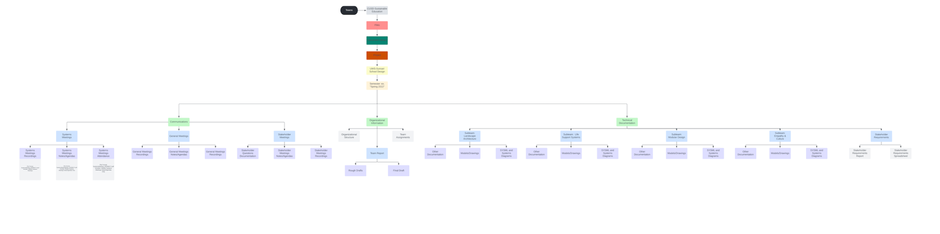

**Figure K-1.** Shows the Teams Data File Check In Structure

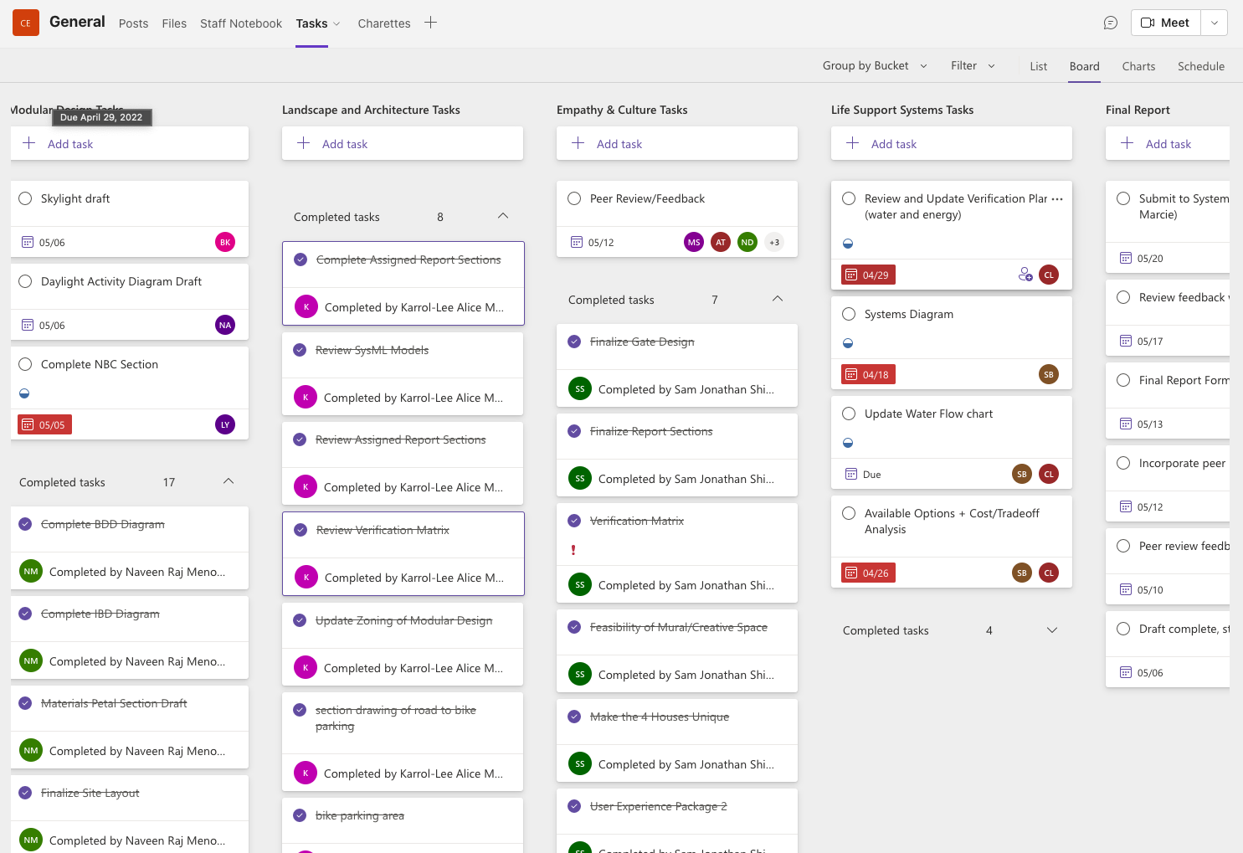

**Figure K-2.** Shows the task planner and tracker feature in the newly adopted Teams Channel for CUSD-SE

1. Ayubov, Sherzod. “Shed Sizes: How to Choose the Right Shed Size?” *DuraStor Structures*, 28 June 2022, durastorstructures.com/shed-sizes.
2. Prep, Site. “Do You Need a Foundation for a Shed? - a Guide for 2022.” *Site Prep*, 28 Apr. 2022, www.siteprep.com/do-you-need-a-foundation-for-a-shed.
3. SFMA. “Field Crowns and Slopes.” *SFMA*, 6 Mar. 2019, staging.stma.org/field-crowns-and-slopes.
4. Merritt, Cam. “What Is the Crown of a Football Field?” *SportsRec*, 15 Oct. 2019, www.sportsrec.com/417272-what-is-the-crown-of-a-football-field.html.
5. Government of Nepal Ministry of Urban Development. *NEPAL NATIONAL BUILDING CODE NBC 206: 2015: ARCHITECTURAL DESIGN REQUIREMENTS*. 2015, www.iibh.org/kijun/pdf/Nepal_25_NBC_206_Architectural_Design.pdf.
6. Cottrell, Wayne D. “Review of Parking Design Practices for Motorcycles.” *Transportation Research Record: Journal of the Transportation Research Board*, vol. 2194, no. 1, SAGE Publications, Jan. 2010, pp. 99–106. https://doi.org/10.3141/2194-12.
7. (Government of Nepal Ministry of Urban Development)
8. Government of Nepal Ministry of Urban Development. *NEPAL NATIONAl BUILDING CODE NBC 202: 2015: GUIDELINES ON: LOAD BEARING MASONRY*. 2015, moud.gov.np/storage/listies/July2019/NBC_202_2015_Guidline_on_Load_Bearing_Masonry.pdf.
9. Ryan, Kira. “The Types of Parking Lot Drainage Systems and Which One Is Right for You.” *Maul Asphalt*, 3 Aug. 2021, maulasphalt.com/blog/the-types-of-parking-lot-drainage-systems-and-which-one-is-right-for-you
10. “2.1 Cycle Parking.” *Mobility and Transport*, transport.ec.europa.eu/transport-themes/clean-transport-urban-transport/cycling/guidance-cycling-projects-eu/cycling-measures/21-cycle-parking_en.
11. ---. *Inverted U Bike Racks | Madrax Commercial Bike Racks*. info.madrax.com/inverted-u-bike-racks.
12. Graber Manufacturing, Inc. *Inverted U Bike Racks | Madrax Commercial Bike Racks*. info.madrax.com/inverted-u-bike-racks.
13. <https://bit.ly/3VymWH3>
14. <https://bit.ly/3P2qa3a>
15. <https://bit.ly/3VA5iTz>
16. <https://bit.ly/3P74qDC> , <https://bit.ly/3UtLyzy> , <https://bit.ly/3urSG4V> , <https://bit.ly/3FvvitA> , <https://bit.ly/3HdPykT>
17. <https://bit.ly/3HekjGq>
18. <https://bit.ly/3VX4veX>
19. <https://bit.ly/3Fd0j4m> , <https://bit.ly/3HfDC24>
20. <https://bit.ly/3Y2RXVx>
21. <https://bit.ly/3B7LRt5>
22. <https://bit.ly/3HeaKao>
23. <https://bit.ly/3VyufyM>
24. <https://bit.ly/3P5kjtV>
25. https://www.yourhome.gov.au/passive-design/passive-cooling